# Lab 4:

1. Implement the following scenario using packet tracer, create FTP server and two nodes a user can login using any of these systems.

## User Creation:

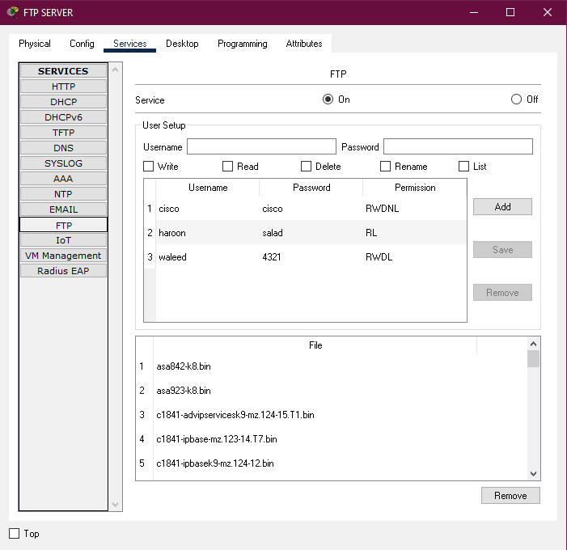

## Server:

## PC0:

## PC1:

## Connecting to FTP Server:

## PC0: PC1:

## Creating File on PC0:

## Uploading File on FTP Server:

From PC0:

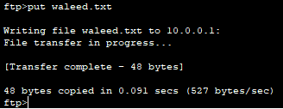

## Server Directory:

## Fetching File from FTP Sever via PC1:

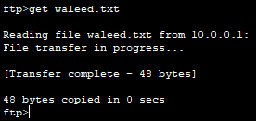

## Deleting File from FTP Server via PC1:

It won’t allow user to delete because user don’t have permission to do so.

## Deleting File from FTP Server via PC0:

File will be deleted because user have permission to do so.

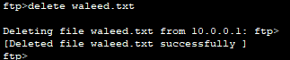

## Server Directory:

