

**Usman Institute of Technology**

**Department of Computer Science Fall 2022**

Name: Muhammad Waleed

Roll no: 20B-115-SE

Course: DCCN (CS-222)

Course Instructor: Engr. Fauzan Saeed

Date: 23-Nov-2022

# Lab Tasks:

1. What is the difference between 29xx switch series and 35xx/36xx switch. What benefit the later series will give explore using Packet Tracer

The main difference between the 29xx and 35xx/36xx series switches is the level of performance and feature support they offer. The 35xx and 36xx series are designed for enterprise-level networks and offer a higher level of capabilities, while the 29xx series is more suitable for small and medium-sized businesses.

In terms of using Packet Tracer, the 35xx and 36xx series switches may offer more advanced features and capabilities that can be explored and simulated in the software. For example, you may be able to simulate the use of advanced security features such as access control lists

1. Implement the scenario given below on packet tracer and show the connectivity between PC’s by using PING Command.

## Config of Switches:

Switch0:

Switch1:

## Configuration of PC’s:

PC0:

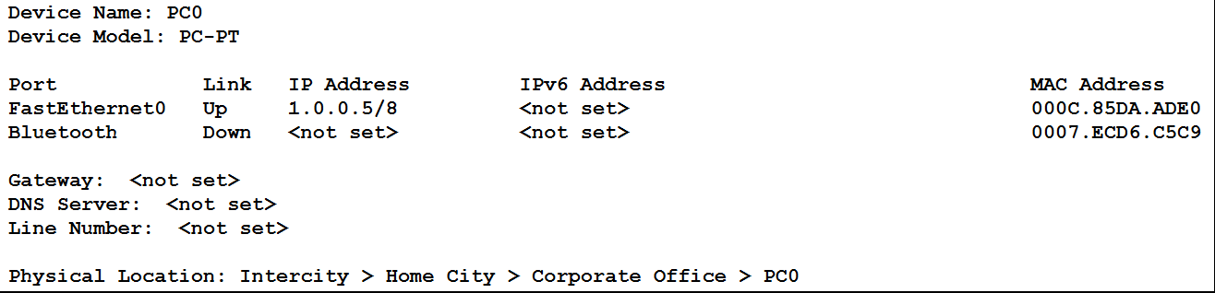

PC1:

PC2:

PC3:

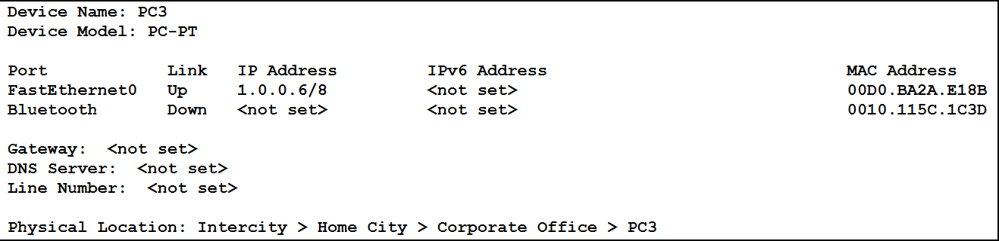

## Testing Connectivity:

From PC0 to PC3:

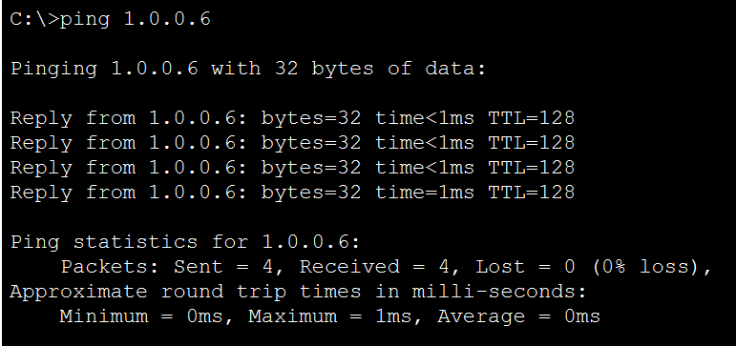

From PC1 to PC2:

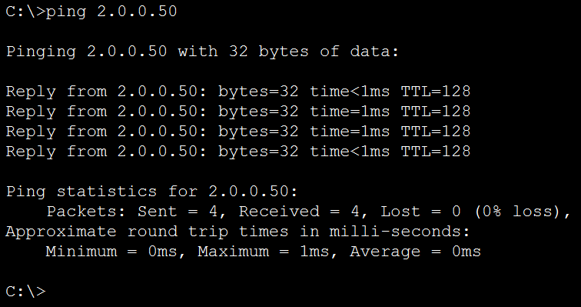

From PC2 to PC1:

From PC3 to PC0:

1. Use Packet Tracer to complete the following network shown below by connecting another switch SW1 and create VLANs in both switches and assign VLANs to the ports: VLAN 2 to FastEthernet Port 5-10 VLAN 3 to FastEthernet Port 11-15 VLAN 4 to FastEthernet Port 16-20 VLAN 5 to FastEthernet Port 21

## Arrangement:

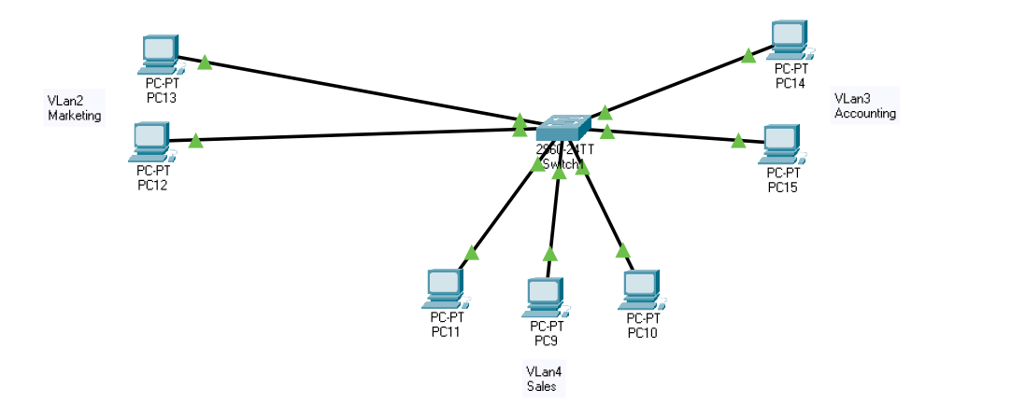

## Switch Config:

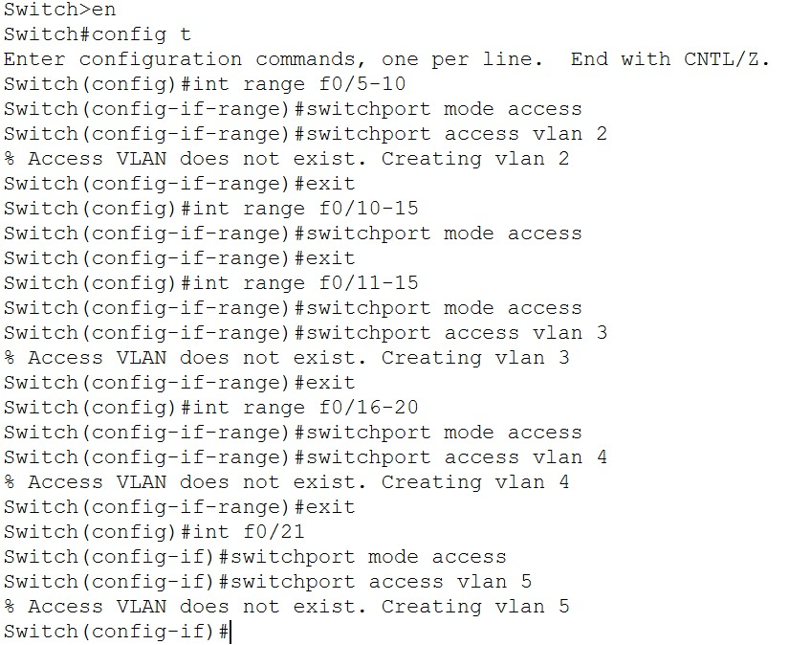

## VLan IP Assign:

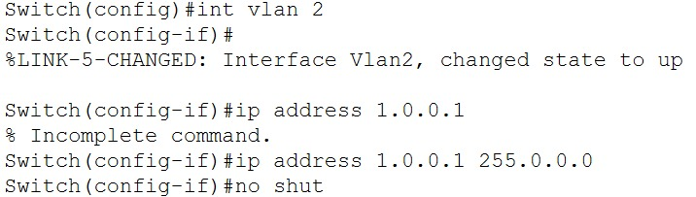

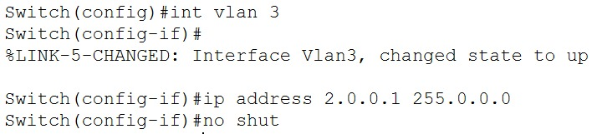

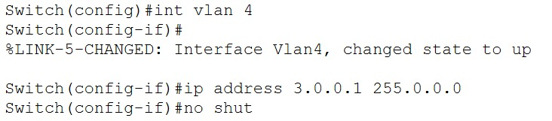

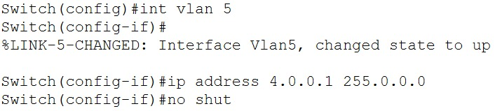

## Connection:

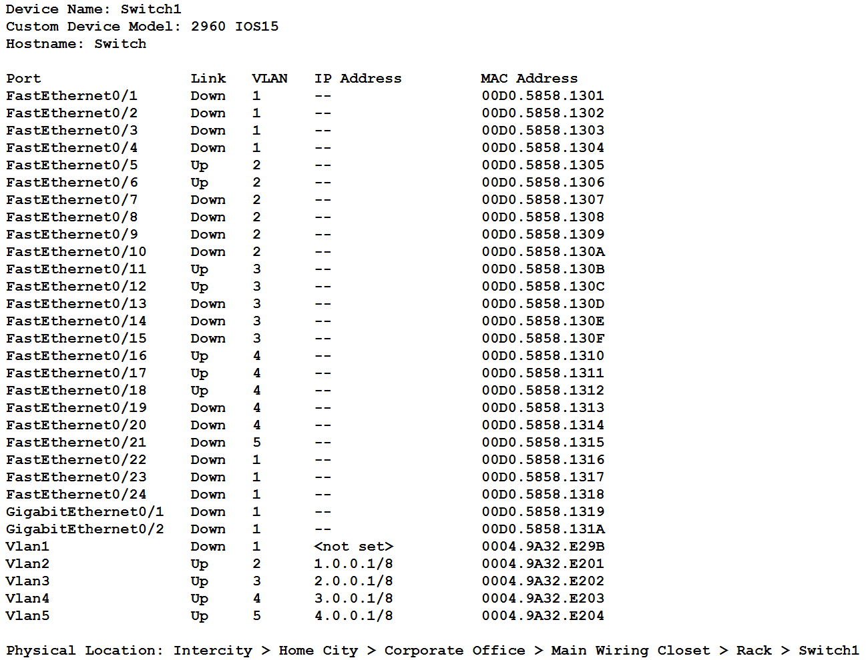

## IP assign to PCs:

Market’s PCs:

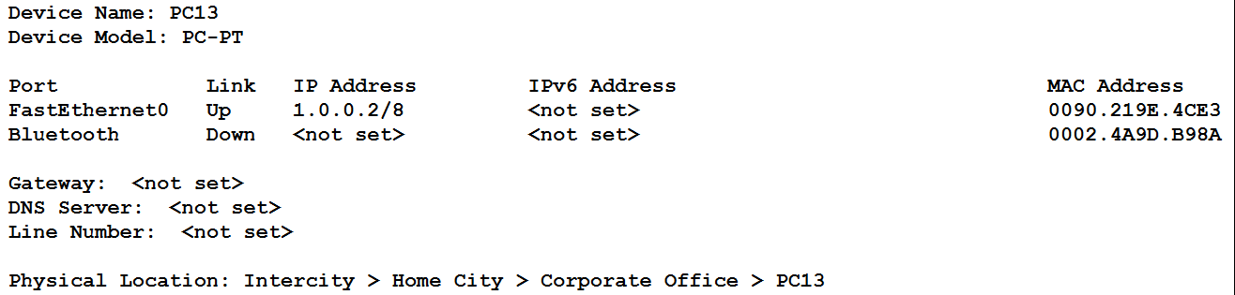

Accounting’s PCs:

Sales PCs:

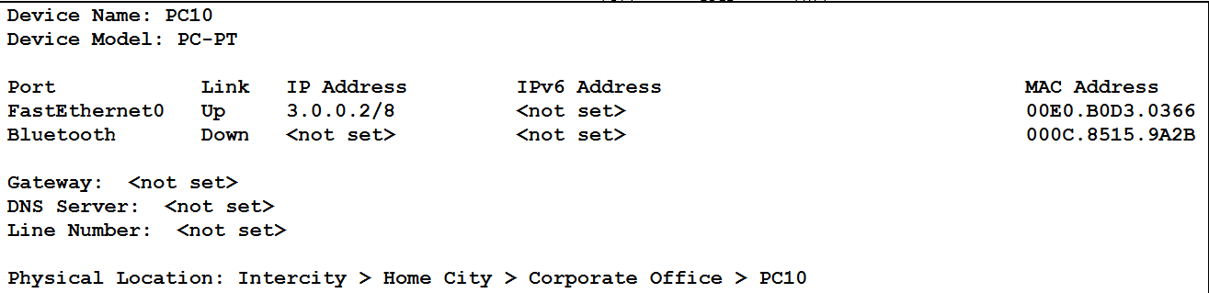

## Testing Connectivity:

Within VLan2:

From PC13 to PC12

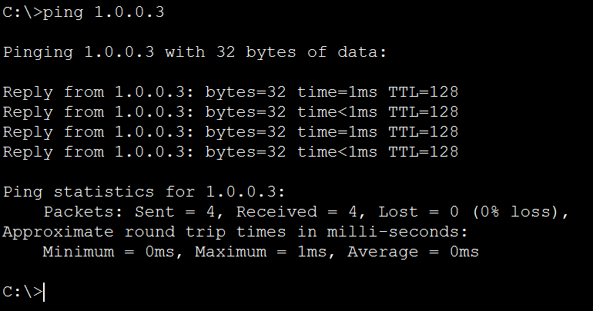

From PC12 to PC13

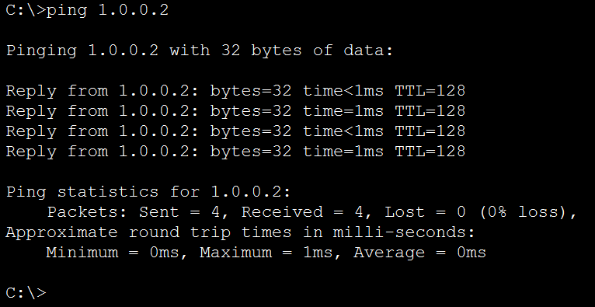

Outside VLan2:

From PC12 to PC09

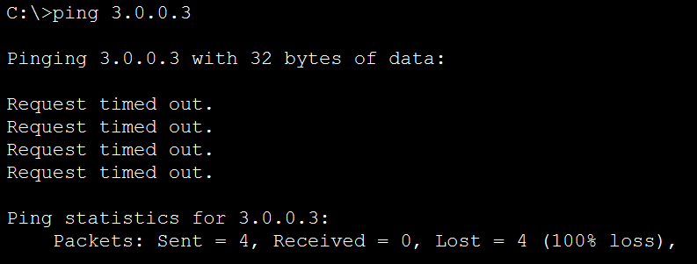

Within VLan3:

From PC14 to PC15

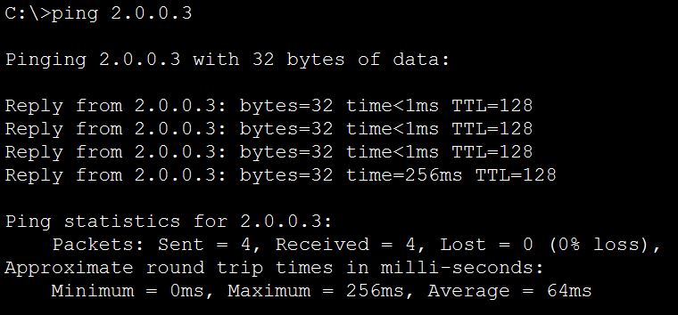

From PC15 to PC14

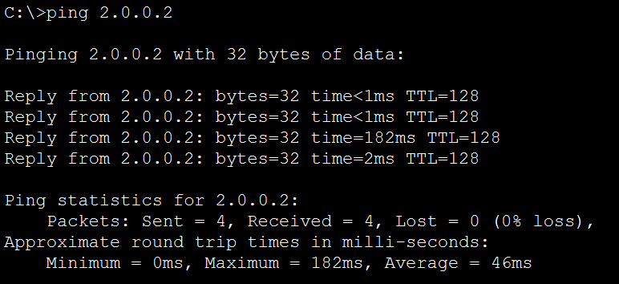

Outside VLan3:

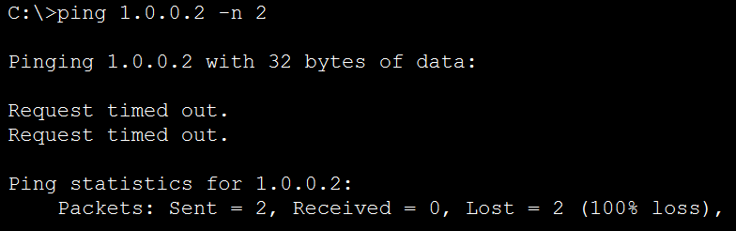

Within VLan4:

From PC11 to PC10

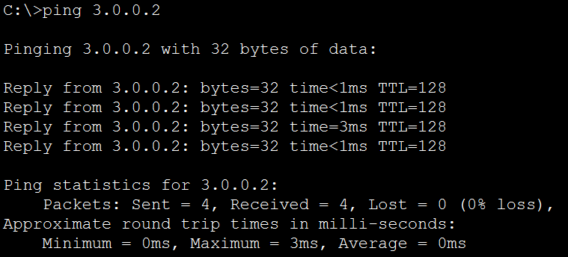

From PC9 to PC11

Outside VLan3:

From PC9 to PC13

