

Usman Institute of Technology

Department of Computer Science

Course Code: CS222

Course Title: Data Communication & Computer Networks Fall 2022

# Lab 02

Objective:

The purpose of this lab is to increase awareness about Packet Tracer and Boson Network Simulator

Student Information

|  |  |
| --- | --- |
| Student Name | Muhammad Waleed |
| Student ID | 20B-115-SE |
| Date | 19-Oct-2022 |

Assessment

|  |  |
| --- | --- |
| Marks Obtained |  |
| Remarks |  |
| Signature |  |

Usman Institute of Technology

Department of Computer Science

CS222 – Data Communication & Computer Networks

Lab 02

Instructions

* Come to the lab on time. Students who are late more than 20 minutes, will not be allowed to attend the lab.
* Students have to perform the examples and exercises by themselves.
* Lab work must be submitted on the same day it is performed.

1. Objective

The purpose of this lab is to increase awareness about Packet Tracer and Boson Network Simulator.

1. Labs Descriptions

## 1. Boson Network Simulator

It is an application that mimics the actual scenarios of network and networking devices in this simulator there are two phases, one being the design phase, here you design your network and other is the command line phase, where you configure your devices to work properly and create a well functional network. This application gives you the freedom to use a variety of routers and switches and test them as if you are interacting with the actual devices.

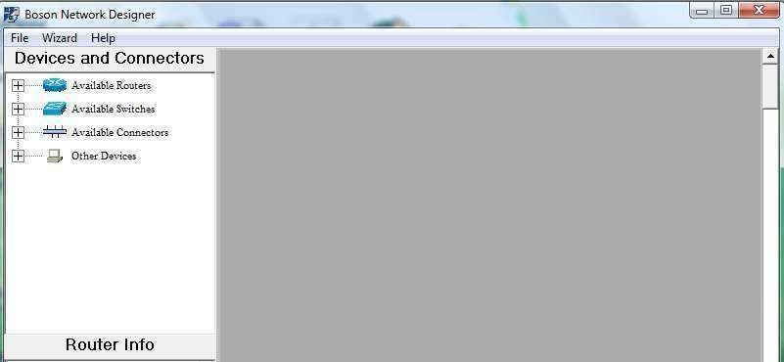

Figure 1: Interface of Boson Network Simulator.

Below is a list of devices that Boson Network Design supports . There is a list of Routers, Switches, wires/cables that will be used to connect the network devices. Last icon in the above list is of “Other devices” this has a provision for PC.

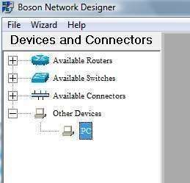

Figure 2: Available Devices and Connectors in Boson

Click on to “Other Devices” here you will the option of “PC” click on this icon and then drag it on to the main screen. As you will do that a screen will appear asking you to either enter the name of device or use default name.

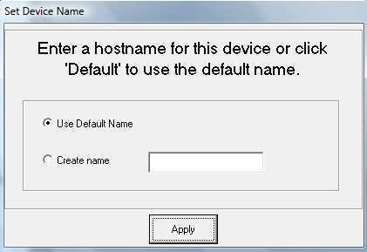

Figure 3: You can specify host name in Boson Network Simulator

Similarly repeat the above step to select another PC and drag n drop it on your main work area screen.

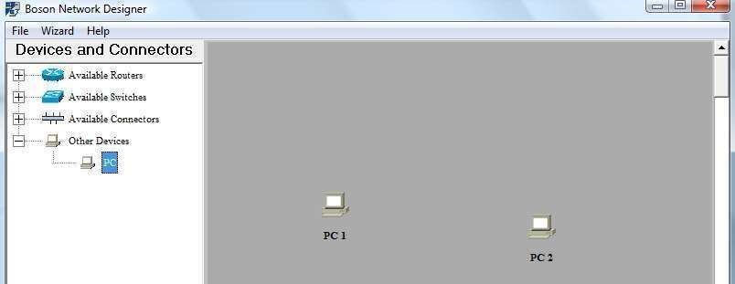

Figure 4: Two nodes are created on Boson Simulator

Now you have two PCs that are not connected. Go to “Available Connections” option and click it to view possible connections.

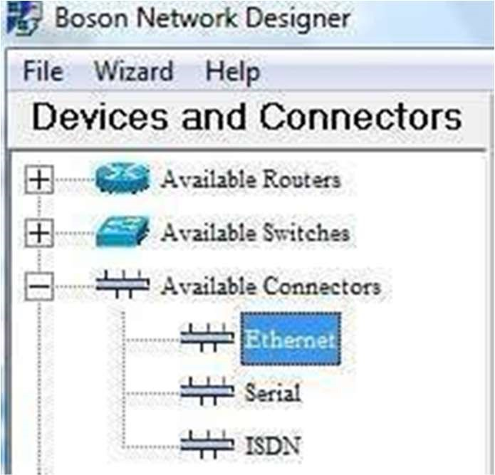

Figure 5:Selecting cables

Select Ethernet as we all know we need Ethernet card to be connected to LAN or Direct connectivity with some other device. As you will click Ethernet icon following screen will open.

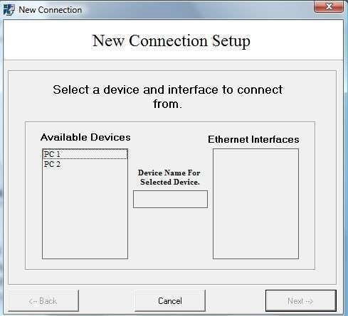

Figure 6: Connect two systems together

Now click on PC1 you will see following result.



Figure 7: Selecting PC1 and ethernet 0

Now click on “Ethernet 0” it will be highlighted like PC1 in above screen. Now press “Next” at the bottom right you will see following screen

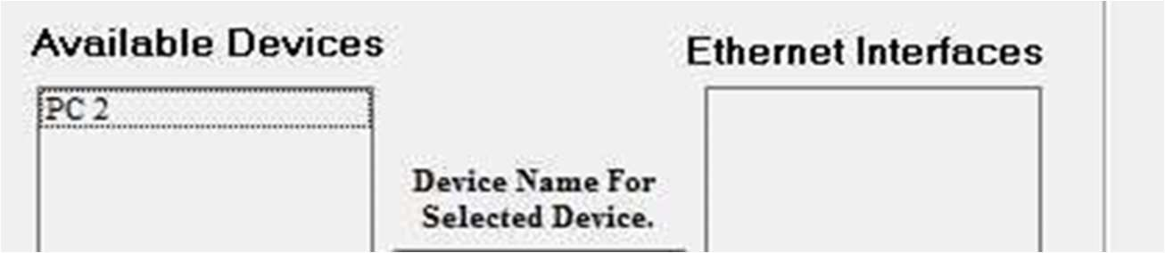

Figure 8: Select PC2 to connect it with PC1

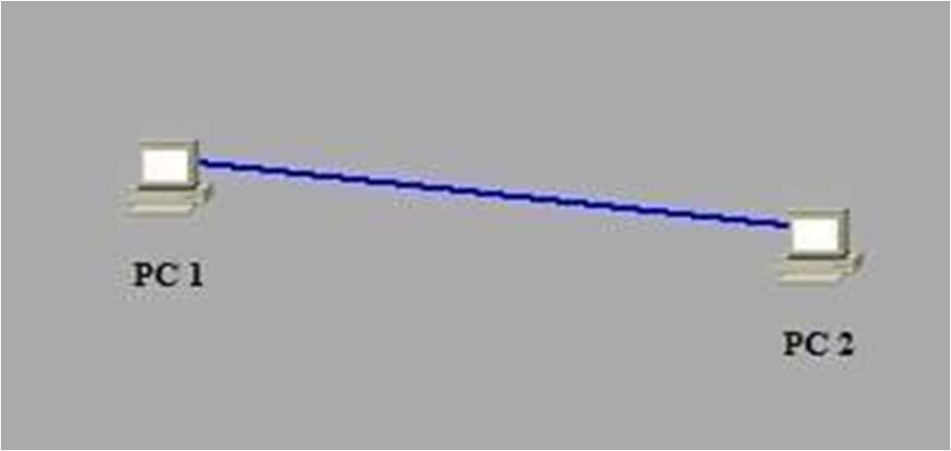

Figure 9: Two devices got connected togather

Physical Connection established between these two PCs. To the option of “File” located top left and save your file. Next step is to open Boson Network Simulator’s Control panel.

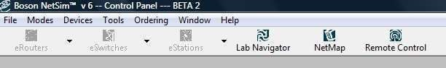

Figure 10: Boson netsim Interface

Here go in to “File” option and click on “Load Netmap” select your file which you saved in the previous step as a result command line environment will appear now this is where you will use commands which you learned in the first lab. Below is a screen shot that shows an icon of eStations having both PC1 and PC2 from here you can toggle from command line of PC1 to that of PC2.

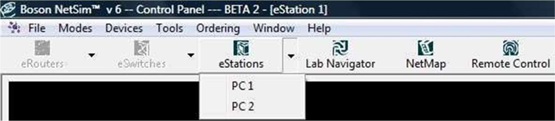

Figure11: Selecting Devices

Run the command “ipconfig” to see their ip address if both has same IP change them by using “winipcfg” command as you will run this command a screen will appear

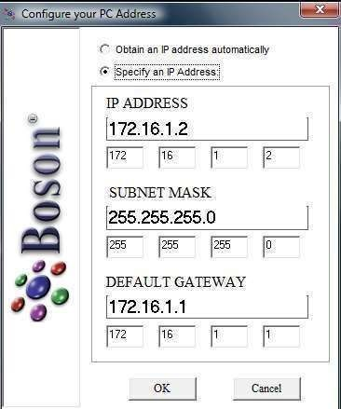

Figure 12: Configuring IP

Here enter IP ADDRESS 192.168.1.1 and set the DEFAULT GATEWAY same as your ip address.

Similarly set IP ADDRESS 192.168.1.2 of PC2 with the same DEFAULT GATEWAY (192.168.1.2) Now use PING command to diagnose connectivity. If PING successful, that is without any loss it means that connection is OK else there is a problem.

## 2. PACKET TRACER

Packet tracer is an alternate of boson network simulator here you can create network just like you do in boson network simulator the difference is that it also gives you pictorial view of the device with its panels and interfaces. You can also send variety of packets and see them travel from one node to another along with that telling which layers are involved on the way. This is an application that gives you interactive environment un-like any other.

## 2.1 PACKET TRACER MODES

Cisco Packet Tracer provides two operating modes to visualize the behavior of a network— realtime mode and simulation mode. In real-time mode the network behaves as real devices do, with immediate real-time response for all network activities. The real-time mode gives students a viable alternative to real equipment and allows them to gain configuration practice before working with real equipment.

In simulation mode the user can see and control time intervals, the inner workings of data transfer, and the propagation of data across a network. This helps students understand the fundamental concepts behind network operations. A solid understanding of network fundamentals can help accelerate learning about related concepts.

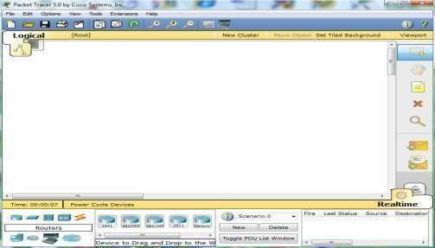

Figure 13: Packet Tracer Environment

At the bottom there is a list of devices which you can select. Drag n drop devices on to the main working area.

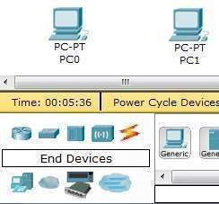

Figure 14: Select and Place Devices

Above screen shows two PCs selected for interconnection. List of some of the icons are shown below:

|  |  |
| --- | --- |
| Symbol | Device Name |
|  | Router |
|  | Switch |
|  | Hub |
|  | Wireless Device |
|  | Connections |

Figure 15: Device Detail

Press the right most icons  this icon is of “Connections” you will see different options like straight, cross-over or fiber if you don’t know the type of connection that will be used then simply select “Automatically Choose connection type” this will be the first option you will see after selecting “connections”.

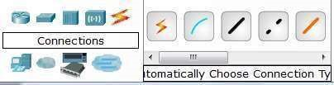

Figure 16: Depicting different cable types

Between similar devices if connection needs to be done then type of wire used is “Copper Cross Over”. Select type of wire using mouse and click on PC0 then Click it again on PC1 your connection will establish.

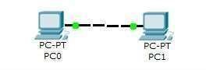

Figure 17: Depicting two PC connected together

A screen will open. Look at the top of this screen and you will see three tabs

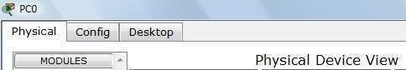

Figure 18: the three tabs on clicking a PC

Now, Click Desktop

Now click Command Prompt.

At command prompt type “ipconfig” to see IP address of PC

If all fields are Null then exit this window and go to “IP Configuration” Tab shown below

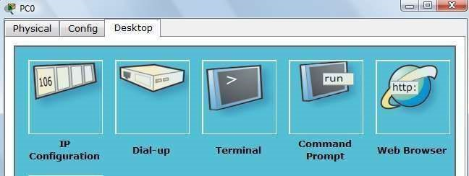

Figure 19: Accessing PC’s Desktop

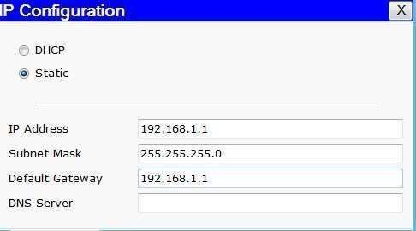

Figure 20: Enter IP 192.168.1.1 and select “static”

Do the same for PC1.

Set IP and Default Gateway 192.168.1.2

Now use PING command to check connection.

Lab tasks

1. After reading the manual elaborate the difference between the two tools.

Boson is a software that simulates real-world network and networking device scenarios. There are two phases in this simulator: the design phase, in which you design your network, and the command-line phase, in which you set up your devices to operate correctly and build a well-functioning network.

Whereas Cisco Packet Tracer uses real-time mode which allows the network to respond to all network activity instantly, just like real devices would. The real-time mode offers students an effective substitute for actual equipment and enables them to practice configuration before using actual equipment.

1. Take two PCs, connect them with suitable wire and also describe the reason of selection of wire. Assign them IP addresses and check their connectivity by using PING command. (Use Packet tracer for this task).

For this task I have used cross-over wire because of the pc configuration. The transmitting wire of pc1 will be the receiving line of p6 and vice versa, in this way the communication between two pc will be possible.

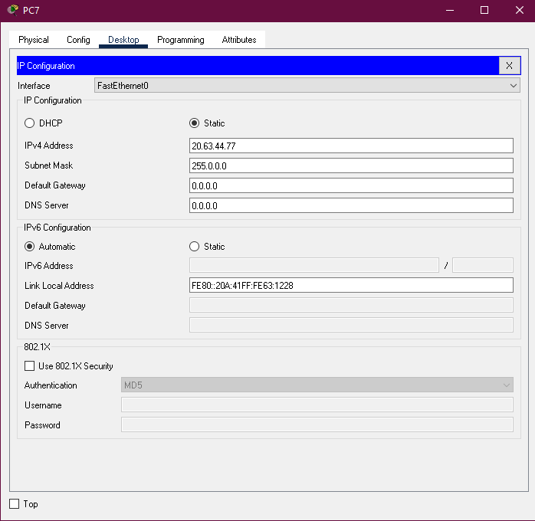

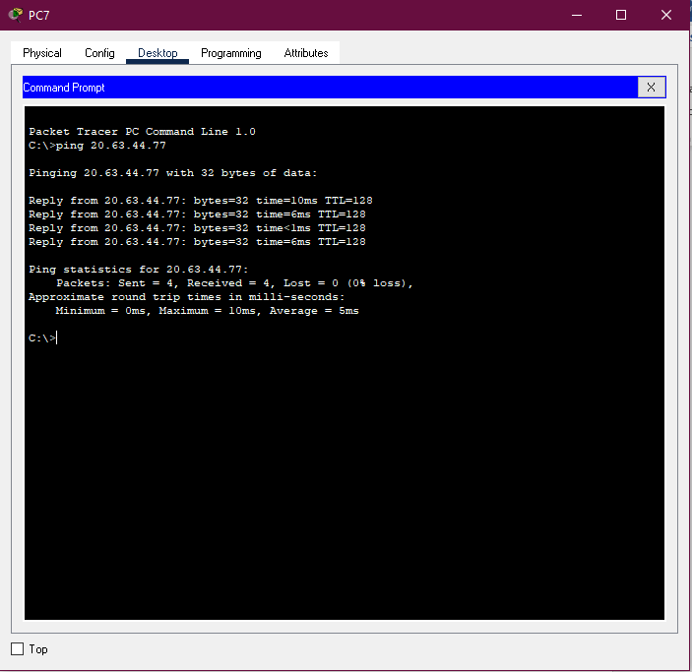

1. Design and configure the network given in the figure below and check the connectivity by PING command. Also describe the functionality of HUB device in given scenario.

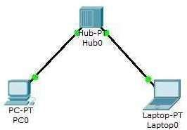

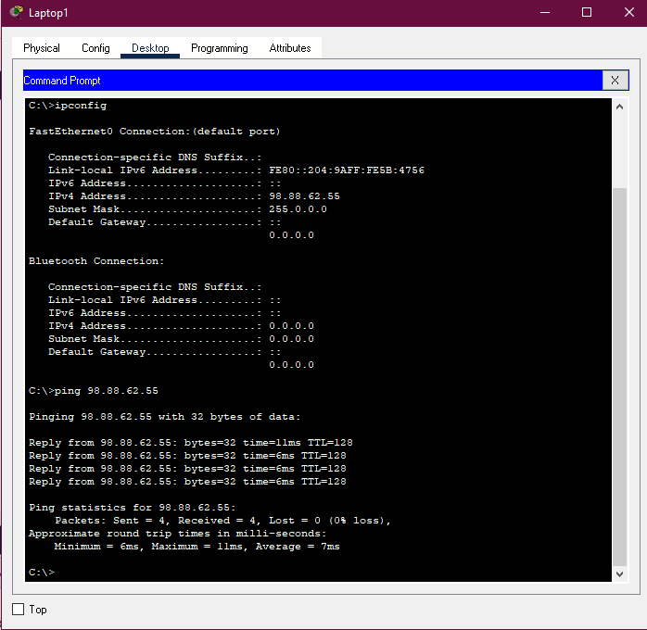

1. Consider the following figure. The PC is connected to the console port of the switch. All the other connections are made through Fast Ethernet links. Which types of UTP cables can be used with segment 1, 2 and 3?

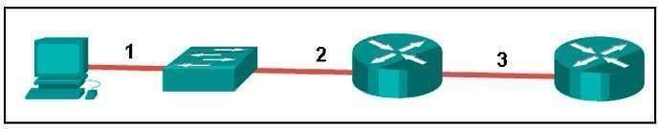

Type of UIT Cables: 1.) Roll Over 2.) Straight-Through 3.) Cross-Over

