

Usman Institute of Technology

Department of Computer Science

Course Code: CS222

Course Title: Data Communication & Computer Networks Fall 2022

# Lab 03

Objective:

This Lab activity focuses on how to create straight and cross cable using RJ-45 connector and Crimping tool

## Student Information

|  |  |
| --- | --- |
| Student Name | Muhammad Waleed |
| Student ID | 20b-115-se |
| Date | 26-Oct-2022 |

## Assessment

|  |  |
| --- | --- |
| Marks Obtained |  |
| Remarks |  |
| Signature |  |

Usman Institute of Technology

Department of Computer Science

CS222- Data Communication & Computer Networks

Lab 03

Instructions

State the instruction that student needs to follow for performing the example and exercises. Some sample instructions are given below which can be altered as needed E.g.

* Come to the lab in time. Students who are late more than 15 minutes, will not be allowed to attend the lab.
* Students have to perform the examples and exercises by themselves.
* Raise your hand if you face any difficulty in understanding and solving the examples or exercises.
* Lab work must be submitted on or before the submission date.

1. Objective

This Lab activity focuses on how to create straight and cross cable using RJ-45 connector and Crimping tool

1. Labs Descriptions Twisted pair cables have different types and categories. Some of its types are given below:
   1. STP (shielded Twisted Pair)
   2. UTP (Un-shielded Twisted Pair)
   3. ScSTP (Screened Shielded twisted pair can also come under STP type)

There are around 7 categories of Twisted pair these categories are defined on the basis of data rates and their usage.

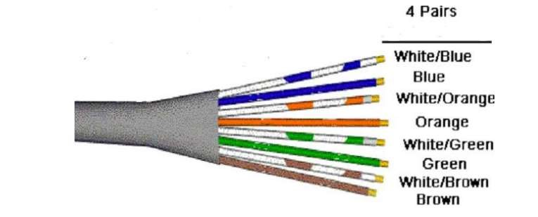

Figure1: Depicting twisted pair cable with colored wires

CONNECTORS

The straight through and crossover patch cables discussed in this article are terminated with CAT 5 RJ-45 modular plugs. RJ-45 plugs are similar to those you'll see on the end of your telephone cable except they have eight versus four or six contacts on the end of the plug and they are about twice as big. Make sure they are rated for CAT 5 wiring. (RJ means "Registered Jack"). Also, there are RJ-45 plugs designed for both solid core wire and stranded wire. Others are designed specifically for one kind of wire or the other. Be sure you buy plugs appropriate for the wire you are going to use.

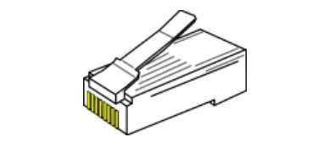

Figure2: RJ45 Connector having 8 pins

NETWORK CABLE TOOLS

Modular Plug Crimp Tool: You will need a modular crimp tool. This one is very similar to the one that can be used for all kinds of telephone cable work and it works just fine for Ethernet cables. You don't need a lot of bells and whistles, just a tool which will securely crimp RJ-45 connectors. Even though the crimper has cutters which can be used to cut the cable and individual wires, and possibly stripping the outer jacket.

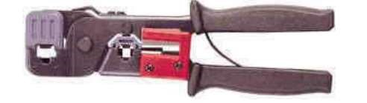

Figure3: Modular Plug Crimp Tool

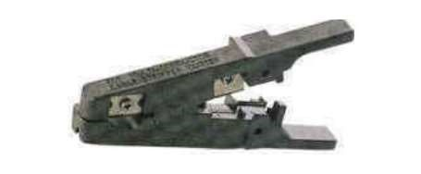 Figure 4: Eclipse

Universal UTP Stripping Tool (Eclipse): It makes a much Neater cut. I recommended that you purchase one if you will be making many cables.

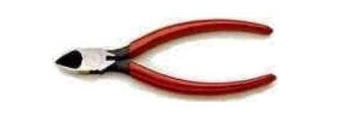

Figure 5: Diagonal Cutter

BASIC THEORY

The 10BASE-T and 100BASE-TX Ethernets consist of two transmission lines. Each transmission line is a pair of twisted wires. One pair receives data signals and the other pair transmits data signals. A balanced line driver or transmitter is at one end of one of these lines and a line receiver is at the other end. Pulses of energy travel down the transmission line at about the speed of light (186,000 miles/second). The principal components of one of these pulses of energy is the voltage potential between wires and current flowing near the surface of the wires. This energy can also be considered as residing in the magnetic field which surrounds the wires and the electric field between the wires. In other words, an electromagnetic wave which is guided by, and travels down the wires. The main concern is the transient magnetic fields which surrounds the wires and the magnetic fields generated externally by the other transmission lines in the cable, other network cables, electric motors, fluorescent lights, telephone and electric lines, lightning, etc. This is known as noise. Magnetic fields induce their own pulses in a transmission line which may literally bury the Ethernet pulses, the conveyor of the information being sent down the line.The twisted-pair Ethernet employs two principle means for combating noise. The first is the use of balanced transmitters and receivers. A signal pulse actually consists of two simultaneous pulses relative to ground: a negative pulse on one line and a positive pulse on the other. The receiver detects the total difference between these two pulses. Since a pulse of noise (shown in red in the diagram) usually produces pulses of the same polarity on both lines one pulse is essentially canceled out by the other at the receiver. Also, the magnetic field surrounding one wire from a signal pulse is a mirror of the one on the other wire. At a very short distance from the two wires the magnetic fields are opposite and have a tendency to cancel the effect of each other out. This reduces the line's impact on the other pair of wires. The second and the primary means of reducing cross-talk--the term cross-talk came from the ability to (over) hear conversations on other lines on your phone--between the pairs in the cable, is the double helix configuration produced by twisting the wires together. This configuration produces symmetrical (identical) noise signals in each wire. Ideally, their difference, as detected at the receiver, is zero. In actuality it is much reduced.

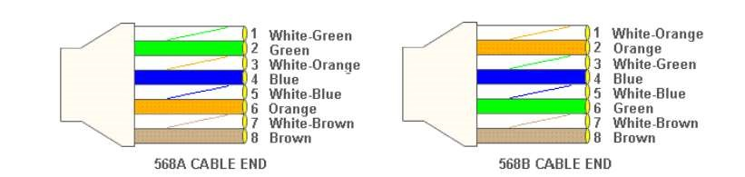

Figure6: The two ends of a cross cable

Again, the wires with colored backgrounds may have white stripes and may be donated that way in diagrams found elsewhere. For example, the green wire may be labeled Green White. The background color is always specified first. PIN CABLE COLOR 1 White/Orange 2 Orange 3 White/Green 4 Blue 5 White/Blue 6 Green 7 White/Brown.

Now, all you need to remember, to properly configure the cables, are the diagrams for the two cable ends and the following rules: A straight-through cable has identical ends. For straight through cable following wire configuration is used on both the sides.

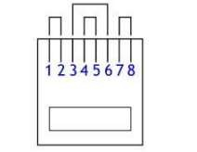

Figure 7: Rj45 and pin arrangement

A crossover cable has different ends. It makes no functional difference which standard you use for a straight-thru cable. You can start a crossover cable with either standard as long as the other end is the other standard. It makes no functional difference which end is which. Despite what you may have read elsewhere, a 568A patch cable will work in a network with 568B wiring and 568B patch cable will work in a 568A network. The electrons couldn't care less.

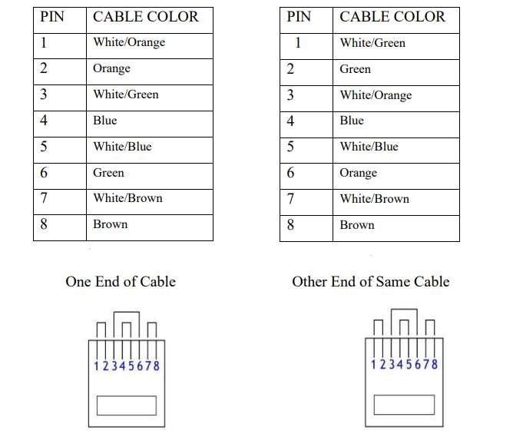

Figure8: Straight Cable Configuration

TO MAKE CABLE

1. Pull the cable off the reel to the desired length and cut. The total length of wire segments between a PC and a hub or between two PC's cannot exceed 100 Meters (328 feet or about the length of a football field) for 100BASE-TX and 300 Meters for 10BASE-T.
2. Strip one end of the cable with the stripper or a knife and diags. If you are using the stripper, place the cable in the groove on the blade (left) side of the stripper and align the end of the cable with the right side of the stripper. This will strip about 1/2" of the jacket off the cable. Turn the stripper about 1 1/4 turns and pull. If you turn it more, you will probably nick the wires. If you are using a knife and diags, carefully slit the cable for about an inch or so and neatly trim around the circumference of the cable with diags to remove the jacket.
3. Inspect the wires for nicks. Cut off the end and start over if you see any. You may have to adjust the blade with the screw at the front stripper. Cable diameters and jacket thicknesses vary.
4. Spread and arrange the pairs roughly in the order of the desired cable end. • Untwist the pairs and arrange the wires in the order of the desired cable end. • Flatten the end between your thumb and forefinger. Trim the ends of the wires so they are even with one another. • It is very important that the unstripped (untwisted) end be slightly less than 1/2" long. • If it is longer than 1/2" it will be out-of-spec and susceptible to crosstalk. • If it less than slightly less than 1/2" it will not be properly clinched when RJ-45 plug is crimped on.. Flatten again. There should be little or no space between the wires.
5. Hold the RJ-45 plug with the clip facing down or away from you. Push the wire firmly into the plug. Now, inspect before crimping and wasting the plug! Looking through the bottom of the plug, the wire on the far left side will have a white background. The wires should alternate light and dark from left to right. The furthest right wire is brown. The wires should all end evenly at the front of the plug. The jacket should end just about where you see it in the diagram below:

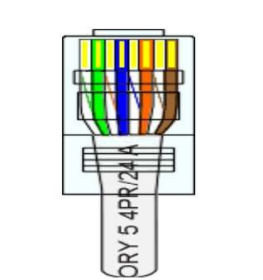

Figure 9: wires attached to RJ45

ALL ABOUT CRIMPING

1. Hold The Wire Near The Rj-45 Plug With The Clip Down And Firmly Push It Into The Left Side Of The

Front Of The Crimper (It Will Only Go In One Way). Hold The Wire In Place Squeeze The Crimper Handles Quite Firmly. This Is What Will Happen

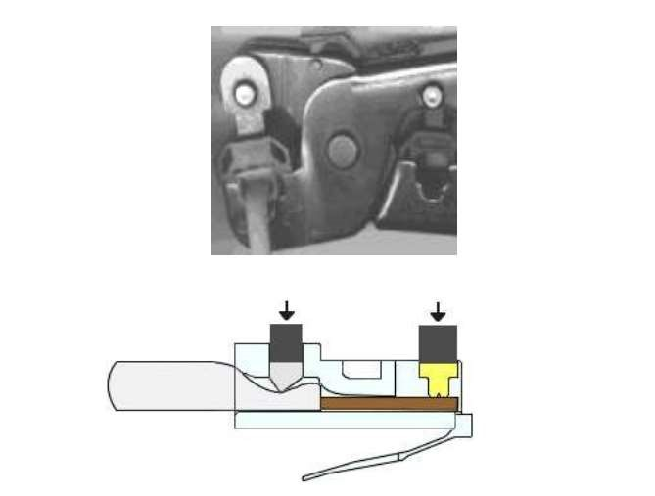

Figure 10: Clamping the RJ45 when the wire is properly inserted.

(Crimp it once.) The crimper pushes two plungers down on the RJ-45 plug. One forces what amounts to a cleverly designed plastic plug/wedge onto the cable jacket and very firmly clinches it. The other seats the "pins," each with two teeth at its end, through the insulation and into the conductors of their respective wires. 7. Test the crimp... If done properly an average person will not be able to pull the plug off the cable with his or her bare hands. And that quite simply, besides lower cost, is the primary advantage of twisted-pair cables over the older thin wire, coaxial cables. In fact, I would say the RJ-45 and ease of its installation is the main reason coaxial cable is no longer widely used for small Ethernets. But, don't pull that hard on the plug. It could stretch the cable and change its characteristics. Look at the side of the plug and see if it looks like the diagram and give it a fairly firm tug to make sure it is crimped well. 8. Prepare the other end of the cable so it has the desired end and crimp. 9. If both ends of the cable are within reach, hold them next to each other and with RJ-45 clips facing away. Look through the bottom of the plugs. If the plugs are wired correctly, and they are identical, it is a straight-thru cable. If they are wired correctly and they are different, it is a crossover cable.

CABLING RULES

1. Try to avoid running cables parallel to power cables.
2. Do not bend cables to less than four times the diameter of the cable.
3. If you bundle a group of cables together with cable ties (zip ties), do not over-cinch them. It's okay to snug them together firmly; but don't tighten them so much that you deform the cables.
4. Keep cables away from devices which can introduce noise into them. Here's a short list: copy machines, electric heaters, speakers, printers, TV sets, fluorescent lights, copiers, welding machines, microwave ovens, telephones, fans, elevators motors, electric ovens, dryers, washing machines, and shop equipment.
5. Avoid stretching UTP cables (the force should not exceed 25 LBS). 6. Do not run UTP cable outside of a building. It presents a very dangerous lightning hazard! 7. Do not use a stapler to secure UTP cables. Use telephone wire hangers which are available at most hardware stores

Lab tasks

1. **Give the reason why it is not advisable to bend UTP cabled more than four times the diameter of the cable?**

**Answer)** If bends exceed this limit, then it can ruin a cable by excessive stretching of conductors and will introduce loss due to attenuation.

1. **Why is it not advisable to run UTP cable outside of a building?**

**Answer)** It is not advisable to run a UTP cable outside because if lightening strikes then the cable will incur great damage. Moreover its a conductor and it is not advisable to leave conducting things open as they can transmit electric current easily.

1. **Define the recommended maximum cable length for UTP and cite for it.**

**Answer)** The length should not be more than 100 meters.

Video Tutorial

Twisted Pair - YouTube

How to make straight cable - YouTube