

**Usman Institute of Technology**

**Department of Computer Science Fall 2022**

Name: Muhammad Waleed

Roll no: 20B-115-SE

Course: DCCN (CS-222)

Course Instructor: Engr. Fauzan Saeed

Date: 21-Dec-2022

# Lab Task:

Implement the following topology with RIP protocol.

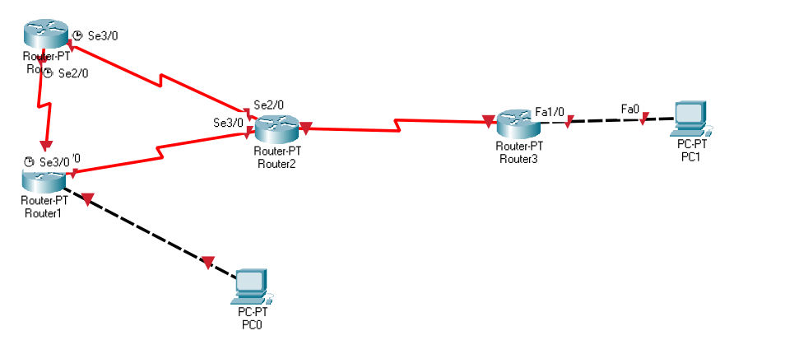

## Configuration:

Router0:

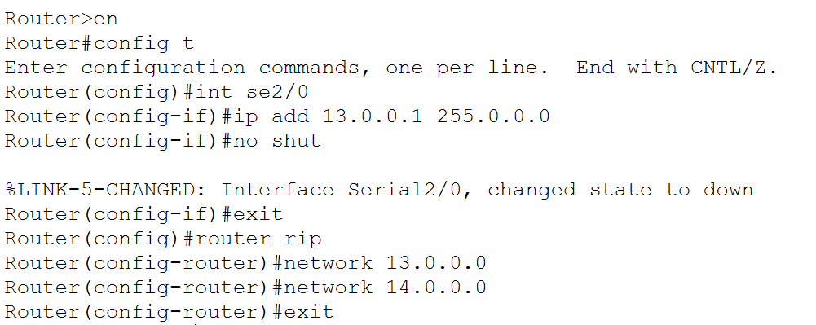

Router1:

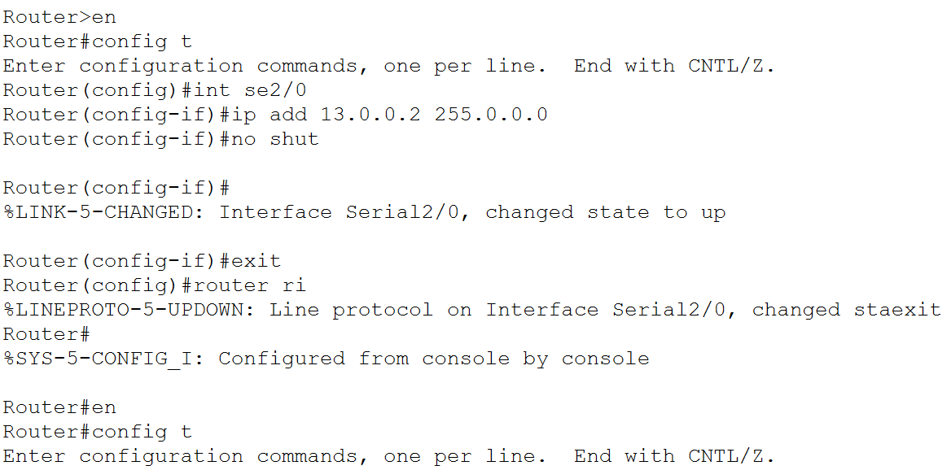

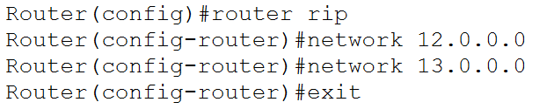

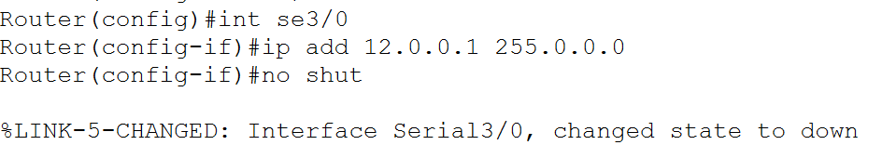

Router2:

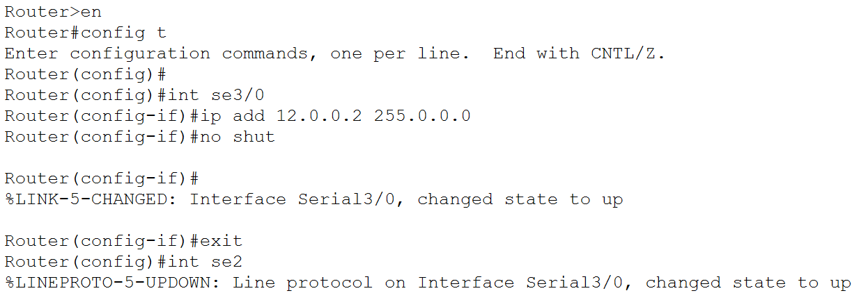

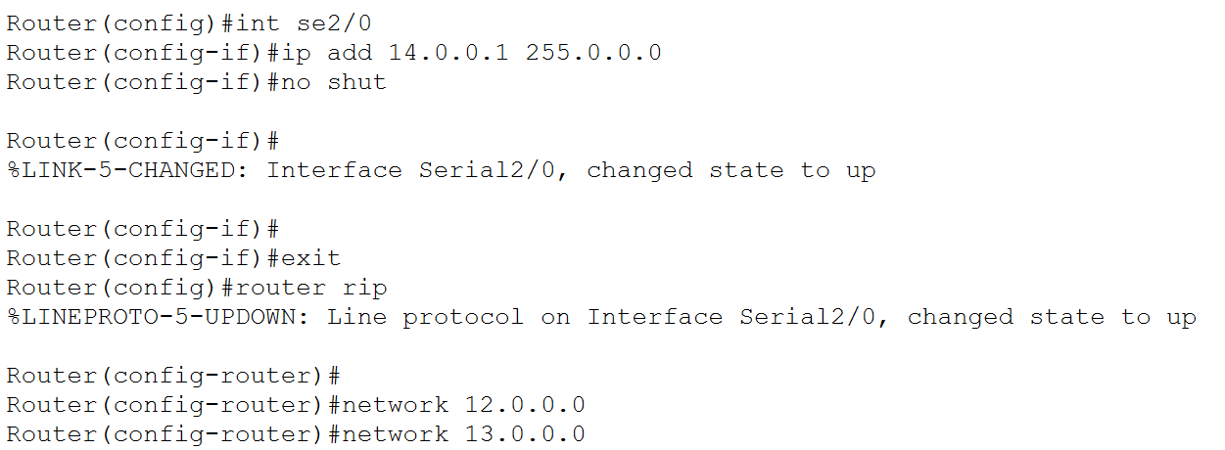

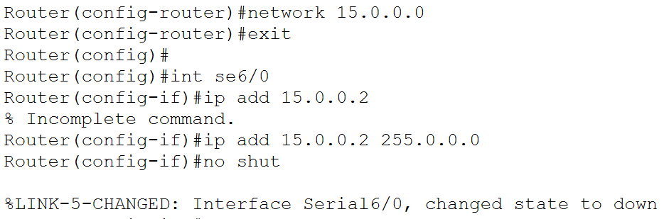

Router3:

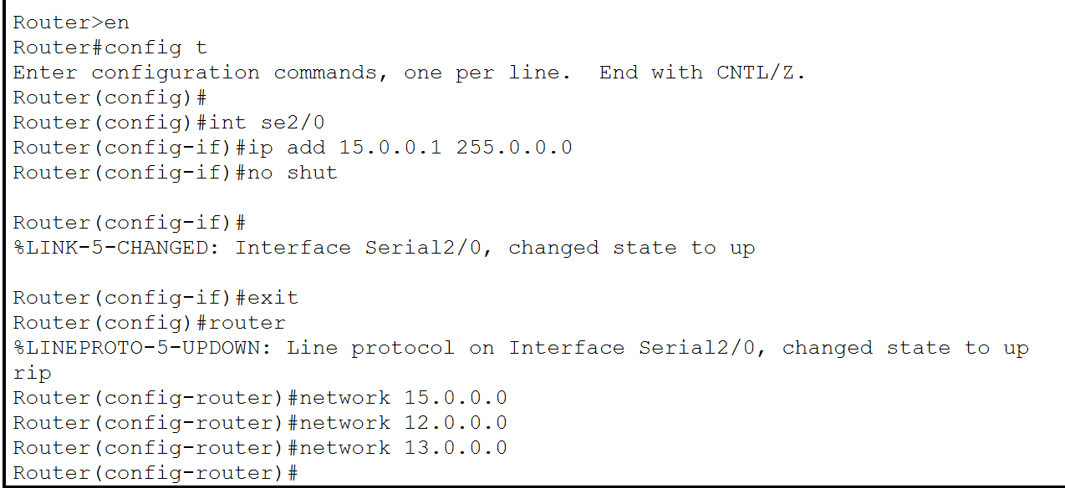

PC Connection with Router:

On Router1:

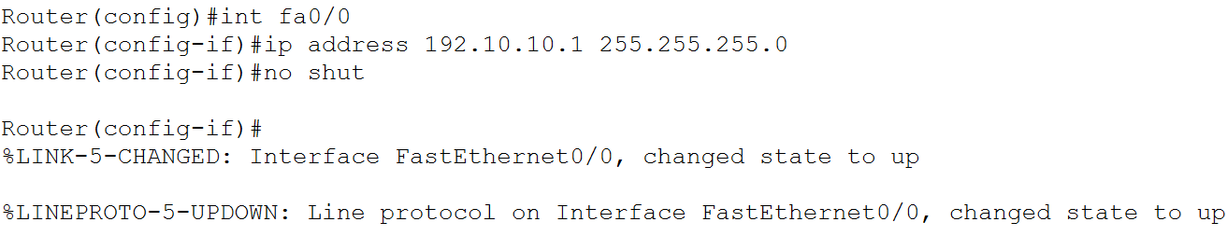

On PC0:

On Router3:

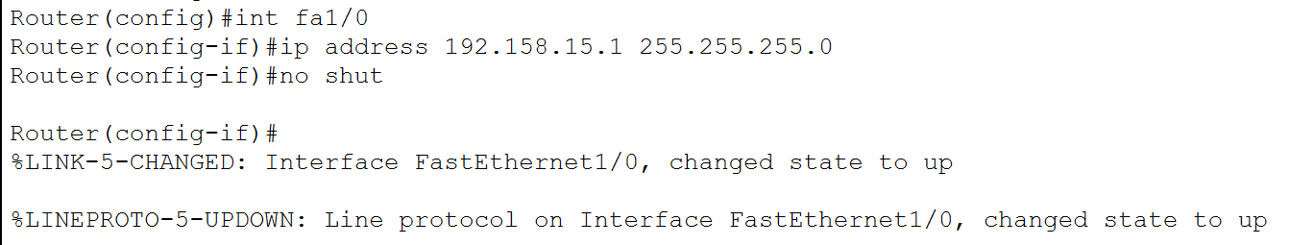

On PC1:

Connectivity Test:

Router Table:

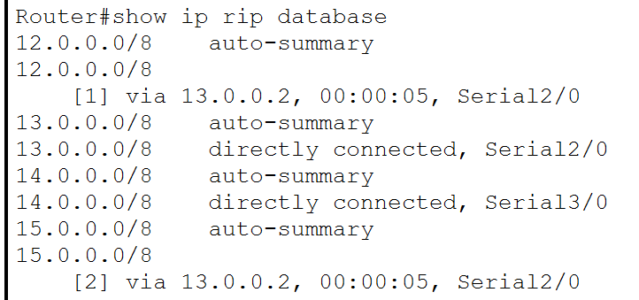

On removing one link,

