# Lab 5:

1. Implementation of DHCP Server.

## Arrangement of Network:

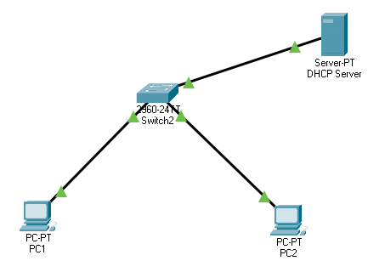

## IP Configuration:

Server’s only, DHCP Server will automatically assign IP address to relevant PCs.

## DHCP Configuration:

## IP Configuration of PC1 and PC2:

# DNS Configuration:

## Arrangement of Network:

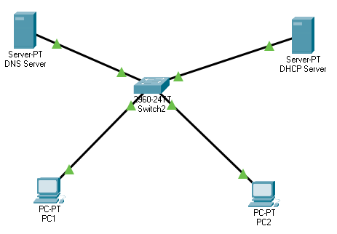

## DNS Configuration:

Of Sever.

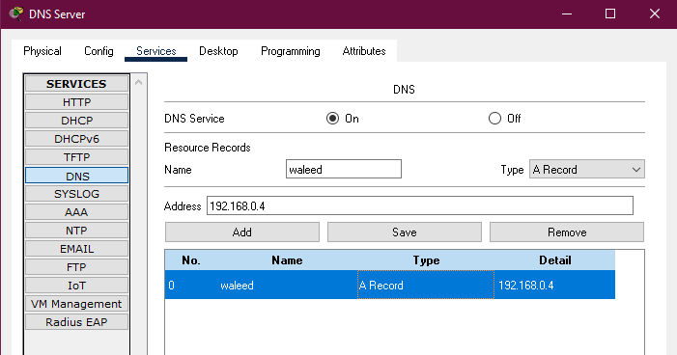

DHCP Configuration.

## Testing DNS on PC1:

## Testing DNS on PC2:



