

**Usman Institute of Technology**

**Department of Computer Science**

**Course Code: CS222**

**Course Title: Data Communication & Computer Networks**

# Fall 2022

**Lab 01**

**Objective:**

This practical performance exposes the students to some of the diagnostic commands that are utilized to diagnose/troubleshoot the problems.

**Student Information**

|  |  |
| --- | --- |
| Student Name | **Muhammad Waleed** |
| Student ID | **20B-115-SE** |
| Date | **12/11/2022** |

**Assessment**

|  |  |
| --- | --- |
| Marks Obtained |  |
| Remarks |  |
| Signature |  |

**Usman Institute of Technology**

**Department of Computer Science**

**CS222 – Data Communication & Computer Networks**

**Lab 01**

## Instructions

* Come to the lab in time. Students who are late more than 20 minutes, will not be allowed to attend the lab.
* Students have to perform the examples and exercises by themselves.
* Lab work must be submitted on the same day it is performed.

## 1.Objective

This practical performance exposes the students to some of the diagnostic commands that are utilized to diagnose/troubleshoot the problems.

## 2.Labs Descriptions

1. Tracert : It is a utility that can be used to determine the route and hop count to a destination

n. Example of tracert is shown below:

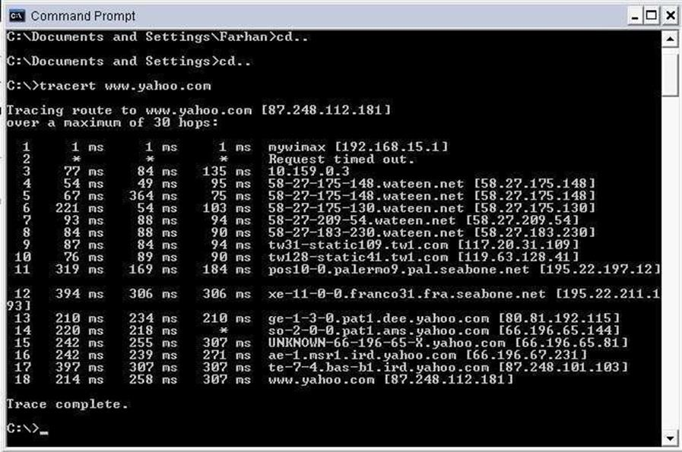

Figure 1: Tracert command being used to depict the hops required to reach the destination

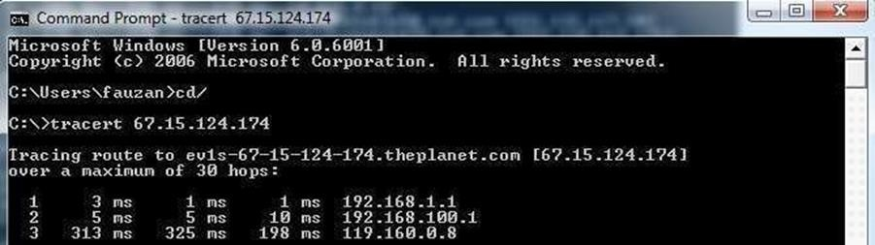

Figure 2: Tracert command used with IP address instead of domain name

1. PING:

PING stands for “Packet Internet Groper” and it is a diagnostic tool that is used to check whether a host is reachable or not. Target can be either a name or IP address.

Syntax:

Ping [www.uit.edu](http://www.uit.edu/)

Ping ip address (you can mention ip address instead of domain name)

Ping ip address or Domain name –n number of packets you want to sent

Ping –a ip address.(will first resolve ip to its domain name)

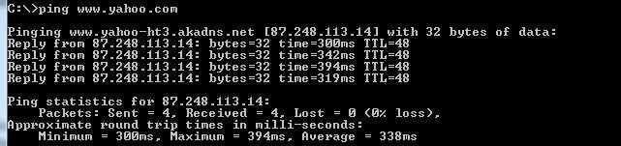

Figure 3: PING using domain name

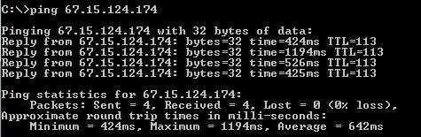

Figure 4: PING using IP Address

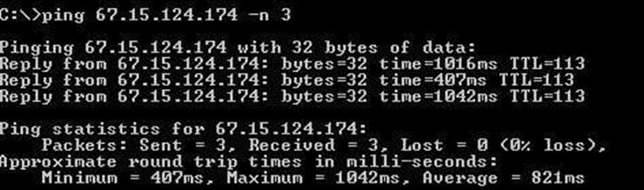

Figure 5: PING using IP Address and specifying number of packets.

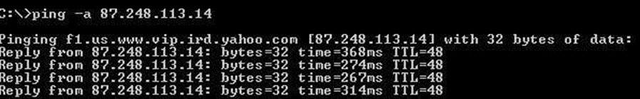

Figure 6: PING using a variant -a will yield domain name associated with IP and rest is same as above.

1. ARP

ARP is “Address Resolution Protocol”. It is used to resolve IP address to MAC address.

arp –a (will show a list of relevant IP addresses and their corresponding MAC addresses)

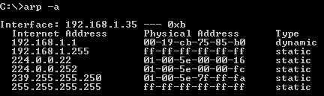

Figure 7: arp with -a variant can show IP and Corresponding MAC address

1. NETSTAT

This command gives you information about transport protocols (TCP and UDP) and their present state like close or listening etc.

Netstat –a Shows the status of port along with the devices local address and the address with which communication is being done.

Netstat -e will yield Ethernet statistics that is number of bytes sent and received

Netstat -r To see routing table information and interface detail use following command

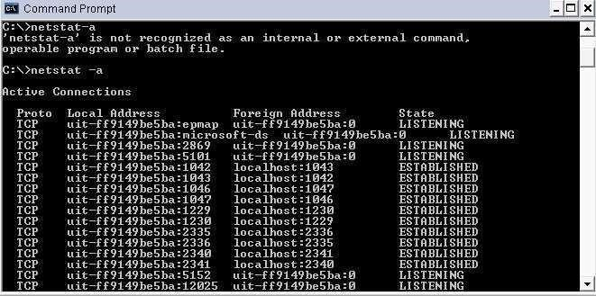

Figure 8: netstat with -a variant can show IP and Corresponding MAC address

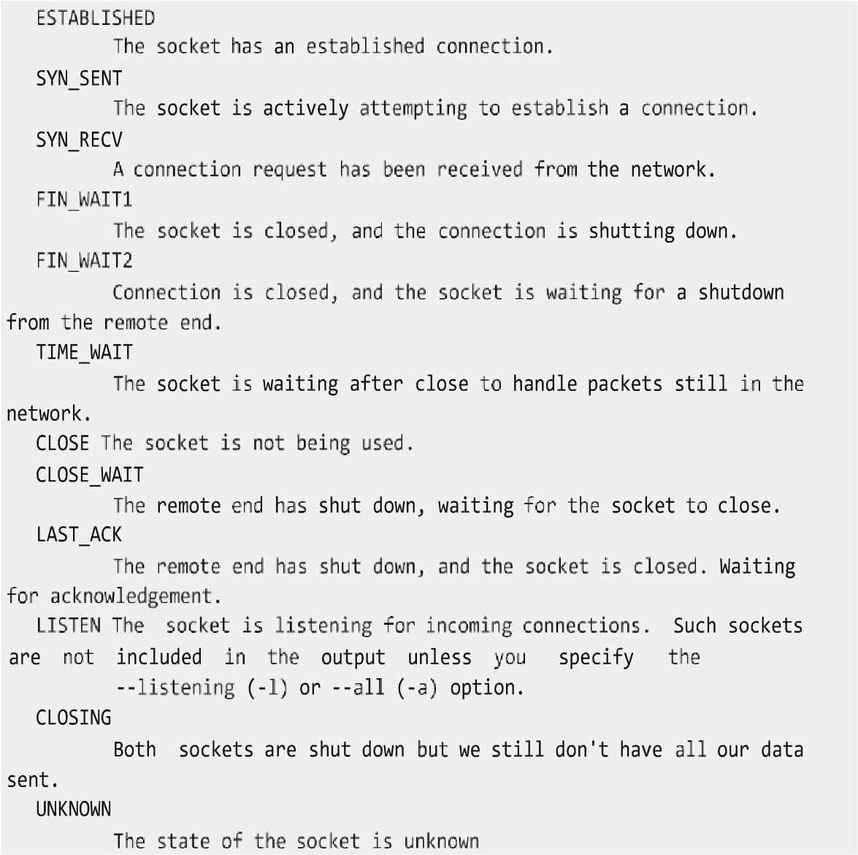

Figure 9: Depicting the different status of ports

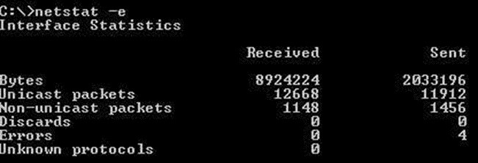

Figure 10: Showing Ethernet statistics that is number of bytes sent and received

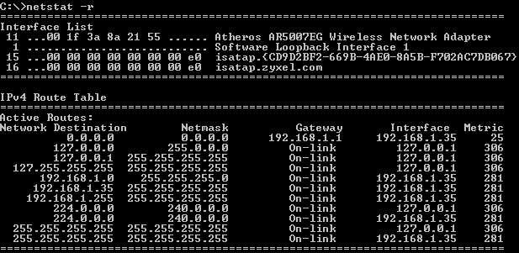

Figure 11: To see routing table information and interface detail use following command

1. Nslookup

Nslookup utility is used to test and troubleshoot domain name servers. Nslookup has two modes. Interactive mode enables you to query name servers for information about hosts and domains, or to print a list of hosts in a domain. Non- interactive mode prints only the name and requested details for one host or domain. Non-interative mode is useful for a single query.

To enter the interactive mode of Nslookup, type nslookup without any arguments at a command prompt, or use only a hypen as the first argument and specify a domain name server in the second. The default DNS name server will be used if you don't enter anything for the second argument.

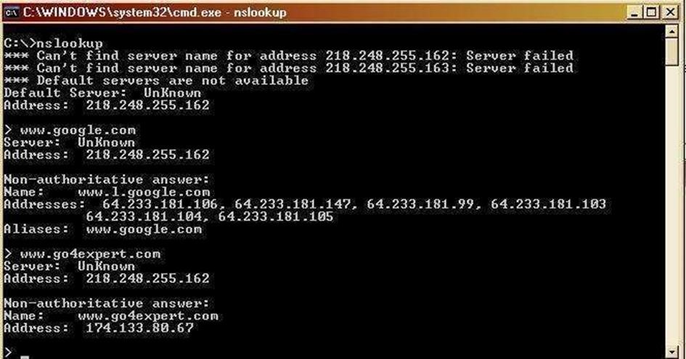

Figure 12: nslookup command being used.

To use non-interactive mode, in the first argument, enter the name or IP address of the computer you want to look up. In the second argument, enter the name or IP address of a domain name server.

The default DNS name server will be used if you don't enter anything for the second argument.

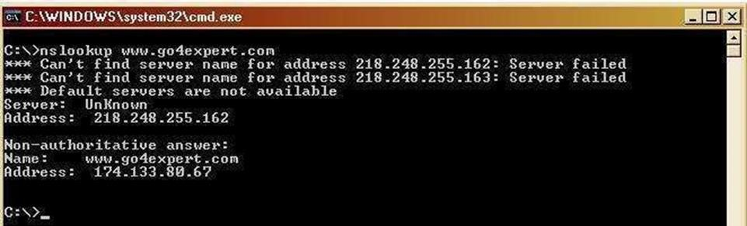

Figure 13: nslookup being used with domain name

6. Ftp

Transfers files to and from a computer running a File Transfer Protocol (FTP) server service such as Internet Information Services. Ftp can be used interactively or in batch mode by processing ASCII text files. Syntax

ftp [-v] [-d] [-i] [-n] [-g] [-s:FileName] [-a] [-w:WindowSize] [-A] [Host]

Parameters

-v : Suppresses the display of FTP server responses.

-d : Enables debugging, displaying all commands passed between the FTP client and FTP

server.

-i : Disables interactive prompting during multiple file transfers.

-n : Suppresses the ability to log on automatically when the initial connection is made.

-g : Disables file name globbing. Glob permits the use of the asterisk (*) and question mark (?) as wildcard characters in local file and path names.

-s: FileName : Specifies a text file that contains ftp commands. These commands run automatically after ftp starts. This parameter allows no spaces. Use this parameter instead of redirection (<).

-a : Specifies that any local interface can be used when binding the FTP data connection.

-w: WindowSize : Specifies the size of the transfer buffer. The default window size is 4096 bytes.

-A : Logs onto the FTP server as anonymous.

Host : Specifies the computer name, IP address, or IPv6 address of the FTP server to which to connect. The host name or address, if specified, must be the last parameter on the line.

/? : Displays help at the command prompt.

## FTP sub commands

|  |  |
| --- | --- |
| Put | Copies a file on your local host to the foreign host. |
| Get | Display the name of the current working directory |
| Block | Sets the data transfer mode to block mode |
| Open | Opens a connection to a foreign host. |
| Pwd | Displays the name of the active working directory on the foreign host. |
| Bye | Leaves the FTP command environment |

Table1: FTP commands

### Lab tasks

**Task 01:** Explore the syntax **“ipconfig”** and **“winipcfg”.** Note down your observations?

Ipconfig itself gives the basic network information of your computer, /all shows detailed info, /renew renews every adapter, /allcompartments shows info about all compartments, adding /all after / allcompartments

Provides even firther detailed info, /renew <> * renews connection with the matc provided /release *<>* releases connection with the match.

Winipcfg is a discontinued command/exe that was available in windows 95, 98, ME and NT. it ptoduces same result to that produced with ipconfig /all

**Task 02:** Answer following questions

1. State the size of MAC address both in Bytes and Bits

6 Bytes and 6*8 = 48 Bits

1. Differentiate between IP and MAC address

Mac address is a physical address allocated to every device on its manufacture while IP address is used to identify a device over a network

1. What is a gateway

Gateway is like a boundary of the network which manages inflows and outflows from and to the network.

1. What is the purpose of loop-back address?

It is used for testing and development purposes over your localhost. From its name its clear that we send the packets and they will loopback and received by our own address

1. PING stands for Packet Internet Groper.

1. What is the difference between ipconfig and ipconfig/all commands?

Ipconfig gives the information about the network of your computer while ipconfig/all displays the basic information as well as additional information about DNS server, DHCP server etc.

1. Explore Nbtstat and finger command and explain its purpose.

Nbtstat is a TCP/IP utility that displays current TCP/IP connections and statistics using NetBIOS over TCP/IP (NetBT). It helps troubleshoot NetBIOS name resolution issues

Finger command provides information about a usrs who are currently logged in. It provides general info about the users like their login name their username, login time, idle time etc

**Task 03:** execute the tasks mentioned in the manual and observe the output



