

**Usman Institute of Technology**

**Department of Computer Science Fall 2022**

Name: Muhammad Waleed

Roll no: 20B-115-SE

Course: Operating Systems (CS312)

Course Instructor: Ma’am Shabina Mushtaq

Date: 20-Oct-2022

# Lab Exercises:

1. Write a command to copy all files of current directory to /home?

**Command: cp * /home**

1. What is the difference between the permissions 777 and 775 of the chmod command?

**Chmod** is a command to grant permission for either write, edit, or execute a file or all to a user, group, and other user.

**Syntax:**

**chmod 777 [file_name]**

**OR**

**chmod ugo+rwx [file_name]**

For different permissions can be represented in numeric form

**Read** = 4, **Write** = 2, **Execute** = 1

To give all permissions to all users (root, group and other) we write 777 (read + write + execute) with chmod which means that numeric values for read, write, and execute are added to represent all permissions and it is written 3 time for different users i.e root, group and other.

To give specific permissions to different users like root can write, read and execute the file and same for group user but other user

can only read and execute the file then we write 775 with chmod

it means that numeric values are added for root user that is 7 to give all permissions and same with group user and for other user only read’s and execute’s numeric values are added to only give them r+w permission.

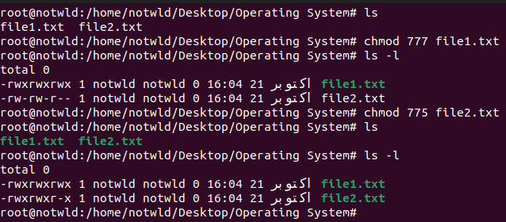

1. Write a command to remove all files with name containing text ‘the’?

**Command: rm -f $(ls | grep -I “the”)**

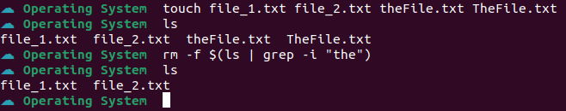

1. Diagram, schematic

   Description automatically generatedDraw Linux Directory Structure (Tree Like structure).