

Name: Muhammad Waleed

Roll no: 20B-115-SE

Course: Operating Systems (CS312)

Course Instructor: Ma’am Shabina Mushtaq

Date: 10-Nov-2022

# Lab Tasks:

1. Modify Example 1 to display strings via two independent threads: thread1: “Hello ! StudentName___”, thread 2: “Student roll no is :__________”

import threading,time

def thread1(promt):

    print(f"Hello {promt}!")

    time.sleep(5)

def thread2(promt):

    print(f"Student roll no is{promt}")

    time.sleep(5)

if __name__ == '__main__':

    t1 = threading.Thread(target=thread1,args=('Muhammad Waleed',))

    t2 = threading.Thread(target=thread2,args=('20b-115-se',))

    t1.start()

    t2.start()

    print('main thread')

    t1.join()

    t2.join()

    print('all done')

Output:

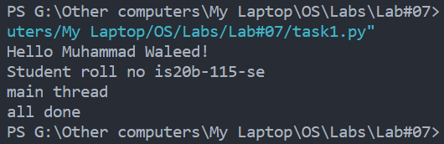

1. Create threads message as many times as user wants to create threads by using array of threads and loop. Threads should display message that is passed through argument.

import threading,random,time

def displayMsg(msg):

    print(msg)

if __name__ == '__main__':

    threads = []

    n = int(input("Enter number of threads: "))

    for i in range(n):

        threads.append(threading.Thread(target=displayMsg, args=(f"[Thread {i+1}]: Dice {random.randint(1,6)}",)))

    for i in range(n):

        threads[i].start()

        time.sleep(1)

    for i in range(n):

        threads[i].join()

Output:

