

**Usman Institute of Technology**

**Department of Computer Science Fall 2022**

Name: Muhammad Waleed

Roll no: 20B-115-SE

Course: Operating Systems (CS312)

Course Instructor: Ma’am Shabina Mushtaq

Date: 27-Oct-2022

# Lab Tasks:

1. Write a shell program that takes one parameter (your name) and displays it on the screen.

1. Write a shell program that takes a number parameters equal to the last digit of your roll number and displays the values of the built-in variables such as $#, $0, and $* on the screen.

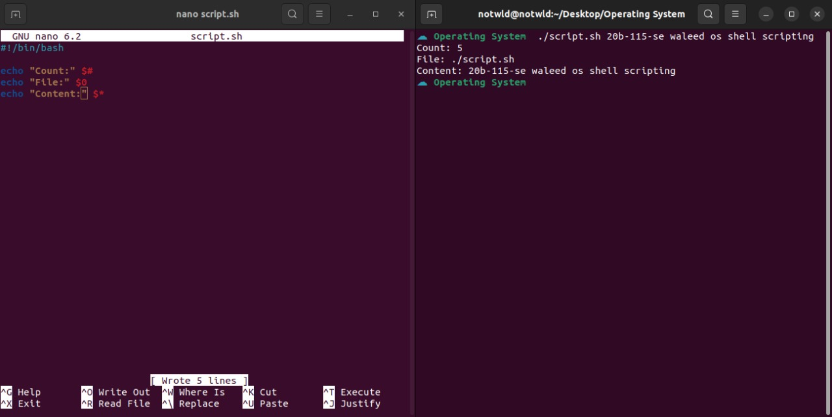

1. Write a Shell script to perform addition on numbers provided by command line parameters.

