

**Usman Institute of Technology**

**Department of Computer Science Fall 2022**

Name: Muhammad Waleed

Roll no: 20B-115-SE

Course: Operating Systems (CS312)

Course Instructor: Ma’am Shabina Mushtaq

Date: 3-Nov-2022

# Lab Tasks:

1. Write a script that takes two strings as input compares them and depending upon the results of the comparison prints the results.

*The user may provide input to the Bash script using read var*

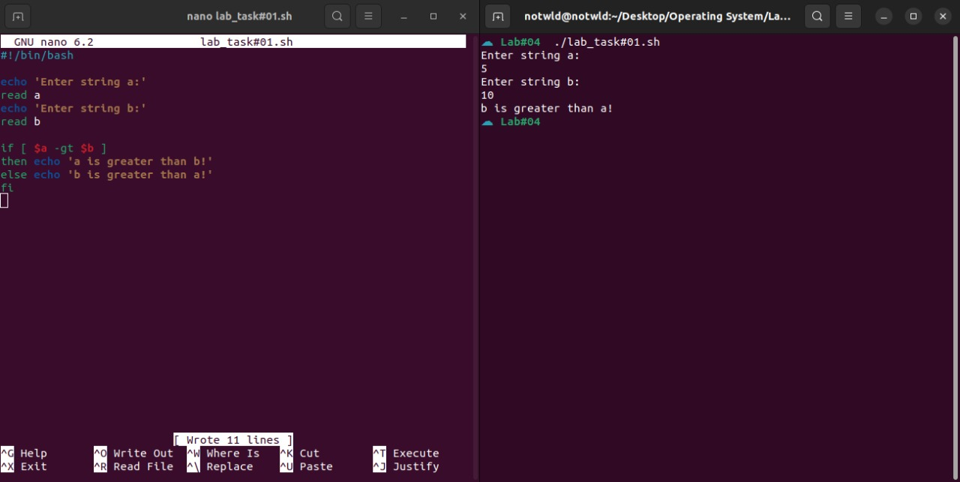

1. Write a script that takes a number (parameter) from 1-3 as input and uses case to display the name of corresponding month.

1. Write a script that takes command-line argument for age and marks and decide whether student is eligible for admission or not. Eligibility Criteria: Age should be lesser than 18 and marks should be greater than 700

