

**Usman Institute of Technology**

**Department of Computer Science Fall 2022**

Name: Muhammad Waleed

Roll no: 20B-115-SE

Course: Operating Systems (CS312)

Course Instructor: Ma’am Shabina Mushtaq

Date: 13-Oct-2022

# Lab Tasks:

1. Write Linux command to List all files (and subdirectories) in the home directory.

1. Write Linux command to display the content of /etc/passwd file with as many lines at a time as the last digit of your roll number.Text

   Description automatically generated

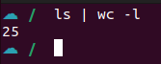

1. Write Linux command to count all files in the current directory.

1. Use grep to search for the pattern. “The” in the text file in the home directory.



# Grep Commands:

### Search for the given string in a single file.

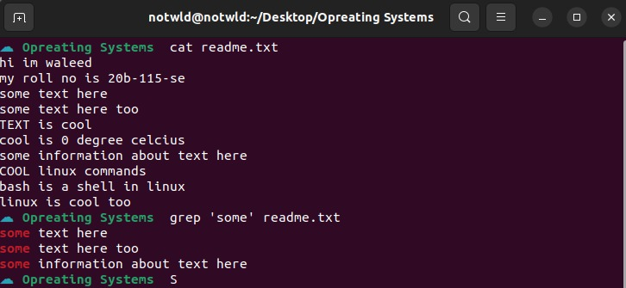

### Case insensitive search using grep -I.

### Match regular expression in files.

#### Display N lines after match.

#### Display N lines before match.



#### Display N lines around match.

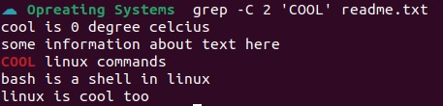

### Searching in all files recursively using grep -r.

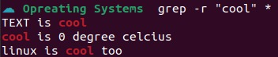

### Invert match using grep -v.

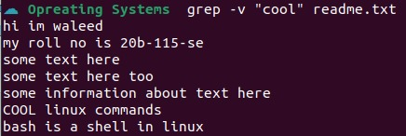

### A screenshot of a computer Description automatically generated with medium confidenceDisplay the lines which does not matches all the given pattern.

### Counting the number of matches using grep -c.



1. When you want do find out how many lines that does not match the pattern.



### Display only the file names which matches the given pattern using grep -l.

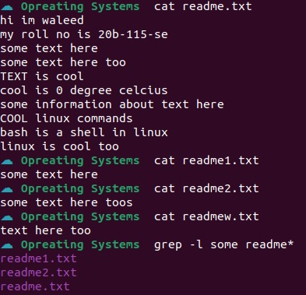

### Show only the matched string.



### Show the position of match in the line.



### Show line number while displaying the output using grep -n.

