

**Usman Institute of Technology**

**Department of Computer Science Fall 2022**

Name: Muhammad Waleed

Roll no: 20B-115-SE

Course: Operating Systems (CS312)

Course Instructor: Ma’am Shabina Mushtaq

Date: 10-Nov-2022

# Lab Tasks:

1. Write a script that creates a backup version of each file in your home directory to a subdirectory called backup using for statement. If the operation fails an error message is to be displayed.

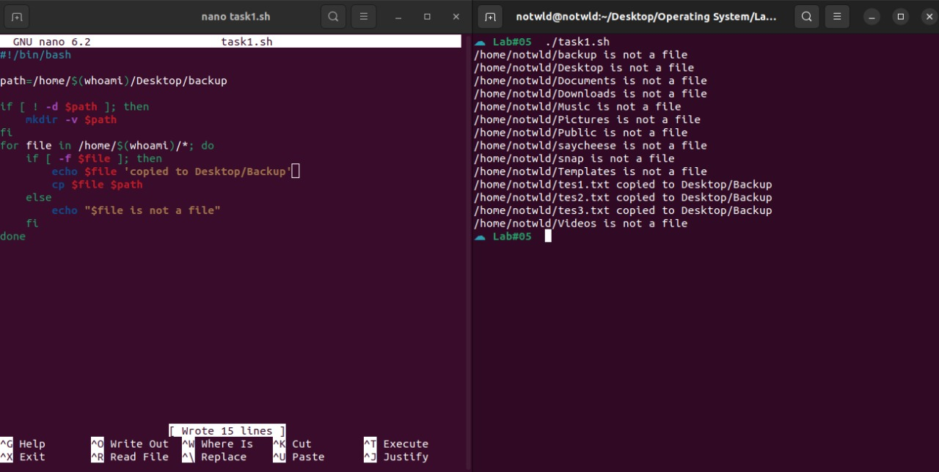

1. Write a script that calculates the average of all even numbers less than or equal to your roll number and prints the result.

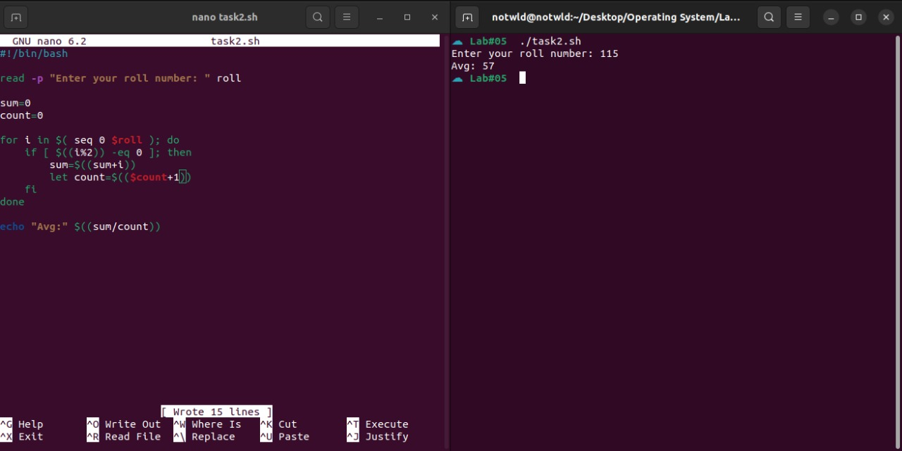

1. Write a function that displays the name of the week days starting from Sunday if the user passes a day number. If a number provided is not between 1 and 7 an error message is displayed.

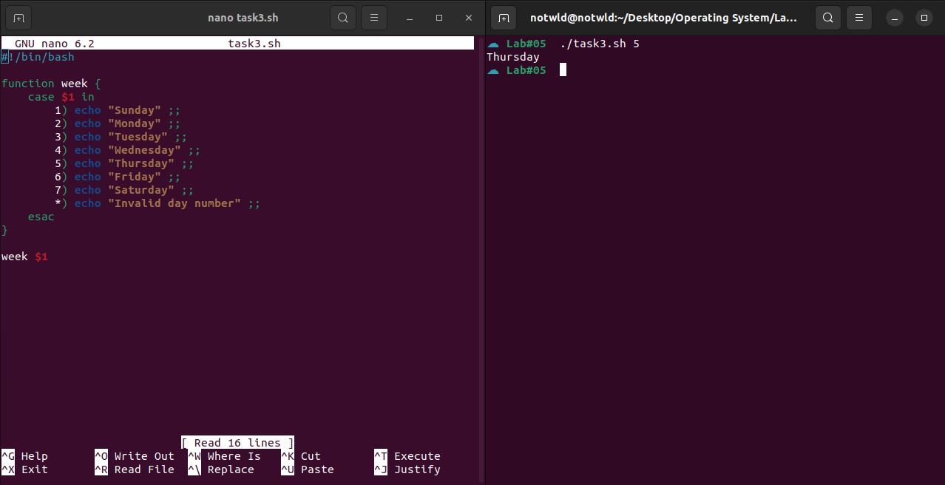

1. Write scripts that displays the parameters passed along with the parameter number using while and until statements.

