# Use Case Diagrams

## Pizza Ordering System:

## 

## Self-Served Fast Food System:

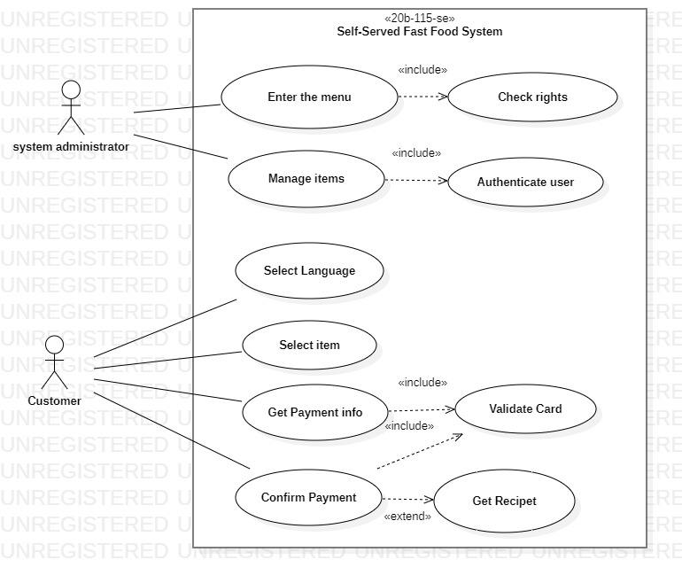

## Alarm Clock:

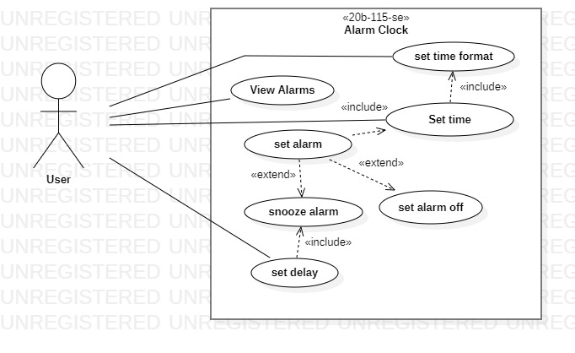

## Online Shopping:

## Course Registration System

# Class Diagrams:

## Order Management System:

## Library Management System:

