

**Usman Institute of Technology**

**Department of Computer Science Fall 2022**

Name: Muhammad Waleed

Roll no: 20B-115-SE

Course: Software Design and Architecture (SE-308)

Course Instructor: Misbah ud Din

Date: 15-Dec-2022

# Class Tasks:

## ChatServer:

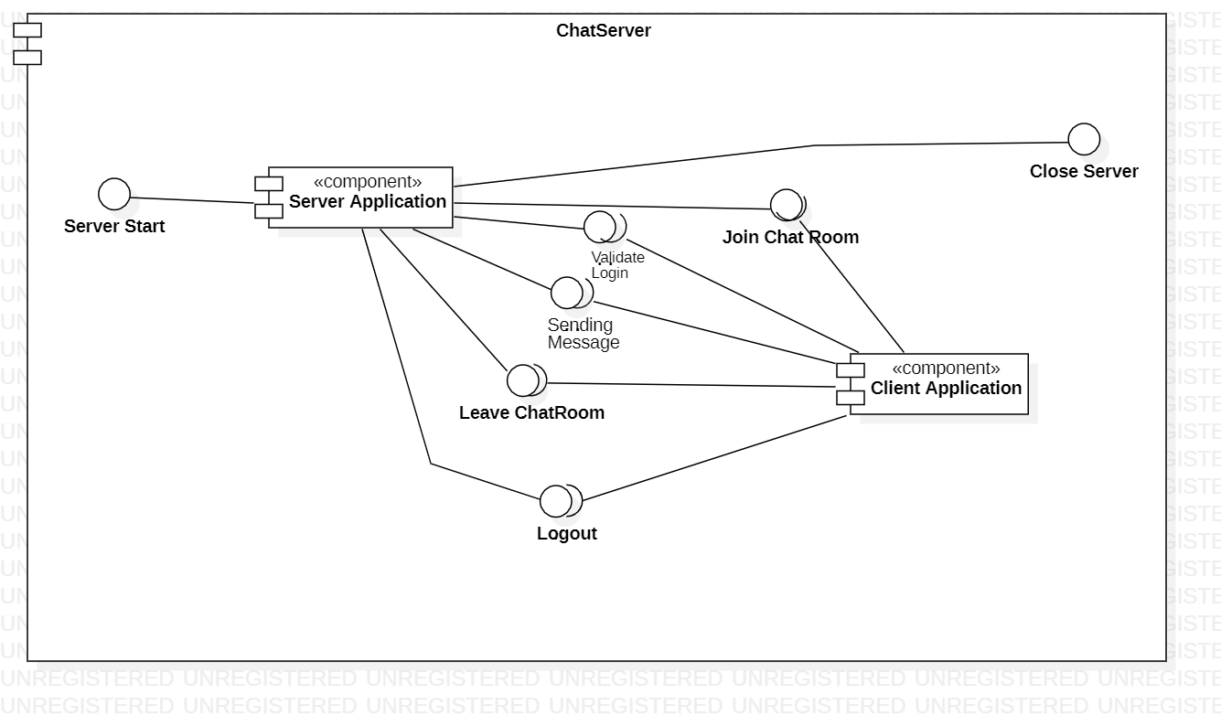

## NewProgLang:

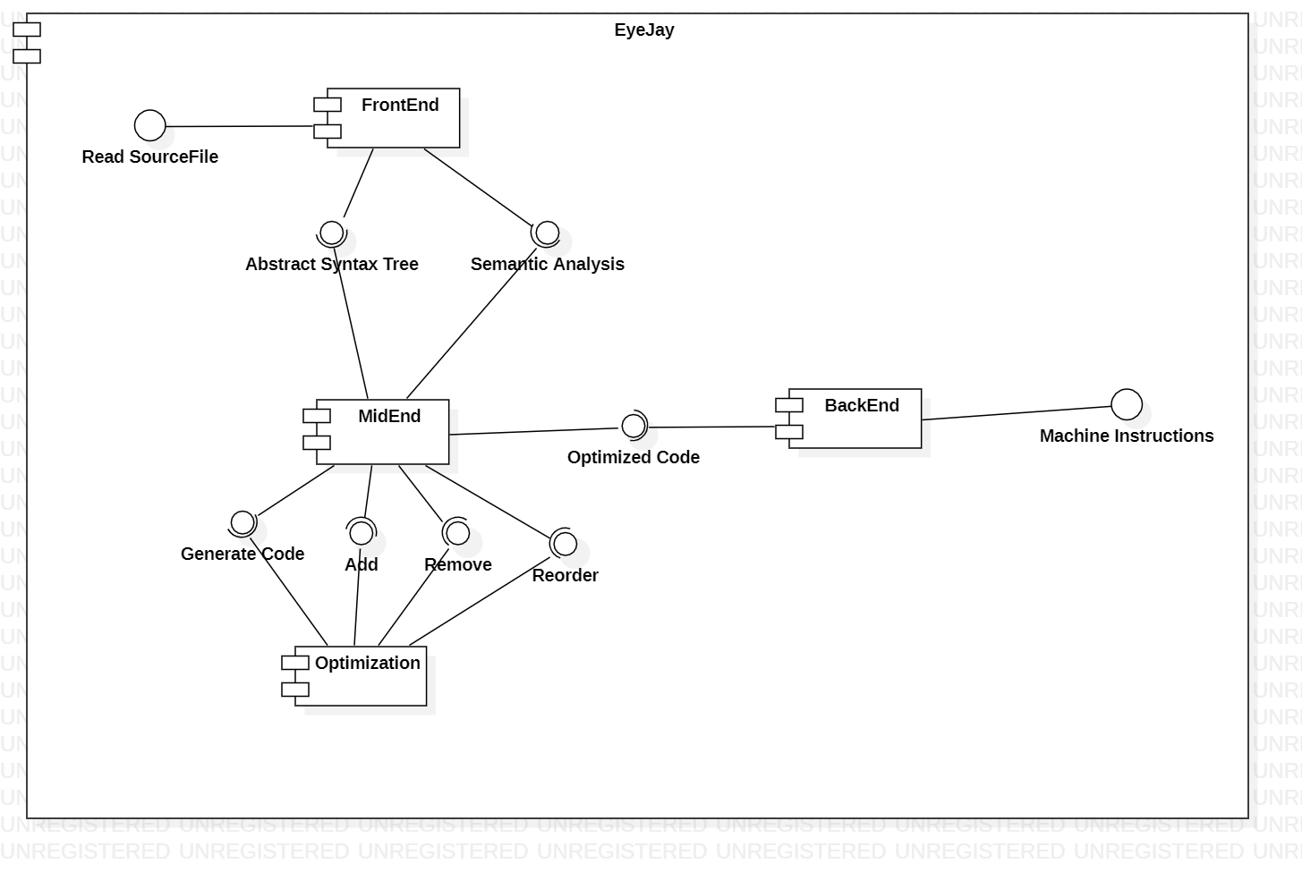

# HomeTask:

## HotelManagementSystem:

