

**Usman Institute of Technology**

**Department of Computer Science Fall 2022**

Name: Muhammad Waleed

Roll no: 20B-115-SE

Course: Software Design and Architecture (SE-308)

Course Instructor: Misbah ud Din

Date: 22-Dec-2022

# Home Task:

Code:

from flask import Flask

from flask_restful import Api,Resource,reqparse,abort

app = Flask(__name__)

API = Api(app)

student_put = reqparse.RequestParser()

student_put.add_argument("Name",type=str,location="form")

student_put.add_argument("Rollno",type=str,location="form")

students = {

    1:{"name":"bajwa","rollno":"20b-017-se"},

    2:{"name":"aun","rollno":"20b-118-se"},

    3:{"name":"farhan","rollno":"20b-055-se"}

}

def notFound(studen_id):

    if studen_id not in students:

        abort(404,message="Student not found")

class Student(Resource):

    def get(self,id):

        notFound(id)

        return students[id]

    def put(self,id):

        newStd = student_put.parse_args()

        students[id] = newStd

        return students[id]

    def post(self,id):

        newStd = student_put.parse_args()

        newid = int(max(students.keys()))+1

        students[newid] = newStd

        print(students)

        return students[newid]

    def delete(self,id):

        del students[id]

API.add_resource(Student,"/show/<int:id>")

if __name__=="__main__":

    app.run(debug=True)

Output:

GET:

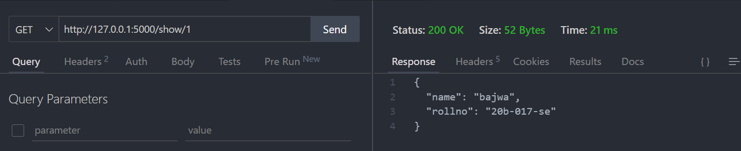

POST

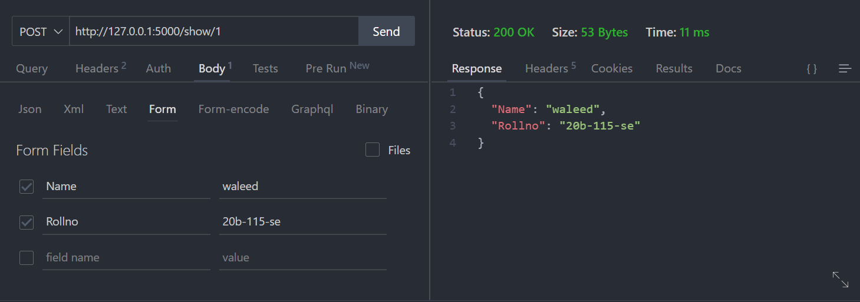

PUT:

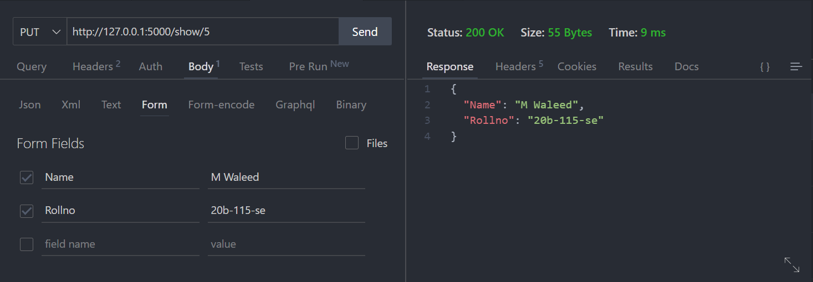

DELETE:

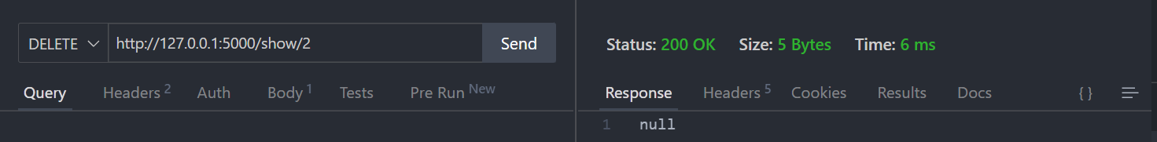

Terminal:



