

**Usman Institute of Technology**

**Department of Computer Science Fall 2022**

Name: Muhammad Waleed

Roll no: 20B-115-SE

Course: Software Design and Architecture (SE-308)

Course Instructor: Misbah ud Din

Date: 27-Oct-2022

# Lab Tasks:

# Appointment Management System:

## Online Train System:

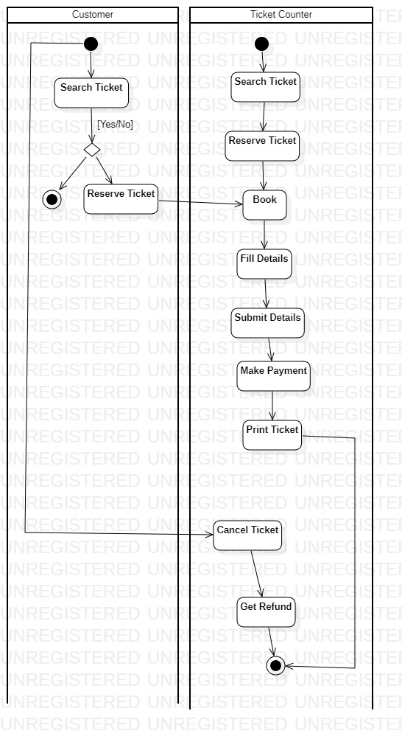

## Bank System:

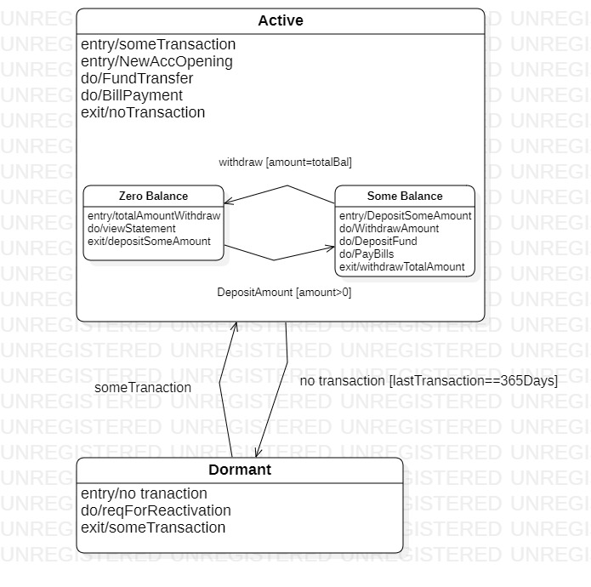

## Payroll Application:

