# Lab Tasks:

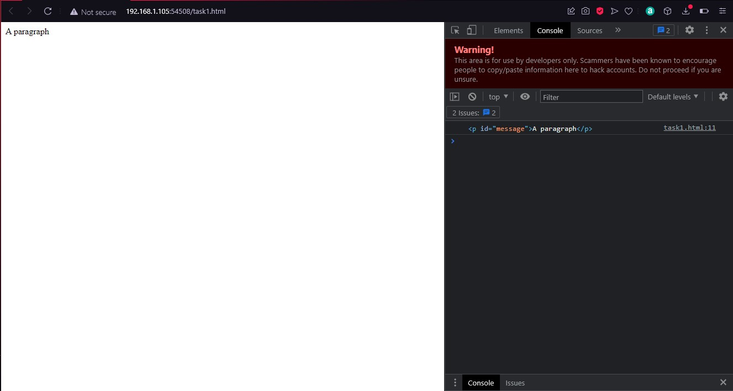

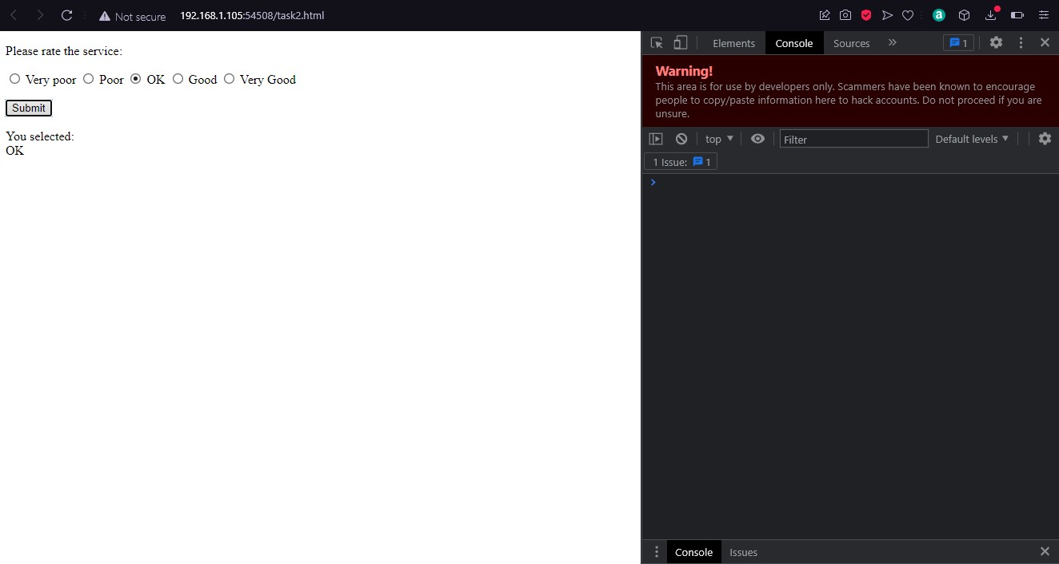

# Home Task:

