# Tasks:

1. When a user clicks on a button, all elements will be hidden:



1. When a user clicks on a button, the element with id="test" will be hidden:

1. When a user clicks on a button, the element with class="test" will be hidden:

1. Attach multiple event handlers to a <p> element:

1. With jQuery, you can hide and show HTML elements with the show() and hide() methods:

1. The jQuery fadeIn() method is used to fade in a hidden element.

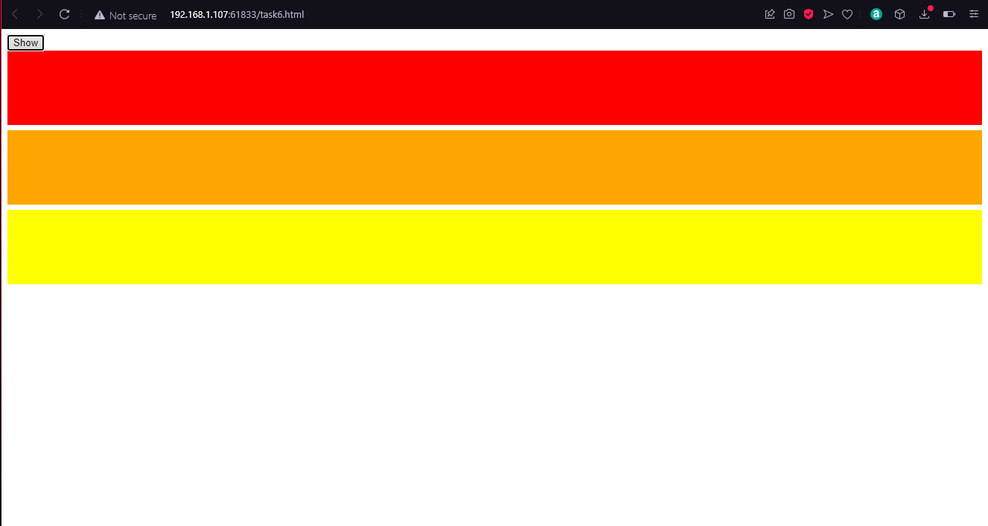

1. The jQuery fadeTo() method allows fading to a given opacity (value between 0 and 1).

1. The jQuery slideUp() method is used to slide up an element.

1. The jQuery animate() method is used to create custom animations.

1. AJAX Method

# Lab Tasks:

1. Use jQuery to filter/search for specific elements. Perform a case-insensitive search for items in a table.

UI:

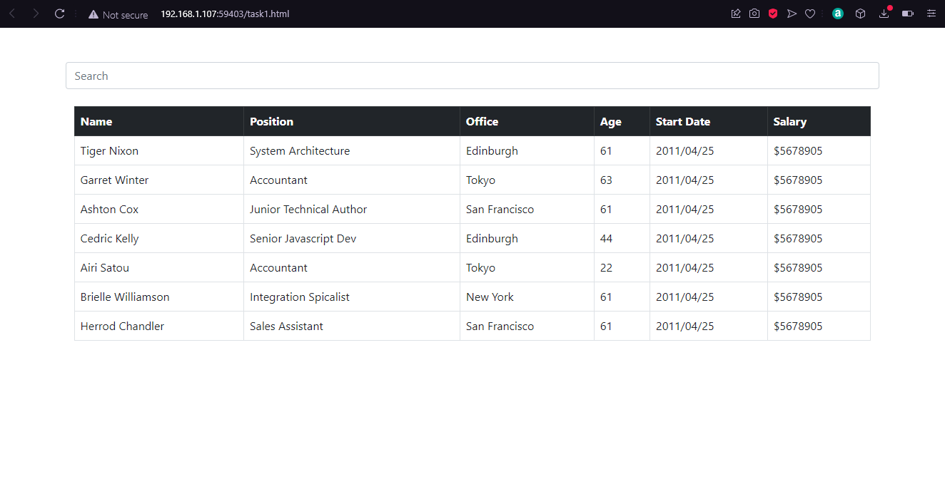

On Search:

1. Create/Design a 2 pages, minimal design, and weather information responsive application for Pakistan’s major cities.

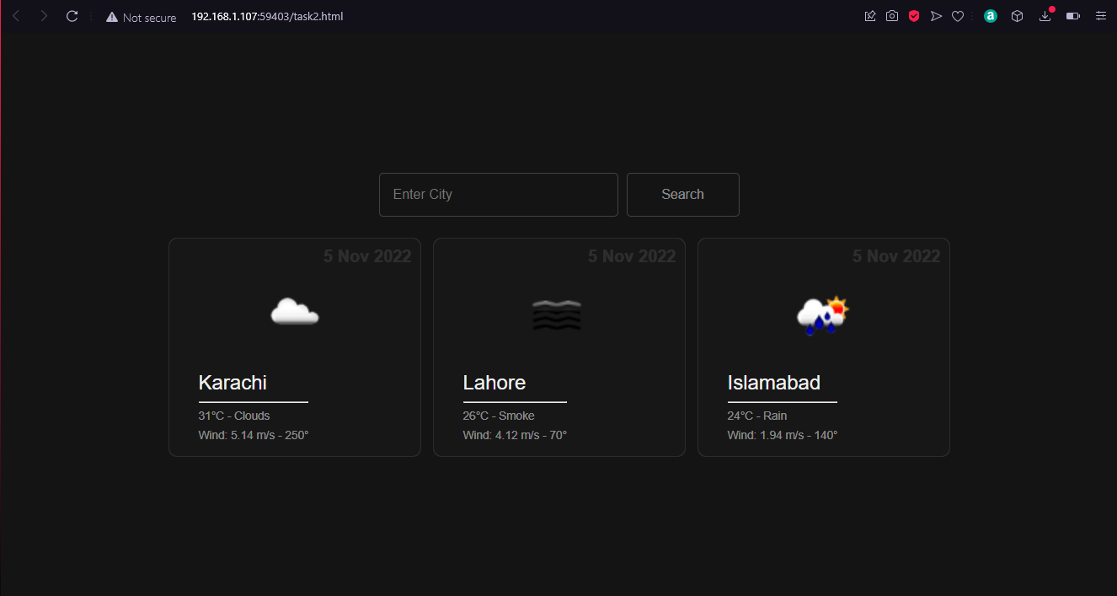

On Search:

(Design is Responsive)