ASSIGNMENT:10.1
NAME: M. Sujith Raj
BATCH:14
HALL.NO:2503A52396
Task Description #1 – Syntax and Logic Errors
Task: Use AI to identify and fix syntax and logic errors in a faulty Python script.
INPUT:
def calc_average(marks):
total = 0
for mark in marks:
total += mark
average = total / len(marks)
return average

marks = [85, 90, 78, 92]
print("Average Score is", calc_average(marks))
OUTPUT:

Task Description #2 – PEP 8 Compliance
Task: Use AI to refactor Python code to follow PEP 8 style guidelines. Sample Input Code: def area_of_rect(L,B) : return L*B print(area_of_rect(10,20))
INPUT:
def area_of_rectangle(length, breadth):
return length * breadth

print(area_of_rectangle(10, 20))
OUTPUT:

Task Description #3 – Readability Enhancement
Task: Use AI to make code more readable without changing its logic.
INPUT:
def calculate_percentage(value, percentage):
return value * percentage / 100

total_amount = 200
percentage_value = 15

print(calculate_percentage(total_amount, percentage_value))
OUTPUT:
Task Description #4 – Refactoring for Maintainability
Task: Use AI to break repetitive or long code into reusable functions.
INPUT:
students = ["Sujithhh", "Sujithh", "Sujith"]

def welcome_student(name):
print("Welcome", name)

for student in students:
welcome_student(student)
OUTPUT:
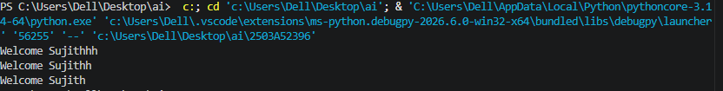

Task Description #5 – Performance Optimization
Task: Use AI to make the code run faster. Sample Input Code.
INPUT:
squares = [n ** 2 for n in range(1, 1000000)]

print(len(squares))
OUTPUT:

Task Description #6 – Complexity Reduction
Task: Use AI to simplify overly complex logic. Sample Input Code:
INPUT:
def grade(score):
if score >= 90:
return "A"
elif score >= 80:
return "B"
elif score >= 70:
return "C"
elif score >= 60:
return "D"
else:
return "F"

print(grade(90))
OUTPUT:

