ASSIGNMENT-9.1
NAME: M. Sujithh
BATCH: 14
HALLTICKET.NO: 2503A52396

INPUT:
def is_strong_password(password):
if len(password) < 8:
return False

if " " in password:
return False

has_upper = False
has_lower = False
has_digit = False
has_special = False

for ch in password:
if ch.isupper():
has_upper = True
if ch.islower():
has_lower = True
if ch.isdigit():
has_digit = True
if not ch.isalnum():
has_special = True

if has_upper and has_lower and has_digit and has_special:
return True
return False

print(is_strong_password("Abcd@123"))
print(is_strong_password("abcd123"))
print(is_strong_password("ABCD@1234"))

assert is_strong_password("Abcd@123") == True
assert is_strong_password("abcd123") == False
assert is_strong_password("ABCD@1234") == True

print("All test cases passed")
OUTPUT:
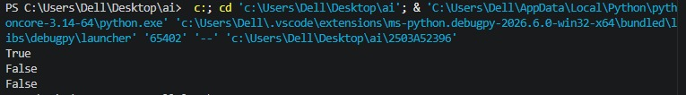

Task Description #2 (Number Classification with Loops – Apply AI for Edge Case Handling) • Task: Use AI to generate at least 3 assert test cases for a classify_number(n) function. Implement using loops.
INPUT:
def classify_number(n):
if not isinstance(n, (int, float)):
return "Invalid Input"

if n > 0:
return "Positive"
elif n < 0:
return "Negative"
else:
return "Zero"

assert classify_number(10) == "Positive"
assert classify_number(-5) == "Negative"
assert classify_number(0) == "Zero"
assert classify_number(-1) == "Negative"
assert classify_number(1) == "Positive"

print("All Task 2 test cases passed")

OUTPUT:
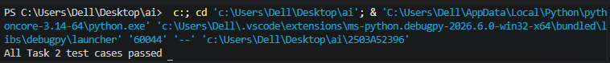

Task Description #3 (Anagram Checker – Apply AI for String Analysis) • Task: Use AI to generate at least 3 assert test cases for is_anagram(str1, str2) and implement the function
INPUT:
import string

def is_anagram(str1, str2):
str1 = ''.join(char.lower() for char in str1 if char.isalnum())
str2 = ''.join(char.lower() for char in str2 if char.isalnum())

return sorted(str1) == sorted(str2)

assert is_anagram("listen", "silent") == True
assert is_anagram("hello", "world") == False
assert is_anagram("Dormitory", "Dirty Room") == True
assert is_anagram("", "") == True

print("All Task 3 test cases passed")
OUTPUT:

Task Description #4 (Inventory Class – Apply AI to Simulate Real World Inventory System)
• Task: Ask AI to generate at least 3 assert-based tests for an Inventory class with stock management.

INPUT:
class Inventory:
def __init__(self):
self.stock = {}

def add_item(self, name, quantity):
if quantity < 0:
return
if name in self.stock:
self.stock[name] += quantity
else:
self.stock[name] = quantity

def remove_item(self, name, quantity):
if name not in self.stock:
return
if quantity < 0 or quantity > self.stock[name]:
return
self.stock[name] -= quantity

def get_stock(self, name):
return self.stock.get(name, 0)

inv = Inventory()

inv.add_item("Pen", 10)
assert inv.get_stock("Pen") == 10

inv.remove_item("Pen", 5)
assert inv.get_stock("Pen") == 5

inv.add_item("Book", 3)
assert inv.get_stock("Book") == 3

print("All Task 4 test cases passed")
OUTPUT:

Task Description #5 (Date Validation & Formatting – Apply AI for Data Validation)
• Task: Use AI to generate at least 3 assert test cases for validate_and_format_date(date_str) to check and convert dates.
INPUT:
from datetime import datetime

def validate_and_format_date(date_str):
try:
date = datetime.strptime(date_str, "%m/%d/%Y")
return date.strftime("%Y-%m-%d")
except ValueError:
return "Invalid Date"

assert validate_and_format_date("10/15/2023") == "2023-10-15"
assert validate_and_format_date("02/30/2023") == "Invalid Date"
assert validate_and_format_date("01/01/2024") == "2024-01-01"

print("All Task 5 test cases passed")
OUTPUT:

