Press side key 1 and PTT key to turn on the radio, the indicator blinks and open upgraded software
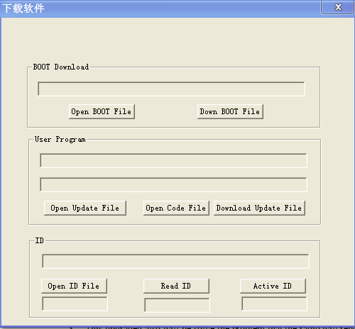

And then write upgraded file named Upgraded software for scanning function into radio, the radio will be upgraded as following:

