Lab 3: Kubernetes Deployments

Step 1 Create a Deployment
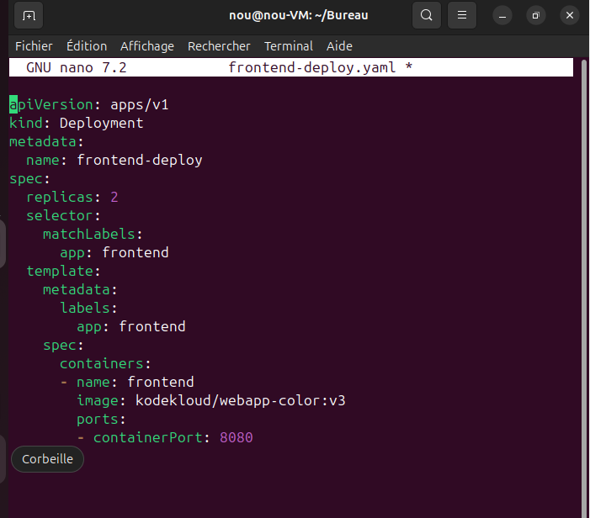
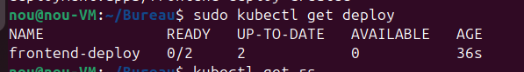
Step 2: Compare Deployment and ReplicaSet
- A Deployment manages ReplicaSets and provides advanced features such as rolling updates.
- A ReplicaSet only ensures that a specified number of Pods are running.

Step 3 Scale up replicas
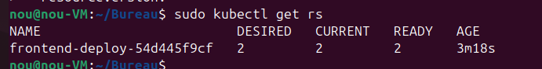
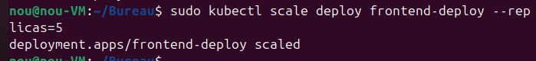
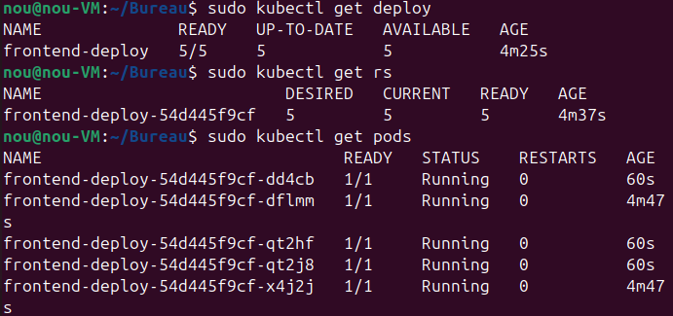
Step 4.1: Change image of a ReplicaSet
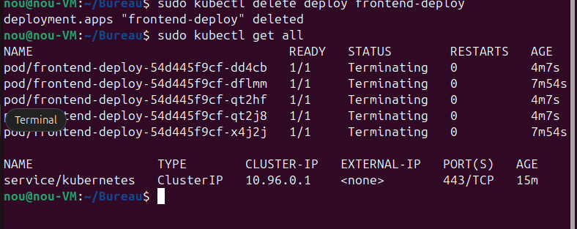
- Changing the image in a ReplicaSet does not update existing Pods
- Pods must be manually deleted for changes to take effect

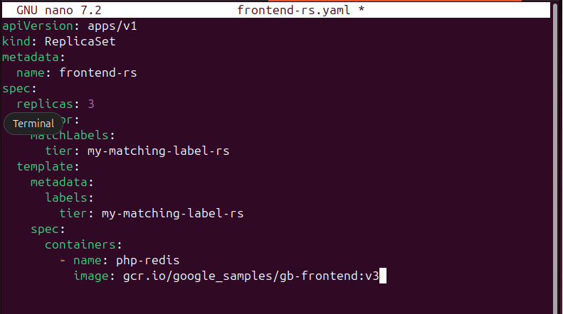
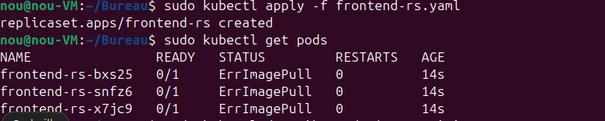
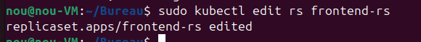
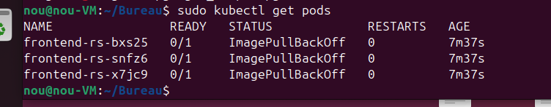
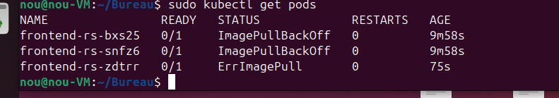
Step 4.2 : Change image of a Deployment
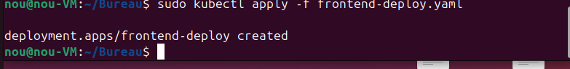

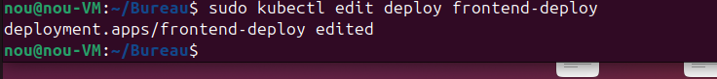

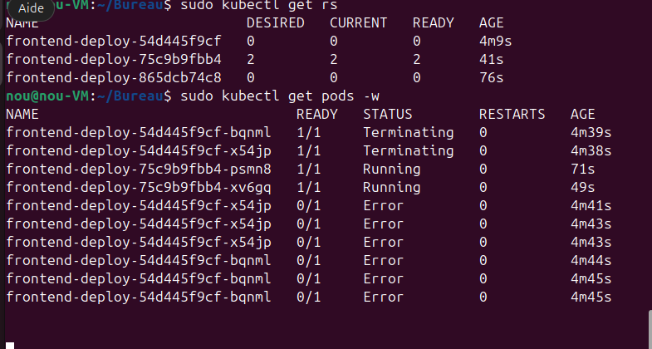

Step 5 Rollout and rollback
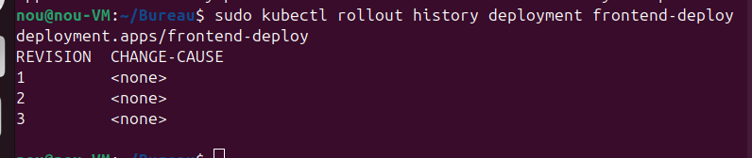
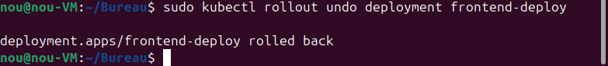
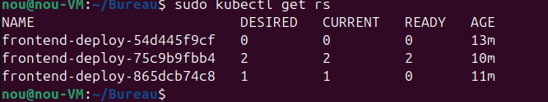

Conclusion
This lab demonstrated the key features of Kubernetes Deployments:
- Deployments manage ReplicaSets and Pods efficiently
- They support scaling, rolling updates, and automatic recovery

