VISVESARAYA TECHNOLOGICAL UNIVERSITY

BELAGAVI, KARNATAKA-590014


A MINI PROJECT REPORT

ON

“BAYMAX – A PERSONAL VIRTUAL ASSISTANT”

Submitted in Partial fulfilment of the requirement of CIE in ADE (18CS33) for the award of

BACHELOR OF ENGINEERING
IN
COMPUTER SCIENCE AND ENGINEERING

Submitted by:

MOHAMMED NOUMAN 4PA20CS059

MUADH BIN MOHAMMED ALI 4PA20CS069

RABEEH T. A 4PA20CS0

MOHAMMED SHABEER 4PA20CS064

MUHAMMED THAJUDDIN SANAD 4PA20CS086



P. A. COLLEGE OF ENGINEERING

DEPARTMENT OF COMPUTER SCIENCE & ENGINEERING

NADUPADAVU MANGALORE-574153,
KARNATAKA 2021-22

P. A. COLLEGE OF ENGINEERING

(Affiliated to Visvesvaraya Technological University and Approved by AICTE)

DEPARTMENT OF COMPUTER SCIENCE AND ENGINEERING



CERTIFICATE

Certified that the project work entitled “BAYMAX” is a bona fide work carried out by
Mr. MOHAMMED NOUMAN USN: 4PA20CS059, Mr. MUADH BIN MOHAMMED ALI USN: 4PA20CS069, Mr. RABEEH TA USN: 4PA20CS0, Mr. MUHAMMED THAJUDDIN SANAD USN: 4PA20CS086, Mr. MOHAMMED SHABEER USN: 4PA20CS064 in partial fulfillment of CIE in MCE (18CS44) for the award of degree of “BACHELOR OF ENGINEERING” in COMPUTER SCIENCE AND ENGINEERING of VISVESVARAYA TECHNOLOGICAL UNIVERSITY, BELGAUM during the year 2021-2022.

Prof Mohammed Saifuddin Dr. Sharmila Kumari
Project Guide Head of the Department

CONTENTS

CHAPTER No. TITLE PAGE No.

CHAPTER 1 | INTRODUCTION | 2
1.1 | Introduction | 2
1.2 | Absract | 2

CHAPTER 2 | COMPONENTS REQUIRED | 3
CHAPTER 3 | METHODOLOGY | 4
3.1 | Block Diagram | 4
3.2 | Procedure | 4
3.3 | Working | 4

CHAPTER 4 | APPLICATION | 5
CHAPTER 5 | CONCLUSION | 5

Chapter 1

INTRODUCTION

1.1 INTRODUCTION:

A metal detector is an instrument that detects the presence of metal nearby. Metal detectors are useful for finding metal inclusions hidden within objects, or metal object buried underground. They often consist of a handheld unit with a sensor probe which can be swept over the ground or other objects. If the sensor comes near a piece of metal this is indicated by a changing tone in earphones, or a needle moving on an indicator. Usually, the device gives some indication of distance; the closer the metal is, the higher the tone in the earphone or the higher the needle goes. Another common type are stationary "walk through" metal detectors used at access points in prisons, courthouses, and airports to detect concealed metal weapons on a person's body.

1.2 ABSTRACT:

Metal detectors are extensively used to find undesirable metal objects in processed food. In such a typical metal detector, the coils are coaxially arranged with the transmitting coil in the center and two receiving coils on the sides. The receiving coils are connected to a differential amplifier. When the magnetic field generated in the transmitting coil is disturbed by metal objects, the amplitude and phase of the output voltage of the differential amplifier change, and, thus, the existence of foreign metal pieces is detected. The relationship between the amplitude and phase of the output and the electromagnetic properties of the metal objects, however, has only been discussed experimentally so far.
Chapter 2

COMPONENTS REQUIRED:

SL. NO | COMPONENTS | QUANTITY
1. | Raspberry Pi (any model) | 1
2. | Display | 1
3. | Keyboard | 1
4. | Mouse | 1
5. | Speaker | 1
6. | Mic | 1
7. | Raspberry Pi Cam | 1
8. | 5V, 2 ‘A Adapter | 1
9. | Required Cables/Connectors | 1

Chapter 3

METHODOLOGY:

3.1 Block diagram:
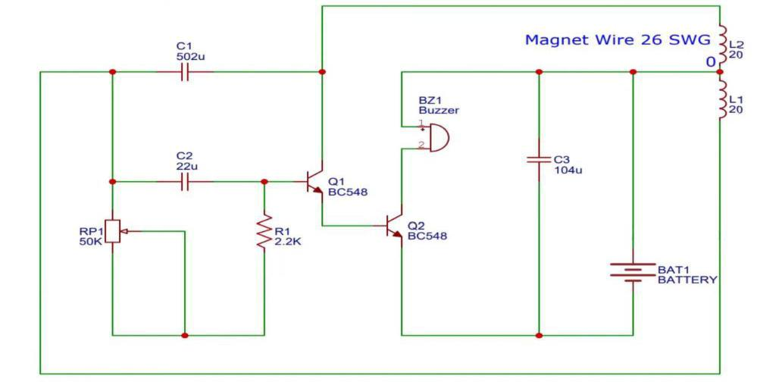

3.2 Procedure:

- Before making the connections, check the components using multimeter.

- Make the connections as shown in figure.

- Switch on the power supply.

- Observe the metal detection by placing on the objects.

3.3 Working:

The operation of metal detectors is based upon the principles of electromagnetic induction. The eddy currents induce their own magnetic field, shown in red, which generates an opposite current in the coil, which induces a signal indicating the presence of metal.
Chapter 4

APPLICATION:

- Detecting land mines.

- Detection of weapons such as knives and guns (especially in airport security).

- Geophysical prospecting.

- Archaeology and treasure hunting.

- Detecting foil wrapped drugs.

- Precious metals associated with jewellery or antiques theft.

Chapter 5

CONCLUSION:

• Overall, we successfully reached our goal and created a circuit that has good potential

applications for the real world.

- The metal detector circuit is already used for different kinds of things.

- One example of an important use for a metal detector is for airport security.

******************

This project is completed successfully. On placing the metal near sensor (Inductor) sound is produced and sound is stopped when metal is removed.

