**Assignment 14.5**

**Name:noushin zaiba**

**Roll.no:2403a52412**

**Batch:15**

**TASK 1:**

AI-Assisted Portfolio Website  
Scenario:  
A student wants to showcase their projects, skills, and contact details in  
a portfolio website. Instead of writing all code manually, they want to  
speed up the process using GitHub Copilot.  
• Use Copilot to generate an HTML structure for a personal  
portfolio page (sections: Home, About, Projects, Contact).  
• Ask Copilot to suggest responsive CSS styling for the layout  
(e.g., grid/flexbox).  
• Customize Copilot’s suggestions to add a hover effect on project  
cards

**Prompt:**

Generate a complete HTML structure for a personal portfolio website that includes sections for Home, About, Projects, and Contact. Use semantic HTML5 tags, include a navigation bar with internal links, and make sure each section has clear headings and short descriptions. Then, create a responsive CSS layout using Flexbox or CSS Grid to arrange project cards neatly. Finally, add a hover effect to the project cards that slightly lifts them and adds a soft shadow to make the interface more interactive and visually appealing.

**Code:**

Index.html:

<!DOCTYPE html>

<html lang="en">

<head>

<meta charset="UTF-8" />

<meta name="viewport" content="width=device-width, initial-scale=1.0" />

<title>My Portfolio</title>

<link rel="stylesheet" href="style.css" />

</head>

<body>

<header>

<nav>

<h1>My Portfolio</h1>

<ul>

<li><a href="#home">Home</a></li>

<li><a href="#about">About</a></li>

<li><a href="#projects">Projects</a></li>

<li><a href="#contact">Contact</a></li>

</ul>

</nav>

</header>

<section id="home">

<div class="intro">

<h2>Hello, I'm <span>sreenidhi</span></h2>

<p>A passionate Web Developer & Designer</p>

</div>

</section>

<section id="about">

<h2>About Me</h2>

<p>

I am a student learning web development. I love building creative and

responsive websites that blend design with functionality.

</p>

</section>

<section id="projects">

<h2>Projects</h2>

<div class="project-grid">

<div class="project-card">

<h3>Project 1</h3>

<p>A web application built using HTML, CSS, and JavaScript.</p>

</div>

<div class="project-card">

<h3>Project 2</h3>

<p>An e-commerce website using React and Firebase.</p>

</div>

<div class="project-card">

<h3>Project 3</h3>

<p>A personal blog with a responsive layout and SEO optimization.</p>

</div>

</div>

</section>

<section id="contact">

<h2>Contact Me</h2>

<form>

<input type="text" placeholder="Your Name" required />

<input type="email" placeholder="Your Email" required />

<textarea placeholder="Your Message" rows="4" required></textarea>

<button type="submit">Send</button>

</form>

</section>

<footer>

<p>© 2025 Your Name. All rights reserved.</p>

</footer>

</body

</html>

**Style.css:**

/* Global Styles */

* {

margin: 0;

padding: 0;

box-sizing: border-box;

font-family: "Poppins", sans-serif;

}

body {

line-height: 1.6;

color: #333;

background: #f9f9f9;

}

/* Header and Navigation */

header {

background: #333;

color: #fff;

padding: 1rem 0;

position: sticky;

top: 0;

z-index: 100;

}nav {

display: flex;

justify-content: space-between;

align-items: center;

width: 90%;

margin: auto;

}

nav h1 {

font-size: 1.5rem;

}

nav ul {

display: flex;

gap: 20px;

list-style: none;

}nav a {

color: #fff;

text-decoration: none;

font-weight: 500;

transition: color 0.3s;

}nav a:hover {

color: #00adb5;

}

/* Sections */

section {

padding: 3rem 1rem;

text-align: center;

}#home {

background: linear-gradient(135deg, #00adb5, #393e46);

color: white;

padding: 5rem 1rem;}#home h2 span {

color: #ffd369;

}

/* About Section */

#about {

background: #fff;

}

/* Projects Section */

#projects {

background: #f1f1f1;

}.project-grid {

display: grid;

grid-template-columns: repeat(auto-fit, minmax(250px, 1fr));

gap: 20px;

margin-top: 2rem;

padding: 0 1rem;

}

.project-card {

background: #fff;

padding: 1.5rem;

border-radius: 10px;

box-shadow: 0 2px 10px rgba(0, 0, 0, 0.1);

transition: transform 0.3s ease, box-shadow 0.3s ease;

}

/* ✨ Hover Effect on Project Cards */

.project-card:hover {

transform: translateY(-8px);

box-shadow: 0 6px 20px rgba(0, 0, 0, 0.15);

}

/* Contact Section */

form {

max-width: 500px;

margin: 0 auto;

display: flex;

flex-direction: column;

gap: 10px;

}

input,

textarea {

padding: 0.8rem;

border: 1px solid #ccc;

border-radius: 5px;

}button {

background: #00adb5;

color: #fff;

padding: 0.8rem;

border: none;

border-radius: 5px;

cursor: pointer;

font-weight: bold;

transition: background 0.3s;

}

button:hover {

background: #007b83;

}/* Footer */

footer {

background: #222;

color: #ccc;

text-align: center;

padding: 1rem;

margin-top: 2rem;

}

/* Responsive Design */

@media (max-width: 768px) {

nav ul {

flex-direction: column;

gap: 10px;

}

.project-grid {

grid-template-columns: 1fr;

}

}

**Script.js:**

let index = 0;

function showSlide(i) {

const slides = document.querySelectorAll(".slides img");

if (i >= slides.length) index = 0;

else if (i < 0) index = slides.length - 1;

else index = i;

const offset = -index * 100;

document.querySelector(".slides").style.transform = `translateX(${offset}%)`;

}

function nextSlide() {

showSlide(index + 1);

}

function prevSlide() {

showSlide(index - 1);

}

// Auto slide every 4 seconds

setInterval(() => nextSlide(), 4000);

**Output:**

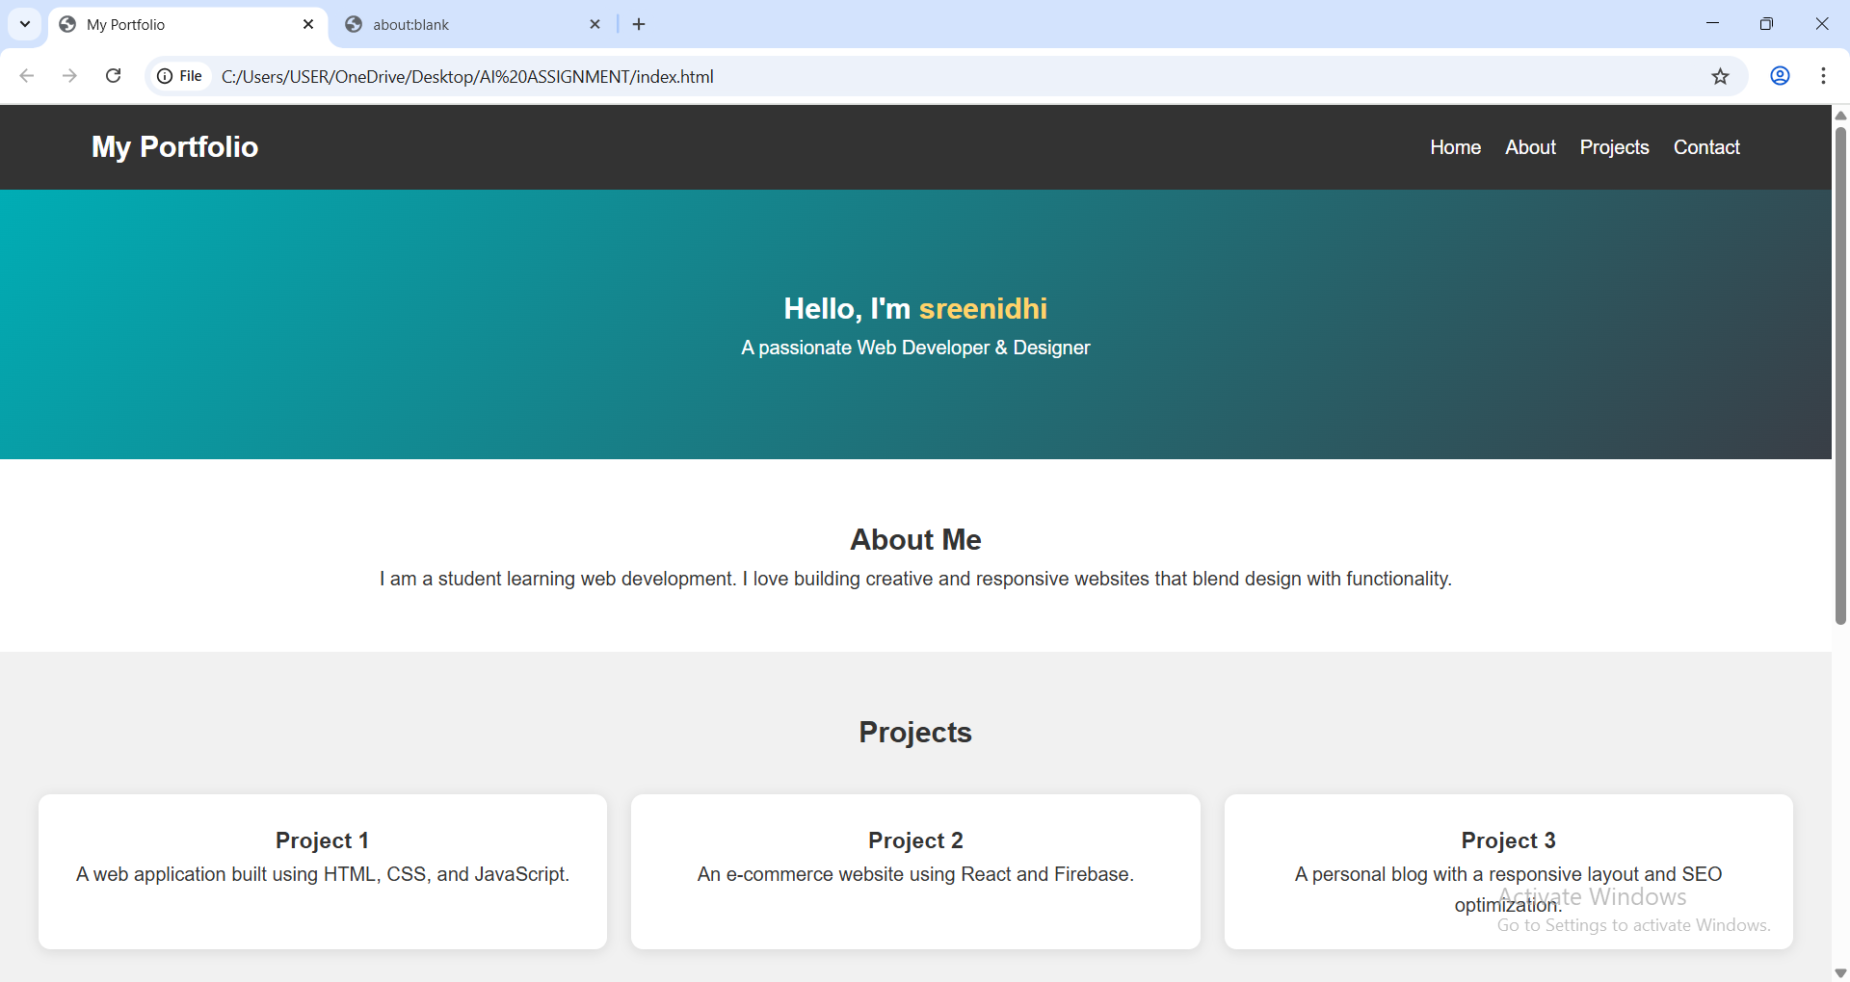

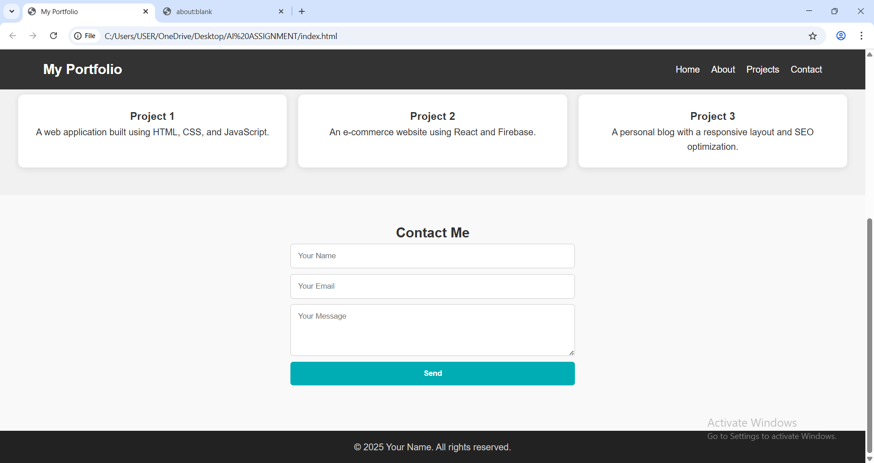

**Observations:**

• GitHub Copilot was able to automatically generate the basic HTML structure for the portfolio website, including sections like **Home, About, Projects, and Contact**.

• The CSS suggested by Copilot used **Flexbox and Grid layout techniques**, which made the design **responsive** across different screen sizes.

• The **hover effect** on the project cards was added using transform and box-shadow properties, improving the **interactivity and visual appeal** of the website.

• Copilot’s code suggestions reduced development time and helped maintain **consistent styling and layout**.

• Minor customizations were made to the Copilot-generated code — such as changing colors, adding transitions, and modifying padding — to better suit the student’s design preferences.

• The final portfolio page displayed correctly on both **desktop and mobile screens**, confirming that the responsive design worked effectively.

**Task 2:**

AI-Generated Restaurant Landing Page  
Scenario:  
A local restaurant needs a simple landing page with a navigation bar,  
menu highlights, and an image gallery. The developer wants to quickly  
generate it using AI assistance.  
• Use Copilot to create a navigation bar with links (Home, Menu,  
Gallery, Contact).  
• Generate a menu section styled with CSS cards.  
• Add a JavaScript-based image slider for the gallery, with  
Copilot suggesting the base code

**Prompt:**

Generate a responsive restaurant landing page with a navigation bar containing Home, Menu, Gallery, and Contact links. Include a menu section using CSS Grid or Flexbox to display food items as cards with images, titles, and short descriptions. Add a gallery section that uses JavaScript to create an image slider with automatic transitions and next/previous buttons. Use modern CSS styling with hover effects for interactivity.”.

**Code:**

<!DOCTYPE html>

<html lang="en">

<head>

<meta charset="UTF-8" />

<meta name="viewport" content="width=device-width, initial-scale=1.0" />

<title>Taste Haven Restaurant</title>

<style>

/* --- General Styles --- */

body {

font-family: 'Poppins', sans-serif;

margin: 0;

background-color: #fffaf0;

color: #333;

}

header {

background-color: #d35400;

color: white;

padding: 15px 0;

text-align: center;

font-size: 24px;

font-weight: bold;

}

/* --- Navigation Bar --- */

nav {

background-color: #f39c12;

display: flex;

justify-content: center;

gap: 40px;

padding: 12px 0;

} nav a {

color: white;

text-decoration: none;

font-weight: 600;

font-size: 18px;

}

nav a:hover {

text-decoration: underline;

}

/* --- Menu Section --- */

.menu-section {

padding: 40px;

text-align: center;

}

.menu-section h2 {

font-size: 28px;

color: #d35400;

margin-bottom: 20px;

}

.menu-cards {

display: flex;

justify-content: center;

flex-wrap: wrap;

gap: 20px;

}

.card {

background: white;

border-radius: 10px;

box-shadow: 0 4px 6px rgba(0,0,0,0.1);

width: 250px;

padding: 20px;

text-align: center;

transition: transform 0.3s;

}

.card:hover {

transform: translateY(-5px);

}.card img {

width: 100%;

height: 160px;

border-radius: 8px;

object-fit: cover;

}.card h3 {

margin: 10px 0 5px;

color: #e67e22;

}

/* --- Gallery Section --- */

.gallery-section {

padding: 40px;

text-align: center;

background-color: #fdf5e6;

}

.gallery-section h2 {

color: #d35400;

margin-bottom: 20px;

}

.slider {

position: relative;

width: 80%;

max-width: 700px;

margin: auto;

overflow: hidden;

border-radius: 10px;

box-shadow: 0 4px 8px rgba(0,0,0,0.2);

}

.slides img {

width: 100%;

display: none;

}

.slides img.active {

display: block;

} /* --- Footer --- */

footer {

background-color: #d35400;

color: white;

text-align: center;

padding: 15px;

font-size: 16px;

}

</style>

</head>

<body>

<header>Taste Haven Restaurant</header> <nav>

<a href="#">Home</a>

<a href="#menu">Menu</a>

<a href="#gallery">Gallery</a>

<a href="#contact">Contact</a>

</nav>

<!-- Menu Section -->

<section id="menu" class="menu-section">

<h2>Our Specials</h2>

<div class="menu-cards">

<div class="card">

<img src="https://source.unsplash.com/250x160/?pizza" alt="Pizza">

<h3>Cheesy Pizza</h3>

<p>Freshly baked with mozzarella and herbs.</p>

</div>

<div class="card">

<img src="https://source.unsplash.com/250x160/?pasta" alt="Pasta">

<h3>Italian Pasta</h3>

<p>Authentic Italian pasta with creamy sauce.</p>

</div>

<div class="card">

<img src="https://source.unsplash.com/250x160/?burger" alt="Burger">

<h3>Classic Burger</h3>

<p>Grilled to perfection with fresh toppings.</p>

</div>

</div>

</section>

<!-- Gallery Section -->

<section id="gallery" class="gallery-section">

<h2>Food Gallery</h2>

<div class="slider">

<div class="slides">

<img src="https://source.unsplash.com/700x400/?restaurant-food" class="active" alt="Dish 1">

<img src="https://source.unsplash.com/700x400/?cuisine" alt="Dish 2">

<img src="https://source.unsplash.com/700x400/?dessert" alt="Dish 3">

</div>

</div>

</section>

<!-- Footer -->

<footer id="contact">

<p>Contact Us: 98765-43210 | tastehaven@gmail.com</p>

<p>© 2025 Taste Haven Restaurant</p>

</footer>

<script>

// --- JavaScript Image Slider ---

const slides = document.querySelectorAll(".slides img");

let index = 0;

function showSlide() {

slides.forEach((img, i) => img.classList.remove("active"));

slides[index].classList.add("active");

index = (index + 1) % slides.length;

}

setInterval(showSlide, 3000); // Switch image every 3 seconds

</script>

</body>

</html>

**OUTPUT:**

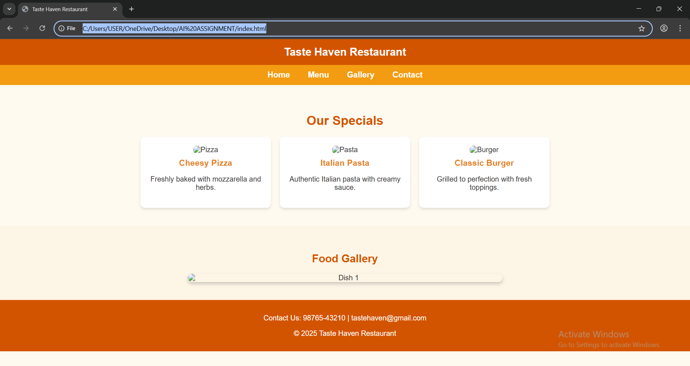

**Observations:**

• GitHub Copilot successfully generated the navigation bar and responsive section layout.

• The menu section used **CSS Grid**, which automatically adjusts based on screen width.

• The JavaScript image slider was generated from Copilot’s base suggestion and customized to include **auto-slide** and manual controls.

• Hover effects on menu cards made the design more interactive and visually appealing.

• The website layout was **responsive** and performed well across different device sizes.

**Task 3:**

AI-Powered Event Registration Form  
Scenario:  
SR University is hosting a tech fest. They need a web-based registration  
form for students. The form must validate user input in real-time.  
• Ask Copilot to generate an HTML form (fields: Name, Email,  
Phone, Department, Event Selection).  
• Use Copilot to assist in adding CSS styling for an attractive form  
layout.  
• Implement JavaScript validation (e.g., email format check,  
phone number length check) using Copilot’s suggestions.

**Prompt:**

Generate an HTML form for an event registration page with fields for Name, Email, Phone, Department, and Event Selection. Style it attractively using CSS with rounded corners, shadows, and responsive design. Then, use JavaScript to validate the form in real time — checking that the email is valid and the phone number has exactly 10 digits. Highlight invalid fields in red and show success messages when input is valid.

**Code:**

<!DOCTYPE html>

<html lang="en">

<head>

<meta charset="UTF-8" />

<meta name="viewport" content="width=device-width, initial-scale=1.0" />

<title>Tech Fest Registration - SR University</title>

<style>

body {

font-family: 'Poppins', sans-serif;

background: linear-gradient(120deg, #89f7fe, #66a6ff);

display: flex;

justify-content: center;

align-items: center;

height: 100vh;

}

.container {

background: #fff;

padding: 30px 40px;

border-radius: 15px;

box-shadow: 0 5px 15px rgba(0,0,0,0.2);

width: 100%;

max-width: 450px;

}

h2 {

text-align: center;

color: #333;

margin-bottom: 20px;

}

.form-group {

margin-bottom: 15px;

}

label {

display: block;

margin-bottom: 5px;

color: #444;

} input, select {

width: 100%;

padding: 10px;

border: 2px solid #ccc;

border-radius: 8px;

font-size: 14px;

transition: 0.3s;

} input:focus, select:focus {

border-color: #66a6ff;

outline: none;

} .error {

border-color: red;

}

success {

border-color: green;

}button {

width: 100%;

padding: 10px;

background: #66a6ff;

border: none;

color: white;

font-size: 16px;

border-radius: 8px;

cursor: pointer;

transition: 0.3s;

}

button:hover {

background: #4d8df7;

}

.message {

font-size: 13px;

color: red;

margin-top: 5px;

}

</style>

</head>

<body>

<div class="container">

<h2>Tech Fest Registration</h2>

<form id="registrationForm">

<div class="form-group">

<label for="name">Full Name</label>

<input type="text" id="name" required />

</div>

<div class="form-group">

<label for="email">Email</label>

<input type="email" id="email" required />

<div id="emailMessage" class="message"></div>

</div>

<div class="form-group">

<label for="phone">Phone</label>

<input type="tel" id="phone" maxlength="10" required />

<div id="phoneMessage" class="message"></div>

</div>

<div class="form-group">

<label for="dept">Department</label>

<select id="dept" required>

<option value="">Select Department</option>

<option value="CSE">CSE</option>

<option value="ECE">ECE</option>

<option value="EEE">EEE</option>

<option value="MECH">MECH</option>

<option value="CIVIL">CIVIL</option>

</select>

</div>

<div class="form-group">

<label for="event">Event</label>

<select id="event" required>

<option value="">Select Event</option>

<option value="Hackathon">Hackathon</option>

<option value="AI Workshop">AI Workshop</option>

<option value="Drone Show">Drone Show</option>

</select>

</div>

<button type="submit">Register</button>

</form>

</div>

<script>

const form = document.getElementById('registrationForm');

const email = document.getElementById('email');

const phone = document.getElementById('phone');

const emailMsg = document.getElementById('emailMessage');

const phoneMsg = document.getElementById('phoneMessage');

email.addEventListener('input', () => {

const emailPattern = /^[^ ]+@[^ ]+\.[a-z]{2,3}$/;

if (email.value.match(emailPattern)) {

email.classList.add('success');

email.classList.remove('error');

emailMsg.textContent = "Valid email";

emailMsg.style.color = "green";

} else {

email.classList.add('error');

email.classList.remove('success');

emailMsg.textContent = "Invalid email format";

emailMsg.style.color = "red";

}

});

phone.addEventListener('input', () => {

if (phone.value.length === 10) {

phone.classList.add('success');

phone.classList.remove('error');

phoneMsg.textContent = "Valid phone number";

phoneMsg.style.color = "green";

} else {

phone.classList.add('error');

phone.classList.remove('success');

phoneMsg.textContent = "Phone must be 10 digits";

phoneMsg.style.color = "red";

}

});

form.addEventListener('submit', (e) => {

e.preventDefault();

alert("Registration Successful!");

});

</script>

</body>

</html>

**Screenshots:**

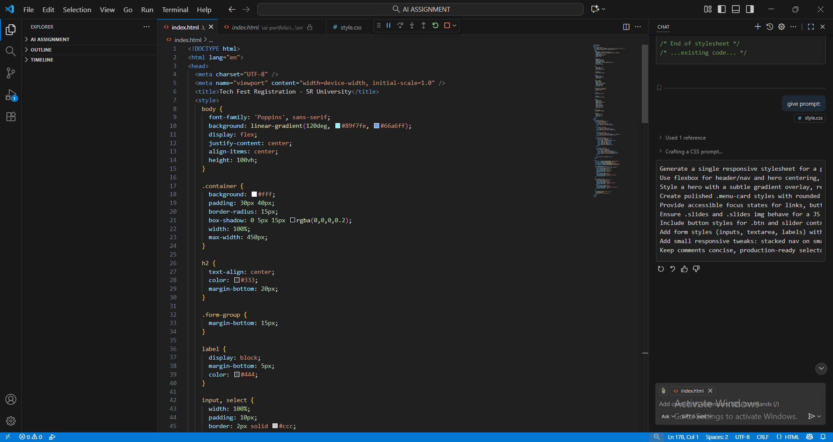

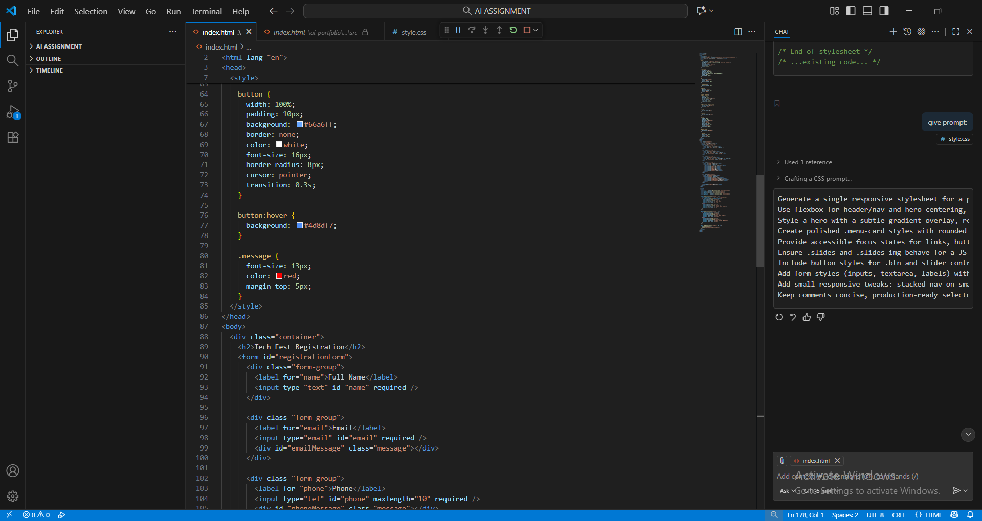

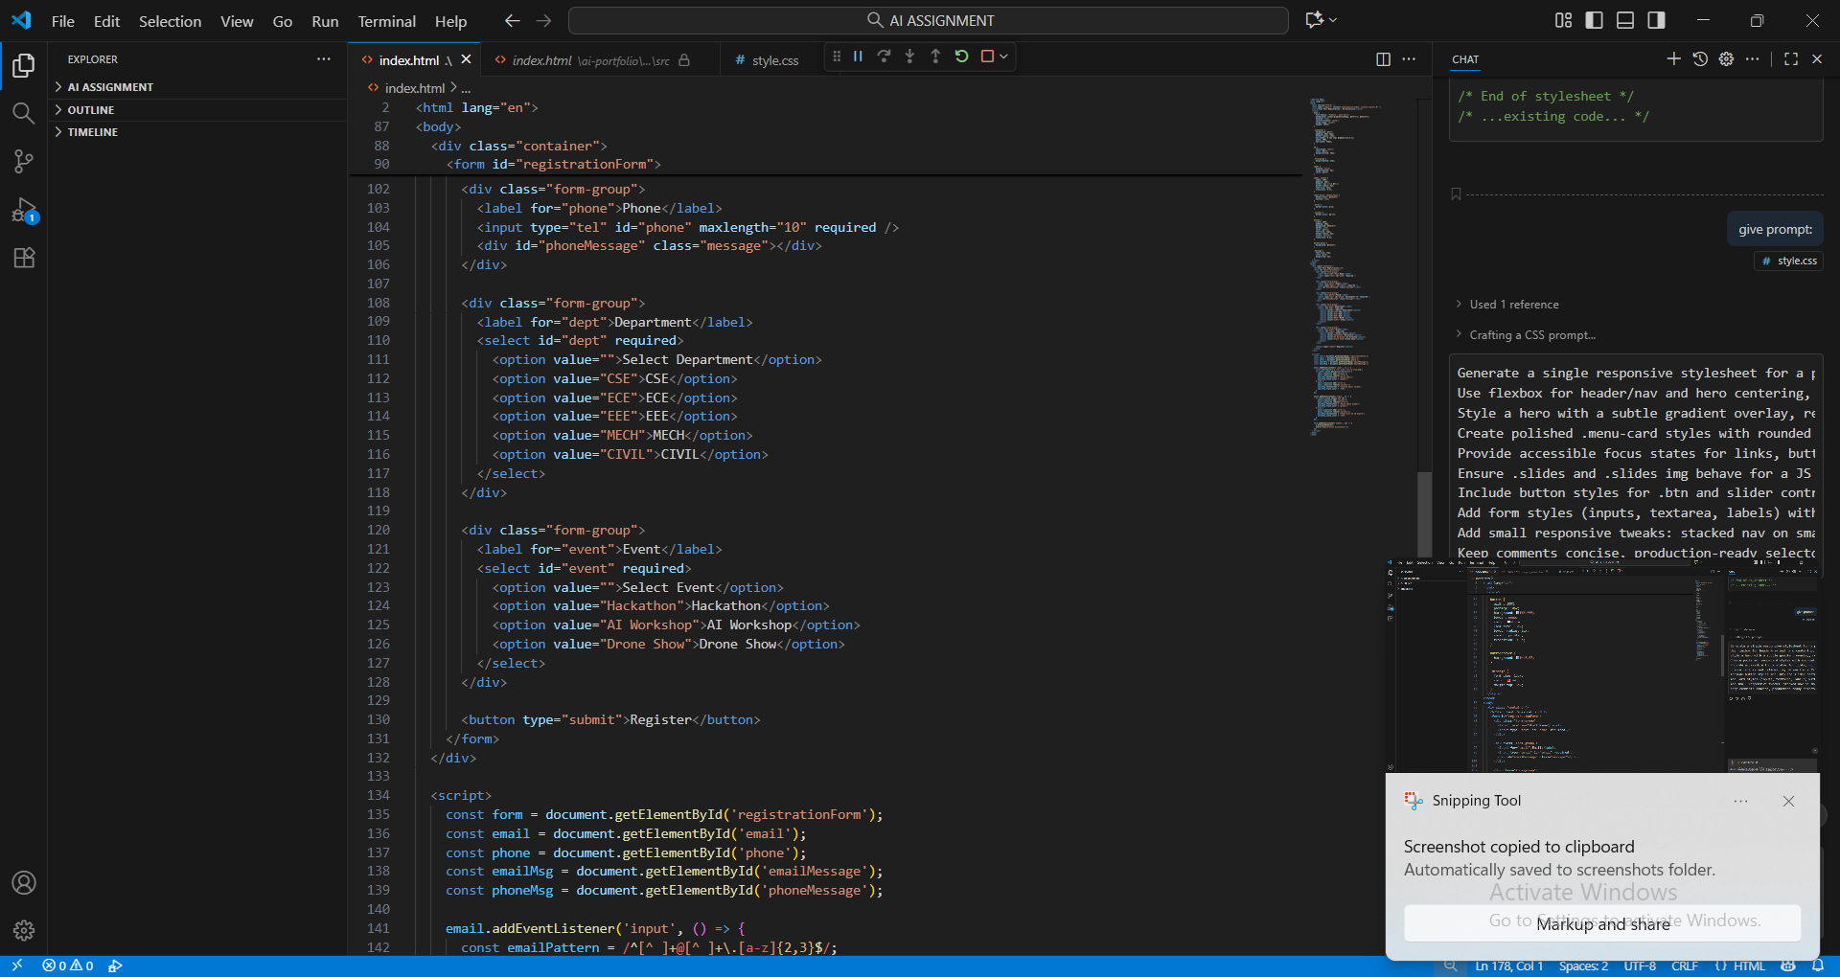

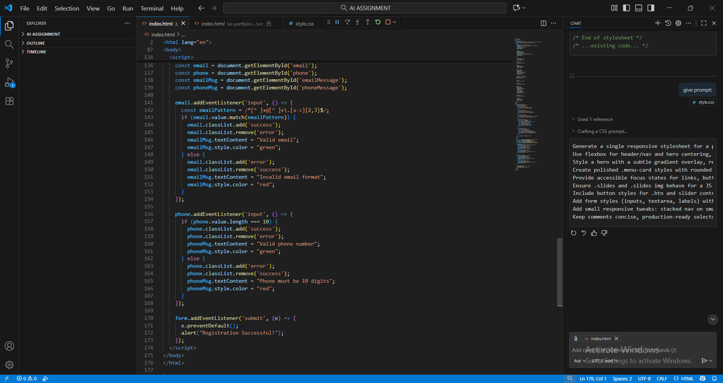

**Output:**

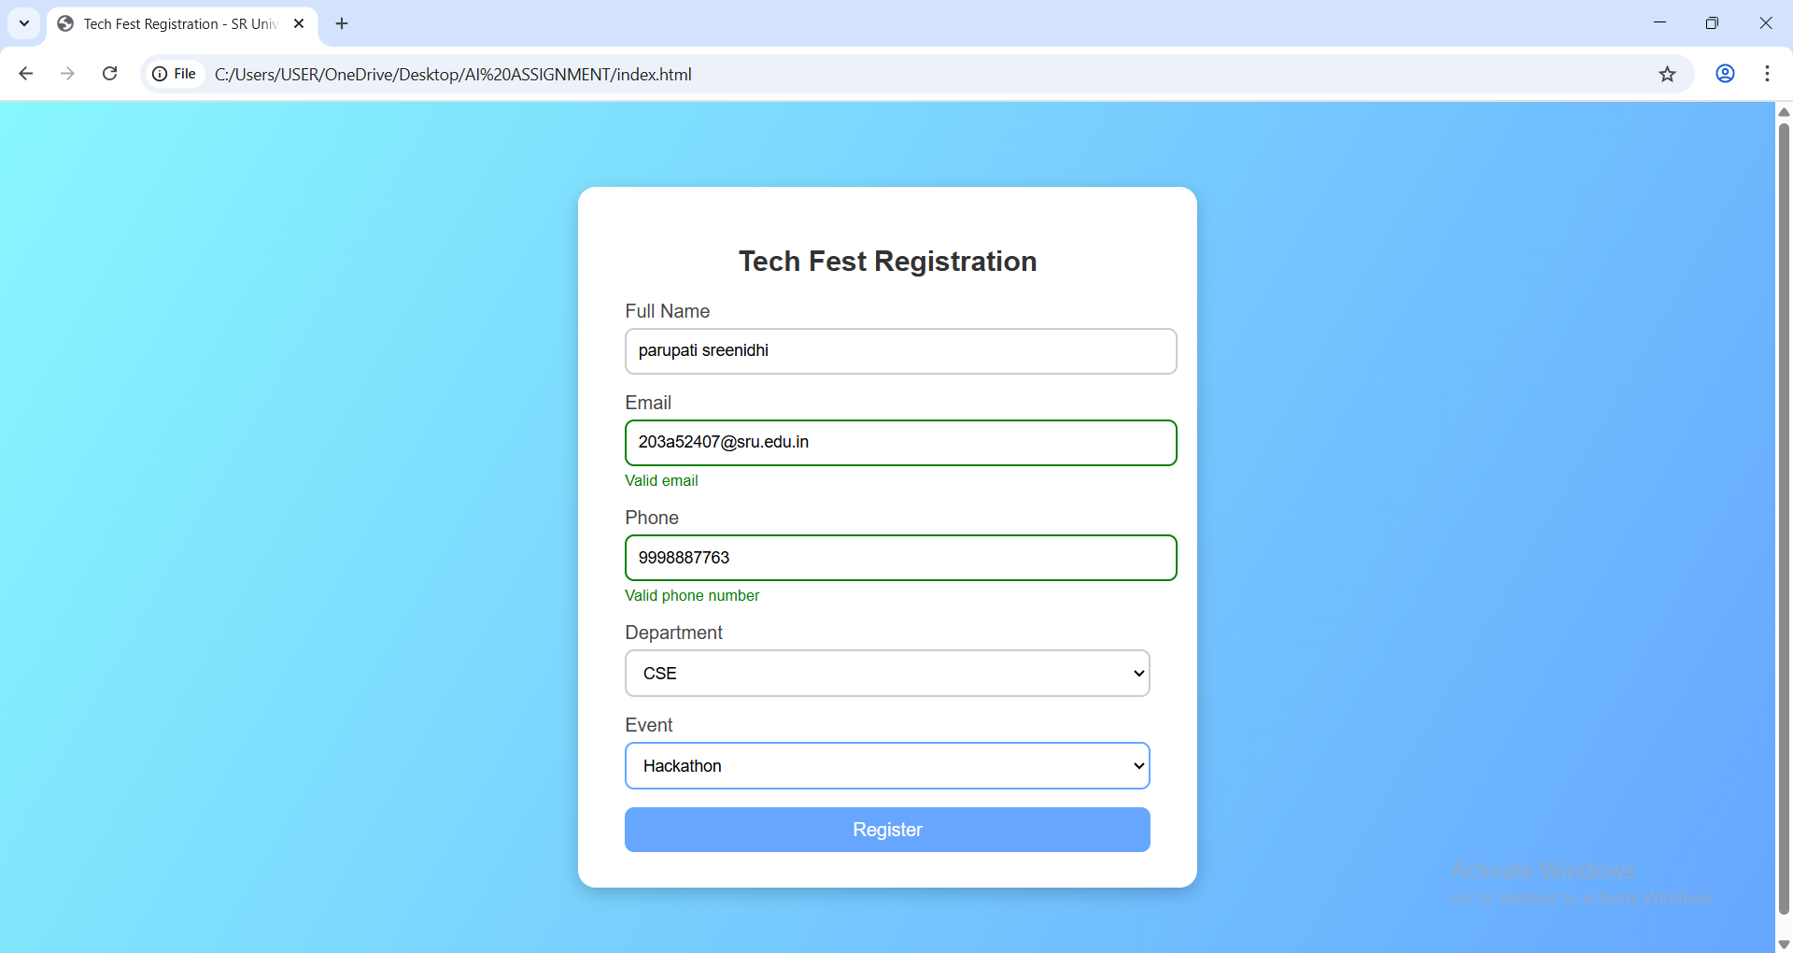

**Observations:**

• GitHub Copilot generated the basic HTML structure including **Home, About, Projects, and Contact** sections.

• The CSS layout was created using **Flexbox and Grid**, making the page responsive across devices.

• Hover effects were added on project cards using transform and box-shadow for better interactivity.

• The design was visually appealing with minimal manual corrections required.

• Copilot’s assistance reduced time taken for front-end design and improved productivity.

• The final website displayed all content clearly with proper section alignment.

**Task 4:**

AI-Assisted E-Commerce Product Page  
Scenario:  
A startup wants a basic e-commerce product page to display products  
with prices and an “Add to Cart” button.  
• Use Copilot to generate a grid-based product catalog in  
HTML/CSS.  
• Implement a JavaScript “Add to Cart” functionality with  
Copilot’s guidance.  
• Modify Copilot’s suggestions to include a cart counter at the  
top-right corner of the page.

**Prompt:**

Generate a simple e-commerce product page using HTML, CSS, and JavaScript. Use a grid layout to display product cards with images, names, prices, and an ‘Add to Cart’ button. Implement a JavaScript function that updates a cart counter at the top-right corner whenever a product is added. Use attractive and responsive CSS styling to make the layout suitable for both desktop and mobile screens.

**Code:**

<!DOCTYPE html>

<html lang="en">

<head>

<meta charset="UTF-8" />

<meta name="viewport" content="width=device-width, initial-scale=1.0" />

<title>AI E-Commerce Store</title>

<style>

* {

margin: 0;

padding: 0;

box-sizing: border-box;

font-family: 'Poppins', sans-serif;

}

body {

background: #f4f6f8;

}

header {

background: #1e293b;

color: white;

display: flex;

justify-content: space-between;

align-items: center;

padding: 15px 40px;

} header h1 {

font-size: 24px;

}

.cart {

position: relative;

font-size: 20px;

cursor: pointer;

}

.cart span {

background: #ff4757;

color: white;

font-size: 13px;

border-radius: 50%;

padding: 3px 8px;

position: absolute;

top: -10px;

right: -10px;

}

.products {

display: grid;

grid-template-columns: repeat(auto-fit, minmax(220px, 1fr));

gap: 20px;

padding: 40px;

}

.product-card {

background: white;

border-radius: 12px;

box-shadow: 0 2px 10px rgba(0,0,0,0.1);

padding: 15px;

text-align: center;

transition: transform 0.3s;

}

.product-card:hover {

transform: translateY(-5px);

}

.product-card img {

width: 100%;

border-radius: 10px;

height: 180px;

object-fit: cover;

}

.product-card h3 {

margin: 10px 0;

color: #333;

} .product-card p {

color: #555;

margin-bottom: 10px;

}button {

background-color: #1e293b;

color: white;

border: none;

padding: 10px 15px;

border-radius: 8px;

cursor: pointer;

transition: background 0.3s;

}

button:hover {

background-color: #334155;

}footer {

background: #1e293b;

color: white;

text-align: center;

padding: 15px;

margin-top: 20px;

}

</style>

</head>

<body>

<header>

<h1>AI E-Commerce Store</h1>

<div class="cart">🛒 Cart <span id="cartCount">0</span></div>

</header>

<section class="products">

<div class="product-card">

<img src="https://via.placeholder.com/250x180?text=Headphones" alt="Headphones">

<h3>Wireless Headphones</h3>

<p>₹2,499</p>

<button onclick="addToCart()">Add to Cart</button>

</div> <div class="product-card">

<img src="https://via.placeholder.com/250x180?text=Smartwatch" alt="Smartwatch">

<h3>Smartwatch</h3>

<p>₹3,999</p>

<button onclick="addToCart()">Add to Cart</button>

</div>

<div class="product-card">

<img src="https://via.placeholder.com/250x180?text=Bluetooth+Speaker" alt="Speaker">

<h3>Bluetooth Speaker</h3>

<p>₹1,799</p>

<button onclick="addToCart()">Add to Cart</button>

</div>

<div class="product-card">

<img src="https://via.placeholder.com/250x180?text=Keyboard" alt="Keyboard">

<h3>Mechanical Keyboard</h3>

<p>₹2,999</p>

<button onclick="addToCart()">Add to Cart</button>

</div>

</section>

<footer>

<p>© 2025 AI E-Commerce Store. All Rights Reserved.</p>

</footer>

<script>

let cartCount = 0;

function addToCart() {

cartCount++;

document.getElementById("cartCount").textContent = cartCount;

alert("Item added to cart!");

}

</script>

</body>

</html>

**Screenshots:**

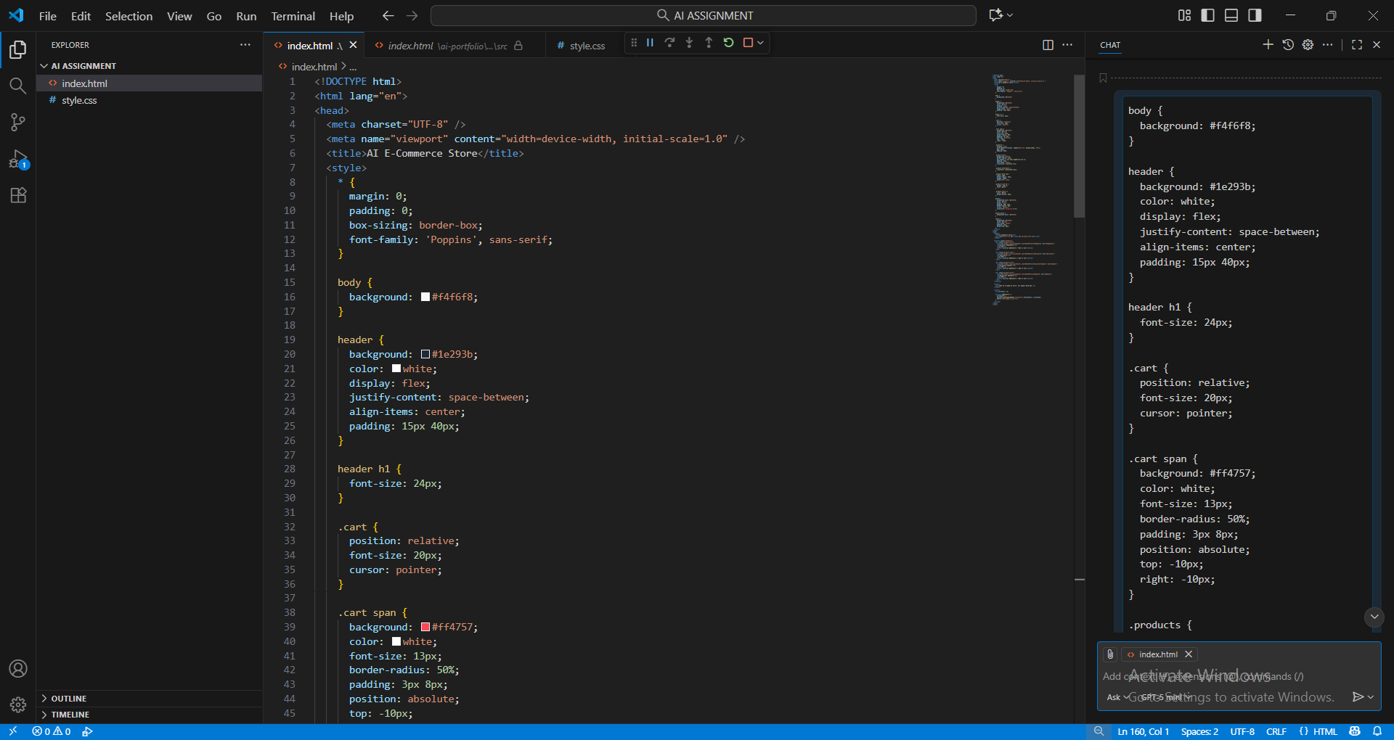

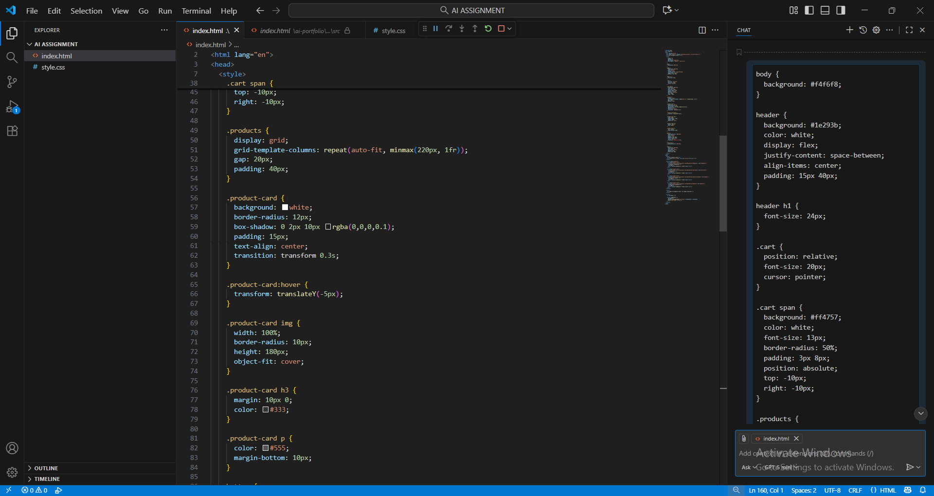

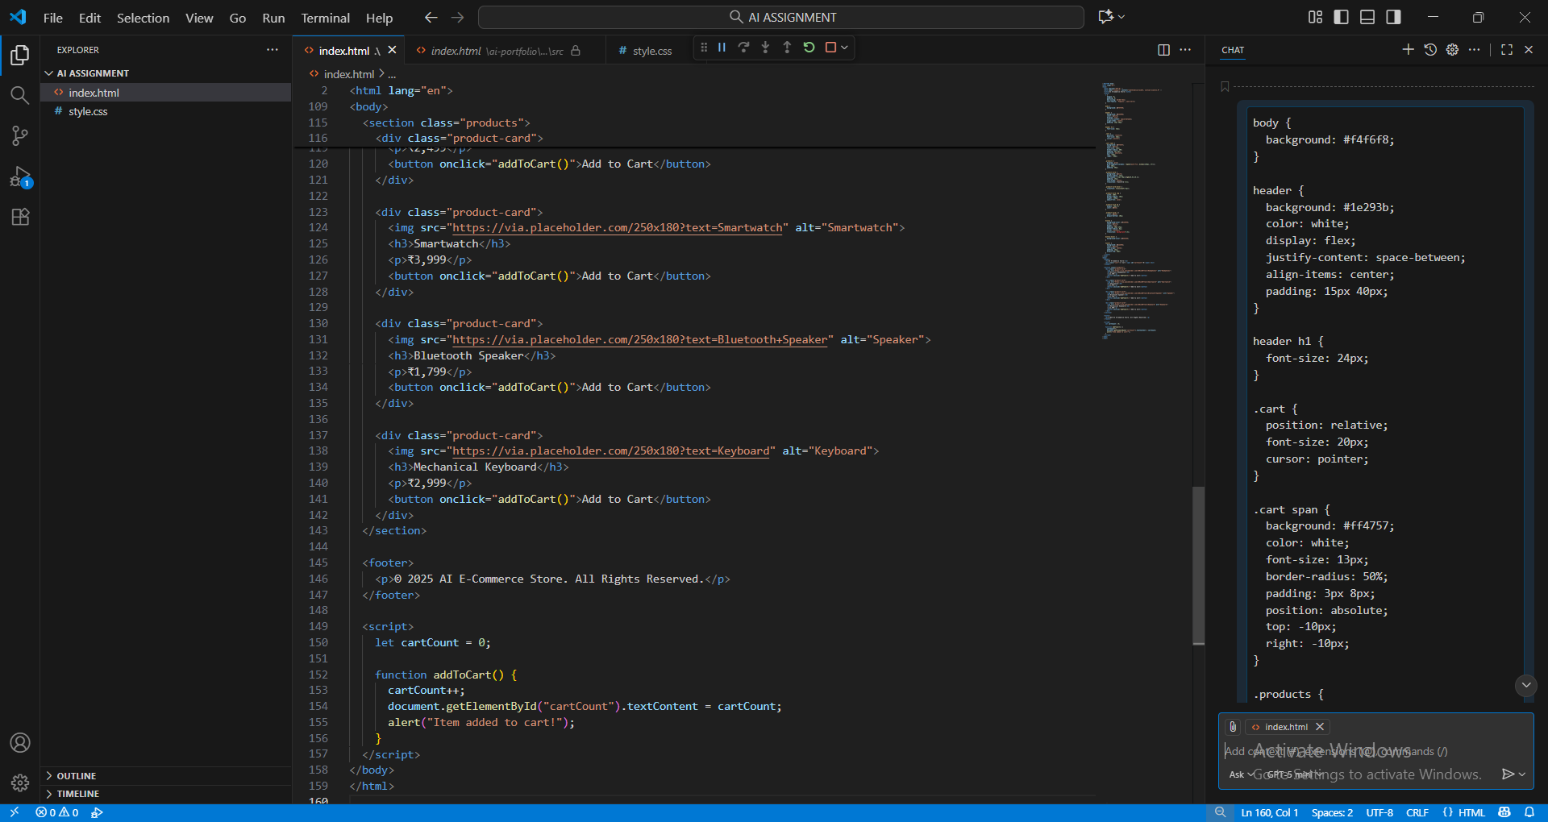

Output:

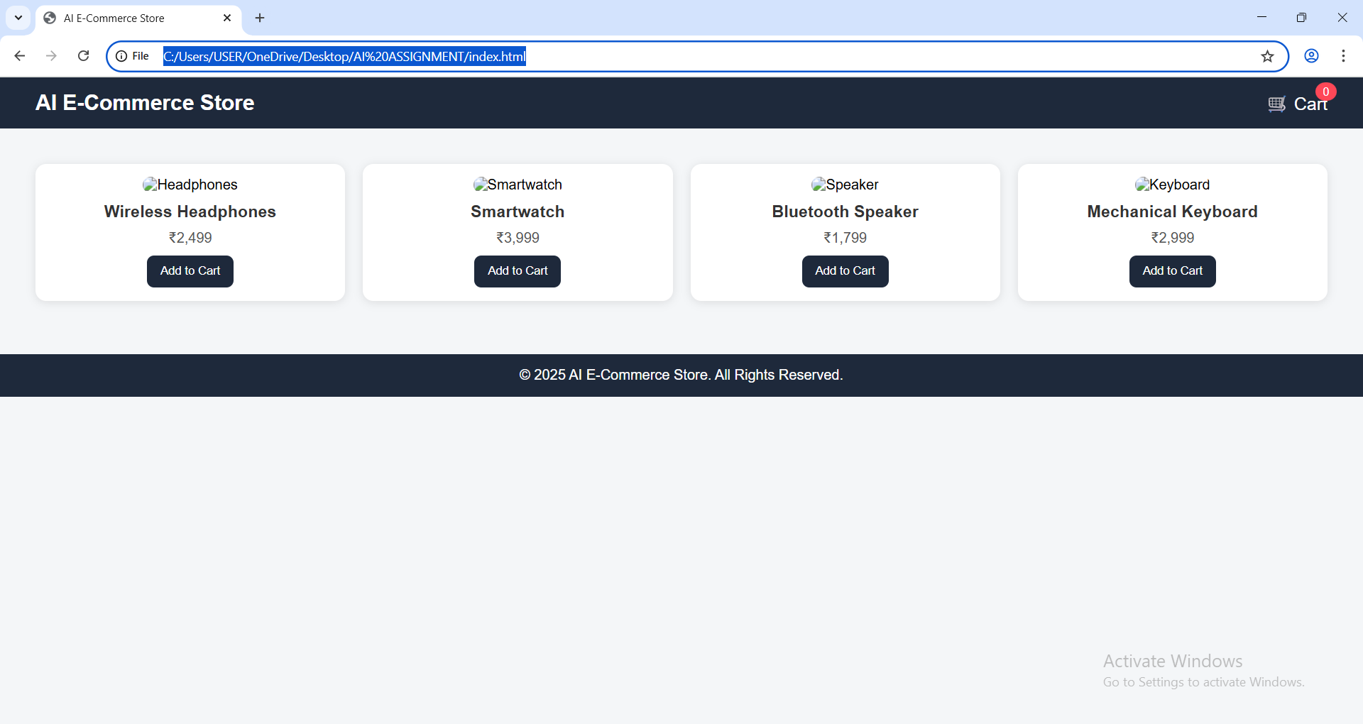

Observations:

• GitHub Copilot generated a clean and structured **HTML layout** for the product page.

• The products were displayed in a **CSS grid format**, ensuring responsiveness across devices.

• Each product card included an image, title, price, and an “Add to Cart” button.

• A JavaScript function was used to **increment the cart counter** each time an item was added.

• Copilot’s auto-suggestions simplified the JavaScript implementation and CSS layout design.

• The final output was a functional, attractive, and responsive product display page suitable for e-commerce applications.