Beavers Choice Multi Agent System Reflective Report
  - Architecture Implementation and Evaluation
This report explains the four-agent system built for Beaver's Choice Paper Company, the decisions behind its architecture, and the evidence from the complete evaluation set. The system processed all 20 supplied requests, fulfilled 9 orders, produced 9 cash-balance changes, and rejected 11 requests with customer-readable reasons. The implementation combines Pydantic AI agent execution and framework-defined tools with deterministic business rules so inventory, pricing, delivery, and transaction decisions remain reproducible.

System purpose and design goals
The company needs a text-based workflow that can interpret customer requests, verify stock, prepare competitive quotes, and finalize only feasible orders. I designed the system around three operating principles: each agent owns one clear responsibility, every order is preflighted before the database is changed, and every customer receives a complete explanation without internal financial details or technical error messages.
- Reliability: unsupported products, ambiguous package sizes, and impossible deadlines are rejected instead of guessed.
- Traceability: all seven starter helper functions are wrapped in framework-defined tools and assigned to a named agent.
- Financial safety: rejected requests do not change cash or stock, while approved orders record replenishment and sales transactions.
- Explainability: confirmations state the order, total, discount rationale, delivery feasibility, and whether replenishment is required.

Architecture and decision process
I selected four agents rather than using the maximum of five. The orchestrator coordinates the workflow, while the three worker agents align directly with the inventory, quoting, and sales responsibilities named in the rubric. This avoids overlapping authority and keeps the flow easy to test. A separate advisor agent was not necessary for the required workflow and would have increased coordination cost without improving the baseline evaluation.

Agent | Primary responsibility | Assigned tools and starter helpers
Orchestrator | Parse and validate the request, sequence worker decisions, and compose the customer response. | financial_report_tool -> generate_financial_report  delegate_inventory_review -> inventory tools  delegate_quote_preparation -> quote tools  delegate_sales_finalization -> sales tools
Inventory | Report stock, calculate shortages, and determine whether replenishment can arrive before the deadline. | inventory_snapshot_tool -> get_all_inventory  stock_level_tool -> get_stock_level  supplier_delivery_tool -> get_supplier_delivery_date
Quote | Use historical context and consistent volume tiers to calculate an explainable price. | quote_history_tool -> search_quote_history
Sales | Check affordability and record approved stock purchases and sales. | cash_balance_tool -> get_cash_balance  record_transaction_tool -> create_transaction

The orchestrator first normalizes product names, quantities, and the requested delivery date. The inventory agent then checks each line against the transaction ledger. If stock is short, it uses the supplier lead-time helper and rejects the request when replenishment would arrive late. Only a fully feasible request reaches the quote agent. The sales agent receives a complete, preflighted transaction plan and records it. This all-or-nothing rule prevents partial database updates when one item in a multi-line request is impossible.

Agent workflow diagram
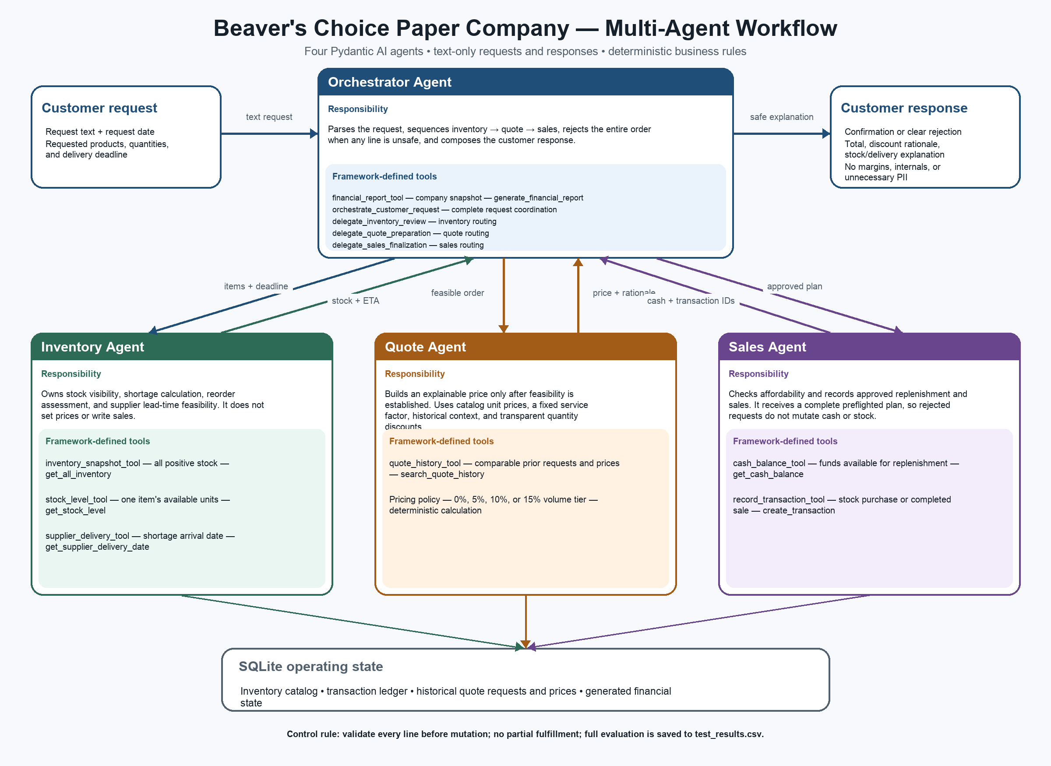
Figure 1 Orchestration data flow and tool ownership

Implementation choices

Pydantic AI framework
Pydantic AI provides the four Agent objects and the tool registration conventions required by the project. Each required starter helper is called from a tool decorated with tool_plain. The application invokes the orchestrator through Agent.run_sync; its async delegation tools then await the inventory, quote, and sales agents, so the runtime follows the same handoffs shown in the diagram. If UDACITY_OPENAI_API_KEY is present, the agents can use the Udacity OpenAI-compatible endpoint. Without a key, a deterministic FunctionModel issues the same framework tool calls locally. This keeps the evaluation reproducible and credentials out of the source code and repository.

Request interpretation and inventory checks
The parser recognizes catalog aliases, quantities, sheets, rolls, and reams, and converts a ream to 500 sheets only for paper products. It does not invent conversions for boxes or packets. The system rejects unsupported items such as balloons and tickets and rejects package descriptions whose unit size is missing. For a supported item, current stock is calculated from all stock-order and sales transactions through the request date. A shortage is accepted only when the supplier date is on or before the customer's deadline and the stock purchase can be funded.

Pricing and sales finalization
The quote agent checks relevant historical requests and applies one pricing policy to every order. The customer price is based on supplied catalog values, a standard service factor, and volume discounts of 5 percent at 500 units, 10 percent at 2,000 units, and 15 percent at 5,000 units. Usable historical quotes provide a per-unit benchmark: the standard rate is retained when it is consistent with history and receives a bounded adjustment only when the benchmark is materially lower or higher. The response communicates the discount but does not disclose internal cost or profit margin. After preflight succeeds, the sales agent records any replenishment and then records each sale line. Rejected requests record no transaction.

Evaluation method
The evaluation resets the SQLite database with seed 137, loads every row in quote_requests_sample.csv, converts request dates, and processes the rows chronologically. Each result records the request identifier, fulfillment status, amount, explanation, cash before and after the decision, whether cash changed, inventory value, and the customer response. The program writes all 20 records to test_results.csv.

Measure | Observed result | Rubric relevance
Requests evaluated | 20 of 20 | Full supplied dataset processed
Fulfilled requests | 9 | Exceeds the minimum of three
Requests with cash changes | 9 | Exceeds the minimum of three
Rejected requests | 11 | Demonstrates active rejection with reasons
Starting cash | $45,059.70 | Baseline after seeded inventory purchases
Final cash | $46,090.42 | Net increase of $1,030.72
Starting inventory value | $4,940.30 | Initial reproducible seeded state
Final inventory value | $4,354.85 | Reflects sales and replenishment decisions

Evaluation strengths
The strongest result is that the system distinguishes a profitable opportunity from an unsafe or underspecified request without relying on random model behavior. Request 1 was fulfilled from current stock for $87.75. The response listed all three products, confirmed that current stock was sufficient, and stated that the deadline was feasible. Request 2 was rejected because balloons are outside the catalog. Request 13 was rejected because replenishment for A4 paper would arrive after the requested date. These outcomes show that product support, stock, and time constraints are all enforced.
The financial evidence is also consistent. Every fulfilled request changes the cash balance, while the 11 rejected requests leave cash unchanged. The generated results therefore demonstrate both successful selling and controlled refusal. Customer messages explain volume discounts and delivery decisions without exposing database names, stack traces, API credentials, or exact profit margins.

Limitations
- The deterministic parser handles the supplied language well but can miss unfamiliar synonyms, unusual punctuation, or package terms that lack a known conversion.
- The supplier model uses quantity-based calendar-day lead times and does not represent weekends, supplier capacity, transportation risk, or split shipments.
- The all-or-nothing policy is safe, but it can reject a request that a customer might accept as a partial shipment or negotiated backorder.
- Historical quotes provide a bounded market benchmark, but the current pricing calculation does not yet learn demand elasticity or customer-specific willingness to pay.

Further improvements

Validated structured extraction and clarification
A future version could ask the Pydantic AI orchestrator to return a typed request model, then validate it against the deterministic parser before any tool is called. When the two interpretations disagree, the system should ask the customer a focused clarification question. This would expand language coverage while preserving the current rule against guessing.

Reservations partial fulfillment and atomic commits
The transaction workflow could reserve stock, propose partial fulfillment or a backorder, and commit all approved lines in one database transaction. This would improve conversion for mixed-feasibility orders and protect against an unexpected write failure between line items.

Demand forecasting and replenishment policy
A forecasting component could combine sales velocity, minimum stock levels, supplier lead time, and seasonal event demand to recommend proactive reorder points. The financial report tool already provides the foundation for this improvement, and the recommendation could remain advisory until a human approves the purchase.

Conclusion
The completed system meets the required architecture, helper-tool, evaluation, and explainability contracts with four clearly separated agents that execute through Pydantic AI. Its most important design choice is deterministic preflight before mutation: the system sells when stock, supplier timing, and cash support the full request, and it gives a specific customer-facing reason when they do not. The 20-row evaluation provides reproducible evidence that the workflow can fulfill orders, change cash, and reject unsafe requests without revealing sensitive internal information.

