**Simple Register and Login Using .net6 web Api, JWT, SQLite, Hashing and Salting**

**Setting up:**

* Install latest .net sdk ([.NET SDKs downloads for Visual Studio (microsoft.com)](https://dotnet.microsoft.com/en-us/download/visual-studio-sdks))
* Use Visual Studio Code([Visual Studio Code - Code Editing. Redefined](https://code.visualstudio.com/)) or Visual Studio – here I’m using Visual Studio Code
* For this project, I'm using Command Prompt.

**Introduction**

Please refer to this document for instructions on how to create your own login method other than the inbuilt login function (I am not using the inbuilt identity component).

**Project Creation:**

Here I have created a folder called "angularPro," and I have added an anular project to that. We'll go over the.net API components rather than the Angular components; I'll add a new document about configuring the API service in an Angular project soon.

My existing folder structure below

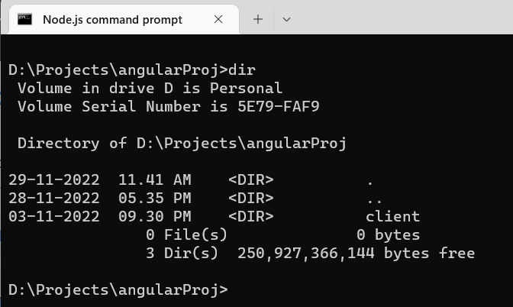

First, we need to create a solution file, and within that, we have to add the API project. Check out the screencaps below.

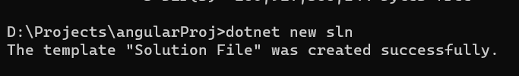

I am adding WEB API project

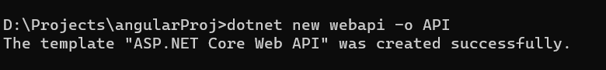

I have added the API project, Check out the screencaps below.

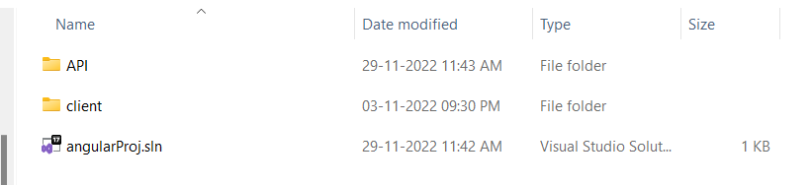

Here I am adding the API project to the solution.



After adding, my .Sln file look like

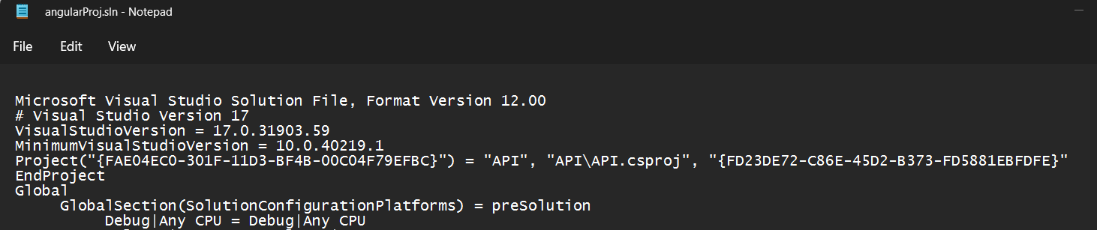

Open the API project by using below command, I am opening the project in Visual Studio code



The folder structure in Visual Studio code is shown below.

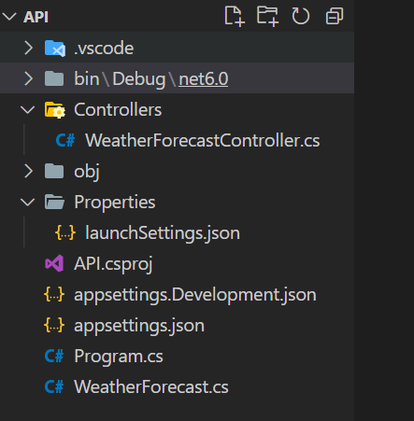

**Extensions**

Add the following: Visual Studio extension, please add the following extension.





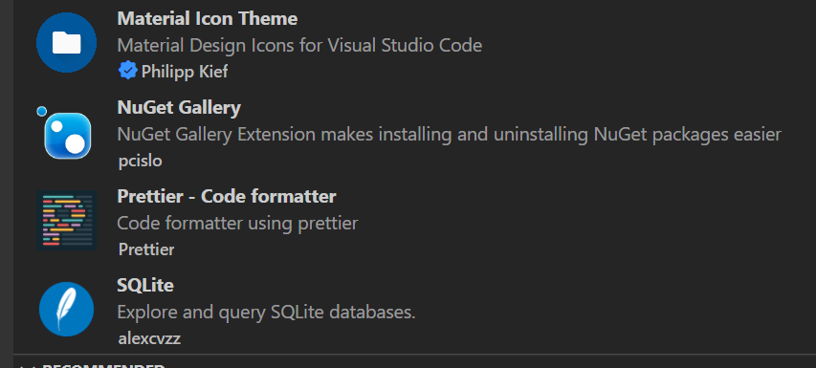

**Install Packages**

* Press Ctrl+Shift+P
* Search for Nuget

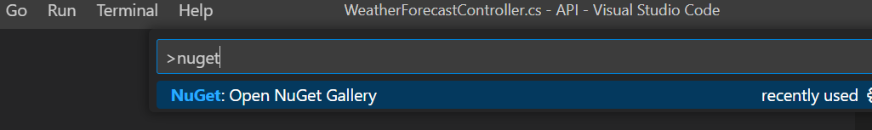

* Select and Press Enter
* Look for and install the following packages.

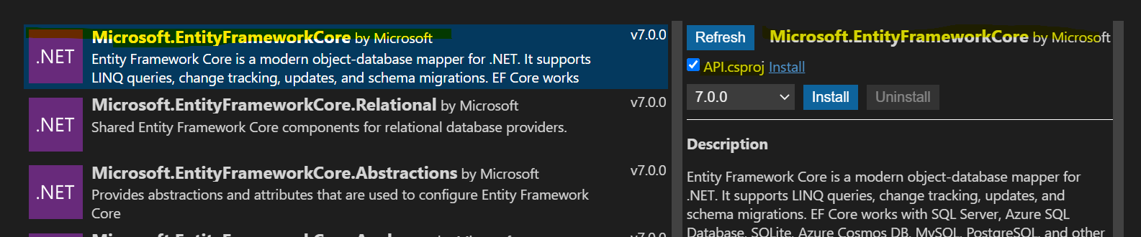





**Application Side:**

1. Create folder, and named it as “Models”, where we can store all user business logic
2. Create class and named it as “User”, the class below

namespace API.Models

{

    public class User

    {

        public int Id { get; set; }

        public string Username { get; set; }

        public byte[] PasswordHash { get; set; }

        public byte[] PasswordSalt { get; set; }

    }

}

If you are facing error on NULLABLE issue, Open the API.csproj and remove or comment the <Nullable> section

<PropertyGroup>

    <TargetFramework>net6.0</TargetFramework>

    <!-- <Nullable>enable</Nullable> -->

    <ImplicitUsings>enable</ImplicitUsings>

  </PropertyGroup>

1. Create “Model” in root level and add a new class and named as DataContext

using API.Models;

using Microsoft.EntityFrameworkCore;

namespace API.Data

{

    public class DataContext : DbContext

    {

        public DataContext(DbContextOptions<DataContext> options) : base(options){}

        public DbSet<User> Users { get; set; }

    }

}

**Appsettings.json**

{

  "ConnectionStrings": {

    "DefaultConnection": "Data Source=sampleapp.db"

  },

  "TokenKey": "secret key should be here"

  ,

  "Logging": {

    "LogLevel": {

      "Default": "Information",

      "Microsoft.AspNetCore": "Warning"

    }

  },

  "AllowedHosts": "*"

}

**DTOs**

1. LoginDto
2. RegisterDto
3. UserDto
4. Login DTO:

namespace API.Dtos

{

    public class LoginDto

    {

        public string Username { get; set; }

        public string Password { get; set; }

    }

}

1. Register DTO

namespace API.Dtos

{

    public class RegisterDto

    {

        [Required]

        public string Username { get; set; }

        [Required]

        [StringLength(12, MinimumLength = 6, ErrorMessage = "You must specify password between 6 and 12 characters")]

        public string Password { get; set; }

    }

}

1. User DTO

namespace API.Dtos

{

    public class UserDto

    {

        public string Username { get; set; }

        public string Token { get; set; }

    }

}

**Services:**

1. **ITokenService**
2. **TokenService**
3. **ITokenService**

namespace API.Services

{

    public interface ITokenService

    {

         string CreateToken(User user);

    }

}

1. **TokenService**

namespace API.Services

{

    public class TokenService : ITokenService

    {

        private readonly SymmetricSecurityKey _key;

        public TokenService(IConfiguration config)

        {

            _key = new SymmetricSecurityKey(Encoding.UTF8.GetBytes(config["TokenKey"]));

        }

        public string CreateToken(User user)

        {

            var claims = new List<Claim>

            {

                new Claim(JwtRegisteredClaimNames.NameId, user.Username)

            };

            var creds = new SigningCredentials(_key, SecurityAlgorithms.HmacSha512Signature);

            var tokenDescriptor = new SecurityTokenDescriptor

            {

                Subject = new ClaimsIdentity(claims),

                Expires = DateTime.Now.AddDays(7),

                SigningCredentials = creds

            };

            var tokenHandler = new JwtSecurityTokenHandler();

            var token = tokenHandler.CreateToken(tokenDescriptor);

            return tokenHandler.WriteToken(token);

        }

    }

}

**API Controller**

using System;

using System.Collections.Generic;

using System.Linq;

using System.Threading.Tasks;

using API.Dtos;

using API.Models;

using Microsoft.AspNetCore.Mvc;

using System.IdentityModel.Tokens.Jwt;

using Microsoft.Extensions.Configuration;

using System.Security.Claims;

using API.Services;

using API.Data;

using System.Security.Cryptography;

using System.Text;

using Microsoft.EntityFrameworkCore;

namespace API.Controllers

{

    [ApiController]

    [Route("api/[controller]")]

    public class AuthController : ControllerBase

    {

        private readonly DataContext _context;

        private readonly ITokenService _tokenService;

        public AuthController(DataContext context, ITokenService tokenService)

        {

            _tokenService = tokenService;

            _context = context;

        }

        [HttpPost("register")] // POST: api/auth

        public async Task<ActionResult<UserDto>> Register(RegisterDto registerDto)

        {

            if (await UserExists(registerDto.Username)) return BadRequest("Username is taken");

            using var hmac = new HMACSHA512();

            var user = new User

            {

                Username = registerDto.Username.ToLower(),

                PasswordHash = hmac.ComputeHash(Encoding.UTF8.GetBytes(registerDto.Password)),

                PasswordSalt = hmac.Key

            };

            _context.Users.Add(user);

            await _context.SaveChangesAsync();

            return new UserDto

            {

                Username = user.Username,

                Token = _tokenService.CreateToken(user)

            };

        }

        [HttpPost("login")]

        public async Task<ActionResult<UserDto>> Login(LoginDto loginDto)

        {

            var user = await _context.Users.SingleOrDefaultAsync(x =>

                x.Username == loginDto.Username);

            if (user == null) return Unauthorized("invalid username");

            using var hmac = new HMACSHA512(user.PasswordSalt);

            var computedHash = hmac.ComputeHash(Encoding.UTF8.GetBytes(loginDto.Password));

            for (int i = 0; i < computedHash.Length; i++)

            {

                if (computedHash[i] != user.PasswordHash[i]) return Unauthorized("invalid password");

            }

            return new UserDto

            {

                Username = user.Username,

                Token = _tokenService.CreateToken(user)

            };

        }

        private async Task<bool> UserExists(string username)

        {

            return await _context.Users.AnyAsync(x => x.Username == username.ToLower());

        }

    }

}

**Program.cs**

using API.Data;

using API.Services;

using Microsoft.EntityFrameworkCore;

using Microsoft.AspNetCore.Authentication.JwtBearer;

using Microsoft.IdentityModel.Tokens;

using System.Text;

var builder = WebApplication.CreateBuilder(args);

// Add services to the container.

builder.Services.AddControllers();

// Learn more about configuring Swagger/OpenAPI at https://aka.ms/aspnetcore/swashbuckle

builder.Services.AddEndpointsApiExplorer();

builder.Services.AddSwaggerGen();

builder.Services.AddDbContext<DataContext> (option=> {

    option.UseSqlite(builder.Configuration.GetConnectionString("DefaultConnection"));

});

builder.Services.AddCors();

builder.Services.AddScoped<ITokenService, TokenService>();

builder.Services.AddAuthentication(JwtBearerDefaults.AuthenticationScheme)

                .AddJwtBearer(options =>

                {

                    options.TokenValidationParameters = new TokenValidationParameters

                    {

                        ValidateIssuerSigningKey = true,

                        IssuerSigningKey = new SymmetricSecurityKey(Encoding

                            .UTF8.GetBytes(builder.Configuration["TokenKey"])),

                        ValidateIssuer = false,

                        ValidateAudience = false

                    };

                });

var app = builder.Build();

// Configure the HTTP request pipeline.

if (app.Environment.IsDevelopment())

{

    app.UseSwagger();

    app.UseSwaggerUI();

}

app.UseHttpsRedirection();

app.UseAuthorization();

app.MapControllers();

app.Run();

**Migarion:**

The migrations feature in EF Core **provides a way to incrementally update the database schema to keep it in sync with the application's data model while preserving existing data in the database.**

**Ref.** [Migrations Overview - EF Core | Microsoft Learn](https://learn.microsoft.com/en-us/ef/core/managing-schemas/migrations/?tabs=dotnet-core-cli)

Here, we need togenerates code for a DbContext and entity types for a database. We must first install **dotnet ef** Open the terminal (Ctrl+') and enter the following code.

API> **dotnet tool install --global dotnet-ef**

Once installed, we are ready to migrate our entities. enter the following command in terminal

**API> dotnet ef migrations add InitialCreate -o Data/Migrations**

Then this will create a migration script like below.

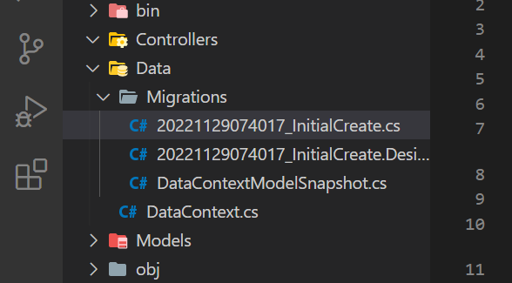

We generated our migration class files, and we need to add the migration snapshots into the database. enter the following command:

API> **dotnet ef database update**

**How can I check if a database was created or not?**

Press "Show all commands" (Ctrl+Shift+P), type "Open Database,"  you will get the screen below, and press enter.

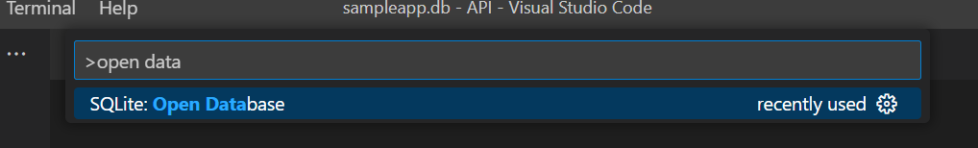

Select your Database, like below

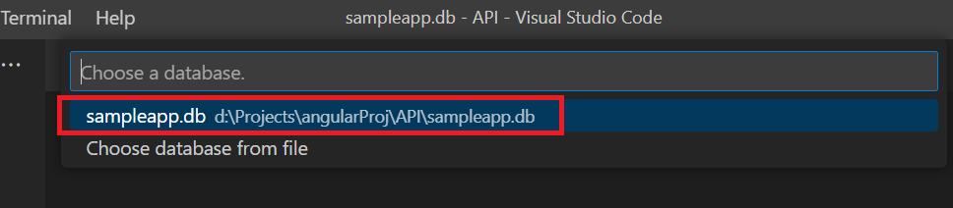

Select your Database from SQLITE EXPLORER

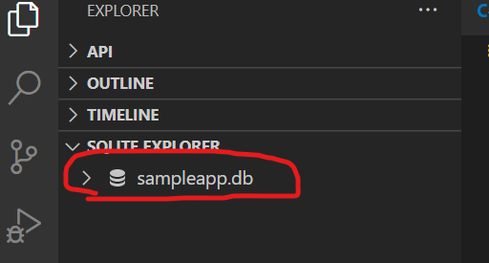

The table has been created successfully. please verify

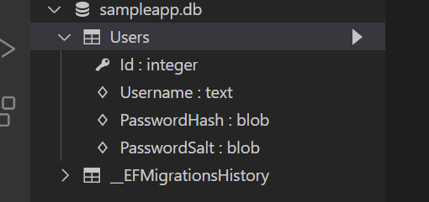

Install JWT

**Implementing JWT Authentication**

Open Nuget and install System.IdentityModel.Token.Jwt

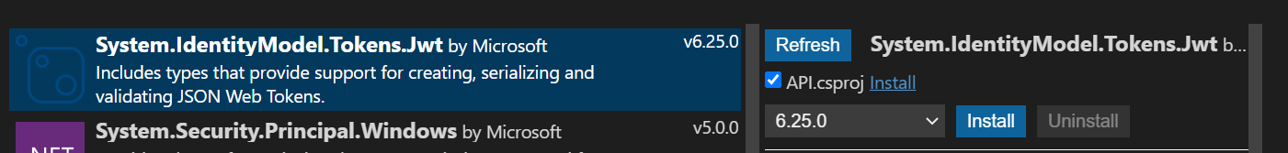

And install Microsoft.AspNetCore.Authentication.JwtBearer



**Application running**:

To run the application, use the following code



**Output**:

