Gender Bias and Fairness in Machine Learning-Based Loan Approval

Nouf AlSalman
Prince Sultan University
222410203@psu.edu.sa
Layan Almuqhem
Prince Sultan University
221410440@ psu.edu.sa

This paper investigates gender bias and fairness in the machine learning-based loan approval prediction. The synthetic tabular dataset of 45,000 loan applications (20,159 women, 24,841 men) has a class distribution of 77.78% rejected loans and 22.22% approved loans. Four classification models (Logistic Regression, Decision Tree, Random Forest, and Gradient Boosting) are trained and evaluated. A preprocessing workflow implemented using scikit-learn, including feature engineering that expands the dataset to 17 features, is combined with 5-fold stratified cross-validation to assess model performance. Random Forest achieves the best performance among the evaluated models (Accuracy: 0.930, F1: 0.831, ROC-AUC: 0.976). Fairness is evaluated by using Demographic Parity Difference (DPD), Disparate Impact Ratio (DIR), and Equal Opportunity Difference (EOD). The results illustrate a close zero bias on each of the provided models, which is in line with the equal gender approval rates that can be observed in the synthetic dataset (DPD ≤ 0.0072, DIR ≥ 0.969, EOD ≤ 0.009). This study provides a reproducible benchmarking framework for assessing algorithmic fairness in automated loan approval systems.

- Introduction
The use of machine learning (ML) models is becoming more widely used in automating financial decisions that have high stakes, such as loan issuance and credit rating. As much as automation has the benefit of increasing processing speed and consistency, the systems can foster or increase the presence of biases that exist within society in the training data, leading to unequal returns for various groups of society members [1]. It is especially catastrophic as gender bias in loan lending may limit access to home ownership, loans to finance education, and capital to start businesses, having socioeconomic implications over the long term [5].
It has been shown that even the unequal treatment between male and female borrowers revealed by historical credit statistics, when given by the ML classifier that is trained on historical data, may result in uneven approvals of the loans [3]. The major issue is that gender bias may be created indirectly, using correlated proxy variables, like income, work stability, or even the purpose of a loan, without assigning gender as an explicit model factor. This is a phenomenon called proxy discrimination, which highlights the importance of post hoc fairness analysis.
This paper investigates whether ML classifiers trained on a synthetic loan approval dataset demonstrate gender-based disparities in prediction outcomes, and whether these disparities can be measured using conventional fairness measures. The prediction problem is binary classification, where the sample size of 13 characteristics of applicants predicts the loan status (approved = 1 , rejected = 0 ). Gender becomes a shielded characteristic, out of model training, and is utilized merely in evaluating fairness.
The work will yield: (1) a fully operationalized, reusable ML pipeline in Python using scikit-learn; (2) feature engineering that is domain-aware, increasing the feature space to 17 columns; (3) systematic performance evaluation of four classifier families based on their predictive and gender fairness; and (4) a validated fairness evaluation framework (DPD, DIR, EOD) as a baseline for future bias-mitigation phases.
- Related work
The literature on bias, fairness, and discrimination in automated credit and loan systems has been widely investigated in recent years. This section reviews six recent studies (2024–2025) that are closely related to this work.
Thu et al. [1] compare fairness-aware machine learning models with traditional classifiers, including Logistic Regression, Random Forest, and Support Vector Machines, on benchmark credit datasets. They consider fairness metrics such as Demographic Parity Difference and Equalized Odds, and they show that conventional classifiers create large gender disparities, while fairness-sensitive approaches lessen but do not fully abolish these disparities. The fairness metrics used in their work inspired the metrics used in the present study.
Chen et al. [2] introduce a framework of fairness-based measurement of ML-based credit rating based on Shapley-Lorenz decomposition and tested on approximately 119,857 records of small and medium enterprises in various European countries. They show that the impact of fairness is extremely sensitive to the characteristics of the datasets, such as class imbalance, correlation in features, and sample size, highlighting the significance of thorough exploratory data analysis (EDA).
Liu et al. [3] determine the equality of credit scoring systems between the genders by evaluating the mis-calibration effects between gender groups using the large-scale alternative and traditional credit data. Their results reveal a systematic overestimation of predicted default risk for female borrowers over male equivalents with the same observed risk characteristics, directly testing the point of gender discrimination in credit systems between algorithms.
Abbas [4] investigates fairness in a credit decision pipeline using information-theoretic analysis on 5000 anonymized US loan applications to learn a Random Forest classifier. Equity is measured by comparing approval rates to subgroup demographics by using AUC as the main performance metric. The research indicates that bias in the approval algorithm can still remain even when gender is not a direct input, and this indicates the problem of proxy discrimination.
Oluoch and Alhassan [5] focus on the gender credit gap phenomenon in low-income countries, and they analyze the large-scale survey data with the help of econometric regression analysis. Although the study is not focused on machine learning, its results show structural disadvantages that women face in accessing credit. The biases revealed suggest that ML systems trained on similar data may inherit this bias.
Ayari et al. [6] provide a synthesis of the systematic literature review that comprises 63 peer-reviewed studies on ML credit scoring published between 2018 and 2024. They record that the family of models that is predominant includes the following: Logistic Regression, Random Forest, Gradient Boosting, Decision Trees, and Neural Networks, with accuracy, AUC, F1-score, precision, and recall being one of the most common evaluation metrics. The modeling selection and evaluation strategy in this study was directly informed by this review.
- dataset, preprocessing, and feature engineering

Dataset Characterization
The data set on which the study is based is loan_data.csv, a simulated tabular dataset containing 45,000 loan applications. It contains 14 attributes, comprising 13 input features and 1 binary target value representing loan status (approved = 1, rejected = 0). The dataset consists of 20,159 female applicants (44.8%) and 24,841 male applicants (55.2%). The target class distribution is imbalanced, with 35,000 rejections (class 0, 77.78%) and 10,000 approvals (class 1, 22.22%). The dataset has no missing values, and all records are complete. A validity check identified a small number of outliers, including 7 records where the person's age surpasses 100. These outliers were retained to maintain dataset integrity.
Key numerical features exhibit wide variability. Annual income ranges from $8,000 to $7,200,766 (mean $80,319), credit scores range from 390 to 850 (mean 632.6), loan amounts range from $500 to $35,000 (mean $9,583), and interest rates range from 5.42% to 20.00% (mean 11.01%). Categorical features include loan intent, education level, home ownership, and prior default history. Loan intent categories include Education (9,153), Medical (8,548), Venture (7,819), Personal (7,552), Debt Consolidation (7,145), and Home Improvement (4,783). Education levels include Bachelor (13,399), Associate (12,028), High School (11,972), Master (6,980), and Doctorate (621). Home ownership categories include Rent (23,443), Mortgage (18,489), Own (2,951), and Other (117). Prior default history is almost balanced, with 22,858 applicants (50.8%) having prior defaults and 22,142 (49.2%) having none. Table I shows key features of some selected features with their types and ranges.
TABLE I. KEY DATASET FEATURES AND STATISTICS
Feature | Type | Range / Values | Role
person_age | Num. | 20–144 (mean 27.8) | Input feature
person_income | Num. | $8,000–$7,200,766 | Input feature
credit_score | Num. | 390–850 (mean 632.6) | Input feature
loan_amnt | Num. | $500–$35,000 | Input feature
loan_int_rate | Num. | 5.42%–20.00% | Input feature
loan_percent_income | Num. | 0.0–1.0 | Input feature
person_gender | Cat. | male/female | Protected attribute
loan_status | Bin. | 0 (77.78%) / 1 (22.22%) | Target variable

Data Cleaning and Preprocessing
The consistency and data leakage were controlled by applying a single preprocessing workflow with ColumnTransformer and Pipeline in scikit-learn. Portions of eight numerical variables (person age, person income, employment experience, loan amount, loan interest rate, loan percentage of income, credit history length, and credit score) were processed using mean imputation to treat missing values and then normalized with StandardScaler (mean = 0, standard deviation = 1). The scaling of all numerical features makes this standardization vital, and is important especially when some features are sensitive to feature magnitude in models.
Six categorical features (person gender, education level, home ownership status, loan intent, loan defaults on file, engineered credit score category) were processed using mode imputation and encoded with OneHotEncoder with the parameter drop=first to decrease multicollinearity while maintaining the essential categorical information. All of the preprocessing stages were integrated into a single workflow so that the same transformations were applied consistently to both training and test data, to prevent data leakage.
The dataset was divided into training and test sets according to the ratio 80/20 with stratify=y and random state=42, resulting in 36,000 training samples and 9,000 test samples. Stratification ensured that in both subsets, the same class structure (77.78%/22.22) was maintained and that the models could be evaluated without bias based on the imbalanced classes.

Exploratory Data Analysis
The 77.78%/22.22% imbalance in the classification made by exploratory data analysis (EDA) strongly demonstrated that the dataset was mostly biased in favor of a single category. Due to this imbalance, accuracy would not be a reliable criterion to measure a model, since it can reach high accuracy by just classifying the majority. Hence, alternative measures of evaluation like F1-score and ROC-AUC were used as they would be a more accurate representation of model performance under imbalanced data sets and give a better balance between precision and recall.
Figure. 1. Distribution of Loan Status (Approved vs Rejected)
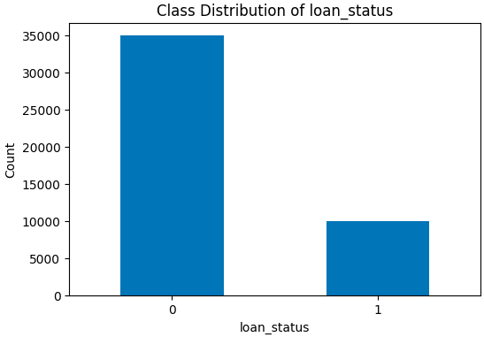
Approval rates were almost the same between the genders, with the females at 22.25% (4,485 out of 20,159) and the males at 22.20% (5,515 out of 24,841). This is a very small difference of 0.05 percent, indicating that there is not much difference between genders on a raw basis.
Figure. 2. Loan Approval Rate by Gender
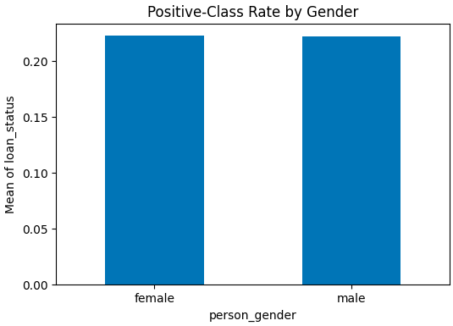
Correlation analysis showed that loan percent income, credit score, and pre-existing loan defaults were most correlated with the target variable, which means that they are crucial in determining whether a loan is approved or not. There was also outlier detection by the use of the IQR that helped to identify extreme values of the variables, especially age and income. Such outliers were left to maintain realistic variation in the data.
Figure. 3. Correlation Heatmap of Numerical Features
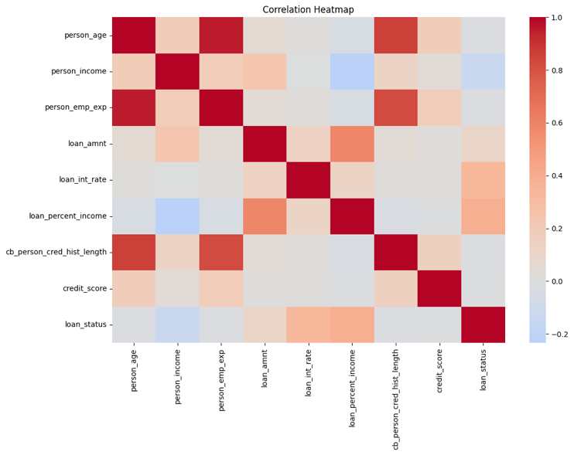
In addition, the histograms of the income distribution were highly right-skewed with a maximum income of $7.2 million as compared to the mean of 80,000. This was what made the use of logarithmic transformation a way of normalizing data so that the model performance can be enhanced.

Feature Engineering
Four domain-informed features were engineered, and the number of features in the feature matrix was increased to 17 columns. Each of the engineered features is described in Table II.
TABLE II. ENGINEERED FEATURES

Engineered Feature | Type | Definition and Rationale
log_income | Numeric | np.log1p(person_income) —  reduces right skew in income;  stabilizes variance for linear  models
high_debt_ratio | Binary | 1 if loan_percent_income > 0.30 —  flags excessive debt burden per  standard underwriting  thresholds
employment_stability | Binary | 1 if person_emp_exp > 5 years —  captures long-term employment as  a proxy for income security
credit_score_category | Ordinal | FICO bands: poor (<580),  fair (580–670), good (670–740),  excellent (>740) — captures  nonlinear credit risk

The thresholds used for credit score categorization follow standard FICO score ranges. The 30% high-debt ratio is in line with the traditional debt-to-income ratios commonly employed in the underwriting of consumer lending and borrowing. Logarithmic transformation is applied to income to address skewness and improve model performance. The binary features (high debt ratio, employment stability) are coded as numeric in the pipeline they are scaled using StandardScaler.

- Methodology
This study evaluates multiple machine learning models for loan approval prediction using a structured tabular dataset. The experimental pipeline was designed in two stages. First, baseline models were trained using default hyperparameters to establish an initial benchmark. Second, hyperparameter tuning was performed to improve model performance and compare optimized models against their baseline counterparts. The implemented models were Logistic Regression, Decision Tree, Random Forest, and Gradient Boosting, selected to represent linear, non-linear, and ensemble-based learning approaches.

A unified preprocessing pipeline was applied using scikit-learn Pipeline and ColumnTransformer to ensure fair comparison across all models.
Numerical features were processed using mean imputation followed by standardization with StandardScaler. Categorical features were processed using mode imputation followed by one-hot encoding with handle_unknown='ignore'. All preprocessing steps were fitted only on the training data during training and cross-validation to prevent data leakage and ensure consistent transformations across models.

Feature engineering was performed to improve representation quality and better capture financially meaningful patterns in the data. Four engineered features were added: log_income, high_debt_ratio, employment_stability, and credit_score_category. These features were motivated by exploratory data analysis and prior studies in credit scoring and loan approval. They were designed to better represent skewed income values, financial burden, employment consistency, and grouped creditworthiness levels that may not be fully captured by the raw variables alone.

The evaluation protocol used an 80/20 train-test split with stratification on the target variable. Cross-validation for baseline evaluation and hyperparameter tuning was performed only on the training data using 5-fold Stratified Cross-Validation, while the held-out test set was reserved for final evaluation. Model performance was assessed using Accuracy, Precision, Recall, F1-score, and ROC-AUC. Because the dataset is imbalanced, F1-score and ROC-AUC were emphasized. In addition to predictive performance, fairness across gender groups was assessed using Demographic Parity Difference (DPD), Disparate Impact Ratio (DIR), and Equal Opportunity Difference (EOD).

To improve performance beyond the baseline settings, hyperparameter tuning was conducted using GridSearchCV with 5-fold Stratified Cross-Validation. The best hyperparameter configuration for each model was selected based on F1-score. The final tuned configurations are summarized in Table III.

TABLE III. Best Tuned Hyperparameter Configuration
Model | Best Hyperparameter
Logistic Regression | C=10, solver =liblinear
Decision Tree | max_depth = 10, min_samples_leaf = 1, min_samples_split = 2
Random Forest | max_depth = None, min_samples_leaf = 1, min_samples_split = 2, n_estimators = 100
Gradient Boosting | learning_rate = 0.1, max_depth = 5, n_estimators = 200

- Experimental Results

Baseline Results

The baseline evaluation showed that Random Forest achieved the strongest overall predictive performance among the untuned models. The baseline results are summarized in Table IV.

TABLE IV. Baseline Model Performance
Model | Accuracy | F1-score | ROC-AUC
Logistic Regression | 0.903 | 0.778 | 0.957
Decision Tree | 0.898 | 0.772 | 0.855
Random Forest | 0.930 | 0.831 | 0.976
Gradient Boosting | 0.923 | 0.810 | 0.970

These results indicate that ensemble methods outperform the simpler baselines on this structured financial dataset.

Five-fold cross-validation on the training data confirmed this pattern. The mean baseline F1-scores are shown in Table V.

TABLE V. CROSS-VALIDATION RESULTS
Model | Average F1-score
Logistic Regression | 0.7679
Decision Tree | 0.7793
Random Forest | 0.8269
Gradient Boosting | 0.8147

Random Forest remained the strongest baseline model under repeated resampling, while Gradient Boosting also showed consistently strong performance.

Hyperparameter Tuning Results
Hyperparameter tuning improved model selection by identifying stronger configurations for each classifier. The best cross-validation F1-scores achieved after tuning are shown in Table VI.

TABLE VI. Hyperparameter Tuning Result
Model | Average F1-score
Logistic Regression | 0.767957
Decision Tree | 0.801193
Random Forest | 0.826872
Gradient Boosting | 0.837957
Among all tuned models, Gradient Boosting achieved the highest cross-validation F1-score, followed by Random Forest, Decision Tree, and Logistic Regression. These results indicate that ensemble methods remained the most effective family of models after tuning.

C. Tuned Model Performance
The tuned test-set results showed additional performance gains. The tuned model results are summarized in Table VII.
TABLE VII. Tuned Model Performance
Model | Accuracy | F1-score | ROC-AUC
Logistic Regression | 0.9031 | 0.7781 | 0.9575
Decision Tree | 0.9198 | 0.8038 | 0.9573
Random Forest | 0.9300 | 0.8309 | 0.9756
Gradient Boosting | 0.9366 | 0.8477 | 0.9787

These findings confirm that Gradient Boosting is the strongest final model, while Random Forest remains a highly competitive alternative.
A direct comparison before and after tuning showed that the strongest improvements were observed for the ensemble methods, particularly Gradient Boosting and Random Forest. The gains were most visible in F1-score, indicating improved balance between precision and recall after tuning.

D. Error Analysis
Detailed classification reports and confusion matrices showed that all models performed better on class 0 than on class 1, which is expected given the class imbalance in the dataset. The minority class remained more difficult to predict across all models. Among the tuned models, Gradient Boosting achieved the strongest class-1 performance, with precision 0.91, recall 0.79, and F1-score
0.85. Its confusion matrix also showed the lowest number of false negatives (411), compared with 471 for Logistic Regression, 521 for Decision Tree, and 452 for Random Forest. This indicates a stronger ability to correctly identify minority-class positive cases. These findings confirm that class imbalance remains a central challenge, but tuned ensemble methods handle it better than the simpler models.
The class 1 precision, recall, and F1-score for the tuned models are summarized in Table VIII.

TABLE VIII. Class 1 Performance for Tuned Models
Model | Class 1 Precision | Class 1 Recall | Class 1 F1-score
Logistic Regression | 0.79 | 0.76 | 0.78
Decision Tree | 0.88 | 0.74 | 0.80
Random Forest | 0.90 | 0.77 | 0.83
Gradient Boosting | 0.91 | 0.79 | 0.85

These results further confirm that tuned ensemble methods are better able to handle minority-class prediction than the simpler models.

E. Fairness Evaluation
Fairness evaluation across gender groups showed very low disparity across all models. Demographic Parity Difference and Equal Opportunity Difference were close to zero, while Disparate Impact Ratio remained close to one.
Logistic Regression showed the most balanced fairness profile, while Random Forest and Gradient Boosting provided stronger predictive performance with only slightly larger disparity values that still remained low overall. Since the dataset is synthetic, these results should be interpreted as evidence of model behavior under controlled conditions rather than as direct evidence of real-world lending discrimination. The fairness results are summarized in Table
IX.
TABLE IX. FAIRNESS RESULTS
Model | Demographic Parity Difference (DPD) | Disparate Impact Ratio (DIR) | Equal Opportunity Difference (EOD)
Logistic Regression | 0.000150 | 1.000699 | 0.002103
Decision Tree | 0.007194 | 0.968515 | 0.000031
Random Forest | 0.002511 | 0.986983 | 0.006123
Gradient Boosting | 0.005812 | 0.970142 | 0.008965

- Discussion
The results demonstrate that structured financial datasets benefit strongly from ensemble learning methods. Even at the baseline stage, Random Forest and Gradient Boosting outperformed Logistic Regression and Decision Tree, and hyperparameter tuning further strengthened this pattern.
After tuning, Gradient Boosting emerged as the best overall model, while Random Forest remained a strong alternative. This suggests that flexible ensemble methods are better able to capture the complex relationships present in loan approval data.
Class imbalance had a clear influence on performance. All models achieved stronger results on the majority class than on the minority class, and minority-class recall remained the most difficult aspect of prediction. This highlights why accuracy alone is insufficient and why F1-score and ROC-AUC provide a more informative evaluation. The stronger minority-class performance of Gradient Boosting suggests that tuning helped improve the balance between catching positive cases and avoiding misclassification.
The fairness findings are also important. All models showed only small gender-based disparities, indicating that high predictive performance can be achieved without introducing large fairness differences in this synthetic setting. Logistic Regression showed the most balanced fairness profile, while the stronger ensemble methods delivered better predictive accuracy with only slightly larger but still low disparity values. This suggests that performance and fairness were not strongly in conflict in the present dataset.
- Conclusion and Future Work
This study showed that feature engineering, unified preprocessing, baseline evaluation, and hyperparameter tuning together provide an effective framework for loan approval prediction. The engineered features improved data representation, while the preprocessing pipeline ensured fair comparison across models. Baseline evaluation identified Random Forest as the strongest initial model, and tuning later improved the overall results further. The final tuned evaluation identified Gradient Boosting as the best overall predictive model, with Random Forest remaining a strong alternative.
Fairness analysis showed only small differences across gender groups, suggesting limited evidence of gender bias in this synthetic dataset. At the same time, the results highlight the importance of evaluating both predictive performance and fairness together when designing machine learning systems for financial decision-making.
For future work, this study can be extended by evaluating additional models and fairness-mitigation techniques, including pre-processing, in-processing, and post-processing methods. Calibration analysis across gender groups could also be added to strengthen fairness evaluation. Finally, applying the same framework to real-world loan approval datasets would allow stronger conclusions about fairness in practical financial systems.
- Code Availability
The full implementation, dataset, and reproducible pipeline are available at: https://github.com/Layanx1/ML-loan-approval-fairness-project

References
[1] H. G. T. Thu, T. V. Doan, and T. L. Quy, "An Experimental Study on Fairness-Aware Machine Learning for Credit Scoring Problem," arXiv:2412.20298, 2024.
[2] Y. Chen et al., "Measuring Fairness in Credit Ratings," Expert Systems with Applications, vol. 258, pp. 125184, 2024.
[3] Z. Liu et al., "Are Credit Scores Gender-Neutral? Evidence of Mis-Calibration from Alternative and Traditional Borrowing Data," Journal of Behavioral and Experimental Finance, vol. 47, pp. 101081, 2025.

[4] S. K. Abbas, "Lending by Algorithm: Fair or Flawed? An Information-Theoretic View of Credit Decision Pipelines," SN Computer Science, vol. 6, art. no. 679, 2025.
[5] W. Oluoch and A. L. Alhassan, "Bridging the gender credit gap in low-income countries: The impact of digital financial inclusion," Emerging Markets Review, vol. 70, p. 101389, 2025.
[6] H. Ayari, R. Guetari, and N. Kraiem, "Machine learning powered financial credit scoring: a systematic literature review," Artificial Intelligence Review, vol. 59, art. no. 13, 2025.

