**Summary**

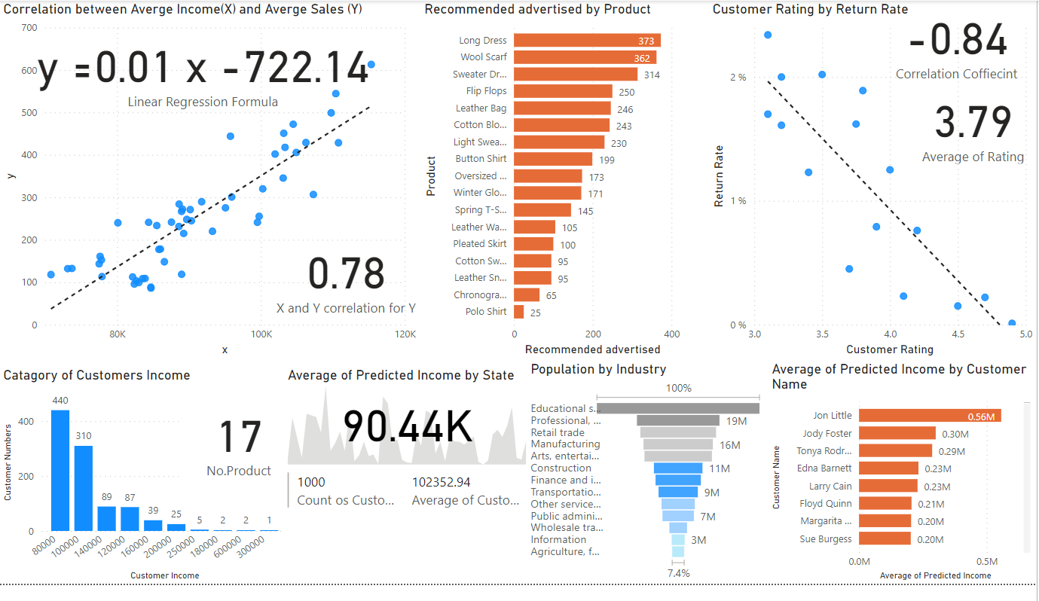

-Analyzed 1000 customers

- There are 17 products

-Average of Range Income equal to 102352.94

-Jhon Little has the highest average income over customers.

-Average predicted income by state equal to 90.44K

-The correlation between sales and income is 0.78

- The linear regression formula is y=0.01 x-722.14

- More than 400 customers have 8K income, 1 customer has 30K

- Industries which have more populations are: Education services, health care and social assistance, less populations are: Agriculture, forestry, fishing and hunting, mining.

- The most product advertised is Long dress, and the lowest advertised is polo shirt.

-The correlation between customer rating and product return rate is

-0.84

-Average Customer rating is 3.79