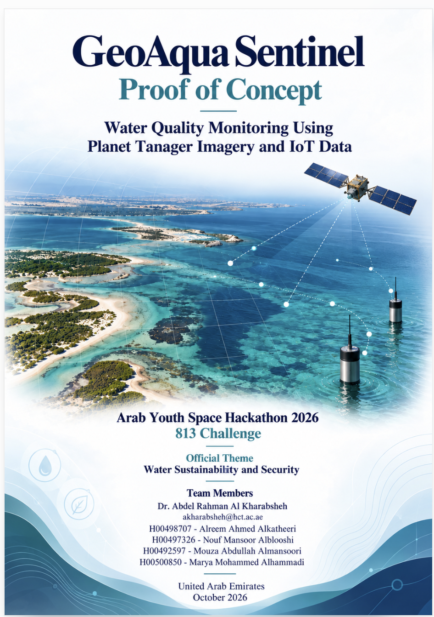

Table of Contents
Business use case 3
PROBLEM STATEMENT 6
TECHNICAL APPROACH AND METHODOLOGY 9
Installation 10
How to Run 11
EXAMPLE INPUT AND OUTPUT 12
RESULTS AND LIMITATIONS 13
TEAM, LICENCE AND ATTRIBUTION 16

Business use case
PROJECT OVERVIEW
GeoAqua Sentinel combines satellite-derived water indicators with simulated sensor observations for real-world decision making in monitoring coastal water.
The proof of concept is in the Tarif coastline area near Al Dhafra, Abu Dhabi. The workflow consists of procedures for the processing of Planet Tanager hyperspectral imaging, data filtering to remove invalid pixel values (e.g. negatives), NDWI calculation for water identification (Gao et al., 1996), NDCI calculation as a chlorophyll indicator (Liu et al., 2013), and a relative turbidity indicator.
The IoT component that replicated pH, turbidity, temperature, total dissolved solids and water flow used 5050 recordings. Sensor Reading in= {Normal / Abnormal} (Random Forest Model)
This procedure combines the sensor categorization with satellite indicator summaries. An inspection alert is generated if the sensor category is Abnormal or if any of the satellite indicators have surpassed the demonstration threshold. Dashboard with maps of satellite indicators, example sensor values and AI classification
This demonstration is now operated with synthetic sensor data and single satellite scene. The mile results may not reflect field performance or absolute water safety. Future work will calibrate and validate against genuine sensor measurements taken at the same locations and times.
PROOF OF CONCEPT ACHIEVEMENT
Planet Tanager hyperspectral imagery processing:
• Masking image quality
• Water identification NDWI
• Calculation of relative chlorophyll indicator by NDCI
• Determination of relative turbidity index
• Generation and analysis of 500 simulated IoT sensor logs
• Sensor reading classification as Normal/Abnormal (Random Forest)
• Satellite indicators and sensor classification at the decision level
• Satellite maps and sensor results visualized on dashboard
• Inspection alerts generation based on demonstration thresholds and AI classification
INNOVATION AND VALUE
GeoAqua Sentinel brings together satellite data and simulated sensor readings in a decision support system. Satellite images give a view of the coastal area being studied. At the time simulated sensor data shows what local water measurements might look like.
The Proof of Concept uses summaries from satellite indicators and AI classification to send out inspection alerts. On the dashboard users can see satellite maps, sample sensor values and the AI results all in one place.
The key benefits are:
- Screening water using hyperspectral satellite imagery
- Analyzing 500 simulated water monitoring records
- Using AI to classify sensor readings as Normal or Abnormal
- Combining satellite indicators with sensor classification at the decision level
- Creating inspection alerts
- A single dashboard that shows satellite indicator maps, example sensor measurements and AI classification
In the future real sensors will be connected. There will also be explanations, for alerts and a way to prioritize inspections.
BUSINESS USE CASE AND TARGET USERS
Who are the users?
GeoAqua Sentinel is designed for organizations that manage water monitoring and conduct field investigations. These include:
· monitoring and regulatory teams
· Municipal and coastal management authorities
· Ports and industrial coastal facilities
· Water utilities
· Environmental research and field sampling teams
What decision do they make?
Users decide whether a given observation needs verification, an on-site inspection or additional water sampling. Now the proof of concept generates an inspection alert when the sensor classification shows Abnormal or when either satellite indicator goes above its demonstration threshold. The current workflow does not assign priority levels. Automatically pick inspection locations. For instance a reading with pH 6.7 turbidity 25 NTU, temperature 35 °C, TDS 48,000 mg/L and flow 20 L/min gets an Abnormal classification and triggers an inspection alert.
What do users use today?
Coastal water monitoring relies on methods:
· Field sampling
· Laboratory water analysis
· Local monitoring sensors
· Satellite observations
· Manual review of monitoring results
Field samples and local sensors give data at specific points. Satellite observations provide spatial coverage across the coastal zone. Teams compare conditions using these sources and plan their next steps in their investigations.
How does GeoAqua Sentinel support them?
GeoAqua Sentinel brings together satellite indicator maps, simulated sensor measurements and AI classification in one interface. It shows satellite-based indicators for water quality, chlorophyll levels and relative turbidity. The AI model classifies simulated sensor readings, as either Normal or Abnormal. These outputs combine to produce an inspection alert.
Currently the demonstration uses scene summaries and synthetic readings without station coordinates or timestamps. In versions the system will integrate real measurements matched to satellite locations and acquisition times to help guide field sampling decisions more effectively.
POTENTIAL OPERATIONAL VALUE
With real sensor integration and field validation, GeoAqua Sentinel aims to:
• Support coastal area review before selecting sampling locations
• Identify observations requiring further investigation
• Support verification of abnormal sensor readings
• Bring satellite indicators, sensor measurements, and AI results into one interface
• Add alert explanations and recommended follow up actions
• Support inspection and field sampling planning
CURRENT LIMITATION AND NEXT STAGE
GeoAqua Sentinel is using made-up data, from sensors right now. The proof of concept shows how the system works and how it can help make decisions. It is not meant to take the place of lab tests or official water quality checks.
The next step is to use sensor data and compare it with Planet Tanager observations from the same places and times. This data will help adjust the system check it in the field and see how satellite data matches water measurements.

PROBLEM STATEMENT
Coastal water monitoring needs information at both big scales. Field sampling and sensors give data at certain spots but there are spaces between the monitoring points. These spaces make it hard to understand the conditions in a coastal area just using local data.
For our Proof of Concept this issue is looked at in the Tarif area in Al Dhafra, Abu Dhabi. Monitoring a coastal area using just a few sampling points takes a lot of field work and gives limited coverage.

Satellite imagery helps with this problem by giving wide area views from one image. Planet Tanager hyperspectral imagery lets GeoAqua Sentinel create a water mask a chlorophyll measure using NDCI and a relative turbidity measure across the area. These maps help in screening and point the way for more research.

Satellite data also has limits, like clouds, when the image is taken and the need for calibration. GeoAqua Sentinel therefore looks at combining satellite data with sensor data to help with field monitoring.

The current Proof of Concept uses Planet Tanager imagery and 500 simulated sensor records to show the analysis and alert process. Real sensor data, from the places and times is needed for local calibration and field checking.

DATA SOURCES
The GeoAqua Sentinel PoC uses two main data sources: real Planet Tanager hyperspectral imagery and a simulated IoT sensor dataset.
Satellite Data
Information | Details
Product Name | Planet Tanager Hyperspectral Surface Reflectance Imagery
Provider | Planet Labs PBC
Study Area | Tarif coastal area, Al Dhafra, Abu Dhabi, UAE
Acquisition Date | 11 May 2025
Acquisition Time | 07:43:11 UTC
Scene Identifier | 20250511_074311_00_4001
Processing Level | The notebook selects ortho_sr_hdf5 when available, otherwise basic_sr_hdf5.
Spectral Bands | Not independently verified from the scene metadata
Licence | The source notebook states CC BY 4.0, © Planet Labs PBC. Confirm the applicable scene terms before redistributing imagery or derived outputs.
The Planet Tanager scene provides hyperspectral surface reflectance data for the study area. Before analysis, the workflow masks cloud, cirrus, and missing data pixels. Negative reflectance values are excluded from indicator calculations.
The processed imagery supports water detection using NDWI, relative chlorophyll analysis using NDCI, and calculation of a relative turbidity indicator. These indicators support spatial comparisons within the scene. They do not represent calibrated chlorophyll concentrations or turbidity measurements in NTU.
Simulated IoT Data
Information | Details
Dataset Name | GeoAqua_Synthetic_IoT_Data.csv
Provider | GeoAqua Sentinel team
Data Type | Synthetic IoT sensor data
Acquisition Date | Not applicable. The notebook generates simulated records using random seed 42.
Number of Records | 500
Normal Records | 250
Abnormal Records | 250
Random Seed | 42
Processing Level | Synthetic tabular dataset prepared for model training and testing
Licence | No separate public dataset licence specified in the supplied project materials

The dataset contains five variables:
• pH, dimensionless.
• Turbidity, NTU.
• Temperature, °C.
• Total dissolved solids, TDS, mg/L.
• Water flow, L/min.
These units describe the simulated values. The records do not represent measurements collected from deployed sensors. The simulated TDS ranges are representative of saline water.
The dataset is used by the team to train and test a Random Forest classifier. The ranges for generation are different in the normal and abnormal classes, which makes classification easier. The performance exhibited by these records is not evidence of accuracy in actual coastal conditions.
Relationship Between the Data Sources
The Planet Tanager scene contains real satellite observations. The IoT dataset contains simulated sensor records without station coordinates or measurement timestamps.
The current PoC therefore combines satellite indicators and sensor classification results through decision rules. The workflow does not match individual sensor records with specific satellite pixels or acquisition times.
Future validation requires real sensor measurements with recorded coordinates and timestamps. Collecting these measurements near satellite acquisition times will support local calibration and direct comparison between satellite indicators and field measurements.

TECHNICAL APPROACH AND METHODOLOGY
Satellite Processing
The workflow starts with loading of Planet Tanager surface reflectance imagery. It then applies quality masks to remove pixels affected by clouds, cirrus clouds and missing data . Negative reflectance values are excluded from all indicator calculations to ensure results.

The notebook selects bands that are closest to the wavelengths of 560, 665 708 and 860 nanometres. To identify water areas, it uses the Normalized Difference Water Index (NDWI) which relies on the 560 nm and 860 nm bands. A pixel is considered a water candidate if the NDWI value is greater than 0.10.
For chlorophyll estimation the Normalized Difference Chlorophyll Index (NDCI) is calculated using the 708 nm and 665 nm bands. A relative turbidity indicator is derived from the normalized difference between the 665 nm and 560 nm bands. These outputs are indicators, not absolute measurements of chlorophyll concentration or turbidity in NTU units. To convert these values into real-world measurements local field data must be used for calibration.

AI Assisted Sensor Classification

The notebook generates 500 sensor records with the random seed set to 42. This data set has 250 records labelled as Normal and 250 as Abnormal. The five input features for Random Forest classifier are pH, turbidity, temperature, total dissolved solids and water flow.
It is a stratified split, with 400 records for training and 100 for testing. The model is set to 100 trees, depth 5 and the same random seed of 42. Evaluation metrics include accuracy, precision, recall, F1 score and a confusion matrix. The simulated classes are generated with ranges, so the evaluation is valid within the synthetic dataset. These results do not reflect how the model would perform on sensor data.

Decision Level Combination
The workflow computes percentile of NDCI and relative turbidity indicator for all candidate water pixels. The rule for decision triggers an alert “Water inspection required”, if any of the following conditions apply:
· NDCI summary is greater than 0.20.
· The relative turbidity summary exceeds 0.10.
· The AI classifier labels the sensor record, as Abnormal.

If none of these conditions are met, the workflow reports conditions based on the demonstration rule.
The satellite thresholds used here are demonstration parameters only. They are not limits or safety thresholds. Local calibration and field validation are essential before this system can be used operationally.
The synthetic sensor records do not include coordinates or timestamps. As a result, the workflow combines the analysis outputs using decision rules without matching sensor records to satellite pixels.
Dashboard Output
The current dashboard shows the NDCI map, the turbidity map, example sensor values and the AI classification result. The notebook also prints a combined inspection alert separately.
Future development plans include adding alert reasons, recommended actions and three decision levels: Verification Required and Priority Inspection. This will help with awareness and decision making.
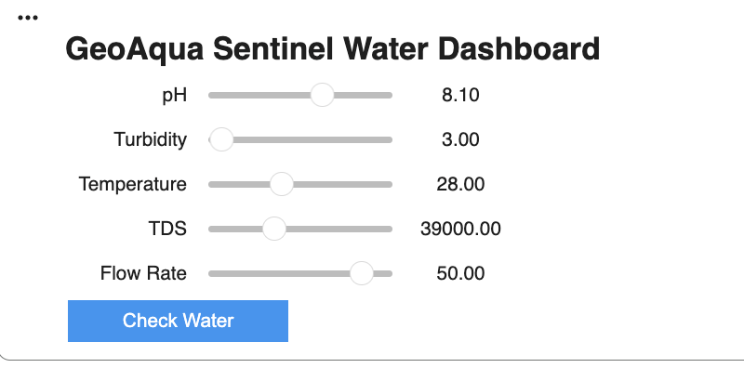
Figure 2. Interactive PoC interface for entering simulated pH, turbidity, temperature, TDS, and water flow values before running the Random Forest classification.

Installation
GeoAqua Sentinel runs in Google Colab. The repository contains the notebook GeoAqua_Sentinel_PoC.ipynb and a requirements.txt file with pinned dependency versions. Internet access is necessary to install dependencies and to download satellite imagery. No GPU is required.
Google Colab Setup
Open Google Colab at https://colab.research.google.com.
Select File, then Upload notebook. Upload GeoAqua_Sentinel_PoC.ipynb downloaded from the repository.
Open the Files panel on the left and upload requirements.txt.
Add a code cell at the beginning of the notebook and run:
%pip install -r requirements.txt
After installation finishes, select Runtime, then Restart session.
Run the notebook cells in order. The notebook downloads the selected Planet Tanager scene, processes the imagery, generates the simulated sensor dataset, trains the Random Forest model, and displays the analysis outputs.
Python Version
To check the Python version used for your run, execute:
Importsys
print(sys.version)
Record the displayed version in your README alongside your tested environment.

How to Run
Main notebook: GeoAqua_Sentinel_PoC.ipynb.
Restart the notebook and execute all the cells from top to bottom.The workflow downloads and processes the Planet Tanager scene, calculates the satellite indicators, creates the synthetic IoT dataset, trains and tests the Random Forest model, evaluates the demonstration case and outputs the combined dashboard.
Files required to run
Notebook: GeoAqua_Sentinel_PoC.ipynb
Dependency file: requirements.txt
Files generated during the run
Sensor dataset: GeoAqua_Synthetic_IoT_Data.csv
Dashboard image: GeoAqua_Sentinel_Dashboard.png
What to edit
No code changes are required for the PoC example provided. Keep file paths relative.
For an interactive test, alter the five sensor inputs: pH, turbidity, temperature, TDS, and water flow. Press Check Water to show the classification.
Keep the supplied satellite thresholds unchanged when reproducing the demonstration.
Expected runtime and final outputs
Runtime varies with satellite download speed and the computing environment.
At the end, the notebook displays the Random Forest evaluation, interactive sensor controls, satellite NDCI and relative turbidity summaries, AI classification, inspection alert, and combined dashboard.

EXAMPLE INPUT AND OUTPUT
Input File Example
Sample input file is GeoAqua_Synthetic_IoT_Data.csv Dataset contains 500 simulated IoT sensor records, containing 250 Normal and 250 Abnormal records. There are five input variables for each record:
• pH • Turbidity, NTU • Temperature, C • Total dissolved solids, TDS, mg / L • Flow of water, L/min
The data set used is synthetic and is used to develop and test the Random Forest classification workflow. The records are not measurements collected from deployed field sensors.
Example Input
The demonstration uses the following simulated sensor reading:
· pH: 6.7
· Turbidity: 25 NTU
· Temperature: 35 °C
· TDS: 48,000 mg/L
· Water flow: 20 L/min
The Random Forest classified this example as Abnormal.
Example Output
The resulting output is displayed in the GeoAqua Sentinel Combined Monitoring Dashboard. The dashboard presents the satellite algal bloom indicator, satellite turbidity indicator, example sensor measurements, and AI classification together.

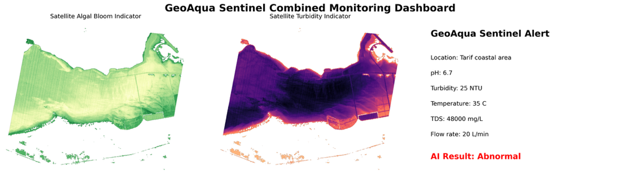
Figure 3. GeoAqua Sentinel Combined Monitoring Dashboard showing relative satellite indicators and a simulated sensor example classified as Abnormal.

Satellite summary measurements were below their demonstration thresholds. Meanwhile the Random Forest model classified the simulated example of the sensor as Abnormal. The PoC decision rule is: if the classification is abnormal, then the alert is “Water inspection required”. The alert shows how the workflow is going. This does not confirm a water quality problem.

RESULTS AND LIMITATIONS
What We Measured
The PoC evaluated the performance of the Random Forest classifier using accuracy, precision, recall, F1 score and confusion matrix.
The model correctly classified all 100 synthetic test records as follows:
• 50 Normal records correctly identified
• 50 Incorrectly classified abnormal records
• Precision: 100%
• Accuracy: 100%
• Recall: 1.0
• F1 score: 1.00 for both classes
These results show successful classification of held out synthetic test records. The class generation ranges are different, so the task is easier so the scores do not set field performance.
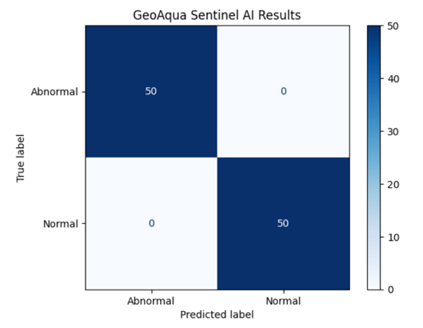
Figure 4. Random Forest confusion matrix for the 100 synthetic test records, 50 correctly classified Normal and 50 correctly classified Abnormal records.

Results from Satellites
Usable scene coverage and relative optical indicators were also included in the satellite analysis.
After filtering out Cirrus, Missing Data and Invalid Pixels, Cloud:
• Valid pixels in scene: 38.6%
• 95 percentile NDCI: ~0.009
• Relative turbidity indicator (95th percentile): ~ -0.169
• NDCI threshold for demonstration: 0.20
• Relative Turbidity Threshold achieved: 0.10
Both satellite indicators were under their demonstration thresholds. These values are relative optical indicators for a single Planet Tanager scene. These are not laboratory-measured chlorophyll or turbidity concentrations and they do not confirm safe water conditions.
How We Validated the Proof of Concept?
The Random Forest was trained and tested with the 500 simulated cases. The dataset was divided into 400 training records and 100 test records. The model is fed with pH, turbidity, temperature, TDS and flow as input variables.
The model evaluation was done based on accuracy, precision, recall, F1 score and confusion matrix. The example abnormal sensor reading and satellite indicator summaries were also tested with the combined workflow.
So, the current validation confirms the PoC workflow works on the synthetic data. It does not deliver real field performance.
Current Limitations and Where the Workflow Fails
- The 500 sensor records are synthetic, not real measurements from deployed sensors.
- It clearly separates several Normal and Abnormal generation ranges, making classification easier. 100% test accuracy does not guaranty performance on real sensor measurements.
- ·Sensor recordings do not contain station coordinates and measurement times. The workflow does not associate individual records to specific satellite pixels or acquisition times.
- The satellite analysis is based on one single Planet Tanager acquisition. Need more dates and environmental conditions to evaluate consistency.
- Cloud cover and missing data limit the satellite coverage that can be used and create gaps in the analysis.
- NDCI and the turbidity product are optical relative indicators. These indicators must be calibrated against physical concentrations with field measurements.
- The NDCI threshold of 0.20 and relative turbidity threshold of 0.10 are demonstration parameters. These values are not limits for regulation or for water safety.
- The inspection alert shows a decision support rule. The workflow does not diagnose the cause of an abnormal reading or certify water safety.
- Field validation requires calibrated sensor measurements with coordinates and timestamps close to the time of satellite acquisition. Different dates of observation should be used to assess the performance under different conditions.

TEAM, LICENCE AND ATTRIBUTION
GeoAqua Sentinel was developed for the Arab Youth Space Hackathon 2026, 813 Challenge. The project was completed by a four student team under faculty mentorship.
Team Members and Roles
Team Member | Student ID | Role / Contribution
Alreem Ahmed Alkatheeri | H00498707 | Earth Observation and satellite data analysis
Nouf Mansoor Alblooshi | H00497326 | PoC notebook development, Google Colab implementation, and technical integration
Mouza Abdullah Almansoori | H00492597 | Study area analysis, project documentation, and Tarif coastal area context
Marya Mohammed Alhammadi | H00500850 | IoT sensor data, synthetic dataset development, and water monitoring variables
Dr. Abdel Rahman Al Kharabsheh | Faculty Mentor | Project guidance and technical review

Licence and Data Attribution
Resource | Provider / Creator | Licence / Attribution
Planet Tanager hyperspectral surface reflectance imagery | Planet Labs PBC | CC BY 4.0, as recorded in the scene metadata
Original educational notebook | Dr. Vincent Markiet, Space42 | Original educational notebook for the Arab Youth Space Hackathon 813 Challenge, adapted for the GeoAqua Sentinel PoC
GeoAqua Synthetic IoT Dataset | GeoAqua Sentinel team | Team generated synthetic dataset. No separate public dataset licence is specified in the supplied project materials
GeoAqua Sentinel adaptations | GeoAqua Sentinel team | Developed and adapted for the GeoAqua Sentinel PoC

Satellite Data Attribution
The PoC uses hyperspectral surface reflectance imagery from Planet Tanager of Planet Labs, PBC. The selected scene is the Tarif coastal area in Abu Dhabi’s Al Dhafra. Scene ID: 20250511_074311_00_4001 Acquisition Date: 11 May 2025 The source notebook acknowledges the imagery as CC BY 4.0, © Planet Labs PBC.
Notebook Attribution
The GeoAqua Sentinel PoC is based on an educational notebook by Dr. Vincent Markiet, Space42, for the Arab Youth Space Hackathon 813 Challenge. The team modified the notebook to fit the GeoAqua Sentinel workflow, and kept credit to the original author.
Synthetic Dataset Attribution
The team produced GeoAqua_Synthetic_IoT_Data.csv in the course of PoC development and testing. The dataset contains 500 simulated sensor records. These records are not measurements taken from deployed field sensors.

Project Licence Status
The project material does not mention a separate public licence for the team’s code or the synthetic IoT dataset. By default, the satellite imagery licence does not apply to these project materials.
Attribution Statement
GeoAqua Sentinel was created for the Arab Youth Space Hackathon 2026, Challenge 813. The PoC makes use of Planet Tanager imagery from Planet Labs PBC and maintains the attribution of source notebook, CC BY 4.0, © Planet Labs PBC. The workflow is based on educational material credited to Dr. Vincent Markiet, Space42. The synthetic sensor dataset was produced by the GeoAqua Sentinel team and the project adaptations were developed by them.
End of Document

