Framed by : Anass BALCAID

Made by:

Nouhaila HAFIDI Ayman BADDOU

Homework 3 : MAIN APPLICATION

# INTRODUCTION :

Qt Designer

Qt Designer is a Qt tool for creating and constructing Qt Widget-based graphical user interfaces (GUIs). You can use a what-you-see-is-what-you-get (WYSIWYG) approach to design and configure your windows or dialogs, and test them in a wide range of styles .

Major objectives :

## Create a MainWindow based application using the designer.

# SpreadSheet :

### **Context:**

The spreadsheet needs to contain the following elements, in order to start:

* Menu Bar
* Two tools bars
* Status bar to print the informations

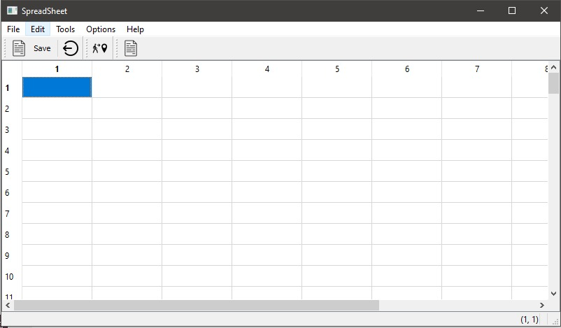The final result must look like this:

**The spreadsheet associates two functions, which are represented by two primary classes:**

* **Gocell**
* **Finddialog**

**Gocell:**

Now we'll add the goCell action function. To do so, we'll need to develop a Dialog that allows the user to choose a cell.

This can be done by :

**gocell.h:**

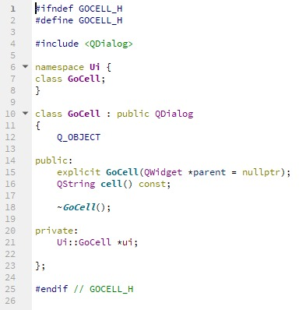

**gocell.cpp :**

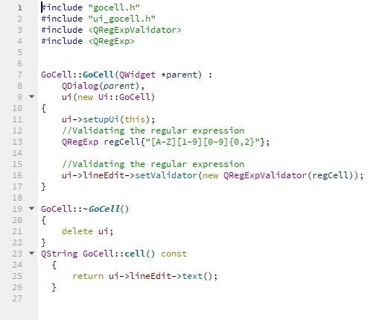

**Finddialog:**

We'll proceed to the Find dialog next. This dialog asks the user for an input and then searches for a cell that contains the entered text.

We need:

**finddialog.h**

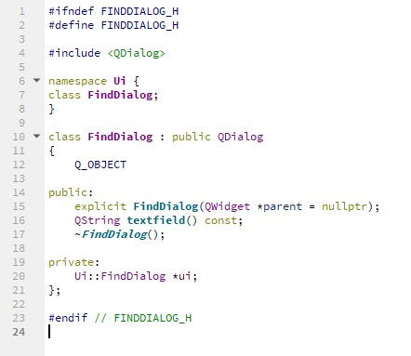

**finddialog.cpp**

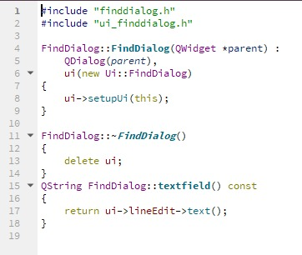

**The output of this step:**

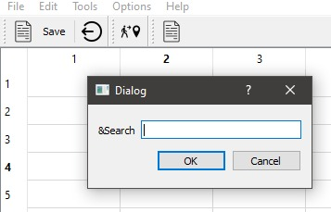

**Spreadsheet:**

here comes the role of the spreadsheet that will connect the entirety of the slots and connexions.

This will be done by:

**Spreadsheet.h :**

The initiation of all the methods and functions utilized will be found in the spreadsheet.h

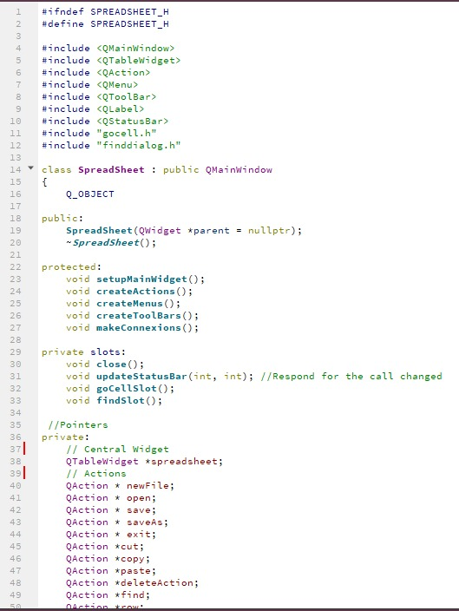

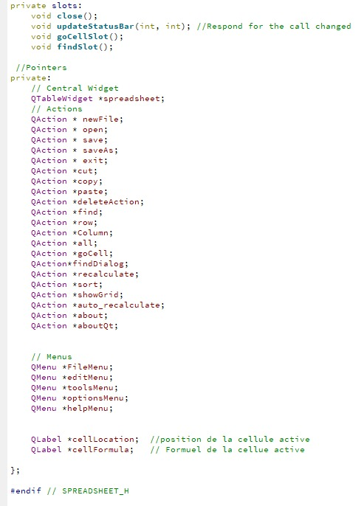

**Spreadsheet.cpp:**

Here we will find the implementation of the fonctions we used :

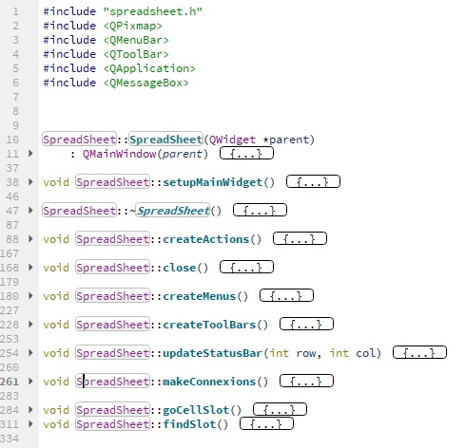

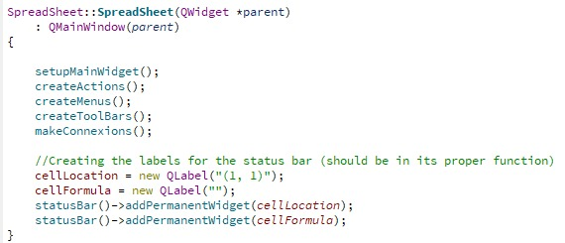Some of the major fonctions we used:

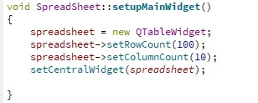

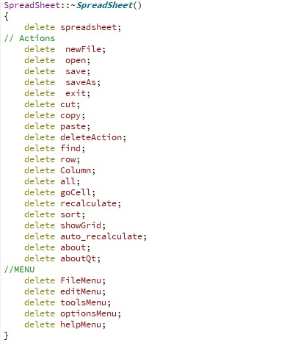

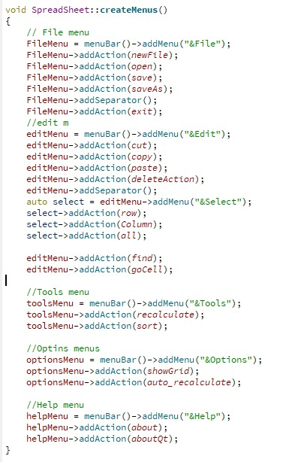

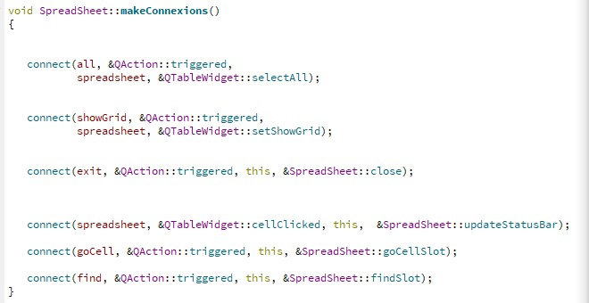now we will add the connexions in the makeconnexion function:

**Saving and loading files :**

For our final task, we will save the content of our spreadsheet in a simple format.

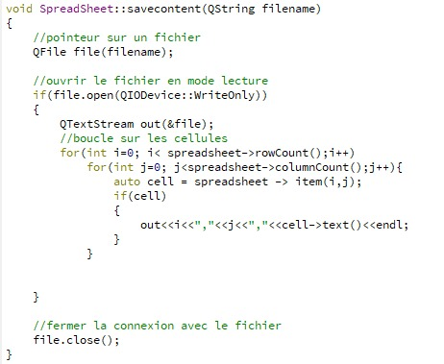

# 

# Text editor :

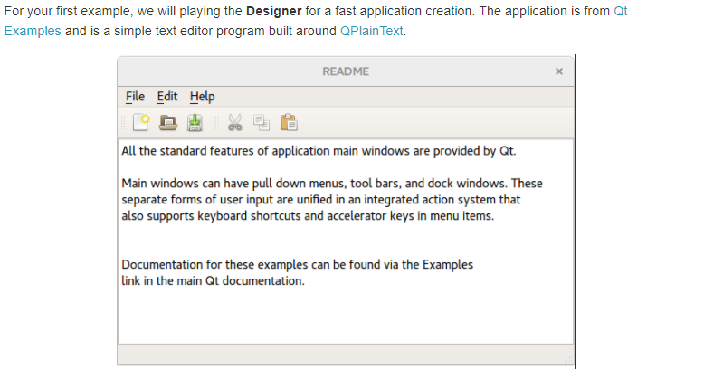

After creating the project.

Choosing a QT Widgets Application.

Naming our project WordText

Inheriting now from **QMainWindow**.

Choosing all the remaining default choices.

We choose some icons :

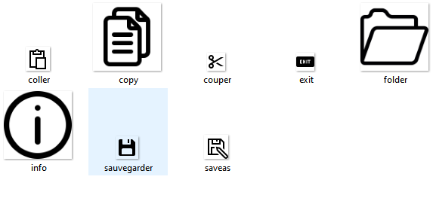

We add it in the menus and make some actions:

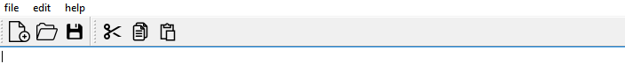

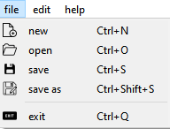 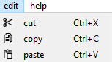

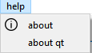

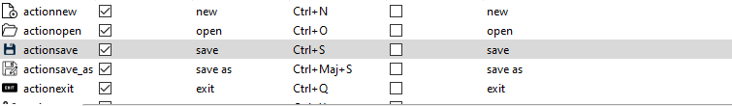

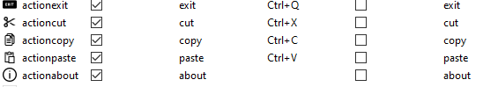

Our out put

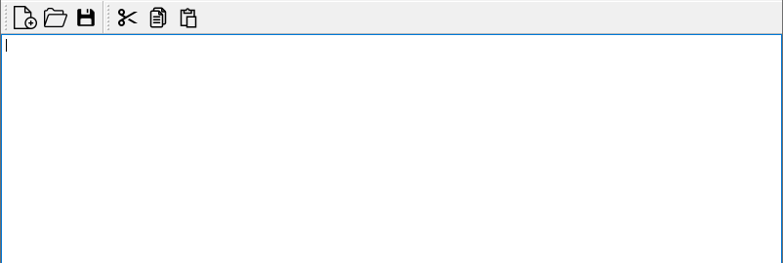

Some functionality

Open :

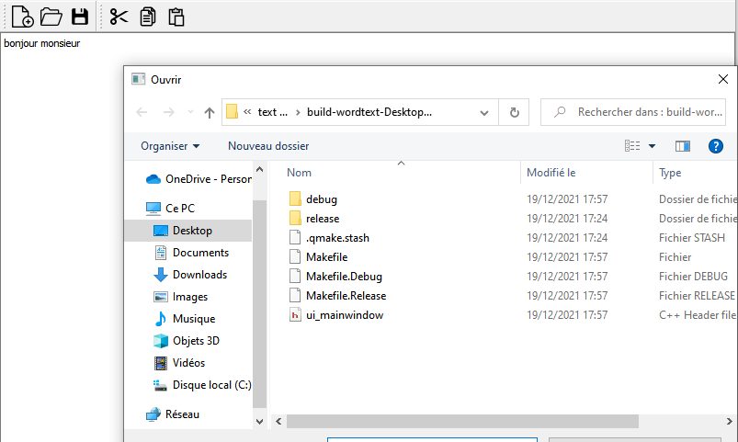

If u don’t choose a file:

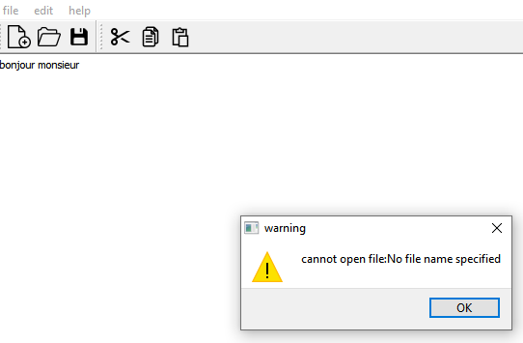

Save:

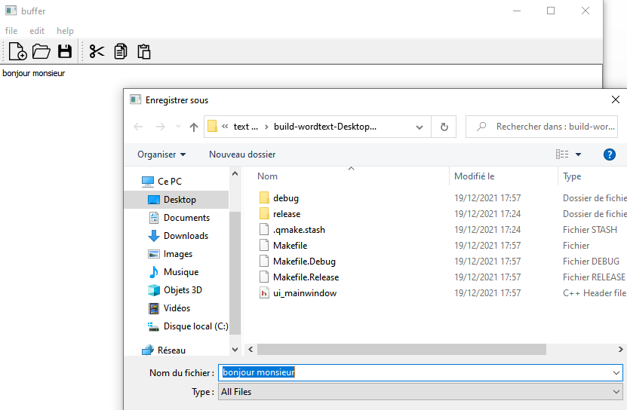

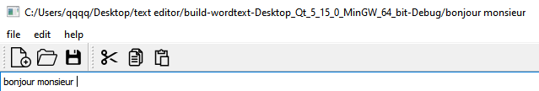

copy cut paste with shortcut

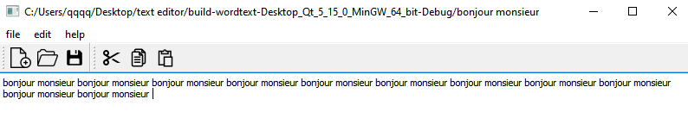

Thank you for your time, and effort put in the classes, in order to improve our knowledge.