|  |  |
| --- | --- |
| AIN SHAMS UNIVERSITYFACULTY OF ENGINEERINGi-CREDIT HOURS ENGINEERING PROGRAMS *Computer Engineering and Software Systems Program* |  |

|  |  |
| --- | --- |
| ***Spring 2021*** | **Course Code: *CSE 439*** |
| **Design of Compilers** | |

**Scanner Project**

Submitted by

|  |  |  |
| --- | --- | --- |
|  | **Name** | **ID** |
| **1** | **Abdel-Rahman Ibrahim Megahed** | **18P7423** |
| **2** | **Hana Yasser Amgad ElSokkary** | **18P5007** |
| **3** | **Maryam Ahmed Galal Nouh** | **18P2824** |
| **4** | **Seif Ahmed Elsayed Elewa** | **18P5662** |
| **5** | **Youssef Mohamed Mostafa Mansi** | **18P5848** |

**Project Snapshots:**

Scan Result:

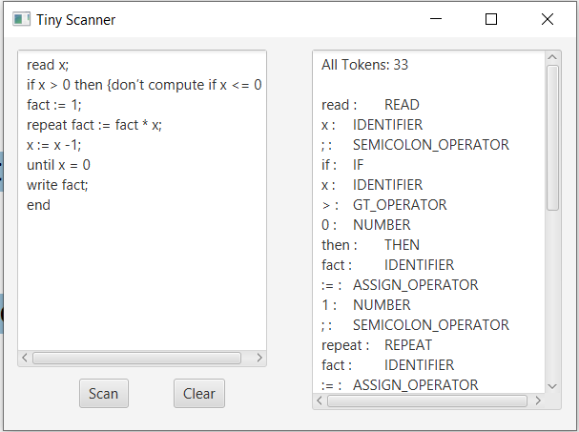

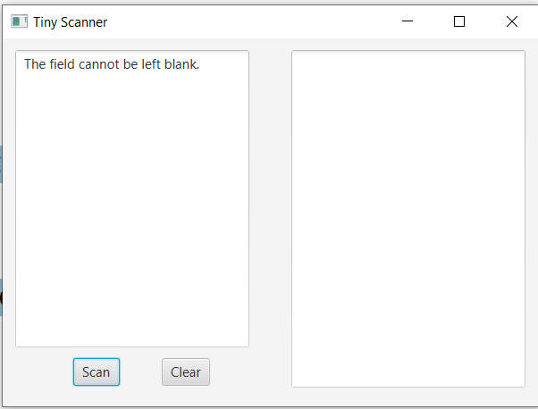Pressing Scan while field is empty:

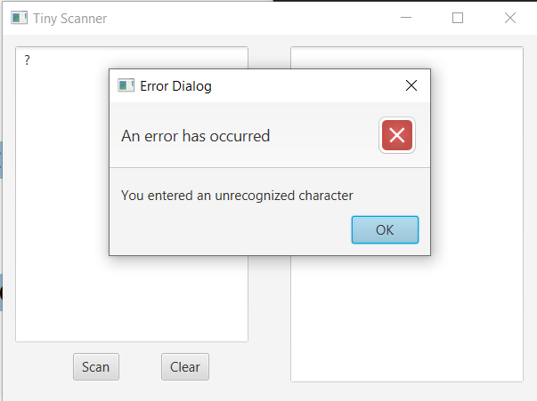Entering an invalid character: