ANStat
Easyline
DESIGN DOCUMENT
Easyline
Secure mobile QR-ticketing and notification-driven boarding platform for urban and intercity transport in Cote d'Ivoire
Capstone thesis: « Gbaka process restructuration design: a new protocol concept that improves business aspects »
Project information
Field | Value
Student | NOUHR TRAORE
Internship supervisor | Mr Ange-Eric
Host organization | ANStat
Academic advisor | Dr. Bayomock
Field | Software Engineering (Bachelor of Science in Computer Science)
Internship period | 18 May 2026 — 21 August 2026 (≈ 14 weeks)
Document version | 2.0 — June 2026
Preliminary design document, to be validated with the advisor before implementation.

Table of Contents
1. Overview 3
1.1. Context 3
1.2. Objective 3
1.3. Actors 3
1.4. Core functional scope 3
1.5. Out of scope (this version) 4
2. Functional requirements 4
2.1. User (passenger) — RF-U 4
2.2. Agent — RF-AG 5
2.3. Director — RF-DIR 5
2.4. Admin — RF-AD (via Django admin) 6
2.5. Cross-cutting (system) — RF-T 6
3. Non-functional requirements 7
4. UML diagrams 8
4.1. Use-case overview 8
4.2. Class-model overview 9
4.3. Sequence flows 10
5. Database schema 14
5.1. Entity-relationship overview 14
5.2. Table descriptions 14
6. Software architecture 19
6.1. Overview (three-tier) 19
6.2. Technical choices and rationale 19
6.3. Demo deployment topology 20
6.4. Deliberately discarded choices 20
7. Required APIs 20
7.1. Authentication (public) 20
7.2. User profile 20
7.3. Lines, stations and checkpoints (authenticated read) 21
7.4. Tickets (user) 21
7.5. Agent (role = agent) 21
7.6. Director (role = director) 21
7.7. Administration (Django admin) 22
7.8. Payment webhooks (public, signed) 22
7.9. Standardized error codes 22
8. Risks and technical challenges 22
9. Future improvements 24
9.1. Short term (V1.1) 24
9.2. Medium term (V2) 24
9.3. Long term (V3+) 24
10. Appendix — assumptions and conventions 24
10.1. Explicit assumptions (to validate with the advisor) 24
10.2. Conventions 25
10.3. Explicit out-of-scope of the V1 design 25

1. Overview

1.1. Context
In Ivorian road stations (Adjame, Yopougon, Cocody, Abobo, Bassam, etc.), passengers pay for their trip before boarding, which produces long physical queues, lost places in the rain, and no visibility over vehicle assignment. Easyline dematerializes ticket purchase and reorganizes boarding through mobile notifications, without disrupting the existing syndicate structures: the syndicate remains the only operator authorized to scan and board.

1.2. Objective
Provide a smooth experience between passengers and transport syndicates while giving the administration an aggregated view of urban and intercity traffic. Operational responsibilities are split between the syndicate director (administration of the syndicate) and the agent (field operations); the overall administration is handled through the Django admin console.

1.3. Actors
Actor | Where | Role
User (passenger) | Mobile app | Buys tickets, displays the QR to board, cancels a ticket (auto-refund), views history and statistics.
Agent | Mobile app | Pre-authorized by the director. Scans tickets, binds passengers to a vehicle, manages the boarding list, marks absentees. No access to passenger personal data in history.
Director | Mobile app | Pre-registered by the admin. Registers agents and vehicles, assigns agents to lines, views statistics per vehicle and per agent (max 2 directors per syndicate).
Admin | Django admin | Pre-registers syndicates and directors, assigns syndicates to stations, manages lines, checkpoints and tariffs, views aggregated urban traffic, exports CSV.
Note. A single mobile application exposes three role-conditioned interfaces (RBAC): user, agent, director. The admin has no mobile interface and acts exclusively through Django admin. Drivers are not users; a driver is an optional attribute of a vehicle.

1.4. Core functional scope
- Dematerialized ticket purchase (Orange Money, MTN Money, Wave; sandbox / mock).
- Electronic ticket with a unique HMAC-signed, single-use QR token.
- Boarding validation by agent scan.
- Ticket cancellation by the user with automatic refund and removal from the line's queue.
- Interactive map (OpenStreetMap) to browse lines and their origin stations.
- Two-level push notifications: payment confirmation, vehicle ready to board, imminent expiry.
- Invisible per-line FIFO queue that triggers notifications when a vehicle opens boarding.
- Unified authentication by phone: OTP on first connection, then a 5-digit PIN.
- Director dashboards (statistics per vehicle and per agent); admin dashboard (aggregated traffic) in Django admin.

1.5. Out of scope (this version)
- Boarding at an intermediate checkpoint (always at the origin station).
- Real-time vehicle geolocation.
- Group tickets (> 2), deferred / scheduled purchase.
- Automatic re-notification after a boarding window expires (deferred to V1.1).
- Real Mobile Money production integration (sandbox only in V1) and real SMS sending (OTP simulated in development).
- iOS application (cannot be built on Windows) and offline scan mode.
- Passenger-visible queue position; multilingual UI (French only in V1).

2. Functional requirements
Numbering convention: RF-X-NN where X is the actor (U: user, AG: agent, DIR: director, AD: admin, T: cross-cutting).

2.1. User (passenger) — RF-U
ID | Requirement
RF-U-01 | Create an account via phone number, verified by an OTP sent by SMS on the first connection (SMS simulated in development).
RF-U-02 | After phone verification, set a 5-digit PIN; subsequent logins use phone + PIN.
RF-U-03 | Browse available lines (origin station, destination, price).
RF-U-04 | View a line's details, including the ordered list of checkpoints.
RF-U-05 | Buy 1 to 2 tickets for a given line in a single transaction.
RF-U-06 | Pay via Orange Money, MTN Money or Wave (sandbox / mock).
RF-U-07 | After successful payment, receive an electronic ticket carrying a unique HMAC-signed QR token.
RF-U-08 | An unscanned ticket remains valid for 30 days after purchase.
RF-U-09 | View the list of active tickets (unused, not expired).
RF-U-10 | View the full history of tickets (used, expired, cancelled, active) and payments.
RF-U-11 | Cancel an active ticket that has not yet been invited to board nor scanned; the system issues an automatic refund and removes the ticket from the line's FIFO queue.
RF-U-12 | After the ticket is scanned, see the assigned vehicle information (plate, syndicate).
RF-U-13 | Hold at most 2 active tickets simultaneously.
RF-U-14 | View the origin stations of available lines on an interactive map (OpenStreetMap).
RF-U-15 | On selecting a line, see the route between checkpoints (ordered polyline).
RF-U-16 | Optionally display own position on the map (with consent).
RF-U-17 | Receive a push notification on payment confirmation.
RF-U-18 | Receive a « vehicle ready » push (come now, 2-minute window, vehicle plate) when among the first C passengers in the queue for a line where a vehicle of capacity C has just opened boarding.
RF-U-19 | Receive a « get ready » push when among the next C passengers (positions C+1 to 2C); informative, no expiry window.
RF-U-20 | Receive a push 24 h before an unused ticket expires.
RF-U-21 | When the ticket is marked absent by an agent, receive a push: the ticket remains valid but has been moved to the back of the line.
RF-U-22 | View personal statistics: trips taken, amount spent, most-used lines.
RF-U-23 | Request account deletion and personal data export.

2.2. Agent — RF-AG
ID | Requirement
RF-AG-01 | Finalize registration with first/last name, phone and syndicate name, after pre-authorization by the director; authenticate by OTP (first time) then PIN.
RF-AG-02 | Activate « Ready to scan » mode.
RF-AG-03 | In scan mode, select an existing vehicle (autocomplete by plate) or create one; the vehicle is dynamically attached to the agent's assigned line for the session.
RF-AG-04 | Scan a passenger's QR via the camera.
RF-AG-05 | On scan, verify: HMAC signature valid, ticket exists, unused, not expired, cancelled, and belongs to the session's line.
RF-AG-06 | After a valid scan, the ticket becomes used and is bound to the active vehicle; it can never be reused.
RF-AG-07 | Explicitly reject a scan for an already-used, expired, cancelled or unknown ticket, with a clear message.
RF-AG-08 | View the boarding list of passengers currently invited to the vehicle, each with first name only (never last name), original queue position, invitation time, individual 2-minute countdown.
RF-AG-09 | Mark a passenger absent: (a) removes them from the active list; (b) does not consume the ticket (stays valid and active); (c) returns the ticket to the back of the queue; (d) triggers automatic promotion of the next passenger.
RF-AG-10 | The list refreshes automatically (HTTP polling) after each scan, mark-absent or promotion; no manual refresh is required.
RF-AG-11 | View the history of vehicles whose passengers the agent scanned, without access to any passenger personal data.

2.3. Director — RF-DIR
ID | Requirement
RF-DIR-01 | Log in by phone + PIN (OTP on first connection); the account is pre-registered by the admin (syndicate name, phone, email).
RF-DIR-02 | Pre-authorize (register) an agent of the syndicate by first name + phone.
RF-DIR-03 | Suspend or reactivate an agent.
RF-DIR-04 | Register a vehicle in the syndicate fleet (plate number, optional label, optional capacity).
RF-DIR-05 | Assign an agent to a line, so that any vehicle the agent loads is attached to that line.
RF-DIR-06 | View statistics per vehicle: revenue, trips, passengers; daily / weekly / monthly totals.
RF-DIR-07 | View statistics per agent: tickets scanned, activity, absence-marking rate.
Note. A syndicate has at most 2 directors. Urban-traffic data is never exposed to the director; it is reserved to the admin.

2.4. Admin — RF-AD (via Django admin)
ID | Requirement
RF-AD-01 | Pre-register a syndicate and its director(s) (organization name, phone, email).
RF-AD-02 | Suspend or reactivate a syndicate.
RF-AD-03 | Assign a syndicate to one or more stations (gares).
RF-AD-04 | Create, modify, delete a line and its checkpoints (with GPS coordinates).
RF-AD-05 | Set or modify a line's tariff.
RF-AD-06 | View the number of passengers carried per line, per period.
RF-AD-07 | View aggregated transaction volume across all syndicates.
RF-AD-08 | Export urban traffic data (CSV).

2.5. Cross-cutting (system) — RF-T
ID | Requirement
RF-T-01 | Each ticket has a unique, non-guessable code (UUID v4); the QR payload is an HMAC-signed, single-use token over that code.
RF-T-02 | Automatic transition active to expired 30 days after purchase (computed lazily at read time).
RF-T-03 | Log every scan (success and failure), cancellation, refund, mark-absent and boarding-list view in an audit log.
RF-T-04 | Reject concurrent scans on the same ticket (one scan wins) via a pessimistic lock.
RF-T-05 | OTP codes expire after 5 minutes, limited to 3 attempts; the PIN is limited in attempts with temporary lockout.
RF-T-06 | Maintain an invisible FIFO queue per line, ordered by ticket purchase date; internal, never shown in the UX.
RF-T-07 | When an agent opens scan mode for a vehicle of capacity C on line L, notify the first min(C, queue size) passengers in the queue (C = seats available at opening = vehicle capacity).
RF-T-08 | Each « vehicle ready » notification opens a 2-minute boarding window; afterwards it expires and the seat is freed.
RF-T-09 | A passenger whose notification expires keeps the original FIFO position (fairness) and becomes eligible for the next notification round.
RF-T-10 | Each user device registers its FCM token with the server to receive push notifications.
RF-T-11 | On scan-mode activation, up to C following passengers (positions C+1 to 2C) receive a « get ready » notification to pre-position near the station; purely informative, no time window.
RF-T-12 | For any vehicle in an active scan session, maintain the invariant invited passengers = remaining seats; as soon as a mark-absent frees an invitation slot, the next passenger in the queue is immediately notified and added to the list.
RF-T-13 | When a ticket is marked absent, its purchased_at (which determines FIFO position) is set to now() to move it to the back of the queue, while keeping status active.
RF-T-14 | Ticket cancellation is allowed only while status = active and the ticket is neither invited (within a boarding window) nor scanned; it sets status = cancelled, triggers an idempotent refund (payment to refunded) and removes the ticket from the queue.
RF-T-15 | After OTP phone verification, the PIN is hashed server-side (never stored in clear); login uses phone + PIN to issue JWT tokens.

3. Non-functional requirements
Category | Requirement
Security — Auth (OTP) | 6-digit OTP, hashed server-side; 5-minute expiry; max 3 attempts; rate limiting per number (max 5 requests/hour).
Security — Auth (PIN) | 5-digit PIN, hashed server-side, never stored in clear; rate limiting and temporary lockout after repeated failures.
Security — Sessions | JWT authentication (access token 1 h, refresh token 7 days); refresh rotation on each use.
Security — Transport | TLS mandatory in production; HSTS enabled. In demo via ngrok, TLS provided by ngrok.
Security — OWASP | Compliance with OWASP API Security Top 10 (2023) and OWASP MASVS: SQLi prevented by the ORM, strict input validation, object-level authorization (anti-IDOR), security headers.
Security — QR | The QR value authorizes nothing by itself: validation goes through the server API, which verifies the HMAC signature and the ticket state.
Security — RBAC | Role-based access control enforced at every endpoint via DRF permission classes (user / agent / director / admin).
Security — Data minimization | The agent only sees the first name of passengers currently invited to their own vehicle during an active session (last name never exposed); the agent history contains no passenger personal data; each list access is logged.
Performance | API response time < 300 ms for 95 % of requests under nominal load (one active agent ≈ 5 scans/min).
Availability | Demo target: available during the defense session; production: 99 % (indicative objective).
Scalability | Layered, stateless API allowing a move from single-machine to multi-machine without redesign (separate DB).
Mobile compatibility | Flutter targeting Android 8+; iOS in perspective (cannot be built on Windows).
Payment compatibility | Sandbox of the three providers (OM, MTN, Wave) in dev; real merchant accounts required in production.
Maintainability | Code thoroughly commented for line-by-line defense; unit tests on critical business rules (expiry, double-scan, 2-ticket limit, refund idempotency); JOURNAL.md; CI.
Usability | French UI; purchase flow in <= 4 screens; high legibility (transport, noisy environment).
Accessibility | WCAG AA contrast; adjustable font sizes (Flutter settings).
Localization | V1: French only. V2: Dioula, Baoule (see section 9).
Legal compliance | Compliance with Ivorian personal-data law (ARTCI): minimization, purpose limitation, limited retention.
Notifications | Push delivery via FCM; target latency < 5 s under normal network conditions; in-app fallback (polling) if push unavailable.
Mapping | OpenStreetMap tiles served per the Tile Usage Policy; local caching recommended to limit requests.
Geolocation | Passenger coordinates used only for local display; never sent to the server.

4. UML diagrams
The UML diagrams below (produced with PlantUML) are accompanied by a short textual summary so the design can also be reviewed in text form.

4.1. Use-case overview
User: verify phone (OTP), set/use PIN, browse lines (list + map), buy 1-2 tickets, pay, display QR, receive notifications, cancel ticket (refund), view history and statistics, delete account / export data.
Agent: finalize registration, log in (PIN), open/close scan mode, view boarding list, scan and board, mark absent (promote next), view scanned-vehicle history.
Director: log in (PIN), pre-authorize agents, register vehicles, assign agents to lines, view statistics per vehicle and per agent.
Admin (Django admin): pre-register syndicates and directors, assign syndicates to stations, manage lines/checkpoints/tariffs, view aggregated traffic, export CSV.
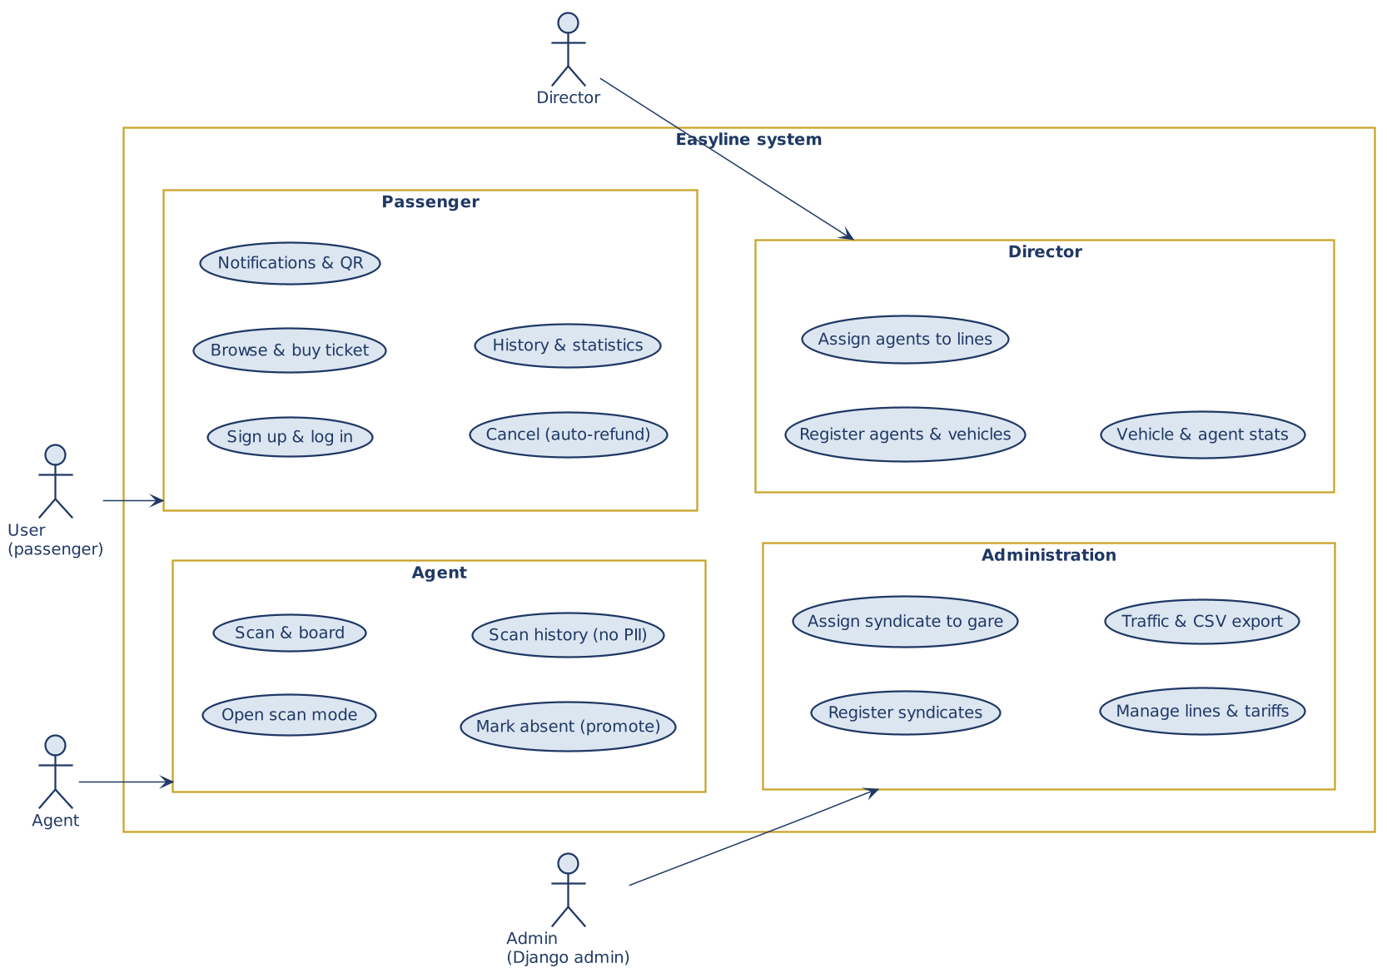
Figure 4.1 — Use case diagram

4.2. Class-model overview
Main entities and relationships: a User has one role; a Syndicate is registered by an admin and assigned to one or more Stations; a Director and several Agents belong to a Syndicate; an Agent is assigned to a Line; a Line departs from an origin Station and owns ordered Checkpoints; a Vehicle belongs to a Syndicate and is attached to a Line only during an active scan session; a Ticket links a passenger (User) to a Line and carries exactly one Payment; an OTP code and audit-log entries support authentication and traceability. The full attribute list is given in section 5.
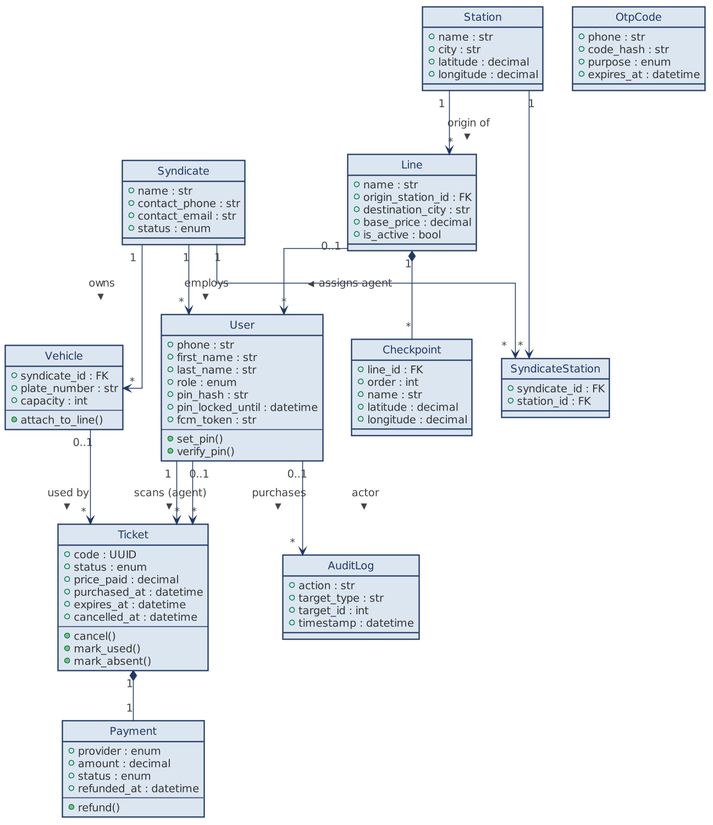
Figure 4.2 — Class diagram

4.3. Sequence flows
4.3.1. Ticket purchase
- User requests 1-2 tickets for a line (POST /tickets) -> server checks the 2 active-tickets limit (pessimistic lock).
- Server creates the ticket(s) with status active and an associated payment (status pending), and inserts each ticket into the line's FIFO queue (purchased_at).
- Payment is processed via the provider (sandbox/mock); on success the payment becomes success and a confirmation push is sent.
- The signed QR token is generated server-side and returned to the app.
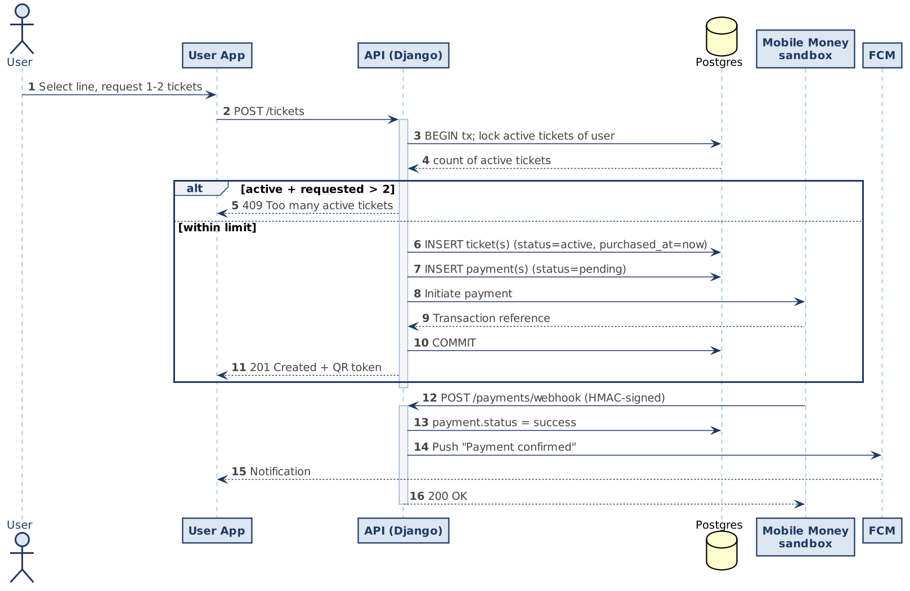
Figure 4.3 — Sequence: ticket purchase
4.3.2. Ticket cancellation with refund
- User requests cancellation (POST /tickets/{id}/cancel) within an atomic transaction (lock on the ticket).
- Server checks the ticket is active and neither invited (within a boarding window) nor scanned; otherwise it returns 409.
- Server sets status = cancelled, removes the ticket from the queue, and issues an idempotent refund (payment -> refunded).
- A confirmation is logged in audit_log; the user is notified.
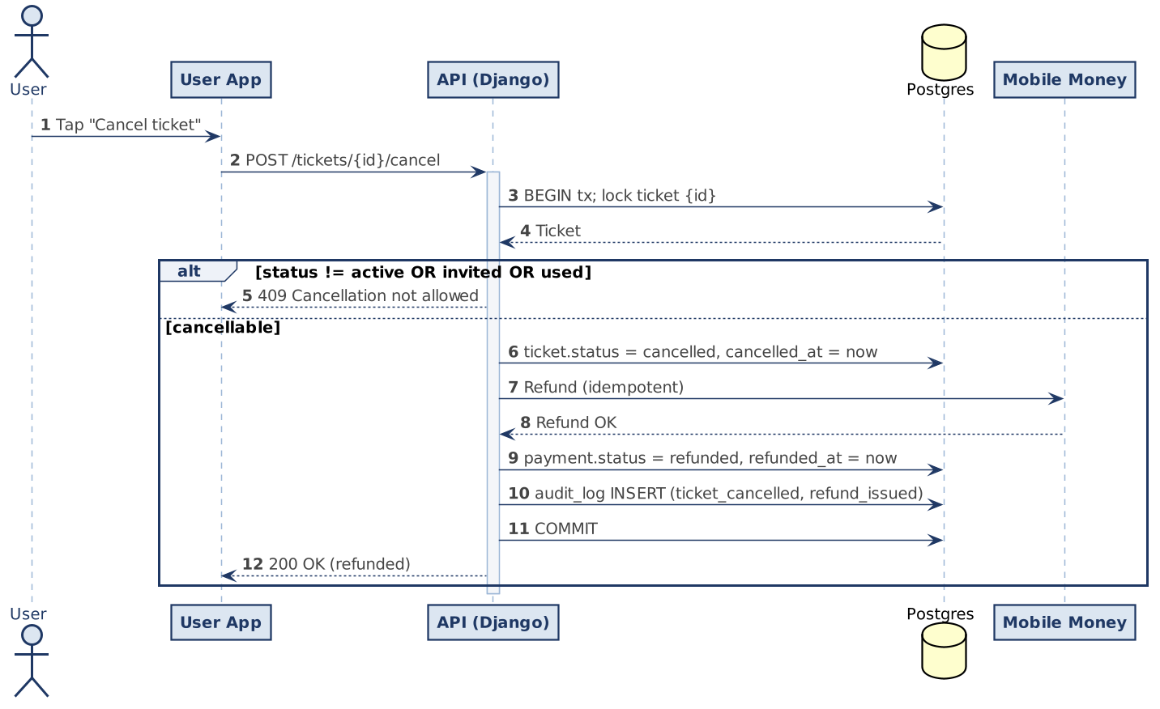
Figure 4.4 — Sequence: ticket cancellation with refund
4.3.3. Scan and boarding
- Agent scans the QR (POST /agent/scan) -> server verifies the HMAC signature and locks the ticket (SELECT FOR UPDATE).
- Server validates: exists, active/invited, not used/expired/cancelled, belongs to the session's line.
- On success: ticket -> used, bound to the active vehicle; the passenger receives the vehicle info; the event is logged.
- On failure: explicit rejection with a clear reason; the failed attempt is logged.
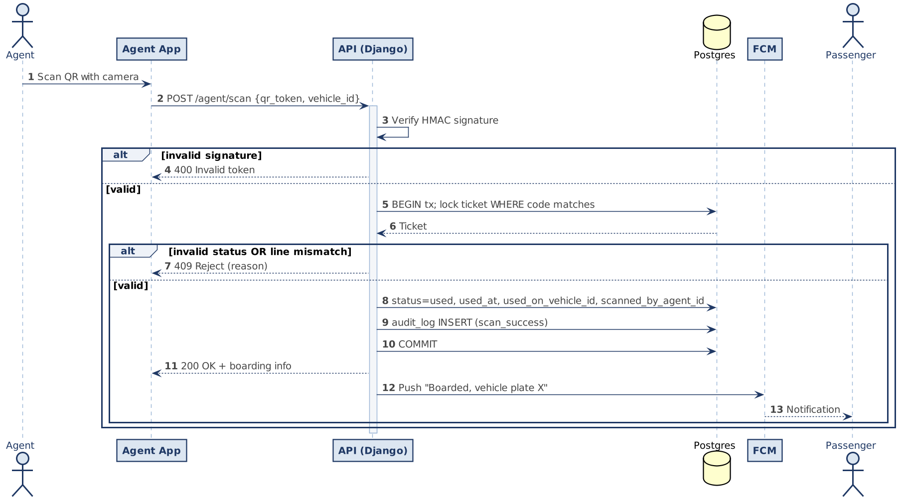
Figure 4.5 — Sequence: scan and boarding
4.3.4. Invisible FIFO queue and boarding notifications
- Agent opens scan mode for a vehicle of capacity C (POST /agent/scan-mode/open); the vehicle is attached to the agent's line.
- Server selects the first min(C, queue size) active tickets for the line (ordered by purchased_at) and sends them the « vehicle ready » push (2-minute window, plate).
- The next C passengers (C+1 to 2C) receive the informative « get ready » push.
- The boarding list is exposed to the agent (first name only) and refreshed by polling.
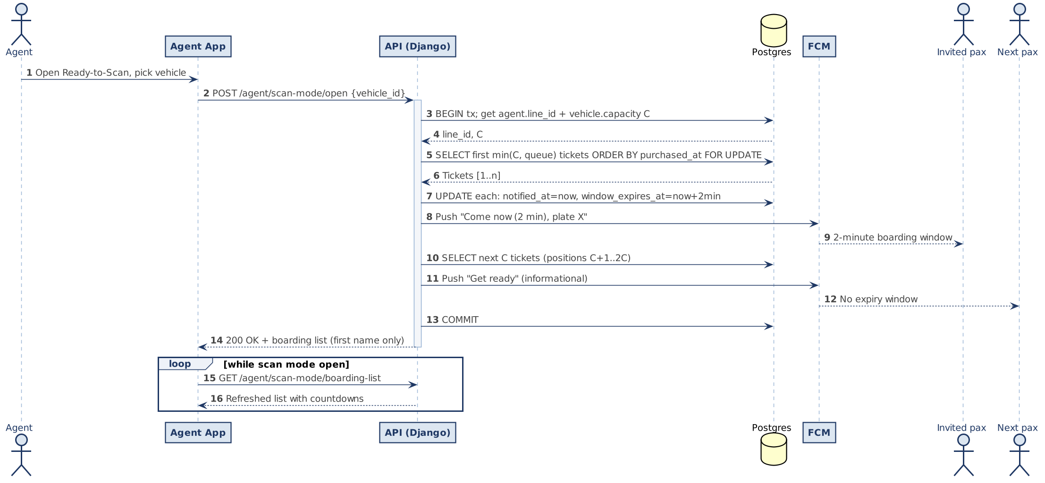
Figure 4.6 — Sequence: scan mode open (FIFO queue and two-level notifications)
4.3.5. Mark absent and automatic promotion
- Agent marks a passenger absent (POST /agent/scan-mode/mark-absent) within an atomic transaction.
- The ticket stays active; its purchased_at is set to now() (back of queue); the event is logged.
- The server immediately selects and notifies the next passenger in the queue, preserving the invariant invited = remaining seats.
- The refreshed boarding list is returned to the agent.
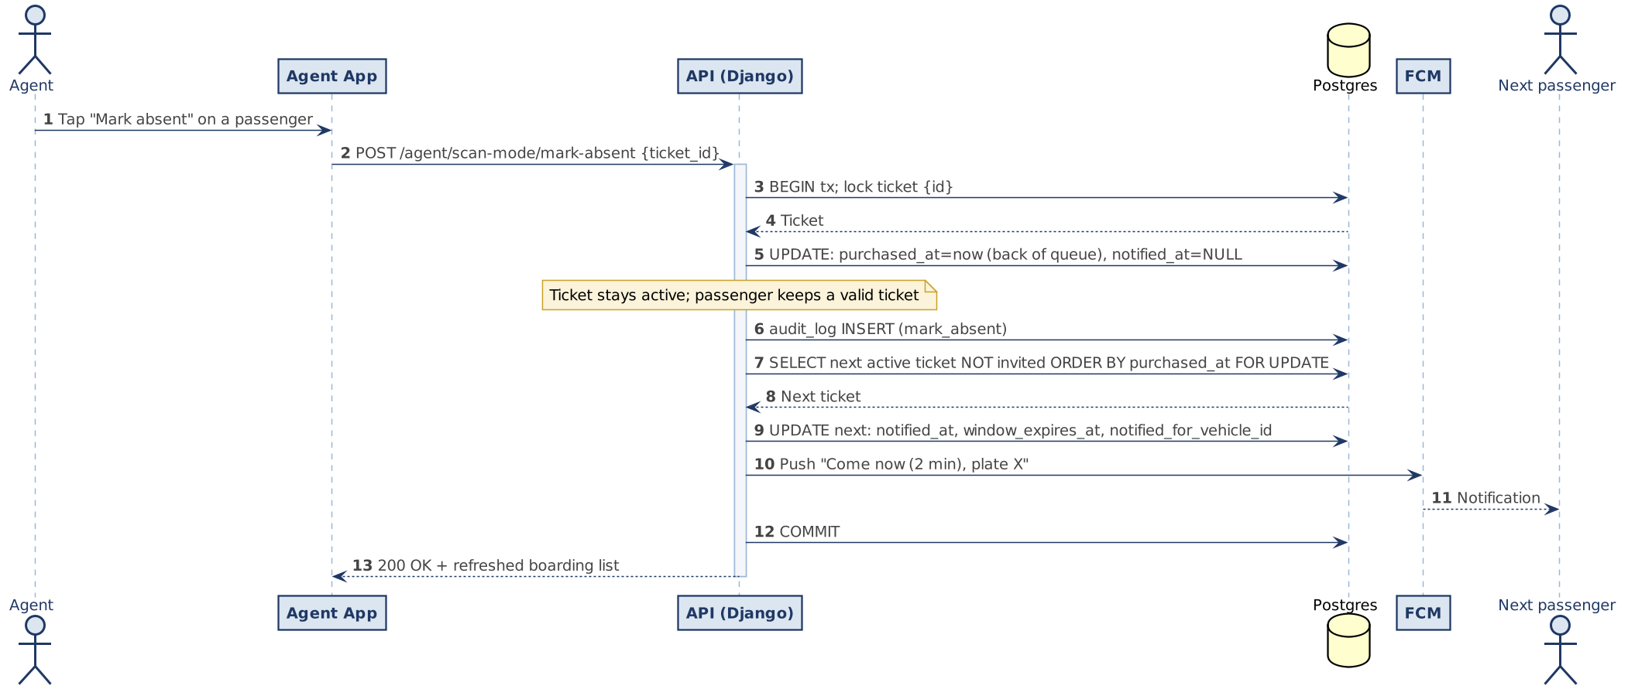
Figure 4.7 — Sequence: mark absent and automatic promotion

5. Database schema

5.1. Entity-relationship overview
Eleven tables. user holds authentication and role data (a passenger has no syndicate; an agent and a director reference a syndicate, and an agent also references its assigned line). syndicate is assigned to stations through syndicate_station. line departs from an origin station and owns ordered checkpoints. vehicle belongs to a syndicate. ticket references a passenger and a line and carries one payment. otp_code and audit_log support authentication and traceability.

5.2. Table descriptions
Table user
Field | Type | Constraints | Description
id | BIGSERIAL | PK | Internal identifier
phone | VARCHAR(20) | UNIQUE, NOT NULL, indexed | Number in +225XXXXXXXXXX format
first_name | VARCHAR(60) | NOT NULL | First name (used alone in the agent boarding list)
last_name | VARCHAR(120) | NOT NULL | Last name (never exposed to the agent)
role | VARCHAR(20) | NOT NULL, CHECK in {passenger, agent, director, admin} | Role
pin_hash | VARCHAR(128) | NULL | Hashed 5-digit PIN (set after OTP verification; never in clear)
pin_failed_attempts | INT | NOT NULL, DEFAULT 0 | Consecutive PIN failures
pin_locked_until | TIMESTAMP | NULL | Temporary lockout end after repeated failures
syndicate_id | BIGINT | FK -> syndicate(id), NULL | For agent and director
assigned_line_id | BIGINT | FK -> line(id), NULL | For agent (assigned by the director)
invited_by_id | BIGINT | FK -> user(id), NULL | Director who pre-authorized the agent
is_active | BOOLEAN | NOT NULL, DEFAULT TRUE | Active account
fcm_token | VARCHAR(255) | NULL | Firebase Cloud Messaging device token
date_joined | TIMESTAMP | NOT NULL, DEFAULT now() | Registration date
last_login | TIMESTAMP | NULL | Last login
Constraint. role in {agent, director} implies syndicate_id NOT NULL; a syndicate has at most 2 users with role = director.
Table syndicate
Field | Type | Constraints | Description
id | BIGSERIAL | PK
name | VARCHAR(200) | NOT NULL | E.g. « Syndicat des transporteurs d'Adjame »
contact_phone | VARCHAR(20) | NULL | Contact number
contact_email | VARCHAR(254) | NULL | Contact email (director)
registered_by | BIGINT | FK -> user(id), NOT NULL | Admin who pre-registered
registered_at | TIMESTAMP | NOT NULL, DEFAULT now()
status | VARCHAR(20) | NOT NULL, CHECK in {active, suspended}
Table station (gare)
Field | Type | Constraints | Description
id | BIGSERIAL | PK
name | VARCHAR(120) | NOT NULL, UNIQUE | E.g. « Gare d'Adjame »
city | VARCHAR(80) | NOT NULL
latitude | DECIMAL(9,6) | NULL | WGS 84, for the map
longitude | DECIMAL(9,6) | NULL | WGS 84, for the map
created_at | TIMESTAMP | NOT NULL, DEFAULT now()
Table syndicate_station
Field | Type | Constraints | Description
id | BIGSERIAL | PK
syndicate_id | BIGINT | FK -> syndicate(id), NOT NULL
station_id | BIGINT | FK -> station(id), NOT NULL | Assigned by the admin
Constraint. UNIQUE (syndicate_id, station_id).
Table line
Field | Type | Constraints | Description
id | BIGSERIAL | PK
name | VARCHAR(120) | NOT NULL, UNIQUE | E.g. « Adjame — Yopougon »
origin_station_id | BIGINT | FK -> station(id), NOT NULL | Origin station (boarding origin)
destination_city | VARCHAR(80) | NOT NULL
base_price | DECIMAL(10,2) | NOT NULL, CHECK >= 0 | In XOF
is_active | BOOLEAN | NOT NULL, DEFAULT TRUE
created_at | TIMESTAMP | NOT NULL, DEFAULT now()
Table checkpoint
Field | Type | Constraints | Description
id | BIGSERIAL | PK
line_id | BIGINT | FK -> line(id), NOT NULL
order | INT | NOT NULL | Position on the line (1, 2, 3...)
name | VARCHAR(120) | NOT NULL | Stop name
latitude | DECIMAL(9,6) | NULL | WGS 84, for the map
longitude | DECIMAL(9,6) | NULL | WGS 84, for the map
is_origin | BOOLEAN | NOT NULL, DEFAULT FALSE
is_destination | BOOLEAN | NOT NULL, DEFAULT FALSE
Constraint. Exactly one checkpoint per line has is_origin = TRUE (coinciding with the origin station) and exactly one has is_destination = TRUE.
Table vehicle
Field | Type | Constraints | Description
id | BIGSERIAL | PK
syndicate_id | BIGINT | FK -> syndicate(id), NOT NULL | Owning syndicate
plate_number | VARCHAR(20) | NOT NULL | Plate (e.g. « 2345 GB 01 »)
label | VARCHAR(80) | NULL | Optional description
capacity | INT | NOT NULL, DEFAULT 25 | Configurable, not hardcoded
created_at | TIMESTAMP | NOT NULL, DEFAULT now()
last_used_at | TIMESTAMP | NULL | For sorting by usage frequency
Constraint. UNIQUE (syndicate_id, plate_number). A vehicle is attached to a line only at scan time (the scan session carries the line).
Table ticket
Field | Type | Constraints | Description
id | BIGSERIAL | PK
code | UUID | NOT NULL, UNIQUE | Stable identifier signed inside the QR token
passenger_id | BIGINT | FK -> user(id), NOT NULL
line_id | BIGINT | FK -> line(id), NOT NULL
price_paid | DECIMAL(10,2) | NOT NULL | XOF
status | VARCHAR(20) | NOT NULL, CHECK in {active, used, expired, cancelled}
purchased_at | TIMESTAMP | NOT NULL, DEFAULT now() | Determines FIFO position
expires_at | TIMESTAMP | NOT NULL | purchased_at + 30 days
notified_at | TIMESTAMP | NULL | Time of the last « vehicle ready » notification
boarding_window_expires_at | TIMESTAMP | NULL | notified_at + 2 min
notified_for_vehicle_id | BIGINT | FK -> vehicle(id), NULL | Vehicle during the invitation window (reset after scan, expiry or absent)
used_at | TIMESTAMP | NULL
used_on_vehicle_id | BIGINT | FK -> vehicle(id), NULL | Set at scan
scanned_by_agent_id | BIGINT | FK -> user(id), NULL | Agent who scanned (audit)
cancelled_at | TIMESTAMP | NULL | Set on cancellation
Indexes. (passenger_id, status) for the active-ticket list; (code) unique for scanning; (line_id, status, purchased_at) for the FIFO queue.
Table payment
Field | Type | Constraints | Description
id | BIGSERIAL | PK
ticket_id | BIGINT | FK -> ticket(id), UNIQUE, NOT NULL | 1 payment = 1 ticket
provider | VARCHAR(20) | NOT NULL, CHECK in {orange_money, mtn_money, wave}
provider_tx_id | VARCHAR(120) | NULL | Provider-side reference
amount | DECIMAL(10,2) | NOT NULL | XOF
status | VARCHAR(20) | NOT NULL, CHECK in {pending, success, failed, refunded}
initiated_at | TIMESTAMP | NOT NULL, DEFAULT now()
completed_at | TIMESTAMP | NULL
refunded_at | TIMESTAMP | NULL | Set when an automatic refund is issued
Table otp_code
Field | Type | Constraints | Description
id | BIGSERIAL | PK
phone | VARCHAR(20) | NOT NULL, indexed
code_hash | VARCHAR(128) | NOT NULL | Hashed code (never in clear)
purpose | VARCHAR(20) | NOT NULL, CHECK in {signup, pin_reset} | Phone verification / PIN reset
created_at | TIMESTAMP | NOT NULL, DEFAULT now()
expires_at | TIMESTAMP | NOT NULL | created_at + 5 min
used_at | TIMESTAMP | NULL
attempts | INT | NOT NULL, DEFAULT 0 | Max 3
Table audit_log
Field | Type | Constraints | Description
id | BIGSERIAL | PK
actor_user_id | BIGINT | FK -> user(id), NULL | Action author
action | VARCHAR(80) | NOT NULL | E.g. scan_success, pin_login_failed, ticket_cancelled, refund_issued, mark_absent, boarding_list_viewed
target_type | VARCHAR(40) | NULL | ticket, vehicle, ...
target_id | BIGINT | NULL
ip_address | INET | NULL
user_agent | TEXT | NULL
timestamp | TIMESTAMP | NOT NULL, DEFAULT now()

6. Software architecture

6.1. Overview (three-tier)
Three tiers: (1) a Flutter Android mobile app with three role-conditioned interfaces; (2) a Django + DRF backend, administered through Django admin; (3) a PostgreSQL database. A notification dispatcher backed by Firebase Cloud Messaging handles push, and the demo is exposed over an HTTPS tunnel via ngrok. The architecture is deliberately simple and defensible: no WebSocket (real-time statistics use HTTP polling) and no Celery/Redis in V1 (ticket expiry and window release are computed lazily at read time).

6.2. Technical choices and rationale
Layer | Choice | Rationale
Mobile frontend | Flutter | Single Android codebase; mature camera/QR libraries; three RBAC interfaces in one app.
Backend | Django + DRF | Maturity; free Django admin console for administration; solid ORM; extensible auth (custom user).
Database | PostgreSQL | ACID transactions for ticket/payment consistency; native UUID; CHECK constraints.
Auth | OTP + PIN + JWT (SimpleJWT) | Phone verification by OTP, fast re-login by 5-digit PIN, stateless JWT suited to mobile.
Public tunnel | ngrok | Simple demo without devops; automatic HTTPS; sufficient for the defense.
Mapping | OpenStreetMap via flutter_map | Free, community-driven; no API key for moderate use.
Push notifications | Firebase Cloud Messaging | De facto standard on Android via Flutter; free for the expected volumes.
Queue orchestration | Django application logic | Virtual FIFO queue via queries ordered by purchased_at; no third-party service.

6.3. Demo deployment topology
For the defense, the Django backend runs locally and is exposed over HTTPS through ngrok; the signed Android APK is installed on a real phone and points to the ngrok URL. PostgreSQL runs on the same machine. Render or Railway are documented as the production path. A pre-recorded demo video is kept as a fallback.

6.4. Deliberately discarded choices
- Django Channels (WebSockets): not used. Real-time statistics are served by HTTP polling every 5-10 s, and user alerts go through FCM push. No persistent server connection.
- Celery + Redis (in V1): not used. Ticket expiry, boarding-window release and statistics aggregation are computed lazily in the relevant endpoints. In V1.1, a scheduled task may handle automatic re-notification after a window expires.
- Containerization (Docker): out of scope for the demo; a possible future enhancement.

7. Required APIs
All routes are prefixed with /api/. Authentication: JWT Bearer unless stated otherwise. Administration operations are performed in Django admin and are not exposed as a public REST API.

7.1. Authentication (public)
Method | Endpoint | Description
POST | /auth/otp/request | Body: { phone, purpose }. Sends an OTP (first connection / PIN reset).
POST | /auth/otp/verify | Body: { phone, code }. Verifies the OTP; returns whether a PIN is already set.
POST | /auth/pin/set | Body: { phone, pin }. Sets the 5-digit PIN after OTP verification.
POST | /auth/pin/login | Body: { phone, pin }. Returns { access, refresh, user }.
POST | /auth/refresh | Body: { refresh }. Returns a new token pair.
POST | /auth/logout | Invalidates the current refresh token.

7.2. User profile
Method | Endpoint | Description
GET | /me | Returns the connected user's profile.
PATCH | /me | Updates the name.
POST | /me/fcm-token | Body: { token }. Registers or updates the device FCM token.
GET | /me/stats | Personal statistics: trips, amount spent, most-used lines.
GET | /me/export | Exports the user's personal data.
DELETE | /me | Requests account deletion.

7.3. Lines, stations and checkpoints (authenticated read)
Method | Endpoint | Description
GET | /stations | List of stations (gares) with coordinates for the map.
GET | /lines | List of active lines. Filters: origin, destination.
GET | /lines/{id} | Line details (incl. origin station).
GET | /lines/{id}/checkpoints | Ordered list of checkpoints.

7.4. Tickets (user)
Method | Endpoint | Description
POST | /tickets | Body: { line_id, quantity (1|2), provider }. Creates the ticket(s) and initiates payment.
GET | /tickets/me | Lists the user's tickets. Filter: status.
GET | /tickets/{id} | Ticket details with the QR payload.
POST | /tickets/{id}/cancel | Cancels an active, non-invited, non-scanned ticket; issues an automatic refund and removes it from the queue.

7.5. Agent (role = agent)
Method | Endpoint | Description
GET | /agent/vehicles | Syndicate vehicles (for autocomplete).
POST | /agent/scan-mode/open | Body: { vehicle_id }. Opens scan mode on the agent's assigned line; notifies the first min(C, queue size) passengers (C = vehicle capacity).
GET | /agent/scan-mode/boarding-list | Currently invited passengers: first_name (never last_name), position, notified_at, boarding_window_expires_at, ticket_id.
POST | /agent/scan-mode/mark-absent | Body: { ticket_id }. Marks absent, moves the ticket to the back of the queue, promotes and notifies the next passenger; returns the refreshed list.
POST | /agent/scan-mode/close | Closes the current scan session.
POST | /agent/scan | Body: { qr_token, vehicle_id }. Validates or rejects the ticket.
GET | /agent/history | Vehicles whose passengers the agent scanned (no passenger personal data).

7.6. Director (role = director)
Method | Endpoint | Description
POST | /director/agents | Body: { first_name, phone }. Pre-authorizes an agent.
GET | /director/agents | Lists the syndicate's agents.
PATCH | /director/agents/{id} | Assigns a line, suspends or reactivates an agent.
POST | /director/vehicles | Body: { plate_number, label?, capacity? }. Registers a fleet vehicle.
GET | /director/vehicles | Lists the syndicate's vehicles.
GET | /director/stats/vehicles | Statistics per vehicle (revenue, trips, passengers).
GET | /director/stats/agents | Statistics per agent.

7.7. Administration (Django admin)
Performed in the Django admin console (no public REST): pre-register syndicates and directors; suspend/reactivate a syndicate; assign syndicates to stations; CRUD lines, checkpoints (with GPS) and tariffs; view aggregated urban traffic per line and period; export CSV. These operations are admin-only and never exposed to directors or agents.

7.8. Payment webhooks (public, signed)
Method | Endpoint | Description
POST | /payments/webhook/orange-money | Orange Money notification (payment / refund).
POST | /payments/webhook/mtn-money | MTN Money notification (payment / refund).
POST | /payments/webhook/wave | Wave notification (payment / refund).
Each webhook is authenticated by the provider's HMAC signature (verified server-side).

7.9. Standardized error codes
Code | Meaning
400 | Invalid data (format)
401 | Missing or invalid token
403 | Insufficient role for the operation
404 | Resource not found
409 | Business conflict (e.g. 2-ticket limit, ticket already used, cancellation after invitation)
410 | Expired resource (expired ticket)
422 | Valid data rejected by business rules
429 | Rate limit exceeded (OTP / PIN)

8. Risks and technical challenges
# | Risk | Mitigation
R1 | Mobile Money integration: three heterogeneous providers, sometimes limited sandboxes. | Stub mode in development (simulated payment); phased real integration; start with one provider (Wave), then extend.
R2 | Fraudulent QR reuse (photo of the QR shown to another vehicle). | Validation is strictly server-side; HMAC signature + single-use; pessimistic lock at scan; one scan wins.
R3 | Concurrency on the same ticket (two agent phones scan simultaneously). | Same lock as R2; atomic transaction.
R4 | Cost and reliability of OTP SMS in CI. | Local aggregator; strict rate limiting; in demo, OTP can be shown in the server logs.
R5 | Brute-force of the 5-digit PIN (100,000 combinations). | Hashed PIN; rate limiting and temporary lockout after failures; attempts logged.
R6 | Cancellation / refund abuse or double refund. | Cancellation refused after invitation/scan; pessimistic lock; idempotent refund; logged in audit_log.
R7 | Degraded connectivity for agents in some stations. | V1: clearly signal network loss and disable scanning. V2: offline scan queue (section 9).
R8 | ngrok: URL changes on each restart, limited free plan, single tunnel. | Reserved ngrok domain (paid option) or a quick app reconfiguration before the defense; fallback demo video.
R9 | Personal data (phone numbers, trip history). | Minimization, encryption at rest via PostgreSQL settings, audit log; documented retention policy (ARTCI).
R10 | Python 3.14 ecosystem support: some libraries may only have initial support. | Version pinning in Pipfile.lock; integration tests of critical dependencies before the defense (and Celery avoided in V1).
R11 | 2-ticket limit bypass via multiple accounts. | V1: no strong mitigation. V2: identity verification.
R12 | FCM notification non-delivery (battery saving, permission denied, app killed). | In-app fallback via polling; visual reminder on next launch; the passenger can consult the app without depending on push.
R13 | Lost seat if a notified passenger does not show within 2 minutes. | « Get ready » push sent to the next C passengers to pre-position; V1: seat documented as vacant; V1.1: scheduled task notifies the next passenger; widen the window to 3-5 min if field tests show too many lost seats.
R14 | OSM tile usage limits on public servers. | Local tile caching; later, a self-hosted tile proxy or third-party provider (MapTiler, Stadia).
R15 | Checkpoint GPS coordinates entered and maintained manually by the admin. | Map-based input tool in Django admin; cross-check with OSM data.
R16 | Exposure of passenger first names to the agent in the boarding list. | Only the first name (never the last name); strictly limited to the active session on the agent's own vehicle; each access logged; no export; mentioned in the passenger terms.
R17 | Repeated mark-absent abuse: a malicious agent could mark the first in line absent to favor others. | Systematic logging (audit_log); director and admin reports of marking rates per agent; alert threshold above 30 % of mark-absent in a session.

9. Future improvements

9.1. Short term (V1.1)
- Automatic re-notification via Celery beat: a scheduled task notifies the next passenger as soon as a window expires without a scan, avoiding vacant seats.
- Offline scan mode for agents: local queue and deferred synchronization on reconnection.
- Passenger-visible queue position (transparency).

9.2. Medium term (V2)
- Boarding at an intermediate checkpoint with a prorated fare.
- Real-time vehicle geolocation.
- Multilingual: Dioula and Baoule in addition to French.
- Web application for the director (in addition to mobile).
- Passenger ratings of syndicates / vehicles.

9.3. Long term (V3+)
- Passenger loyalty program (cumulative discounts).
- Anonymized public API for authorities and researchers (urban-traffic open data).
- Multimodal integration (SOTRA, taxis, water buses, future metros).
- Group tickets (> 2) and scheduled purchases.
- Ministerial dashboard for the Ministry of Transport.

10. Appendix — assumptions and conventions

10.1. Explicit assumptions (to validate with the advisor)
- The « max 2 tickets » limit is interpreted as 2 simultaneously active tickets, not a lifetime quota.
- All three application roles (user, agent, director) authenticate by phone: OTP on the first connection, then a 5-digit PIN. The admin uses Django admin's native authentication.
- The director account is pre-registered by the admin (syndicate name, phone, email); the email is a contact field, the PIN replaces any password.
- An agent is pre-authorized by their director (first name + phone), then finalizes their own account.
- Real-time statistics by HTTP polling; no WebSocket in V1.
- One payment provider per ticket (no split payment on a single ticket).
- A syndicate is assigned to one or more stations by the admin; a station is the origin of a line.
- An agent is assigned to a line by the director; vehicles are attached to that line dynamically at scan time; several agents may serve the same line; at most 2 directors per syndicate.
- Invisible per-line FIFO queue, ordered by purchase date; passengers do not see their position in V1.
- Boarding window = 2 minutes, deliberately short, compensated by the « get ready » notification to the next C passengers; adjustable to 3-5 min if field tests show too many lost seats.
- Window expiry preserves the original FIFO position (fairness, no penalty).
- No automatic re-notification in V1: if a notified passenger does not show within the window, the seat stays vacant for that vehicle (resolved in V1.1).
- Ticket cancellation is allowed only while active and not yet invited or scanned; it triggers an automatic, idempotent refund and removes the ticket from the queue.
- A passenger marked absent keeps a valid ticket (status active) but is moved to the back of the queue (purchased_at = now()), unlike a natural window expiry (which preserves the position).
- Agent boarding list shows the first name only (never the last name); restricted to the active session and logged. The agent's history contains no passenger personal data.

10.2. Conventions
- Currency: CFA franc (XOF), DECIMAL(10,2).
- Phone: E.164 (+225XXXXXXXXXX).
- Times: stored in UTC; displayed in local time (Africa/Abidjan, UTC+0).
- External identifiers (QR): UUID v4 inside an HMAC-signed token, never the internal BIGINT id.
- Encoding: UTF-8 everywhere.
- UI language: French.

10.3. Explicit out-of-scope of the V1 design
- Separate driver application (the agent performs scanning).
- Seat reservation system.
- In-app cash payment.
- iOS build (Android only in V1).
End of document — version 2.0.

