FINAL YEAR PROJECT PROPOSAL

Gesture-Controlled Robotic Arm
With Task Recording, Web-Based Monitoring, and Pick-and-Place Automation
BS Software Engineering | Proposed Budget: PKR 15,000–30,000 | No Machine Learning Required
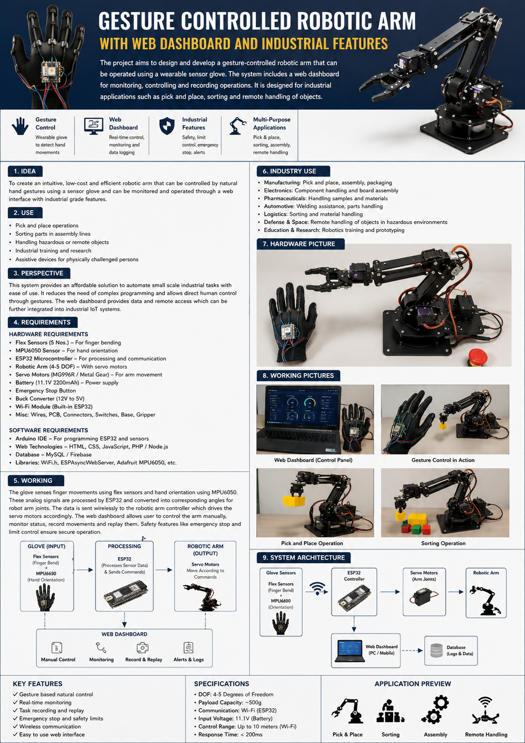
Concept illustration: wearable glove, robotic arm, dashboard, and proposed workflow. Illustrative—not a photograph of a completed prototype.

Prepared for supervisor review

1. Executive Summary
This project proposes a low-cost robotic manipulation prototype controlled through a wearable sensor glove. Finger-bending sensors and a hand-orientation sensor capture the operator’s movements. Microcontrollers translate these readings into joint commands for a small robotic arm. A web dashboard provides manual control, calibration, status monitoring, task recording, and replay of predefined pick-and-place sequences.
The project combines embedded systems, wireless communication, control logic, web development, data logging, and fault handling. It does not require a machine-learning model. The prototype is intended for education, research, and evaluation of lightweight handling tasks; it is not presented as a certified industrial robot.

2. Project Idea
The central idea is to let an operator demonstrate a simple movement using a sensor glove and then save the resulting sequence for later replay. For example, the operator can guide the arm to pick up a lightweight object from Tray A and place it in Tray B. The dashboard makes the system easier to configure, monitor, and test.
- Gesture mode: control selected joints using hand orientation and finger bending.
- Manual mode: operate each joint through dashboard sliders for calibration and troubleshooting.
- Record/replay mode: save a sequence of joint positions and replay it at a controlled speed.
- Monitoring mode: display connection state, joint targets, task status, and fault/event logs.
- Safety logic: enforce joint-angle limits, reject invalid commands, and stop movement on communication timeout.

3. Problem Statement
Small workshops and robotics training environments may need a flexible way to demonstrate and repeat basic object-transfer tasks without investing in a full industrial automation cell. A low-cost, glove-guided prototype can be used to investigate whether intuitive motion teaching and sequence replay simplify task setup. The project will measure performance rather than assume that gesture control is faster or better than conventional control.

4. Aim and Objectives
Aim: Design, implement, and evaluate a wireless gesture-controlled robotic arm with web-based monitoring and task replay.
- Build a wearable glove that measures finger bending and hand orientation.
- Control a small robotic arm with bounded, smoothed target angles.
- Develop a dashboard for gesture mode, manual mode, calibration, task recording/replay, and system status.
- Implement wireless communication between the glove and arm controller.
- Add fault handling such as communication timeout, invalid-command rejection, and joint limits.
- Evaluate task completion time, successful transfers, response latency, and repeatability using controlled trials.

5. Intended Use and Industry Perspective
Potential setting | Possible use | Important limitation
Robotics labs and technical training | Teach sensors, embedded programming, motor control, and automation workflows. | Best initial target for a student prototype.
Small workshops | Demonstrate lightweight pick-and-place between fixed trays or workstations. | Payload, speed, precision, and safety must be tested.
Electronics / small-part sorting | Move lightweight components or colored objects in a controlled demo. | Not suitable for production until reliability and guarding are validated.
Automation prototyping | Explore operator-guided teaching and replay of simple movements. | Does not replace certified industrial robots or safety systems.
Remote manipulation demonstrations | Operate a small arm from a nearby workstation. | Not for hazardous, sterile, or high-risk tasks in this version.

Industry relevance: flexible automation, intuitive task teaching, and low-cost robotics education are credible application areas. However, demand for this exact product should be validated through interviews with local workshops, automation technicians, or labs. The project should not claim that factories will adopt it without user feedback and performance evidence.

6. System Working
- The operator wears the glove. Flex sensors measure finger bending, while an MPU6050 inertial sensor measures hand orientation.
- The glove ESP32 reads the sensors, filters noise, applies calibration, and sends a compact command packet wirelessly.
- The arm ESP32 validates incoming data, checks communication freshness and joint limits, and updates the requested positions.
- A PCA9685 PWM driver sends control signals to the servo motors that move the base, shoulder, elbow, wrist, and gripper.
- The dashboard displays status and allows manual control, calibration, and saved-task replay.
- If data becomes stale or invalid, the controller stops issuing new motion commands and moves to the defined safe response.

7. System Architecture
Layer | Proposed technology | Responsibility
Glove input | 2 flex sensors + MPU6050 | Capture finger bend and hand orientation.
Glove controller | ESP32 #1 | Read, calibrate, filter, and transmit sensor values.
Wireless link | ESP-NOW | Carry glove commands to the arm controller without requiring internet.
Arm controller | ESP32 #2 | Validate commands, apply limits, and serve the local dashboard/API.
Motor driver | PCA9685 | Generate PWM signals for multiple servo motors.
Robot mechanics | 4–5 controlled axes including gripper | Move and grasp lightweight objects.
Web interface | React + Vite; local HTTP/WebSocket API | Control, monitoring, calibration, task replay, and event display.
Storage | Browser local storage initially; optional SQLite later | Save task sequences and session/event records.

8. Hardware Requirements and Estimated Budget
Component | Qty. | Purpose | Estimated cost (PKR)
Robotic arm frame with servo motors and gripper | 1 set | Mechanical arm and joints | 7,200–13,500
ESP32 development boards | 2 | Glove and arm controllers | 2,100–2,500
PCA9685 servo driver | 1 | Multi-servo PWM control | 1,000–1,300
MPU6050 sensor module | 1 | Hand orientation | 350–700
Flex sensors | 2 | Finger bending / gripper command | 1,500–3,500
Regulated servo power supply | 1 | Separate motor power | 1,000–1,800
Glove, resistors, wires, connectors, mounting | 1 set | Wearable assembly and sensor circuits | 800–1,500
Shipping / contingency | — | Price variation and small parts | 1,000–2,000
Indicative total | — | Depends on selected arm kit and local availability | 14,950–26,800

Budget note: these are planning estimates, not supplier quotations. Confirm the price, servo count, torque, and power requirements of the selected kit before purchase. Some metal-arm kits can bring the total close to PKR 30,000. A laptop is assumed to be available for development and is not included in the estimate.

9. Software Requirements
Software / tool | Purpose
Arduino IDE / ESP32 core | Firmware development and upload.
C/C++ | Sensor reading, communication, control, and safety logic.
React + Vite | Browser dashboard.
HTML, CSS, JavaScript | Dashboard layout and interaction.
ESP-NOW | Direct wireless communication between ESP32 boards.
HTTP API or WebSocket | Dashboard-to-arm-controller communication.
Local storage / optional SQLite | Task and event persistence.
Git | Version control and team collaboration.

10. Proposed Dashboard
- Overview: controller status, glove link, active mode, and current task state.
- Manual control: safe sliders and gripper open/close commands.
- Glove calibration: neutral hand pose and flex-sensor min/max calibration.
- Task editor: record named sequences of joint positions, delays, and gripper actions.
- Replay: run a stored sequence at a selected speed with pause/stop controls.
- Logs: show task start/end, communication failures, emergency-stop events, and errors.
- Settings: joint limits, movement speed, and communication timeout.

11. Safety and Reliability Requirements
- Use a separate, appropriately rated power supply for servos; do not power multiple servos from the ESP32 3.3 V output.
- Connect logic and servo-supply grounds together as required by the driver design.
- Use a physical emergency-stop switch that disables servo power; a web button alone is not a physical emergency stop.
- Start with the arm unloaded and test one servo at a time; keep fingers clear of joints and gears.
- Clamp commands to mechanically safe joint limits and move gradually to reduce sudden motion.
- Reject invalid or stale packets and stop new movement commands after a communication timeout.
- Keep the prototype on a local network; do not expose control endpoints directly to the public internet.
- Do not claim industrial safety certification or suitability for hazardous work.

12. Working Pictures and Illustrations
The following concept illustration is included to communicate the proposed hardware and workflow. It is an AI-generated design concept, not evidence that the prototype has already been built. Replace or supplement it with photographs of the actual assembled glove, wiring, robotic arm, dashboard, and pick-and-place test once the prototype is working.
Figure 1. Concept overview of glove input, arm hardware, dashboard, and sample applications.

13. Evaluation and Testing Plan
Test | Method | Evidence to record
Gesture response | Change hand tilt / finger bend and measure command-to-motion delay. | Latency in milliseconds.
Pick-and-place | Transfer a lightweight object between two marked tray positions. | Successful transfers / total attempts.
Replay repeatability | Run the same stored sequence 10 times. | Success rate and final placement variation.
Communication loss | Interrupt glove link during a safe, unloaded test. | Time until new motion commands are stopped.
Dashboard correctness | Change mode, adjust joint targets, save and replay a task. | Pass/fail results and screenshots.
Baseline comparison | Compare manual movement with glove-guided teaching and replay. | Task time and operator feedback.

Suggested initial trial: 20 controlled object-transfer attempts. Report actual results, including failures. Any response-time or repeatability targets should be treated as goals until verified on the assembled hardware.

14. Proposed Development Timeline
Week | Milestone
1 | Finalize requirements, select arm kit, assemble mechanics.
2 | Test servo driver, individual joints, power supply, and angle limits.
3 | Build glove electronics and calibrate flex / orientation sensors.
4 | Implement wireless communication and packet validation.
5 | Integrate gesture control, motion smoothing, and fault handling.
6 | Build dashboard and manual controls.
7 | Add task recording, replay, and event history.
8 | Run evaluation, capture real working photographs, and complete report.

15. Expected Deliverables
- A working wearable glove and robotic arm prototype.
- ESP32 firmware for sensor processing, wireless commands, and bounded motor control.
- Web dashboard for monitoring, manual operation, calibration, and task replay.
- Documented wiring diagram, architecture diagram, source code, and bill of materials.
- Test plan, measured results, limitations, and final project report.
- A demonstration video showing gesture control, saved-task replay, and fault response.

16. Conclusion
The proposed system is a feasible hardware-software FYP if the scope is kept focused on lightweight pick-and-place tasks. Its strongest software engineering contribution is the integration of embedded control, wireless communication, task recording/replay, web monitoring, and systematic evaluation. The project should be presented as a research and training prototype with potential for further development, not as a ready-to-deploy industrial robot.

Appendix: Suggested Demonstration Sequence
- Power on the arm with the physical emergency stop available and test each joint without a payload.
- Calibrate the glove in a neutral pose and record flex-sensor minimum and maximum readings.
- Use gesture mode to move the arm slowly toward a lightweight object.
- Close the gripper, move the object to the target tray, and release it.
- Record a safe sequence and replay it several times while monitoring the dashboard.
- Demonstrate a controlled communication-loss test with the arm unloaded.

