Week-2

- Creating and attaching an EBS volume to an EC2 instance
Go to EC2 Dashboard → EBS → Volumes, click Create Volume, choose the volume type, size, and the same Availability Zone as your EC2, then create it.
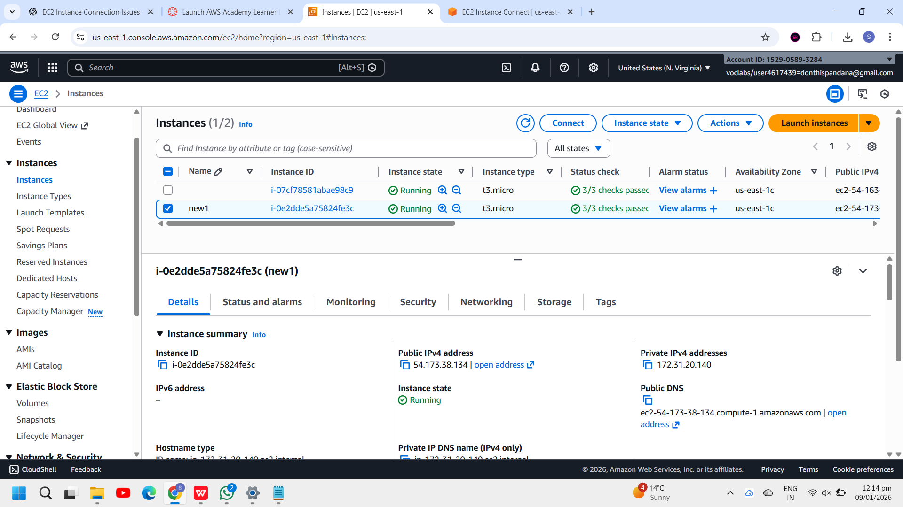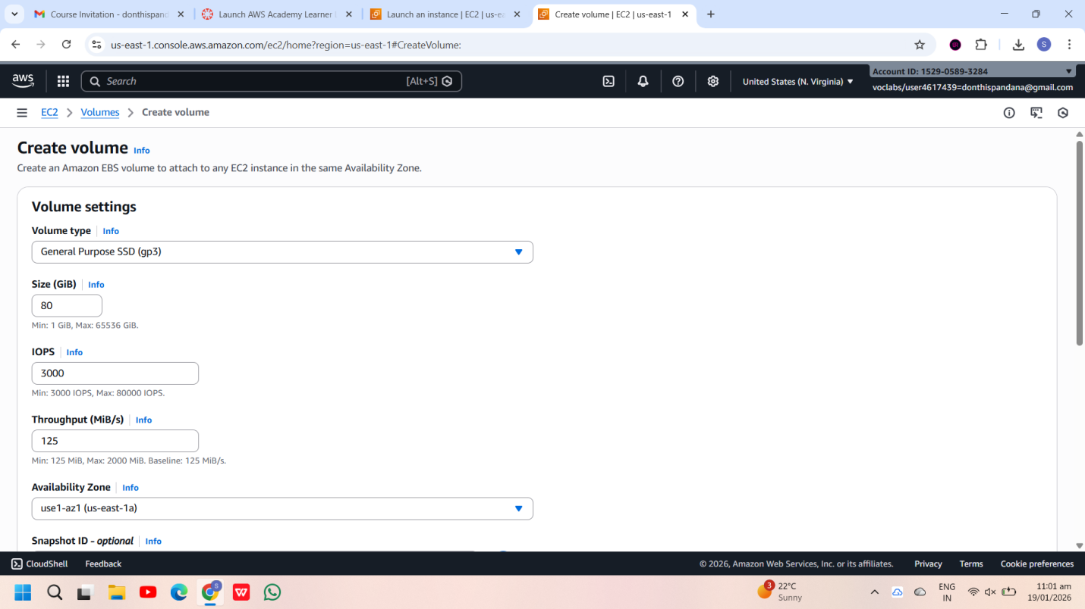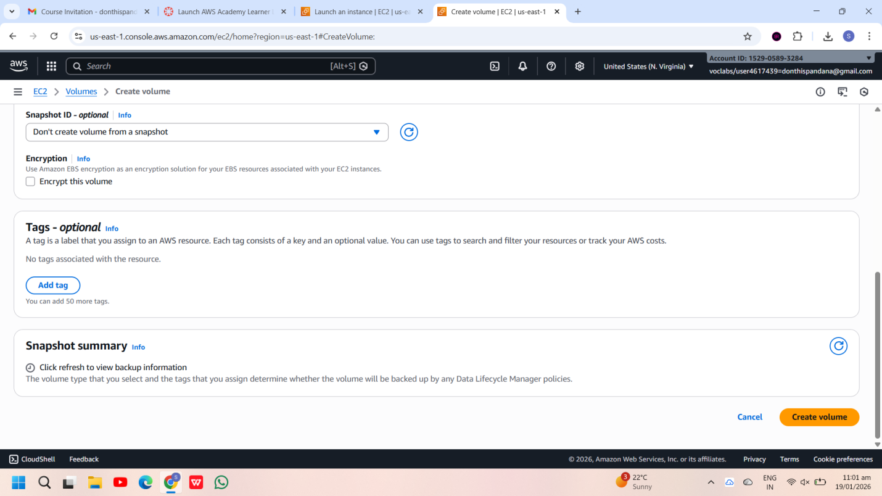
Step 2: Select the new EBS volume, click Actions → Attach Volume, choose the EC2 instance, specify the device name, and attach it.

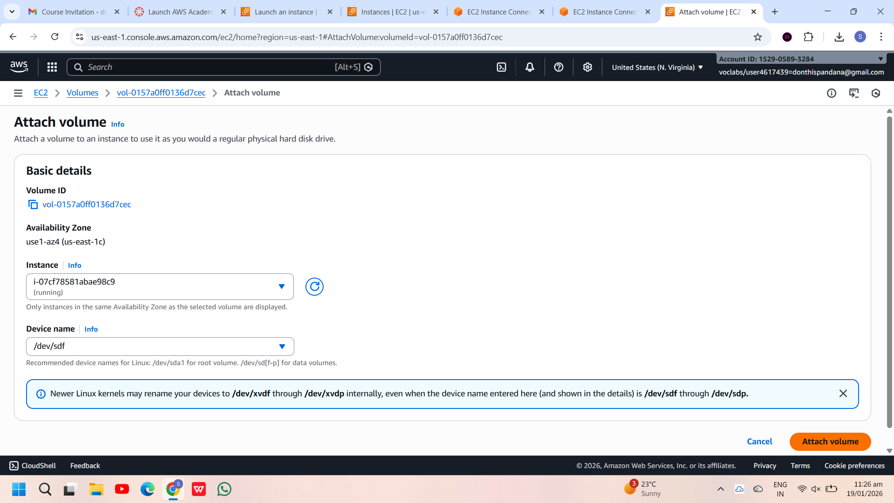
SSH into the EC2 instance, run lsblk, and verify that the new volume (for example, /dev/xvdf) is attached.

2.Attach and permanently mount an EBS volume to a Linux EC2 instance to ensure data persistence across reboots.
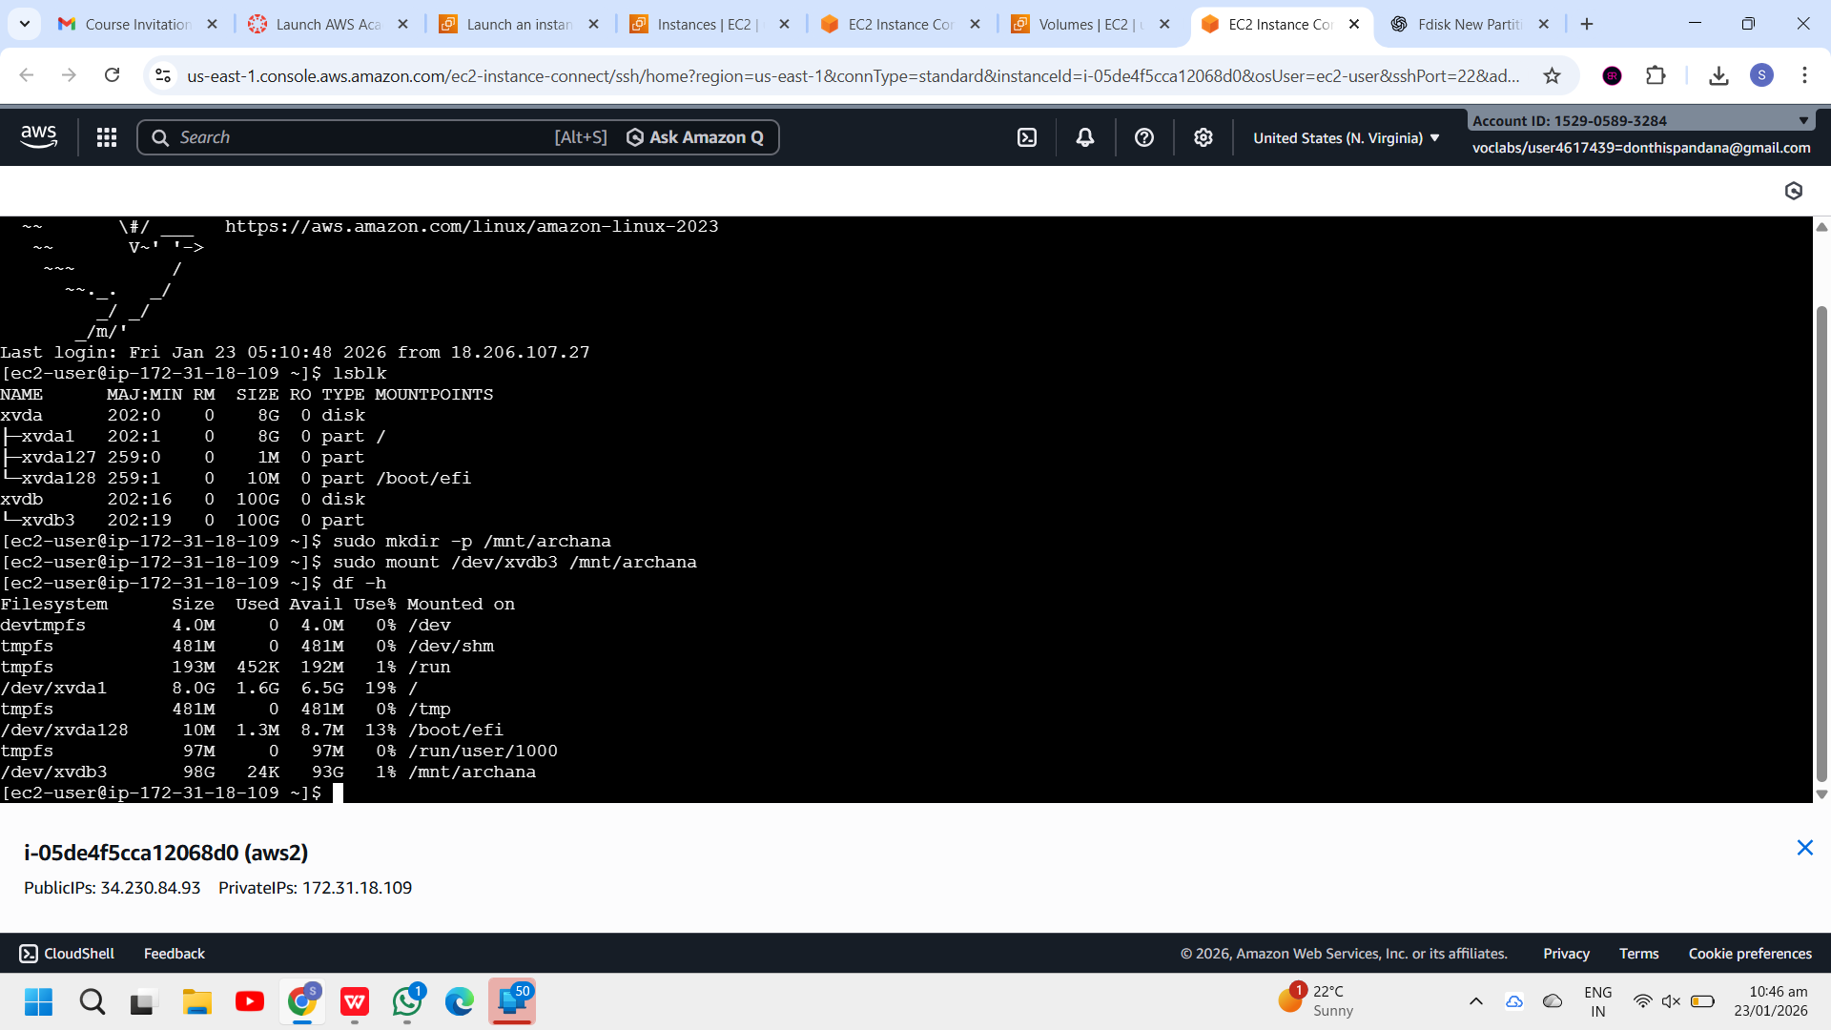 partitions as /dev/nvme1n1p1.

Step 1: Create an EBS Volume
- Log in to AWS Management Console
- Go to EC2 → Volumes
- Click Create volume
- Choose:
  - Volume type: gp3 (recommended)
  - Size: 20 GB (example)
  - Availability Zone: Same AZ as the EC2 instance
- Click Create volume
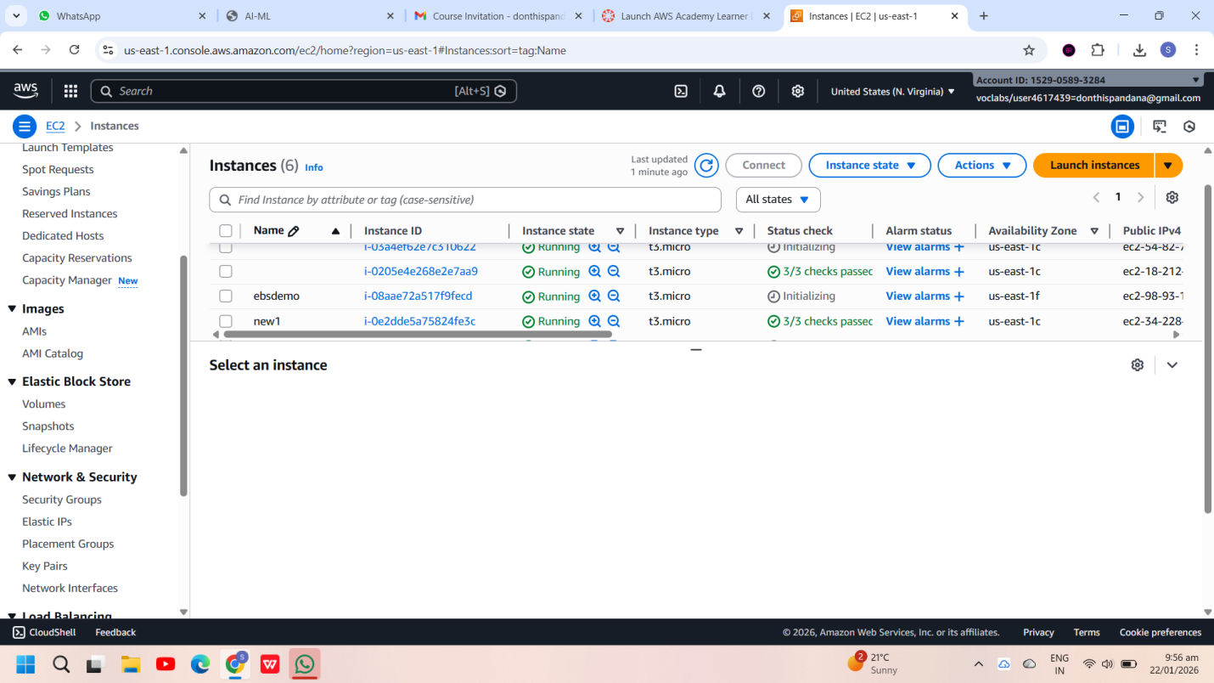
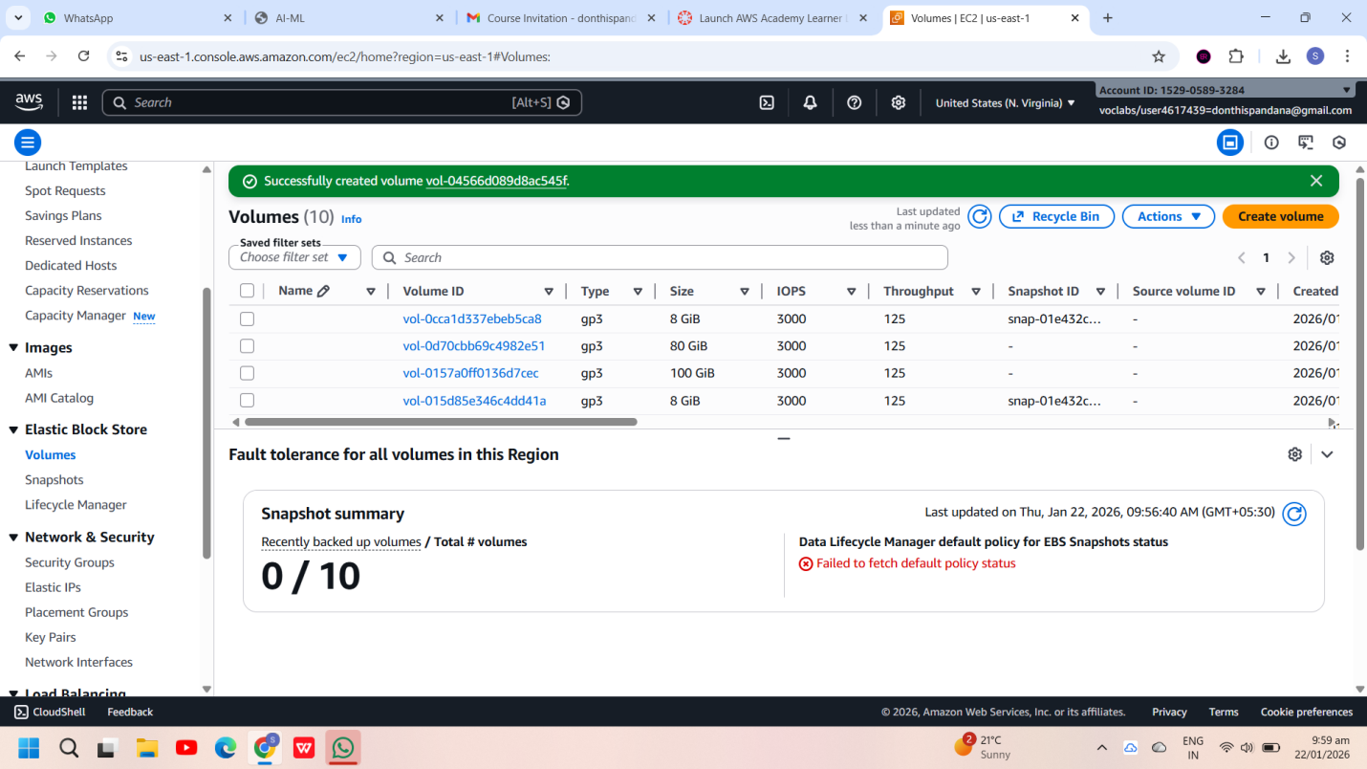
Step 2: Attach the EBS Volume to EC2
- Select the newly created EBS volume
- Click Actions → Attach volume
- Choose:
  - Instance: Your Linux EC2 instance
  - Device name (console level): /dev/xvdf
- Click Attach
Internally, Linux will expose this as an NVMe device (for example /dev/nvme1n1).

Step 3: Connect to the EC2 Instance
Connect using SSH:
ssh -i key.pem ec2-user@<public-ip>
Step 4: Verify the Attached Disk
List all block devices:
lsblk
You will typically see:
- Root volume: /dev/nvme0n1 (with partitions like nvme0n1p1)
- New EBS volume: /dev/nvme1n1 (no partition yet)
Check filesystem information:
lsblk -fs
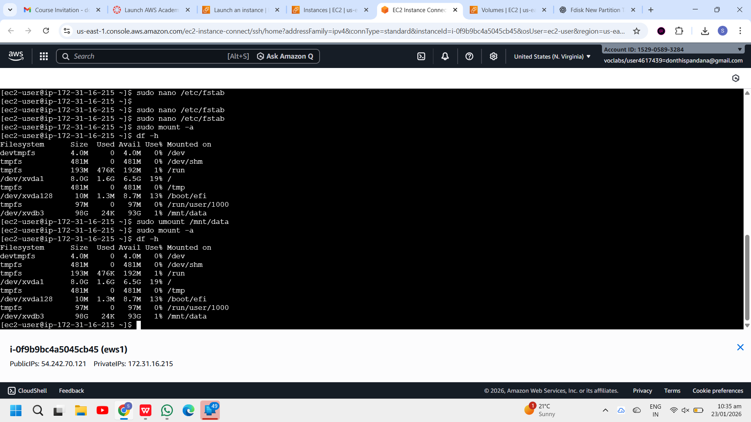
Step 5: Create a Partition on the New Volume
Create a partition on the unpartitioned disk:
fdisk /dev/nvme1n1
Inside fdisk:
- Press m → Help menu
- Press n → New partition
- Press p → Primary partition
- Press Enter → Default partition number
- Press Enter → Default first sector
- Press Enter → Default last sector (use full disk)
- Press w → Write changes and exit
Notify the kernel:
partprobe
Step 6: Verify the New Partition
lsblk -fs
You should now see:
- /dev/nvme1n1p1
Step 7: Format the Partition
Format the partition with XFS filesystem:
mkfs.xfs /dev/nvme1n1p1
Verify:
lsblk -fs
Step 8: Create a Mount Directory
mkdir /mnt/archana

Step 9: Mount the Volume
mount /dev/nvme1n1p1 /mnt/archana
Verify:
df -h
Step 10: Make the Mount Persistent (fstab)
Get the UUID:
blkid /dev/nvme1n1p1
Example output:
UUID="f1e294e6-7657-4761-bba5-bb2d0eab3936"
Edit /etc/fstab:
nano /etc/fstab
Add this line at the end:
UUID=f1e294e6-7657-4761-bba5-bb2d0eab3936 /mnt/archana xfs defaults,nofail 0 0
Save and exit.
Test the entry:
mount -a
navigate to cd /mnt/archana
create the files here
touch f1
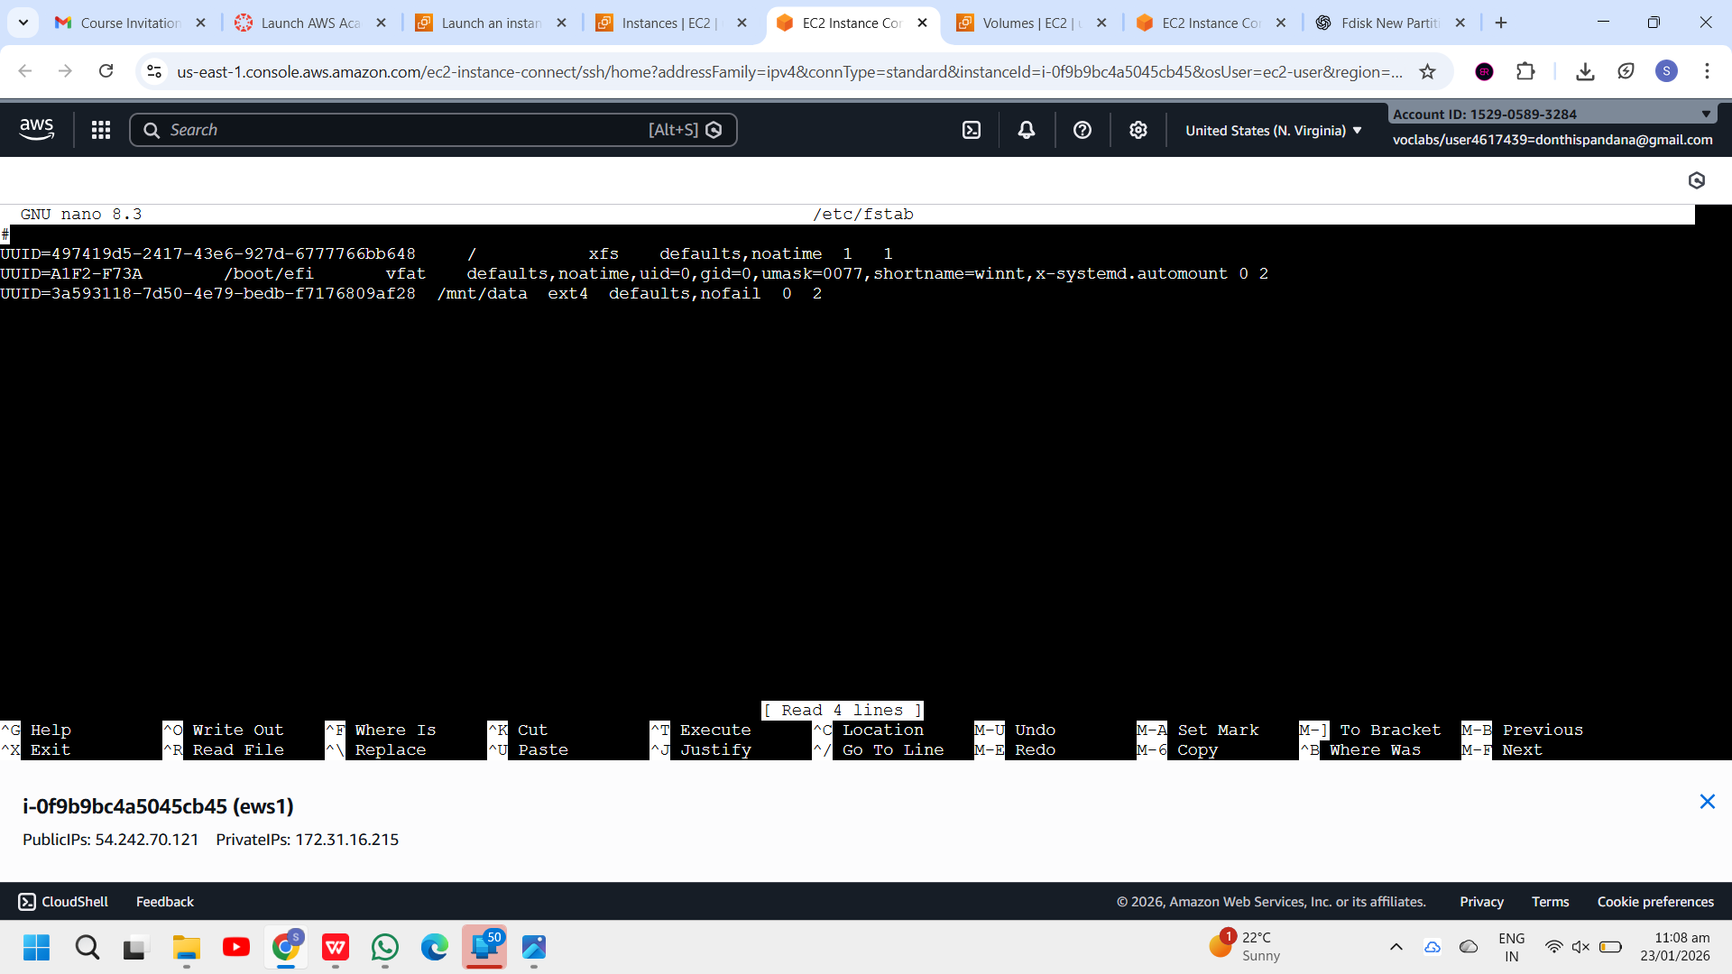
Step 11: Verify Persistence
- Reboot the instance:
reboot
- Reconnect and check:
df -h
➡️ The volume should mount automatically.
Step 12: Detach and Reattach Volume (Data Recovery Scenario)
Detach the Volume
- EC2 → Volumes → Select volume
- Actions → Detach volume
Attach to Another EC2 Instance (Same AZ)
- Attach the volume to a new instance
- Log in to the new instance
- Create mount directory:
mkdir /mnt/archana
- Mount the existing partition:
mount /dev/nvme1n1p1 /mnt/archana
✅ All previously stored data will be available.
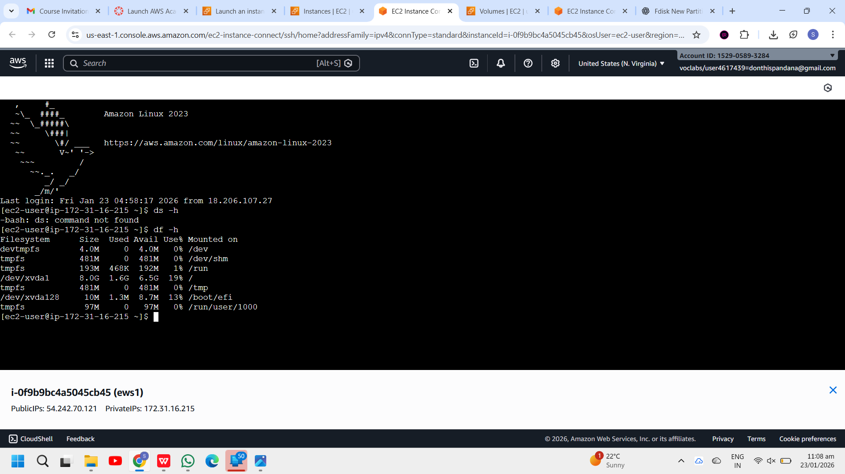
Summary Flow
Create Volume → Attach → lsblk → fdisk → mkfs → mkdir → mount → fstab → reboot

Create a snapshot of the attached EBS volume and use it to create and attach a new volume to an EC2 instance in another AWS region
Step 1. Create a Snapshot:
a. Sign in to the AWS Management Console.
b. Navigate to the EC2 Dashboard.
c. Click on "Volumes" in the left-hand navigation pane.
d. Select the EBS volume you want to create a snapshot of.
e. Click on the "Actions" dropdown menu above the volume list and select "Create Snapshot."
f. Provide a name and description for the snapshot.
g. Click on the "Create Snapshot" button to initiate the snapshot creation process.
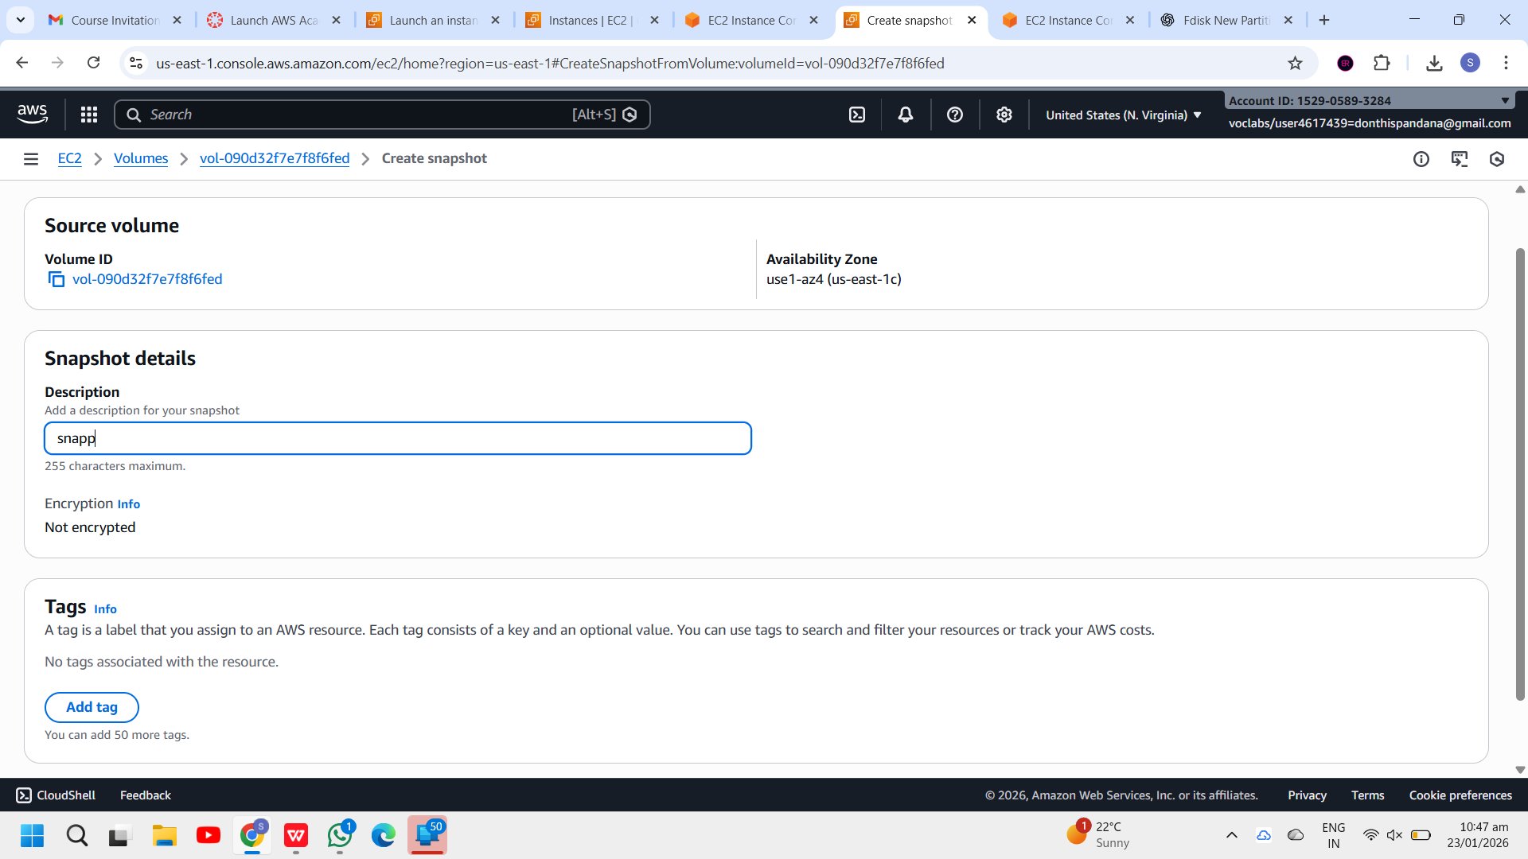

Step 2. Copy the Snapshot to Another Region:
a. Once the snapshot is created, go to the "Snapshots" section in the EC2 Dashboard.
b. Select the snapshot you just created.
c. Click on the "Actions" dropdown menu above the snapshot list and select "Copy Snapshot."
d. Choose the destination region where you want to copy the snapshot.
e. Click on the "Copy Snapshot" button to initiate the copy process. This may take some time depending on the size of the snapshot and the network speed.
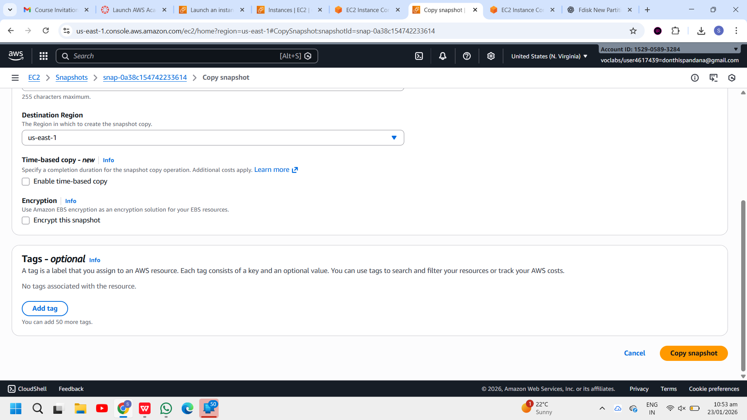

Step 3. Monitor the Snapshot Copy Progress: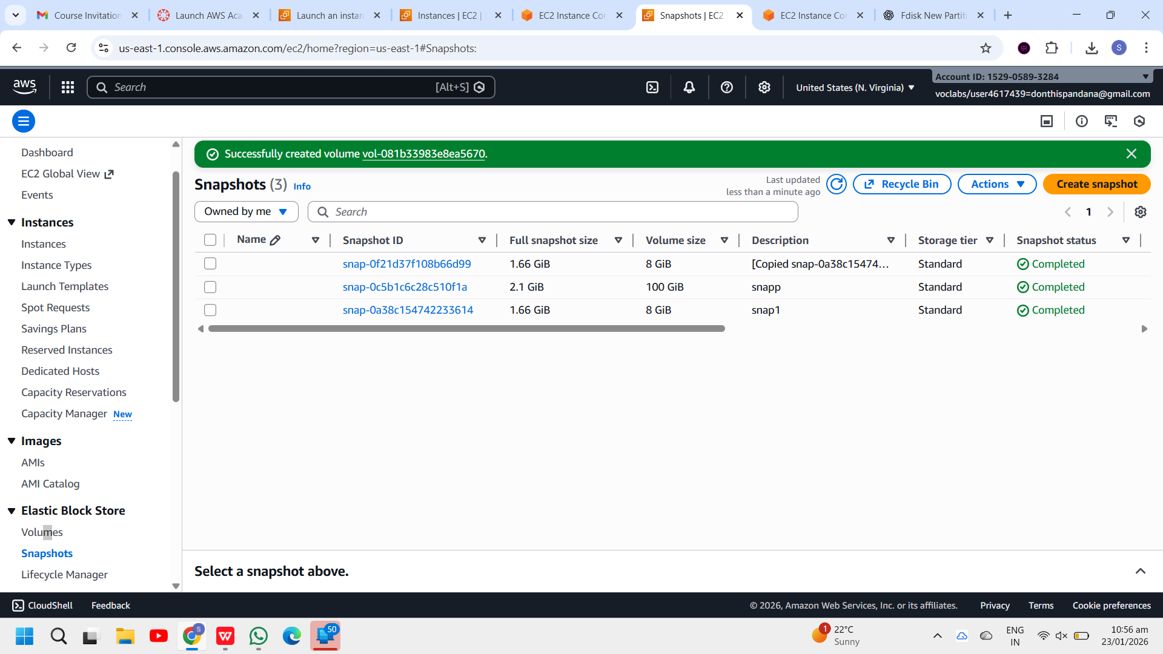
a. You can monitor the progress of the snapshot copy by navigating to the "Snapshots" section in the EC2 Dashboard of the source region.
b. Look for the snapshot you copied and check its status. It will change from "pending" to "completed" once the copy process is finished.

Step 4. Switch to the Destination Region:
- Use the region selector in the top-right corner of the AWS Management Console to switch to the destination region where you copied the snapshot.

Step 5. Create a Volume from the Snapshot:
a. In the EC2 Dashboard of the destination region, go to the "Snapshots" section.
b. Find the snapshot you copied from the source region.
c. Click on the snapshot, then click on the "Actions" dropdown menu and select "Create Volume."
d. Configure the volume settings, such as volume type, size, and availability zone.
e. Click on the "Create Volume" button to create the volume from the snapshot.
