Article
Argument-Aware Runtime Least-Privilege Enforcement against Tool-Poisoning-Induced Actions in MCP-Based Agentic Systems
Mohammad Nouman¹ *, Syed Ijlal Haider¹, and Rajja Ujjan¹
1 School of Computing, Engineering and Physical Sciences, University of the West of Scotland, Paisley PA1 2BE, United Kingdom
* Corresponding Author: Mohammad Nouman (mohammadnouman666@gmail.com)
Abstract
Tool poisoning can induce Model Context Protocol (MCP) agents to perform harmful host-side actions through manipulated tool metadata or invocation arguments. This paper studies a client-side least-privilege capability-inference mechanism that translates concrete tool names and recursively structured arguments into six behavioural categories before policy lookup. On a review-driven audit of 27 calls labelled from documented official MCP reference-server semantics, the corrected mapper obtains 27/27 exact category sets. On 16 author-instantiated, external-provenance MCPTox cases, it recovers all specified minimum capabilities with three additional conservative categories; neither set constitutes blind generalization evidence. A separate policy matrix yields 27/27 expected decisions. An independently implemented declared-capability policy comparator agrees with B4 on 170/172 decisions across four profiles, including 43/43 under limited-network (0% ASR; 59.26% benign-call allow rate). Hardened launch validation rejects eight malformed or bypass specifications. Twelve live stdio checks verify tool discovery, two benign workflow outputs, denied-write non-execution, error propagation, ASK denial, symlink protection, and upstream-crash failure. The 20-workflow authorization replay is reported separately from executed task success. The contribution is automatic name/argument-to-capability inference and bounded enforcement evidence, not universal interception or confinement of malicious server internals.
Keywords: Model Context Protocol; tool poisoning; agentic systems; runtime enforcement; least privilege; access control; LLM security; MCP proxy

1. Introduction
Large language model (LLM) agents are increasingly entrusted with concrete host-side actions: reading and writing files, calling remote APIs, inspecting environment variables, and executing shell commands [1,2]. The Model Context Protocol (MCP) has emerged as a practical standard for discovering and invoking such tools across heterogeneous clients and servers [3]. Standardisation improves interoperability and developer velocity, but it also concentrates risk. Tool definitions, including names, descriptions, and schemas, enter the model-facing tool context and influence tool selection, while the model constructs invocation arguments that can be adversarially steered or contain attacker-controlled values [4,5].
Tool poisoning exploits that surface. An adversary influences metadata or parameters so that the agent performs harmful side effects such as credential theft from SSH or cloud directories, exfiltration over HTTP, destructive writes, or reverse-shell-style execution, while the interaction still looks like ordinary tool use [6,7]. Unlike classical malware that must bypass OS controls directly, poisoned tools co-opt the agent’s own privileged workflow. Because many clients treat an approved server as broadly trusted, a single compromised definition or argument can unlock powerful capabilities for the remainder of a session.
Empirical evidence shows that the threat is practical. MCPTox constructed 1,348 malicious test cases across 45 real MCP servers and reported attack success rates up to 72.8%, with the highest refusal rate below 3% [6]. MCP-ITP further studied implicit poisoning, in which a poisoned tool may remain uninvoked while steering the agent towards a high-privilege legitimate call, with success rates up to 84.2% [7]. OWASP’s MCP Top 10 lists tool poisoning among priority risks for production deployments [5]. Collectively, these results indicate that relying on model judgement alone is insufficient. Broader LLM and generative-AI application risks are catalogued in the OWASP GenAI LLM Top 10 2026 [8].
Despite this evidence, current MCP-capable clients provide heterogeneous combinations of user approval, tool enablement, auto-run modes, and tool-level or argument-pattern permissions. Anthropic and Cursor document their own client controls [9,10]. Cline and Continue expose related MCP or agent controls with different semantics [11,12]. These mechanisms are valuable, but their semantics and configuration remain client-specific rather than uniformly standardised. Consequently, they do not provide a portable enforcement layer that consistently derives behavioural capability requirements from concrete invocation arguments, elevates sensitive-resource accesses, and applies the same default-deny aggregation across heterogeneous upstream servers. Related work on server sandboxing, gateway scanning, and runtime governance is reviewed in Section 2.
This paper addresses a narrower design point within that landscape: a lightweight client-side capability-inference mechanism that derives behavioural requirements from concrete tool names and invocation arguments, elevates sensitive resources, and places the inferred set behind declarative default-deny authorization. We do not propose a learned attack classifier. The configured mediation path (i) receives each tools/call request presented to the proxy, (ii) infers required categories using name semantics, recursive argument inspection, canonicalization, and sensitive-resource elevation, (iii) evaluates YAML rules with ALLOW/DENY/ASK outcomes, and (iv) emits an audit record. The revised evaluation deliberately separates capability-inference validity from policy-profile effectiveness. No claim is made that requests sent through an alternative client-to-server route are intercepted, or that call-level authorization confines arbitrary hidden behaviour inside a malicious upstream server.
Contributions. (1) A compact automatic capability-inference mechanism that maps concrete MCP tool names and recursively structured invocation arguments to six behavioural categories, with token-aware name matching, path/domain canonicalization, sensitive-resource elevation, and conservative handling of unresolved resource intent. (2) Direct, policy-independent validation of this mapping on documented official reference-server semantics, together with an external-provenance MCPTox challenge whose source case identifiers are retained. (3) A separately validated default-deny ALLOW/DENY/ASK checker, plus configured-path interception validation: the four published profile/category matrices and resource restrictions are tested independently, a validated client configuration rejects direct-upstream bypass entries, and every routed test call is audited. (4) A controlled independent declared-capability policy comparator and a scripted workflow authorization replay that report both call-level ASR/BCAR and workflow authorization and controlled execution outcomes. (5) Staged security/utility evaluation on development, stress, organic, white-box boundary, schema-shaped, workflow, and ASK-path sets, with uncertainty bounds, component knock-outs, and separated latency boundaries. (6) A reproducibility artifact containing raw per-case decisions, external-source provenance, deterministic generators, pinned dependencies and content hashes. The proxy architecture, capability vocabulary, and server-side confinement concepts themselves are not claimed as novel.
Research Questions. The final evaluation is organised around four questions. RQ1: Independent of any YAML profile, how faithfully does the automatic name/argument inference recover documented or externally specified behavioural capabilities? RQ2: Given inferred categories, does the checker faithfully implement the published category/profile matrix and resource restrictions, and does the validated configured deployment prevent direct-upstream client entries while intercepting all routed test calls? RQ3: How does B4 compare with a controlled independent declared-capability policy abstraction, and how does enforcement affect authorization of scripted workflows and outcomes in a controlled live fixture? RQ4: How do the corrected mechanism and fixed policy profiles behave on development, stress, organic, white-box boundary, external-provenance, and real-MCP-style workflow conditions? These questions separate capability recovery, policy faithfulness, configured-path interception, alternative authorization, and task-level impact instead of attributing all outcomes to a single profile-level metric.

2. Related Work and Research Positioning
This section reviews the attack models, benchmarks, and runtime controls most closely related to MCP tool poisoning. It then identifies the specific gap addressed by the proposed argument-aware client-side enforcement layer.

2.1. Indirect Prompt Injection and Tool-Oriented Attacks
Indirect prompt injection established that untrusted content can influence LLM-integrated applications even when an attacker has no direct access to the user’s conversation [4]. Greshake et al. showed that malicious instructions embedded in retrieved or otherwise untrusted content can redirect model behaviour. Subsequent agent-security benchmarks, including InjecAgent and AgentDojo, extended this concern to tool-using agents, demonstrating that untrusted observations can affect both tool selection and tool arguments [13,14]. Together, these studies established that, once language models are connected to executable tools, the boundary between data and instructions becomes difficult to enforce. Design-level control/data separations have also been proposed [15].
Within MCP, this broader threat is expressed as tool poisoning. Explicit-trigger hijacking places overtly harmful instructions in tool metadata, whereas implicit-trigger hijacking can steer an agent towards unsafe tool sequences without directly invoking the poisoned tool. Parameter tampering further extends the attack surface by altering paths, URLs, recipients, or command strings so that an apparently legitimate tool produces harmful effects [6,7]. Because MCP servers advertise capabilities that clients subsequently trust, poisoning may occur during registration or schema presentation, while attacker-controlled or adversarially steered arguments may introduce additional risk at invocation time.

2.2. MCP Threat Benchmarks and Empirical Evidence
MCPTox provides a large attack corpus grounded in real MCP servers and reports high attack success rates across multiple models [6]. MCP-ITP complements this work by automating implicit poisoning scenarios and showing that the poisoned tool need not be the tool that ultimately executes the harmful action [7]. Broader MCP landscape and threat surveys similarly indicate that tool ecosystems accumulate untrusted capability descriptions over time [16]. These studies establish the practical relevance of tool poisoning and provide benchmark evidence for attack success; however, they do not directly evaluate a client-side runtime permission gate together with paired measures of security and legitimate task utility.

2.3. Defences: Server, Gateway, and Client Controls
Existing defences operate at several points in the MCP execution path. Server-oriented approaches such as AgentBound attach Android-style manifests and sandboxes to MCP servers, constraining the capabilities of the server process on the host without modifying server source [17,18]. Gateway approaches scan definitions or minimise the tool interfaces exposed to the model [19,20]. Microsoft AGT provides a broader control-plane approach with policy enforcement and definition scanning [21]. Governed MCP proxies enforce attribute-based or role-based authorisation at discovery and/or invocation time [22]. Runtime policy-enforcement points (PEPs) intercept tool calls with declarative rules and, in some designs, cross-step information-flow labels [23]. Industry frameworks such as ShieldMCP combine parameter sanitisation, response validation, and semantic checks against tool poisoning and indirect injection [24]. Complementary execution-control work defines explicit runtime invariants for MCP-style agents [25]. Interface firewalls can also reduce tool inputs and have shown effectiveness on selected injection benchmarks [20]. At the client level, Anthropic and Cursor document permission or MCP controls [9,10], while Cline and Continue document their own agent or MCP controls [11,12].
These approaches establish runtime enforcement as an important architectural boundary, but they differ substantially in the abstraction used to decide whether a call is permissible. Classical least privilege motivates explicit permission grants and default-deny behaviour [18,26]. Existing systems variously emphasise server-side capability confinement [17], role/attribute-based authorisation over tool registries [22], information-flow labels and cross-step taint [23], definition scanning and broad governance toolkits [21], or semantic/response validation [24]. In an agent setting, however, a poisoning-oriented least-privilege decision must also account for natural-language tool names, free-form arguments, sensitive paths, and changing server inventories under measurable security–utility trade-offs.

2.4. Research Gap and Positioning
The preceding literature can be positioned along enforcement point, decision abstraction, modification requirements, and whether security–utility trade-offs are reported on tool-oriented workloads. Runtime MCP governance is already well developed: AgentBound provides server-side declarative confinement [17], Wang et al. implement call-boundary policy enforcement with cross-step information-flow state [23], and capability-enhanced MCP specifications can constrain data flows and tool sequences [28]. Progent, a preprint, likewise performs deterministic least-privilege control over tool calls with programmable policies and adaptive evaluation [29]. The remaining research opportunity addressed here is therefore narrower: automatic translation of concrete MCP tool names and argument values into a compact behavioural capability set, including sensitive-resource elevation and conservative treatment of unresolved resources, followed by poisoning-oriented measurement of that inference layer.
Table 1. Literature review comparison.
Work | Boundary | Call-time / args | Decision abstraction | Source-code modifications required | Utility eval
AgentBound [17] | Server sandbox | Server caps | Declarative manifest | No server source change | Limited
Microsoft AGT [21] | Control plane | Policy + def. scan | YAML/OPA/Cedar-style | Adapter/config | Internal
Prompts Don’t Protect [22] | Governed proxy | Discovery+ call ABAC | Role/attribute ABAC | No client/model mod. | UIR-focused
Wang et al. PEP [23] | Tool-call PEP | Yes + IFC labels | Declarative/IFC | In-process/stdio | Yes (ASR + call-level utility)
ShieldMCP [24] | Interception | Parameters / responses | Semantic/validation | Framework deploy | Yes
Client controls [9] | Client UX | Heterogeneous | Approval/allowlists | N/A | Rare
This work | Client proxy | Yes (name+args) | 6-cat YAML profiles | Config-only | Yes (ASR + BCAR + ablation)
Doshi et al. [28] | Capability-enhanced MCP | Call/data-flow specs | Capabilities, trust, confidentiality | Framework/spec change | Design-level
Progent preprint [29] | Agent/tool-call control | Yes | Programmable policy DSL | Minimal integration | Yes
The comparison indicates that runtime enforcement, declarative authorization, approval, capability models, and server confinement are prior art; this work focuses specifically on automatic call-time capability inference from concrete names and recursively structured arguments.

2.5. Differentiation From AgentBound and Runtime MCP Governance
Because runtime MCP access control is an active research area, the contribution is positioned relative to AgentBound [17], Microsoft’s Agent Governance Toolkit (AGT) [21], governed MCP proxies [22], Wang et al.’s runtime PEP with information-flow labels [23], capability-enhanced MCP specifications [28], ShieldMCP-style semantic defences [24], and Progent [29]. AgentBound is server-centric: an AgentManifest and AgentBox constrain what the MCP server process may access [17]. The present mechanism instead infers what capability a concrete client request appears to require before that request is forwarded. These are complementary boundaries, and the present gate cannot substitute for server-process confinement when an upstream implementation is itself malicious.
AGT, governed proxies, and Wang et al. already demonstrate that per-call interception, declarative policy evaluation, approval outcomes, audit logging, and cross-step controls can be implemented at runtime [21–23]. Doshi et al. further propose capability-enhanced MCP specifications over trust, confidentiality, data flows, and tool sequences [28]. Progent, currently a preprint, provides programmable deterministic privilege control over tool calls and evaluates security/utility and adaptive attacks [29]. Accordingly, this paper does not claim novelty for runtime mediation, declarative authorization, approval, audit, or the existence of filesystem/network/execution capability classes. Its distinct design point is the automatic inference step that converts heterogeneous concrete names and argument values into a small behavioural capability set before policy evaluation. The revised novelty claim is therefore narrow: recursive, canonicalized, argument-aware capability inference from concrete MCP calls, sensitive-resource elevation, conservative handling of unresolved resource intent, and poisoning-oriented evaluation of that inference mechanism. The six-category vocabulary and the surrounding runtime proxy are treated as implementation choices rather than architectural novelties.

3. Materials and Methods
This section defines the threat model, permission taxonomy, policy profiles, runtime architecture, implementation, and evaluation protocol used in the study. The sequence moves from the security assumptions and enforcement rules to the experimental design and metrics.

3.1. Threat Model and Assumptions
The threat model considers adversarial influence over model-facing MCP tool metadata (names, descriptions, and schemas), tool selection, and invocation arguments. An adversary may rename tools, nest or split resource representations, or steer arguments toward sensitive paths, attacker-controlled destinations, destructive writes, or command execution. The permission-inference layer authorizes only the expected capability implied by the observable invocation. Its guarantee therefore depends on semantic correspondence between the inferred permission and what the upstream tool actually does. Registration of or redirection to an untrusted MCP endpoint is in scope only to the extent that the endpoint faithfully performs the operation represented by the observable tool invocation. The evaluated security objective is to prevent harmful requests from crossing the client-side mediation boundary; it is not to confine arbitrary hidden behaviour inside a compromised server implementation.
The proxy, policy files, audit storage, client operating-system trust boundary, and configured tools/call routing are trusted. The call-level model additionally assumes that an upstream tool implementation faithfully implements the operation represented by its advertised invocation and arguments. Thus, inferring fs.read, fs.write, net.http, code.exec, env.read, or process is an authorization decision about the requested action, not a proof of the server's internal behaviour. A server that internally reads credentials, executes commands, writes elsewhere, or opens outbound connections despite receiving an apparently benign call is outside the guarantee of this client-side gate and requires a complementary server sandbox, trusted capability declaration, or operating-system confinement mechanism such as the server-side boundary studied by AgentBound [17]. User weakening of a policy remains a configuration error rather than a bypass of a correctly deployed gate. The launch manifest and interpreter are also trusted. Hash verification assumes these files cannot be changed concurrently by the adversary; no system-wide process or network isolation is claimed.

3.2. Permission Taxonomy Derivation
The permission taxonomy was derived through a structured, evidence-driven procedure rather than by assuming an a priori ontology. First, harmful outcomes were collected from the OWASP MCP Top 10 [5] and from MCPTox and MCP-ITP [6,7]. These outcomes include credential theft, exfiltration, shell execution, environment or secret access, destructive writes, and process control. Second, each outcome was mapped to the minimum host capability required to realise it. Third, capabilities sharing the same enforcement predicate were merged; for example, SSH and cloud-file reads require filesystem access together with sensitive-path elevation. Finally, category expansion was stopped when adding another category no longer changed ALLOW/DENY decisions on the pilot threat set under default-deny profiles. Table 2 records the resulting behaviour-to-capability mapping.
The resulting six categories are fs.read, fs.write, net.http, code.exec, env.read, and process. They represent the dominant poisoning behaviours evaluated here and are organised around distinct enforcement predicates rather than an open-ended ontology of MCP tools. They do not cover every capability, such as databases, browser automation, cloud IAM, email, or arbitrary SaaS tools. Sensitive filesystem reads, including ~/.ssh/** and **/.env, are elevated to env.read and marked high-risk; env.read therefore also serves as the high-risk secret-access category. If inference yields no category, the current prototype conservatively adds code.exec and marks the call high-risk. This is a fail-closed surrogate for an unclassified call, not a claim that every unrecognised tool executes code.
Table 2. Taxonomy derivation from attack behaviours.
Attack behaviour | Required capability | Category
Read SSH/cloud secrets | Filesystem read of sensitive path | fs.read + elevation
Exfiltrate file contents | Read + outbound HTTP | fs.read + net.http
Execute shell / reverse shell | Command execution | code.exec
Read environment secrets | Environment access | env.read
Overwrite configs / keys | Filesystem write | fs.write
Spawn/kill processes | Process control | process
The mapping shows how the evaluated attack behaviours reduce to distinct host capabilities, which are then represented by the six permission categories used by the enforcement layer.

3.3. Policy Profiles
Policy profiles provide the declarative control layer for the inferred permission categories. Each YAML profile specifies whether a category is allowed, denied, or requires ASK, together with optional path and domain restrictions. Four profiles define the evaluated security–call-utility spectrum. Read-only permits ordinary filesystem reads while denying writes, execution, and unconstrained networking. Limited-network additionally permits HTTP only to an explicit domain allow-list and is evaluated as a restrictive coding-like profile; the call-level BCAR measurements are not an end-to-end task-completion result or a general deployment recommendation. No-code-exec preserves broader filesystem and network allowance while denying execution. Approval-gated routes selected high-risk categories to ASK.
The policy model is intentionally fail-closed. Open network allow-lists such as allow_domains: ["*"] can nullify net.http restrictions and are treated as high-risk misconfiguration. Profiles can be reloaded at runtime through the proxy policy-reload path.
Table 3. Policy profiles and restrictions (exact YAML category matrix in the following note).
Profile | ALLOW / ASK categories | DENY / restrictions
read-only | fs.read | fs.write, net.http, code.exec, env.read, process; sensitive paths denied
limited-network | fs.read; net.http (domain allow-list) | fs.write, code.exec, env.read, process; sensitive paths denied
no-code-exec | fs.read, fs.write, net.http | code.exec, env.read, process
approval-gated | fs.read, net.http; ASK on fs.write/code.exec/env.read | process; in automated studies ASK→DENY
The four profiles create different security and utility settings by varying category permissions, path restrictions, domain restrictions, and ASK behaviour.
Exact category decisions matching the YAML profiles: read-only = {fs.read:ALLOW*, others:DENY}; limited-network = {fs.read:ALLOW*, net.http:ALLOW†, others:DENY}; no-code-exec = {fs.read/fs.write/net.http:ALLOW, code.exec/env.read/process:DENY}; approval-gated = {fs.read/net.http:ALLOW, fs.write/code.exec/env.read:ASK, process:DENY}. * sensitive-path deny-list; † domain allow-list. Automated non-ASK studies map ASK→DENY.

3.4. Runtime Architecture and Inference
The enforcement layer comprises four cooperating components: the Policy Manager, Permission Checker, Enforcement Proxy, and Audit Logger. The Policy Manager loads and validates YAML profiles; the Permission Checker performs category inference and policy evaluation; the Enforcement Proxy provides both an in-process Python API and a stdio MCP mediator between the client and upstream servers; and the Audit Logger appends structured JSON Lines records for each decision. Because logs may contain tool names and argument summaries, they should be access-controlled.
The runtime path follows a five-stage decision sequence: parse the tool call, infer categories, look up policy rules, check resource restrictions, and aggregate category-level decisions. The proxy then enforces and logs the final outcome. Because mediation occurs on the client host before upstream execution, when traffic is correctly routed through the proxy, denied calls are prevented from reaching the upstream server. Figures 1–3 present the placement, decision pipeline, and three-layer inference structure of this runtime design.
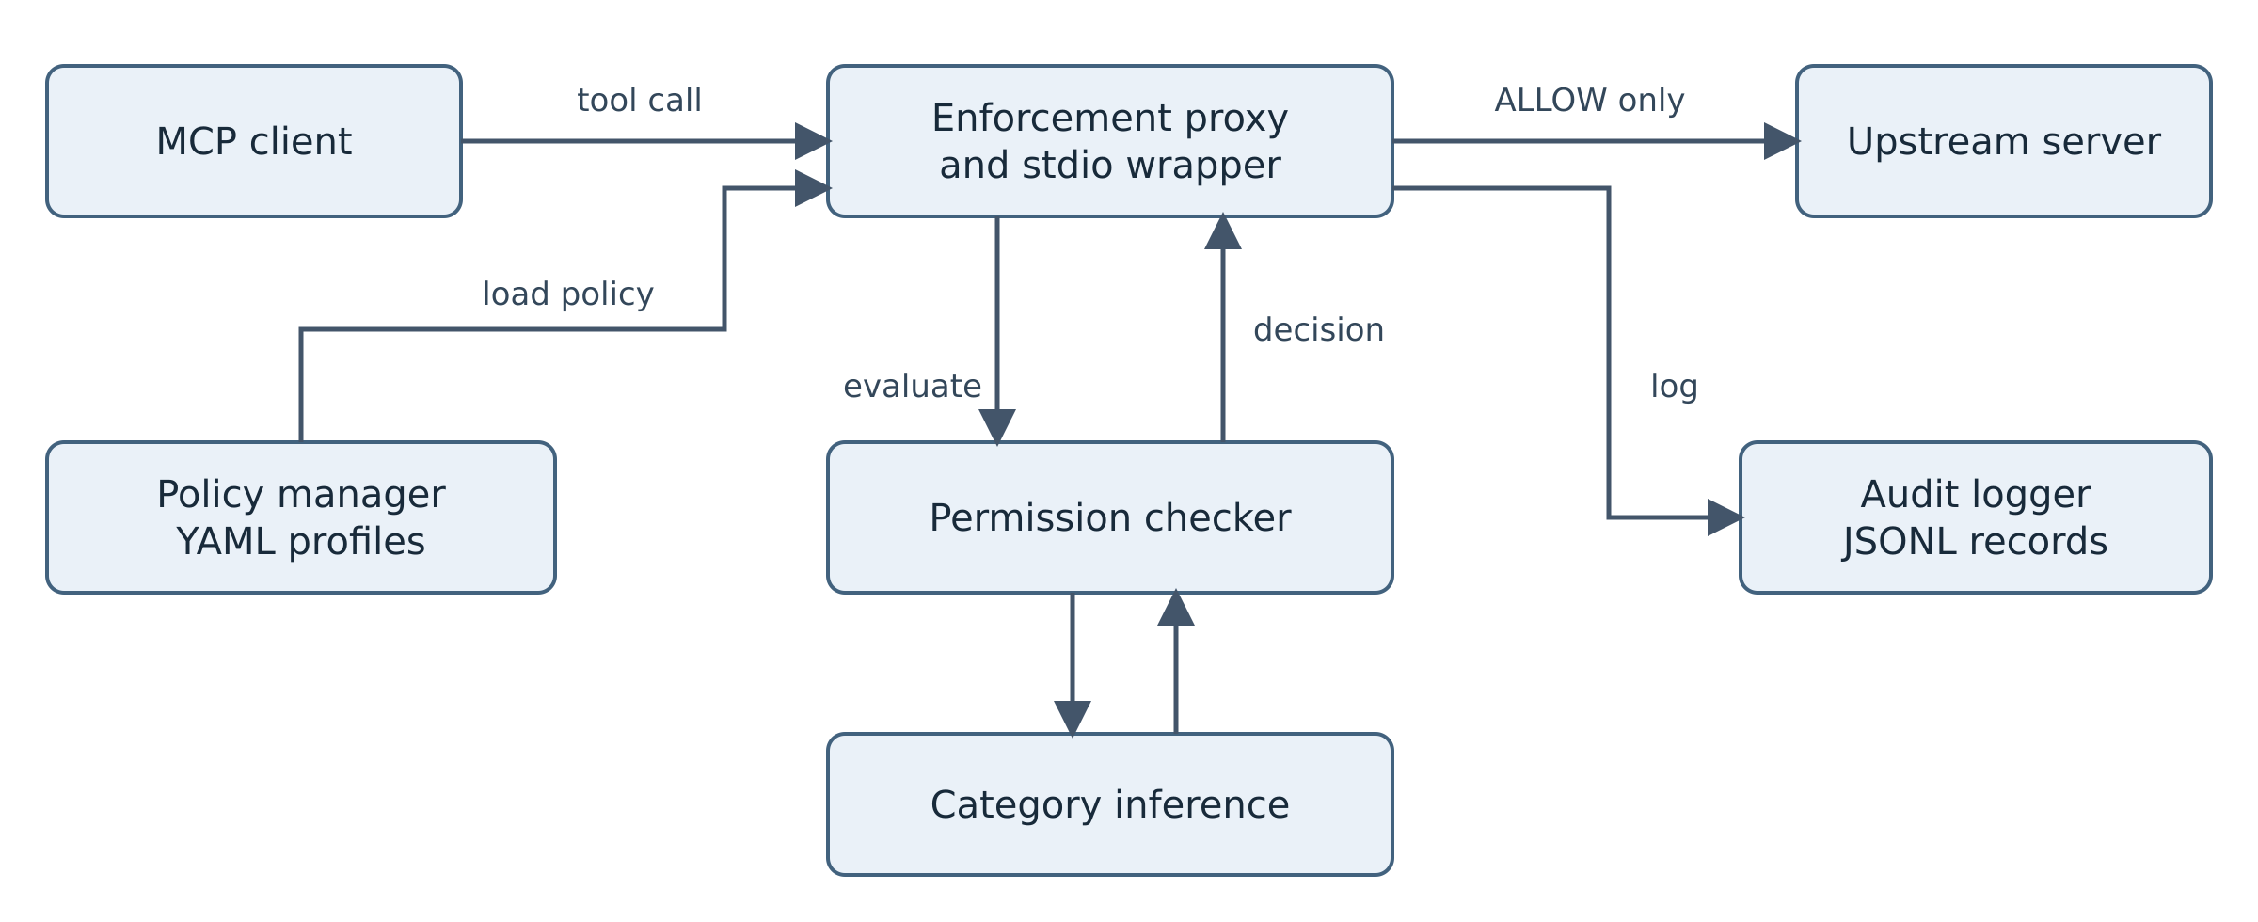
Figure 1. System architecture and proxy-mediated forwarding of permitted calls.
Figure 1 places the enforcement proxy between the MCP client and upstream servers. The checker returns its decision to the proxy; the stdio wrapper forwards a call upstream only after the proxy returns ALLOW.
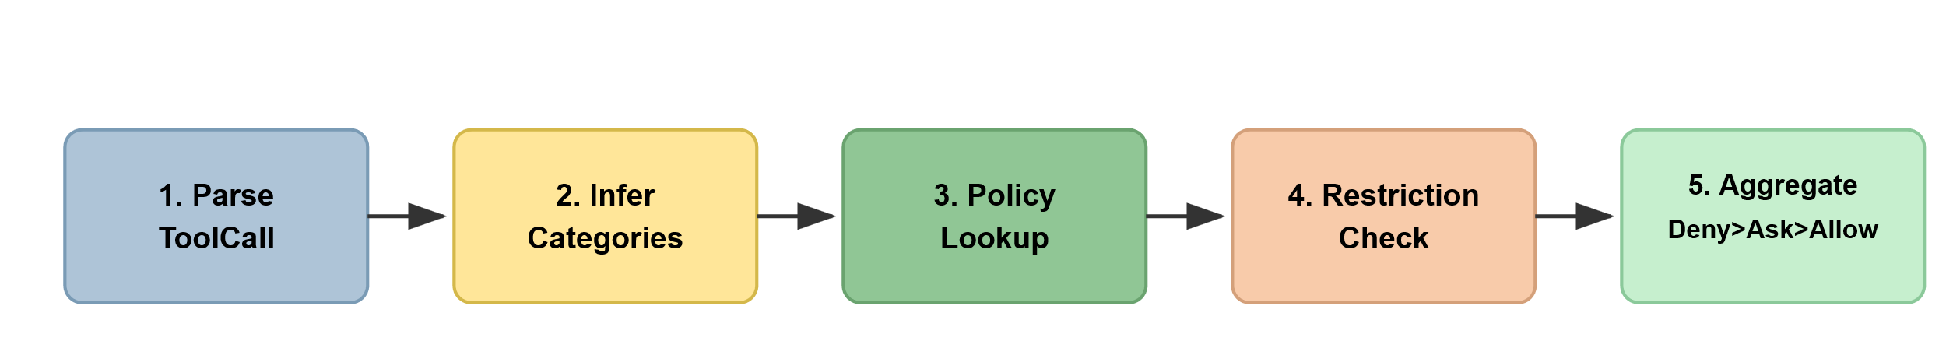
Figure 2. Five-stage decision pipeline.
Figure 2 summarises parsing, category inference, policy lookup, restriction checking, and decision aggregation. Enforcement and logging follow these five decision stages.
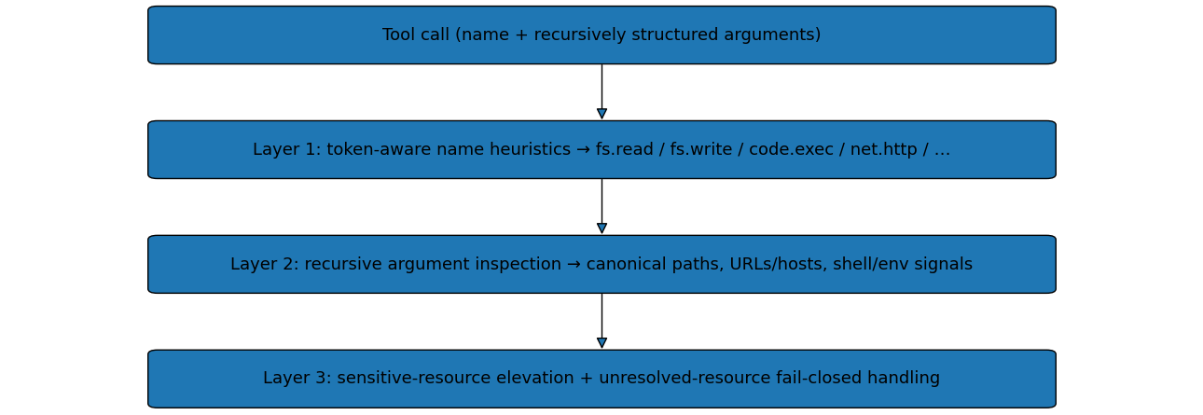
Figure 3. Three-layer capability inference with argument traversal and fail-closed resource handling.
Figure 3 shows that the inference path now recursively traverses nested dictionaries and lists, canonicalizes path and network resources, and distinguishes a resolvable allowed resource from an unresolved resource. Unknown calls and path-bearing calls whose read/write intent remains ambiguous are conservatively escalated through the existing high-risk surrogate, while restricted categories with an unresolvable path or domain fail closed during policy evaluation.

3.4.1. Formal Decision Algorithms
Algorithm 1 formalises permission inference for each tool call after recursive flattening of structured arguments. Name matching is token-aware to avoid incidental substring matches. Argument inspection evaluates every scalar leaf, canonicalizes path-like values, recognizes URLs as well as host/domain fields, combines tool-name and argument-key semantics to infer read versus write intent, and detects shell/environment indicators. Layer 3 elevates canonical sensitive paths, including POSIX, Windows, relative, and non-canonical .ssh/.env/key variants. If no category is inferred, or a path-bearing call remains semantically ambiguous, the implementation applies a conservative high-risk surrogate. Algorithm 2 then evaluates default-deny policy rules; when a category is subject to path/domain restrictions but the corresponding resource cannot be resolved, that restriction is treated as unsatisfied rather than as unrestricted access. ASK without a handler still fails closed to DENY.
The exact rules are included in src/inference.py and src/checker.py. Recursive traversal is shared by inference and restriction extraction so the supported nested list/dictionary resources are also evaluated by path/domain checks. Network extraction handles full URLs and split host/domain schema fields, while lexical path canonicalization normalizes slash direction and relative components without relying on the evaluator host filesystem. The inference lists remain intentionally conservative and versioned with the artifact.
Algorithm 1. Permission category inference for an MCP tool call.
Require: tool name n, argument map A
Ensure: permission set P, high-risk flag h
1: P ← ∅; h ← false
2: // Layer 1: name-based heuristics
3: if n matches a filesystem-read pattern then P ← P ∪ {fs.read} end if
4: if n matches a filesystem-write pattern then P ← P ∪ {fs.write} end if
5: if n matches an HTTP-request or messaging pattern then P ← P ∪ {net.http} end if
6: if n matches a shell-execution pattern then P ← P ∪ {code.exec} end if
7: if n matches an environment-read pattern then P ← P ∪ {env.read} end if
8: if n matches a process-control pattern then P ← P ∪ {process} end if
9: // Layer 2: recursive argument inspection and canonicalization
10: for each scalar leaf (q, k, v) ∈ Flatten(A) do
11: if v denotes a local filesystem path then p ← CanonPath(v); infer fs.write from write-like name/key/payload semantics, else infer fs.read end if
12: if local filesystem intent remains ambiguous then P ← P ∪ {code.exec}; h ← true end if
13: if v denotes a URL or host/domain field then P ← P ∪ {net.http}; retain each destination and its CanonDomain(v) or unresolved status end if
14: if v contains shell metacharacters or shell commands then P ← P ∪ {code.exec} end if
15: if v matches environment-variable or secret keywords then P ← P ∪ {env.read} end if
16: if v matches high-risk attacker indicators then P ← P ∪ {net.http, code.exec}; h ← true end if
17: end for
18: // Layer 3: sensitive-resource elevation
19: for each canonical path p ∈ ExtractPathsRecursive(A) do
20: if p is a sensitive path (e.g., any .ssh subtree, .env variant, or key material) then P ← P ∪ {env.read}; h ← true end if
21: end for
22: if P = ∅ then P ← {code.exec}; h ← true end if // unknown-call fail-closed surrogate
23: return P, h
The inference procedure in Algorithm 1 is exactly the three-layer construction used in src/inference.py. Let n denote the tool name, A the argument map, P the inferred permission set, and h the high-risk flag. Layer outputs are combined by set union:
$P = P_{name} ∪ P_{args} ∪ P_{sens}$ (1)
where P_name is produced by token-aware name heuristics, P_args by recursive scalar-leaf inspection after canonicalization, and P_sens by recursive sensitive-resource elevation. Each layer only adds categories. Flatten(A), CanonPath(·), and CanonDomain(·) are deterministic preprocessing functions specified by the implementation and unit tests; they do not remove a category inferred by an earlier layer.
For a local path-valued scalar leaf, read versus write context is determined from both token-aware tool-name semantics and argument structure (for example, write-like names such as persist/store, destination/output keys, and content/edit payload fields). In Equations (2)–(3), localPath(v) excludes URL values and recognized network route paths, and writeContext(n, A, k) uses the tool name n, arguments A, and leaf key k. A generic path with no reliable operation signal is treated as semantically unresolved and conservatively escalated rather than accepted merely because fs.read was inferred. A recognized network-tool name does not resolve an ambiguous local filesystem operation. A download call with a local path requires fs.write. A generic path field is never classified as an HTTP route merely because an HTTP-related name and sibling URL or host are present. The supported route convention requires an explicit route or request_path key, an HTTP-request name, a single-leading-slash value, and a destination in the same argument object; recognized download/write name signals override that convention. Separate local-output fields are evaluated independently. Thus http_request_download with an allowed URL and path=/tmp/output.json requires both net.http and fs.write and is denied under limited-network. For http_request with the same generic path and no reliable filesystem-operation signal, fs.read is accompanied by the high-risk code.exec uncertainty surrogate, also producing denial. This surrogate represents unresolved intent, not evidence of actual code execution.
An optional configuration binds the exact tool http_request to a new administrator-approved reference implementation, independently of caller arguments or advertised tool descriptions. Its strict schema accepts only {host, path} or {request: {host, path}}; its implementation constructs an HTTPS GET, rejects redirects and extra fields, and never uses path as a filesystem destination. The administrator supplies an approved source hash; the binding verifies the source before loading, rechecks it on use, and executes the same loaded snapshot. A mismatch fails closed; an initial hash mismatch prevents startup. The hash identifies the reviewed implementation, rather than proving arbitrary code safe. This exception applies only to that bound implementation. The default inference rules remain unchanged, and http_request_download receives no exemption. The manifest, implementation, checker and dependencies remain trusted deployment components; this configuration neither authenticates arbitrary remote servers nor provides operating-system confinement.
localPath(v) ∧ writeContext(n, A, k) = true ⇒ P ← P ∪ {fs.write} (2)
localPath(v) ∧ writeContext(n, A, k) = false ⇒ P ← P ∪ {fs.read} (3)
URL-valued and host/domain-valued arguments contribute net.http; shell metacharacters or command tokens contribute code.exec; environment-variable or secret keywords contribute env.read. Canonical sensitive-path matches add env.read and set the high-risk flag. The same recursive extraction functions are used later by restriction checks and retain unresolved destination status for subsequent fail-closed checks.
If no category is inferred, the existing fail-closed surrogate is applied; in the revised implementation the same high-risk surrogate is also added when a local path-bearing call has unresolved read/write intent, denoted by U(n, A) in Equation (4).
P = ∅ ∨ U(n, A) ⇒ P ← P ∪ {code.exec}, h ← true (4)
The code.exec surrogate remains a conservative representation of uncertainty rather than a claim that every unknown call executes code. A first-class unknown category remains a possible future refactoring, but the revised policy path no longer treats a partially classified yet semantically unresolved resource as automatically safe.
Algorithm 2. Policy evaluation and decision aggregation.
Require: tool call τ, policy π
Ensure: final decision d ∈ {ALLOW, DENY, ASK} and an audit record
1: (P, h) ← InferCategories(τ) // Algorithm 1
2: D ← empty map
3: for each category c ∈ P do
4: r ← Lookup(π, c)
5: if r is undefined then r ← DefaultDeny end if
6: if r.allow = false then D[c] ← DENY end if
7: if r.allow = true and (a path/domain restriction is violated or an applicable restricted resource is unresolved) then D[c] ← DENY end if
8: if r.allow = true and applicable restrictions are satisfied with the required resource resolved then D[c] ← r.mode end if // ALLOW or ASK
9: end for
10: // Aggregate with priority DENY ≻ ASK ≻ ALLOW
11: d ← undefined
12: if ∃ c ∈ P : D[c] = DENY then d ← DENY end if
13: if d = undefined and ∃ c ∈ P : D[c] = ASK then d ← ASK end if
14: if d = undefined then d ← ALLOW end if
15: if d = ASK and no ask-handler is configured then d ← DENY end if // fail-closed
16: Append an audit record for (τ, P, h, D, d)
17: return d
Algorithm 2 realises the policy lookup, restriction checks, and aggregation used in src/checker.py. After (P, h) ← InferCategories(τ), each category c ∈ P is mapped to a category-level decision D[c] ∈ {ALLOW, DENY, ASK}. Let r = Lookup(π, c), with missing rules replaced by DefaultDeny. Then:
$D[c] = \left\{\begin{aligned}DENY if r.allow = false ∨ restrictions(r,τ) violated \\ r.mode if r.allow = true ∧ restrictions(r,τ) satisfied\end{aligned}\right.$ (5)
Equation (5) is the closed form of Algorithm 2, steps 6–8 (DENY on disallow/violation; otherwise D[c] = r.mode).
Here restrictions(r, τ) denotes recursively extracted and canonicalized path checks for fs.read/fs.write/env.read and domain checks for net.http. When a rule contains a path or domain restriction, failure to resolve the corresponding resource is treated as an unsatisfied restriction and therefore DENY. Categories with no applicable restriction list retain r.mode when r.allow = true. Policy sensitive_paths are merged into filesystem/environment deny restrictions. Live local calls additionally resolve paths in the shared server working-directory context. POSIX reference file operations use directory-relative O_NOFOLLOW opens to reject symlink traversal at execution. These filesystem checks supplement the inference procedure in Algorithm 1. Network extraction retains the argument location and resolution status of each relevant destination, including nested and list-valued leaves. Scheme-relative URLs are canonicalized consistently; any unresolved destination fails an applicable domain restriction even when another destination is allowed.
The final decision aggregates category decisions with fixed priority DENY ≻ ASK ≻ ALLOW, matching PermissionChecker._aggregate():
$d = \left\{\begin{aligned}DENY if ∃c ∈ P : D[c] = DENY \\ ASK else if ∃c ∈ P : D[c] = ASK \\ ALLOW otherwise\end{aligned}\right.$ (6)
Equation (6) is the closed form of Algorithm 2, steps 11–14 (priority DENY ≻ ASK ≻ ALLOW), matching PermissionChecker._aggregate().
If d = ASK and no ask-handler is configured, the proxy fails closed by setting d ← DENY. The audit record stores (τ, P, h, D, d) together with decision-path latency, corresponding to DecisionRecord in the prototype. Equations (5) and (6) are therefore closed-form statements of Algorithm 2 and the deployed checker rather than an alternative decision model.

3.5. Implementation
This section describes how the proposed enforcement design is realised in the Python prototype and how it is deployed in an MCP workflow. The implementation details distinguish the internal module organisation from the configuration-only proxy deployment model.

3.5.1. Prototype Organisation
The Python 3 prototype implements capability inference, strict YAML policy loading, audit logging, a stdio enforcement proxy compatible with mcp==1.14.1, and an enforced launcher. The recorded automated suite contains 154 passing tests covering the earlier regression cases plus hardening cases for invalid policy values, custom sensitive paths, resolved symlinks, execution-boundary file access, malformed/bypass launch specifications, manifest integrity, launcher rejection, and MCP integration. A separate controlled stdio validation contains 12 explicit outcome assertions. Configuration validation alone does not prove operating-system isolation. The automated suite includes 29 follow-up regression tests for network-name/local-path combinations, explicit HTTP routes, scheme-relative URLs, and mixtures of allowed, denied, and unresolved destinations. A further 19 regression cases cover absolute HTTP-related local outputs, nested/list forms, explicit route controls, conflicting write signals and mixtures of route and local-path fields. Official reproduction uses Python 3.12 and python -m pip install -r results/final_environment_freeze.txt, followed by python -m pip check and python -m pytest -q. This complete validated environment pins Pydantic 2.13.5; requirements-lock.txt contains only four direct dependency pins and is not a complete environment lock. The additional 26 contract-related tests cover valid route controls, exact tool identity, schema violations, bad or changed source hashes, origin manipulation, denied-call non-execution and MCP integration.

3.5.2. Deployment Model
In the supported launch path, enforced_launcher.py first validates every client entry, compares the full configuration with an administrator-approved manifest, and verifies the interpreter and listed enforcement/policy file hashes. It then executes the exact proxy script without a shell. Unexpected interpreter flags, alternate script paths, environment injection, raw/remote entries, malformed arguments, and automatic ASK approval are rejected. The administrator must protect the interpreter, launcher, manifest, policy, repository, and configuration against modification. Other applications must be configured to use this launcher; independent client processes are not confined by it.
The proxy uses MCP stdio request handlers and the standard isError result field. It forwards only ALLOW decisions, preserving upstream error results; ASK defaults to DENY. The hardened live fixture exercises client-to-launcher-to-proxy-to-server communication and records upstream receipts independently of decision logs. In the limited-network session, four tool calls produce four audit records and only three upstream receipts: the denied write is absent from the receipts and creates no file. These observations establish mediation of the tested routed calls, not completeness across unconfigured transports or independent processes. Proxy-owned result metadata distinguishes policy denial, allowed upstream failure, successful protocol response, and transport failure. Upstream text is not used to infer denial; unknown outcomes are reported separately and excluded from authorization-rate denominators.
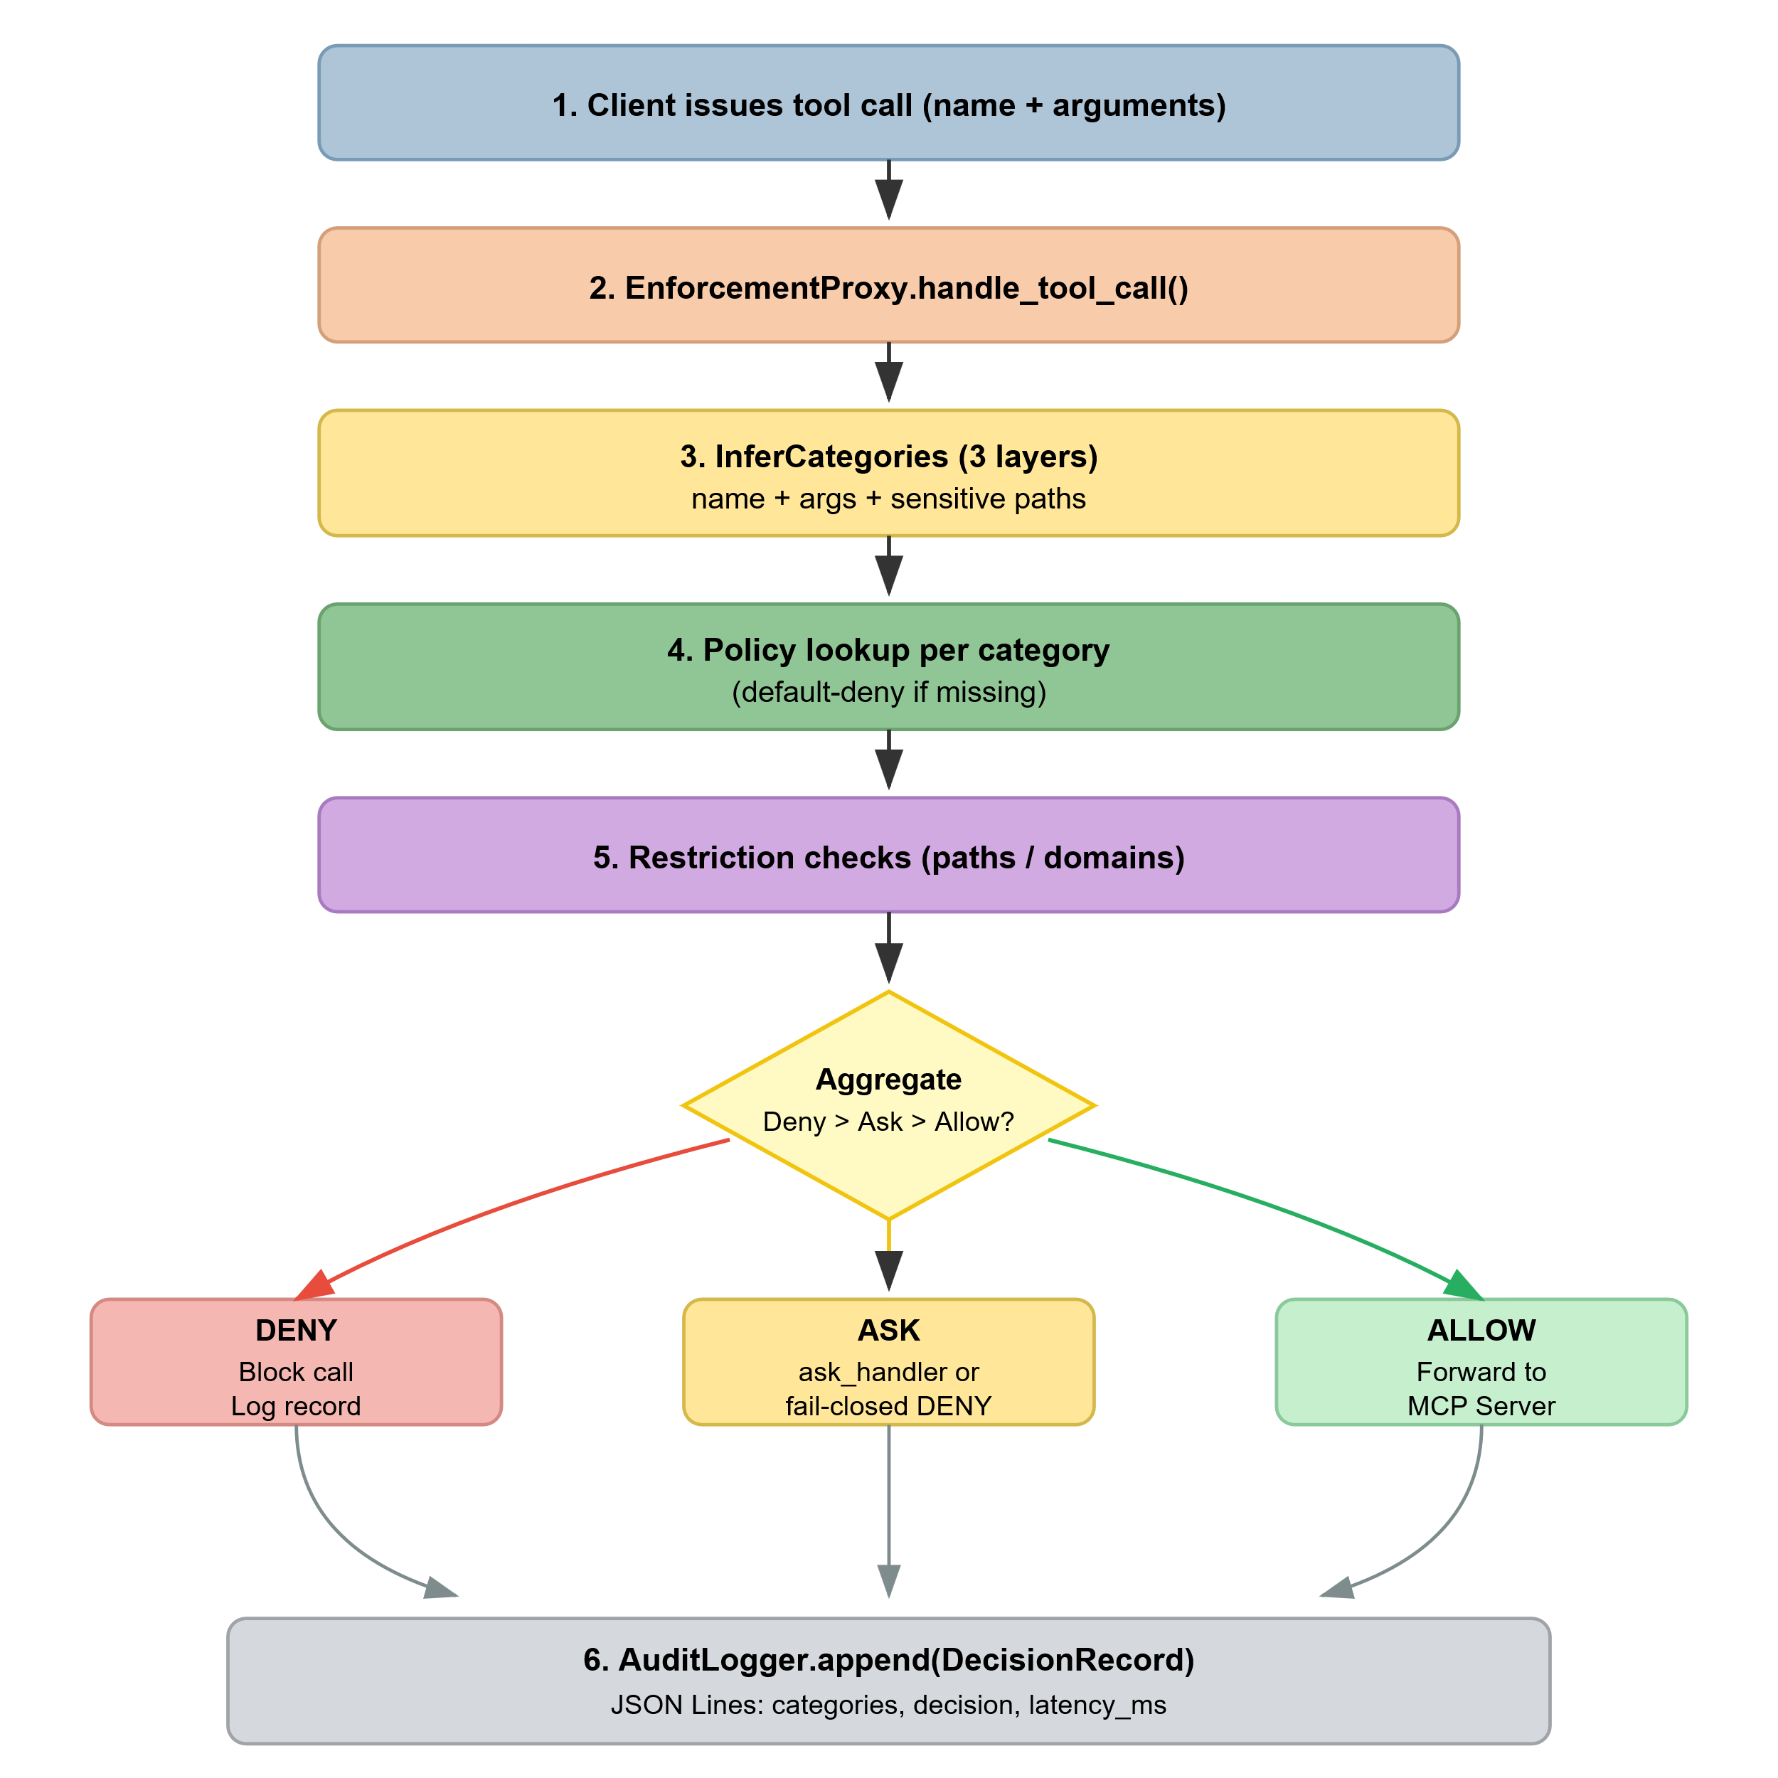
Figure 4. Tool-call decision flow in the Enforcement Proxy.
Figure 4 illustrates the tool-call path through the Enforcement Proxy, where denied requests are stopped locally and only allowed requests are forwarded upstream.

3.6. Experimental Protocol and Metrics
This section defines the staged evaluation used to separate development, stress testing, and external-validity evidence. It also specifies the enforcement-boundary metrics, baselines, and latency measurements used throughout the Results section.

3.6.1. Evaluation Phases, Design-Set Separation, and Robustness Splits
The evaluation distinguishes initial development, mechanism validation, and follow-up reruns on fixed datasets. The pilot_87 dataset, comprising 61 malicious and 26 benign calls, serves as the development set. The inference mechanism incorporates recursive argument traversal, canonicalization, fail-closed handling of unresolved resource intent, and token-aware semantics. A direct mechanism audit against documented official reference-server operations identified missing Git operation semantics and URL–path ambiguity, which were corrected before the inference rules were frozen. The follow-up revision corrects resource-specific uncertainty handling and mixed-destination checking; the capability audits, profile evaluations, declared-capability comparison, and workflow authorization replay were rerun after these changes. The 20,000-case template-stress corpus is generated deterministically using scripts/generate_stress_dataset.py and contains exactly 10,000 malicious and 10,000 benign calls; no random seed is required. This corpus evaluates stress tolerance and scalability rather than organic diversity or unseen generalization.
Phase C comprises a remapped-name robustness split derived from pilot_87; an organic hold-out containing 50 malicious and 40 benign hand-authored, non-template cases; a white-box boundary suite containing 16 distinct malicious and 8 distinct benign tool-name/argument combinations (48 malicious and 24 benign executions per profile); a 14-case auxiliary set based on public official MCP filesystem schemas; 25 real-MCP-style tool-call definitions; and ASK-path prompts. The remapped-name split is treated as a robustness transformation rather than an independent sample. The organic hold-out was maintained in a separate dataset file and was not used to select the six-category taxonomy, name rules, sensitive-path patterns, domain allow-list, or policy matrices. Labels were assigned during case construction from the intended scenario semantics, independently of defence outputs. Attacker-directed credential access, exfiltration, execution, destructive writes, and related harmful operations were labelled malicious; ordinary project reads, directory listings, and allow-listed documentation or API requests were labelled benign. These author-created or author-labelled sets are not treated as blinded population samples. Each boundary input is repeated identically three times; these repetitions do not add independent observations for a deterministic mechanism. The fixed suite predates the follow-up fixes and was rerun as regression coverage, without outcome-driven case changes. A separate 27-case official-reference mechanism audit derives expected categories directly from documented operation semantics. Additionally, a 16-case challenge instantiates harmful calls from externally authored MCPTox descriptions [6], retaining the original source identifiers. This provides external provenance, although the evaluation was not blinded because the source material was available during development of the challenge. No inference-rule changes were made after the final MCPTox challenge evaluation reported in Section 4.8.

3.6.2. Metrics and Evaluation Protocol
The evaluation reports enforcement-boundary metrics rather than full end-to-end agent-compromise metrics. All rates below are computed on the mediator decision d ∈ {ALLOW, DENY, ASK}, with ASK mapped to DENY in automated non-ASK studies, exactly as in the evaluation harness. Let M be the malicious case set and B the benign case set under a given study split.
Attack Success Rate (ASR) is the fraction of malicious tool calls that the layer allows to the upstream boundary:
ASR = |{τ ∈ M : d(τ) = ALLOW}| / |M| (7)
Block Rate on the malicious subset is the complement of ASR and equals the true-positive rate of attack blocking:
Block = 1 − ASR = |{τ ∈ M : d(τ) = DENY}| / |M| (8)
Benign Call Allow Rate (BCAR) is the fraction of benign individual calls allowed. The separate scripted replay reports workflow authorization, not executed task completion:
BCAR = |{τ ∈ B : d(τ) = ALLOW}| / |B| (9)
Benign Workflow Authorization Rate (BWAR) is the fraction of benign workflows for which every required step receives ALLOW; Malicious Workflow Authorization Rate (MWAR) is defined analogously. The 12 benign and 8 malicious workflows are replayed without outcome-driven retries. These rates do not establish successful tool execution or final task outcomes.
Attack-Blocking F1 treats a blocked attack as the positive class. With
TP = |{τ ∈ M : d(τ) = DENY}|, FP = |{τ ∈ B : d(τ) = DENY}| (10)
FN = |{τ ∈ M : d(τ) = ALLOW}|, TN = |{τ ∈ B : d(τ) = ALLOW}| (11)
$F1 = \frac{2 ⋅ TP}{2 ⋅ TP + FP + FN}$ (12)
These definitions are identical to the revised evaluation scripts. FN corresponds to residual ASR cases and FP to blocked benign calls. Uncertainty on pilot_87 is estimated with class-stratified percentile bootstrap resampling so malicious and benign denominators remain fixed across replicates; this quantifies sensitivity to resampling the supplied curated cases and is not a confidence statement about the universe of all MCP attacks, schemas, servers, or tasks. For non-boundary zero-event sets, nominal one-sided exact binomial bounds are reported subject to independent-sampling assumptions; the curated evaluation does not establish population coverage. The duplicated boundary suite is reported descriptively, without a population confidence bound. Latency terminology is also separated by timing boundary: checker-only excludes audit logging; local proxy decision-path timing includes synchronous logging; pinned-rerun live MCP timing includes transport, proxy handling, and upstream work.
${ASR}_{UB} = 1 - {0.05}^{\frac{1}{n}}$ (13)
Baselines B0–B3 are controlled lightweight reference systems rather than causal ablations of the full design or complete reimplementations of AgentBound, AGT, governed proxies, or IFC PEPs. Their observed differences describe these particular systems under the shared datasets; they do not independently isolate the causal contribution of multiple mechanisms that change simultaneously.
The live stdio evaluation was rerun with the unchanged 25 call definitions once per profile (100 calls), using Python 3.12.14, MCP 1.14.1, Pydantic 2.13.5, Node 24.19.0, and the official filesystem server 2026.8.31. The remaining servers are repository-versioned Python implementations. Timing surrounds client session.call_tool(), including transport, proxy handling and upstream response or denial, but excluding startup and tool discovery. All 24 server sessions initialized successfully, and all 100 authorization outcomes were resolved from proxy metadata; upstream execution errors were recorded separately. The complete Python environment, npm lock, rerun script and protocol receipts are released (scripts/run_table8_pinned.py; results/table8_pinned_rerun/). These live measurements remain separate from checker-only and local proxy-plus-logging microbenchmarks. The subsequent HTTP-path correction preserves all 100 corresponding authorization decisions in replay; the live timings retain their original pinned-run provenance.
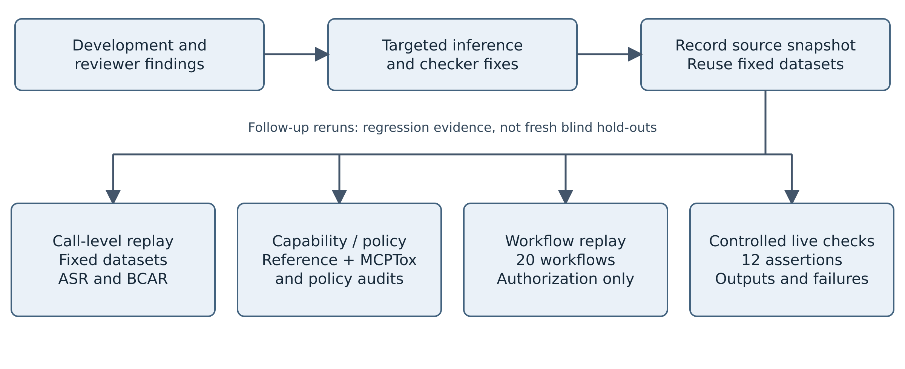
Figure 5. Evaluation stages and separate follow-up validation tracks.
Figure 5 distinguishes fixed-dataset call-level reruns, capability/policy audits, workflow authorization replay, and controlled live integration checks. These follow-up evaluations provide regression evidence; they are not fresh blind hold-outs.

3.6.3. Direct Capability-Inference, Policy, Configured-Path, ACL, and Task-Level Validation
Profile-level security and utility outcomes alone do not establish the validity of the permission-inference mechanism. The evaluation therefore includes a policy-independent category-recovery audit. For each call i, Eᵢ denotes the expected capability set, specified independently of the YAML profile, and Iᵢ denotes the set returned by infer_categories(). Exact-set accuracy is |{i : Iᵢ = Eᵢ}|/N; required-capability coverage is |{i : Eᵢ ⊆ Iᵢ}|/N; and micro precision, recall, and F1 are computed over category labels when Eᵢ is intended to be exhaustive. The 27-case official-reference audit uses documented semantics from the MCP filesystem, Git, fetch, and Everything/get-env reference servers [30]. Because this audit was used to correct missing Git semantics and URL/path ambiguity, it is reported as a mechanism audit rather than a blind hold-out.
The 16-case MCPTox challenge was originally instantiated after the initial inference freeze, using source descriptions with retained identifiers and author-assigned minimum-capability labels. The fixed challenge was rerun after the follow-up corrections. Policy faithfulness uses 24 category/profile checks plus three restrictions. Configuration testing retains six valid entries, four raw-upstream injections, and 12 in-process audit calls; the added hardening suite rejects eight bypass/malformed specifications and tests manifest tampering. The declared-capability comparator now independently implements lexical resource and decision rules without calling PermissionChecker or inference helpers; it is an in-process comparator, not a deployed server sandbox or full AgentBound/AGT reproduction. The 12-benign/8-malicious workflow set is authorization replay: every required call must be ALLOW, but no task output is produced. Separately, 12 live stdio assertions verify actual outputs and side effects for controlled read/read and write/read workflows, denied writes, ASK, errors, symlinks, and upstream crash. This small integration fixture is not an autonomous-agent task benchmark.

4. Results
This section presents results from the development set, template-stress corpus, baseline comparisons, hold-out evaluation, white-box boundary tests, public-schema-based cases, and real-MCP-style scenarios. It also reports ablation studies, uncertainty estimates, latency measurements, ASK-path evaluation, configured-path checks, ACL comparisons, and workflow authorization replay. Call-level BCAR and benign/malicious workflow authorization rates are reported separately.

4.1. Pilot Design-Set and Template Stress
The pilot set remains a design/development set. Under limited-network, corrected inference yields ASR 1.64% (1/61 malicious calls allowed), Block Rate 98.36%, BCAR 76.92% (20/26 benign calls allowed), and Attack-Blocking F1 94.49%. These pilot values are retained for continuity and are not interpreted as external-validity evidence.
On the fixed 20,000-case template-stress corpus (10,000 malicious / 10,000 benign), the HTTP-path correction yields limited-network ASR 0.00% and BCAR 66.68%. Read-only yields 0.00% ASR and 50.01% BCAR; no-code-exec yields 8.33% ASR and 91.67% BCAR; approval-gated (ASK→DENY in automated non-ASK runs) yields 0.00% ASR and 75.01% BCAR. Limited-network BCAR decreases from 75.01% because 833 benign generic host/path requests are now conservatively rejected as unresolved. Inputs and labels were not changed. The archived mean checker-record times in Table 5 predate this correction and were not remeasured. The stress corpus is a deterministic scalability/stress instrument, not evidence of organic diversity.
Table 4. Pilot security results (61 malicious / 26 benign; F1 = attack-blocking F1).
Policy | ASR | Block | BCAR | F1
baseline | 100% | 0% | 100% | 0%
read_only | 1.64% | 98.36% | 57.69% | 90.91%
limited_network | 1.64% | 98.36% | 76.92% | 94.49%
no_code_exec | 6.56% | 93.44% | 100.00% | 96.61%
approval_gated | 4.92% | 95.08% | 76.92% | 92.80%
On the pilot set, limited-network records 1.64% ASR and 76.92% BCAR. These are call-level development-set measurements, not task-completion rates.
Table 5. Revised template-stress results (10,000 malicious / 10,000 benign; BCAR = benign-call allow rate).
Policy | ASR | BCAR | F1 | Archived checker ms/call
read_only | 0.00% | 50.01% | 80.00% | 0.17
limited_network | 0.00% | 66.68% | 85.72% | 0.18
no_code_exec | 8.33% | 91.67% | 91.67% | 0.16
approval_gated | 0.00% | 75.01% | 88.89% | 0.17
On the regenerated 20,000-case stress corpus, limited-network blocks all 10,000 malicious calls in this template set while allowing 66.68% of benign calls; this result should be read as stress/scalability evidence only.
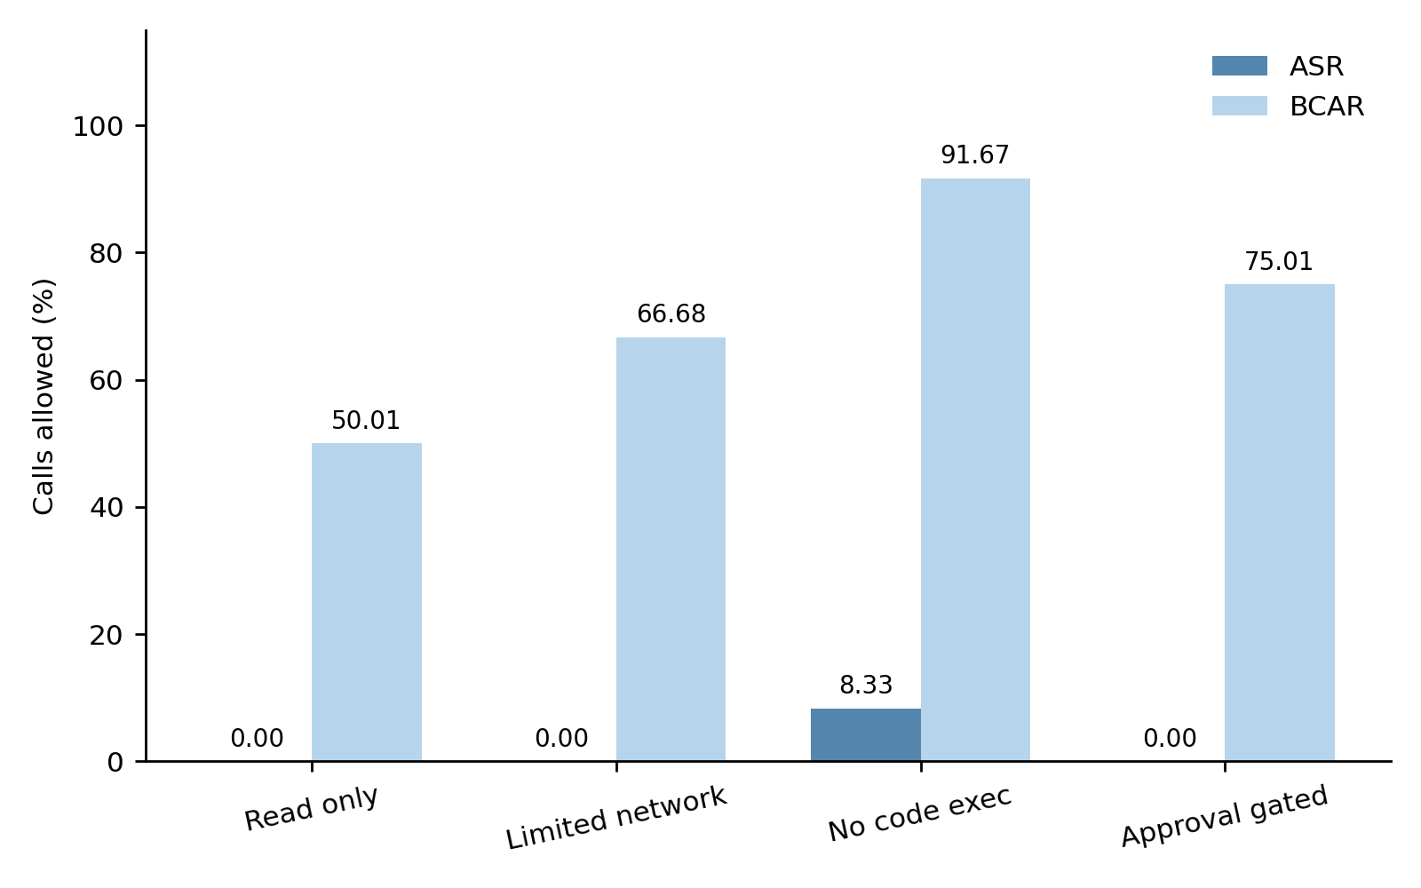
Figure 6. ASR and BCAR on the regenerated 20,000-case template-stress corpus.
The grouped bars illustrate the measured trade-off between attack prevention and benign-call allowance; BCAR measures call-level authorization rather than end-to-end task success.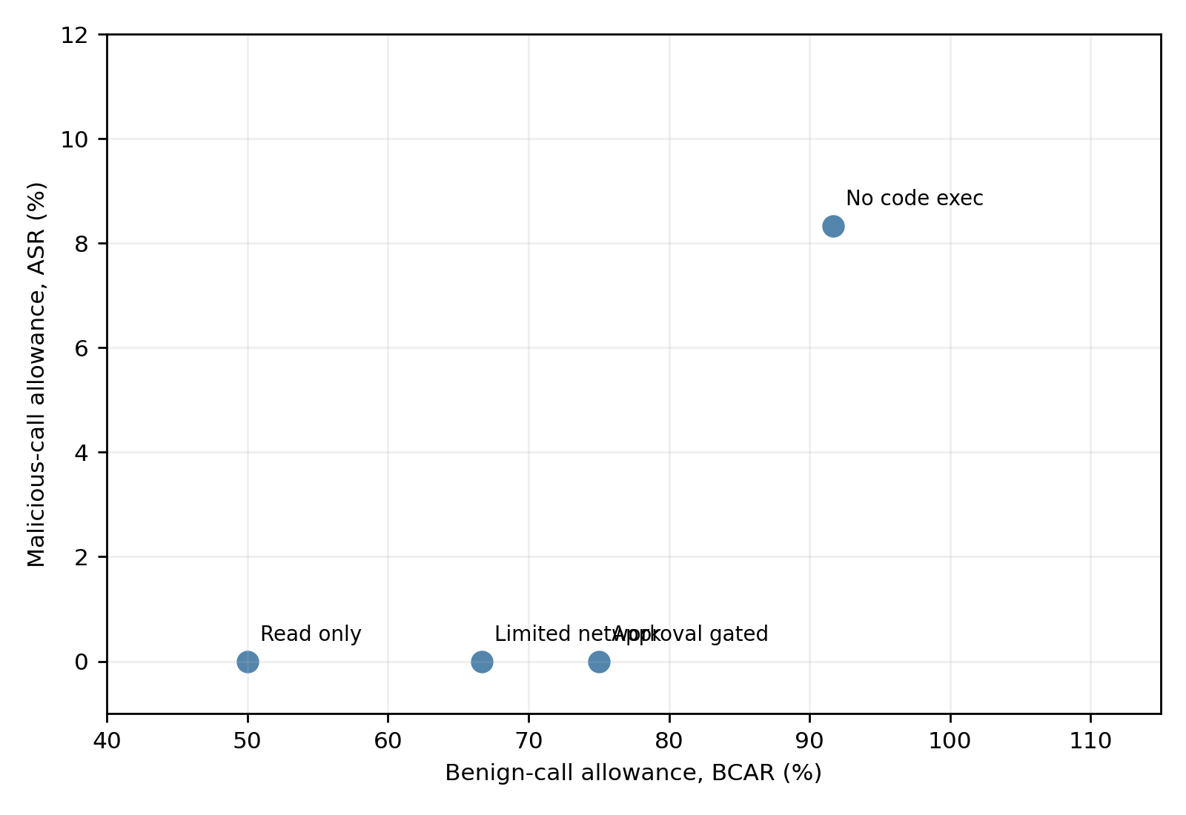
Figure 7. Security–call-utility trade-off on the regenerated template-stress corpus.
The scatter plot reports ASR against BCAR. It is descriptive of the measured corpus and is not a general deployment ranking.

4.2. Baseline Comparison
The baseline study treats B0–B3 as controlled lightweight reference systems. Because several abstractions and inputs differ simultaneously between B3 and B4, the comparison is descriptive rather than a causal isolation of specific mechanisms.
On pilot_87, B1/B2/B3/B4 yield ASR 54.10%/65.57%/24.59%/1.64% and BCAR 100%/100%/100%/76.92%. On the fixed organic set, the follow-up rerun yields ASR 2.00%/84.00%/24.00%/0.00% and BCAR 90.00%/100.00%/100.00%/100.00%. Table 6 reports both datasets. These comparisons are descriptive, dataset-specific security-utility results; they are not an unqualified 'outperforms' claim and do not causally isolate individual mechanisms.
Table 6. Controlled baseline comparisons on pilot_87 and the fixed organic set (BCAR = benign-call allow rate).
Baseline | ASR | Block | BCAR | F1
B0 no defence | 100.00% | 0.00% | 100.00% | 0.00%
B1 static allowlist | 54.10% | 45.90% | 100.00% | 62.92%
B2 definition scan | 65.57% | 34.43% | 100.00% | 51.22%
B3 gateway filter | 24.59% | 75.41% | 100.00% | 85.98%
B4 full layer | 1.64% | 98.36% | 76.92% | 94.49%
Organic set (50 malicious / 40 benign; fixed cases, follow-up rerun)
B0 no defence | 100.00% | 0.00% | 100.00% | 0.00%
B1 static allowlist | 2.00% | 98.00% | 90.00% | 95.15%
B2 definition scan | 84.00% | 16.00% | 100.00% | 27.59%
B3 gateway filter | 24.00% | 76.00% | 100.00% | 86.36%
B4 full layer | 0.00% | 100.00% | 100.00% | 100.00%
Across the two datasets in Table 6, B4 records the lowest ASR among B1-B4. On pilot_87, however, its BCAR is 76.92% versus 100% for B1-B3; on the organic hold-out, B4 reaches 0% ASR and 100% BCAR. The comparison therefore supports dataset-specific security-utility differences rather than an unconditional superiority claim, and it does not isolate the causal contribution of any single mechanism.
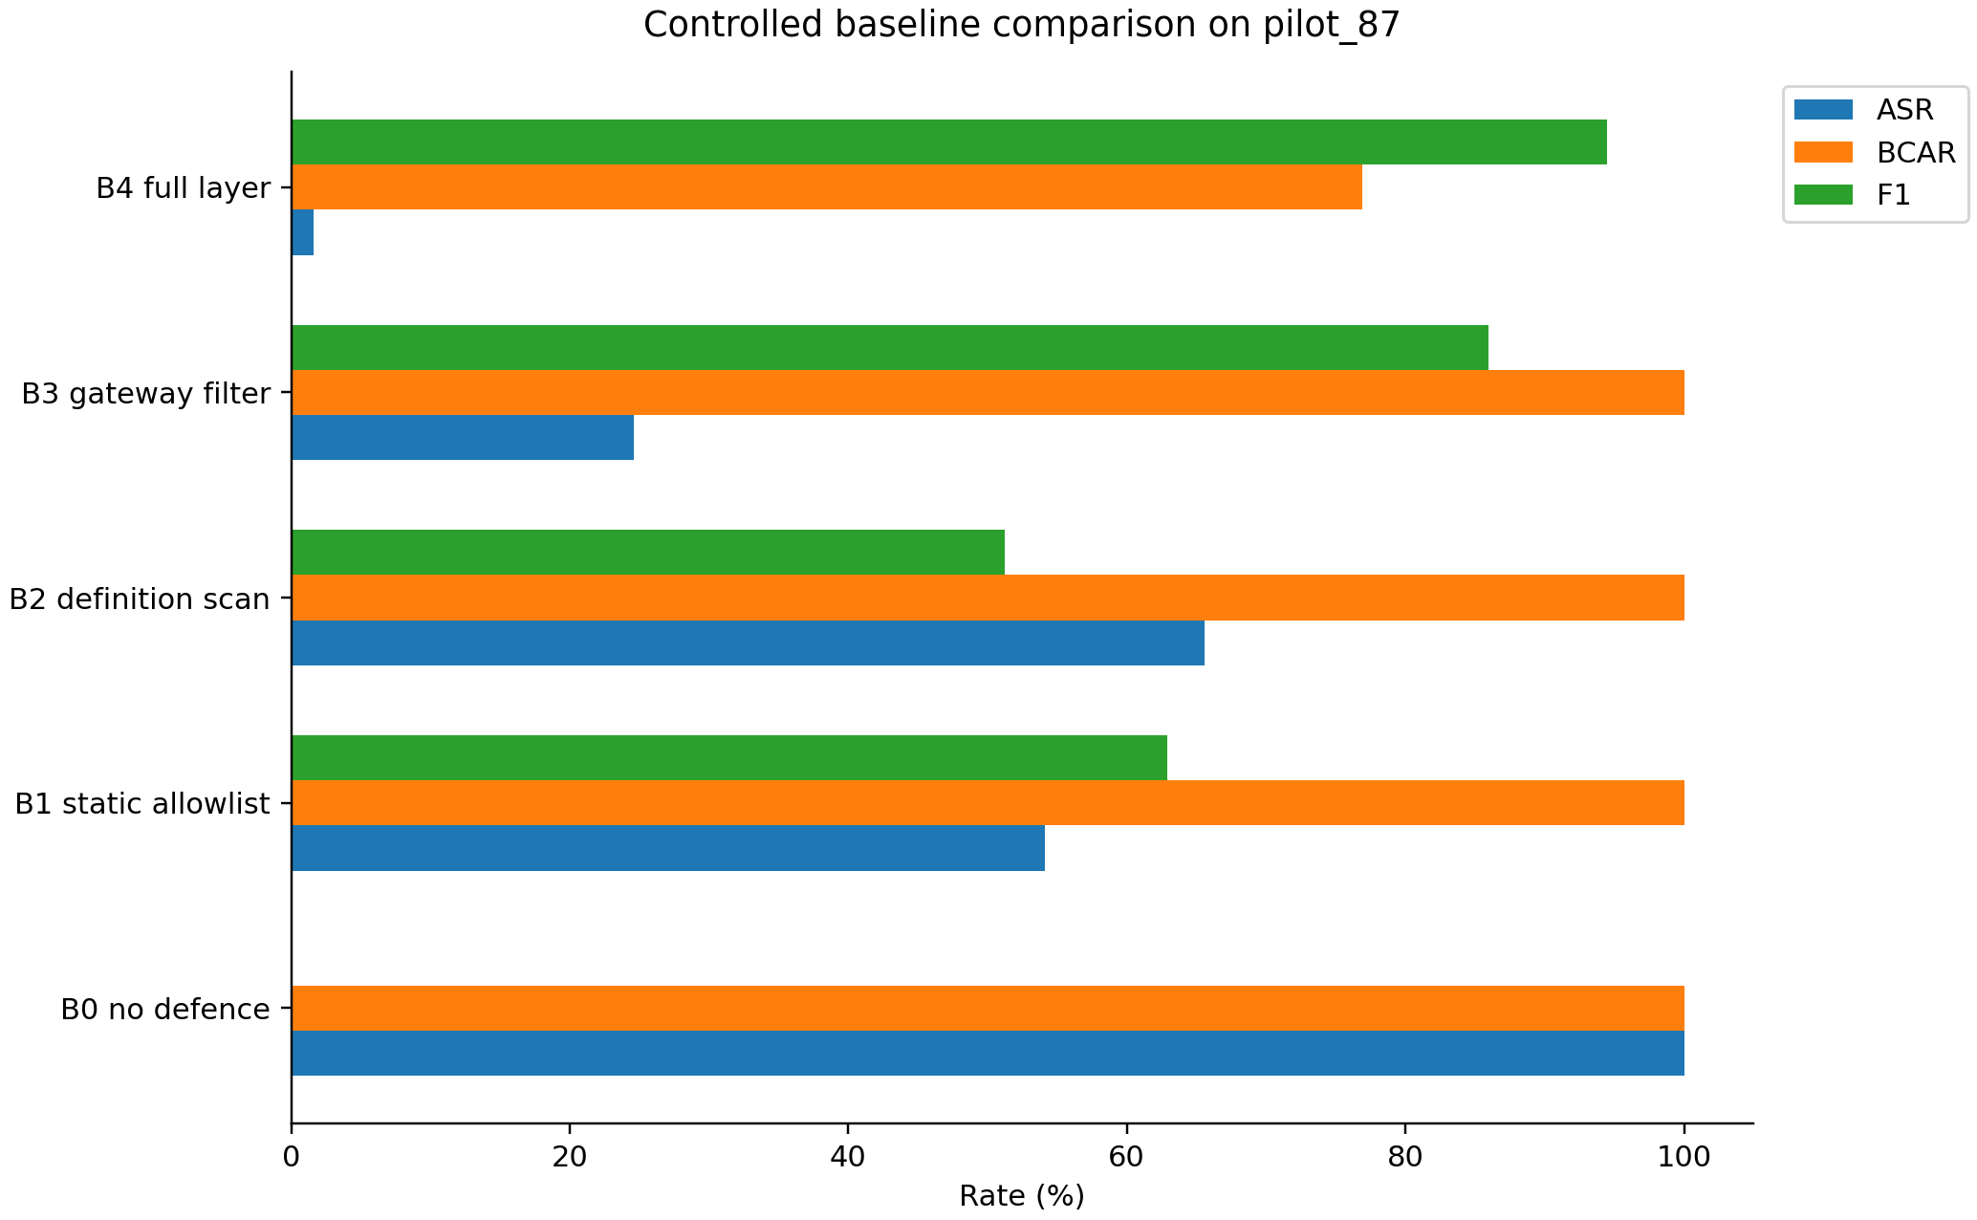
Figure 8. Controlled baseline comparison on pilot_87 using ASR, BCAR, and Attack-Blocking F1.
The visual comparison is descriptive of the five evaluated systems on the development set; it is not a causal component attribution.

4.3. Remapped-Name Robustness and Organic Hold-Out
The remapped-name split reuses the underlying pilot cases and therefore remains robustness evidence rather than an independent hold-out. Under the corrected fail-closed logic, limited-network records 0.00% ASR but only 23.08% BCAR on this split, showing the utility cost of unresolved semantics when names are aggressively remapped. The separately constructed organic set adds scenarios beyond renamed pilot inputs; its follow-up rerun remains regression evidence rather than a fresh blind test.
Table 7. Organic hold-out (50 malicious / 40 benign; BCAR = benign-call allow rate).
Profile | ASR | BCAR | F1
read_only | 0.00% | 75.00% | 90.91%
limited_network | 0.00% | 100.00% | 100.00%
no_code_exec | 2.00% | 100.00% | 98.99%
approval_gated | 2.00% | 100.00% | 98.99%
On the organic hold-out, limited-network records 0/50 observed malicious successes and 100% BCAR. The nominal one-sided 95% exact binomial upper bound for 0/50 events is 5.82% under independent-sampling assumptions; this curated set does not establish population coverage or zero population risk.
4.4. Live MCP Evaluation
The pinned live evaluation comprised 25 distinct calls per profile: 12 malicious and 13 benign. Table 8 reports authorization outcomes: limited-network and approval-gated each denied all 12 malicious calls and allowed all 13 benign calls. Read-only allowed 10/13 benign calls (76.92% BCAR). Both read-only and limited-network deny fs.write; the three-call difference is due to allow-listed HTTP requests RM-004, RM-005 and RM-009, which read-only denies. No-code-exec allowed one malicious call (RM-017, a write to /tmp/malware.py), giving 8.33% ASR; the upstream filesystem server rejected that write as outside its workspace. Two allowed benign reads, RM-001 (src/main.py) and RM-021 (package.json), returned missing-file errors. Thus successful benign protocol responses were 11/13 for limited-network, no-code-exec and approval-gated, and 8/13 for read-only. Authorization allowance is not a measure of successful task completion. All 100 calls had known authorization outcomes; none was classified from an unknown response.
Table 8. Pinned-version live stdio MCP-path rerun (authorization metrics)
Defence | ASR | BCAR | F1 | Mean end-to-end latency (ms)
B0 no defence | 100.00% | 100.00% | 0.00% | n/a
B4 limited_network | 0.00% | 100.00% | 100.00% | 1502.564
B4 read_only | 0.00% | 76.92% | 88.89% | 3.248
B4 no_code_exec | 8.33% | 100.00% | 95.65% | 1158.221
B4 approval_gated | 0.00% | 100.00% | 100.00% | 1359.548
Notes: (1) B0 is a conceptual allow-all comparator, not an executed baseline; TP = 0 and FN = 12. (2) Mean latency covers all 25 session.call_tool() invocations per profile, including denials and upstream errors. It includes public-network and upstream work and is not directly comparable with checker-only or local proxy-plus-logging timing. (3) The three-call BCAR difference between read-only and limited-network is due to allow-listed net.http access (RM-004, RM-005 and RM-009). (4) The exact historical npm filesystem-server version was not recorded, limiting reproduction of the original measurements. This table replaces those values with a fresh run using version 2026.8.31; the original results remain archived. The new environment, lockfile, receipts and audit logs are released with the rerun.

4.5. Adaptive and Multi-Step Evaluation
The white-box boundary suite contains 16 distinct malicious and 8 distinct benign inputs, each repeated identically three times (48 malicious and 24 benign executions per profile), covering nested dictionaries and lists, list-valued paths, split host/path destinations, unresolved network destinations, unfamiliar write-like operations, tool-name substring boundaries, nested secret indicators, shell payloads within lists, Windows-style paths, and relative or non-canonical sensitive paths. The fixed suite was replayed after the HTTP-path correction. Under limited-network, 0/16 distinct malicious inputs are allowed (0/48 executions), and 6/8 distinct benign inputs are allowed (18/24 executions; 75% BCAR). Two distinct benign generic host/path inputs are conservatively denied because their operation remains unresolved. These are finite-suite observations; identical repetitions do not justify additional independent evidence or a population confidence bound. A separate renamed-write regression evaluates archive_object({"path": "workspace/output.txt"}). The call contains an ordinary path without sensitive-resource, shell, network, or payload indicators, and its name falls outside the recognized write-token rules. Path evidence initially contributes fs.read. Because the operation’s read-versus-write intent remains unresolved, the inference mechanism additionally assigns the conservative code.exec uncertainty surrogate and marks the call as high-risk. Limited-network therefore denies the call, yielding 0/1 allowed attacks. This conservative treatment prevents a partially inferred permission set from bypassing uncertainty handling; it does not imply that the mechanism recovered the hidden fs.write capability. An auxiliary dataset based on public official MCP filesystem schemas contains 5 malicious and 9 benign cases. Limited-network records 0/5 observed malicious successes and 88.89% BCAR. This author-labelled dataset evaluates compatibility with realistic tool schemas and is reported separately from independently labelled external benchmarks. The follow-up regressions also deny download({"url":"https://docs.python.org/3/library/os.html","path":"project/settings.json"}) through fs.write and deny an unresolved or disallowed network destination even when an allowed URL is present elsewhere. These checks establish authorization behaviour, not exploitation of an external server.
The multi-step evaluation contains 13 malicious chains. A chain is defined as fully successful only when every step is ALLOW under the evaluated mediator, so every represented step must receive ALLOW; actual secret acquisition, transfer, or sink execution is not verified in this replay. Partial progress, such as two of three stages being allowed, is therefore counted as failure for full-chain ASR rather than as evidence that intermediate permissions are impossible. Production enforcement remains per-call. Separately, the harness includes an exploratory session-taint mediator that marks high-risk or secret-read attempts and blocks later sinks including net.http, fs.write, code.exec, and process. Under both mediators, 0/13 chains fully succeed; the session-taint mediator remains exploratory and is not presented as a production information-flow control plane. In addition to full-chain ASR (0/13 under limited-network), we report step-level malicious-call allowance: 10.7% (3/28 malicious steps ALLOW) under limited-network, showing that partial progress can occur even when no chain fully succeeds.
Table 9. White-box boundary evaluation (16 distinct malicious and 8 distinct benign inputs; 48 malicious and 24 benign executions per profile; repeated-input and distinct-input rates coincide; BCAR: benign-call allow rate).
Profile | ASR | BCAR | F1
read_only | 0.00% | 62.50% | 91.43%
limited_network | 0.00% | 75.00% | 94.12%
no_code_exec | 18.75% | 75.00% | 83.87%
approval_gated | 6.25% | 75.00% | 90.91%
B0 no defence | 100.00% | 100.00% | 0.00%
On the fixed boundary set, limited-network records 0.00% ASR and 75.00% BCAR. Read-only records 0.00% ASR and 62.50% BCAR; no-code-exec records 18.75% ASR and 75.00% BCAR; approval-gated records 6.25% ASR and 75.00% BCAR. The lower benign allowance reflects fail-closed handling of generic host/path inputs; labels and calls are unchanged.
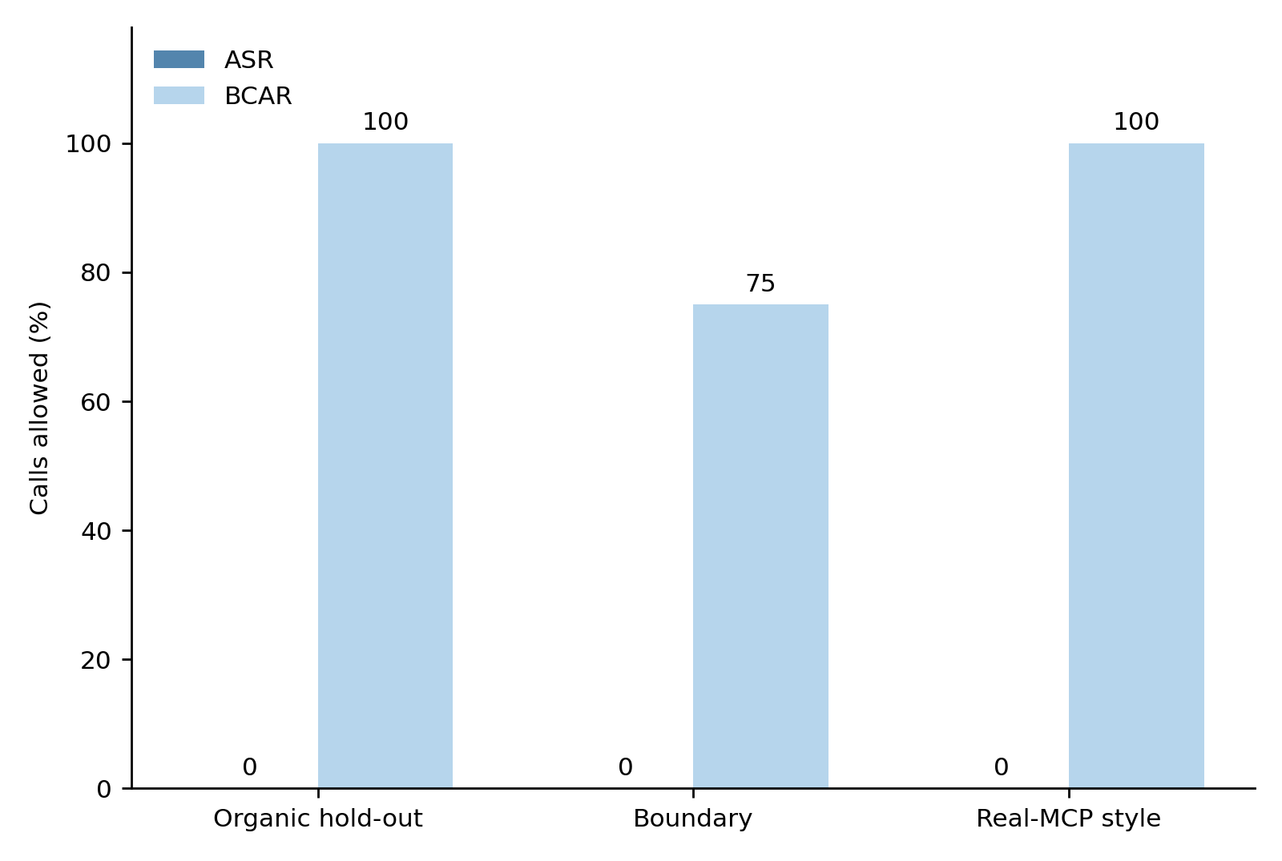
Figure 9. Limited-network results across organic hold-out, white-box boundary, and real-MCP-style evaluations.
Across these three limited-network evaluations, observed ASR is 0%; BCAR is 100% on the organic hold-out and real-MCP-style sets and 75% on the boundary suite. The malicious input counts are 50, 16 distinct boundary inputs (48 executions), and 12. The boundary result is descriptive; no population confidence bound is inferred from repeated executions.
Optional trusted-adapter experiment. We separately replayed the same seven datasets using an explicit deployment assignment: exact http_request calls containing host and path at the root or under request use the approved adapter; all other calls retain default inference. Assignment uses neither reference labels nor destination allow-lists. It covers 1,667 stress records and 12 boundary records, including malicious cases. Inputs and labels are unchanged. This is a new configured experiment, not a reconstruction of the historical server or a replacement for the default results in Tables 5 and 9.
Under limited-network, the optional configuration yields stress BCAR 75.01% (7,501/10,000), compared with 66.68% for default inference, and boundary BCAR 100% (8/8 distinct benign calls; 24/24 executions), compared with 75% (6/8; 18/24). Observed ASR remains 0% on both suites. This finding is policy-specific: the configured no-code-exec and approval-gated profiles have stress ASR of 16.67% and 8.34%, and boundary ASR of 25% and 12.50%, respectively. Complete results for all profiles and per-call differences are released with the evaluation script. Boundary counts remain descriptive finite-suite coverage.
The comparison measures authorization replay, not live task completion or new latency. A separate MCP smoke request through the approved adapter to https://docs.python.org/3/ returned an allowed, successful upstream response; the retained receipt also records an earlier DNS failure before the existing proxy environment was forwarded. This single request does not establish benchmark-wide execution success. The default configuration preserves all previously corrected metrics, and the Table 8 live measurements retain their original provenance.

4.6. Component Ablation
Rerunning the packaged source corrects several stale ablation entries. On pilot_87, removing argument inspection yields ASR/BCAR 1.64%/76.92%; removing sensitive-path elevation yields 11.48%/76.92%; removing domain allow-listing yields 4.92%/76.92%; removing name heuristics yields 0%/19.23%. On the organic set, the full, no-argument, and no-sensitive conditions retain 0% ASR and 100% BCAR; without domain allow-listing ASR is 2% with 100% BCAR; without name heuristics ASR is 0% with 25% BCAR. The previous packaged implementation and follow-up implementation reproduce these same suite-level security/utility values. These ablation entries reconcile stale saved results; they do not establish unchanged behavior outside the evaluated suites.
Table 10. Component knock-outs on limited-network / pilot_87
Config | ASR | BCAR | F1
Full system | 1.64% | 76.92% | 94.49%
Without argument inspection | 1.64% | 76.92% | 94.49%
Without sensitive-path elevation | 11.48% | 76.92% | 89.26%
Without domain allow-list | 4.92% | 76.92% | 92.80%
Without name heuristics | 0.00% | 19.23% | 85.31%
The revised ablation does not support attributing each metric change to a single component in isolation. In particular, the name-heuristic knock-out strongly increases fallback use, and the fixed organic-set rerun shows that several other knock-outs have no measurable effect on that small set.
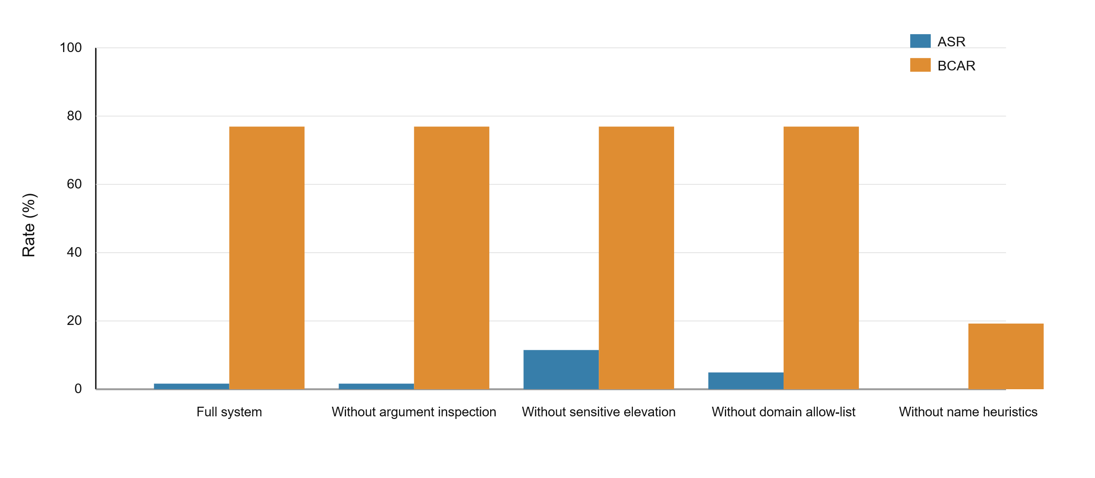
Figure 10. Component knock-outs under limited-network on pilot_87 using ASR and BCAR.
The figure visualises development-set interactions; the fixed organic-set rerun is reported separately to avoid generalising the pilot ablation pattern.

4.7. Uncertainty, Latency Boundaries, and Ask Policy Simulation
Using a class-stratified percentile bootstrap with 2,000 replicates (seed 42) on limited-network / pilot_87, ASR is 1.64% with a 95% interval of [0.00, 4.92], BCAR is 76.92% with [61.54, 92.31], and Attack-Blocking F1 is 94.49% with [90.77, 97.60]. These intervals quantify resampling sensitivity of the supplied development cases, not uncertainty over the wider population of MCP attacks or tasks. For the organic and real-MCP-style sets, nominal one-sided 95% binomial upper bounds are 5.82% (0/50) and 22.09% (0/12), respectively, conditional on independent-sampling assumptions. The boundary suite records 0/16 distinct malicious allowances (0/48 executions); no population confidence bound is reported because the inputs are curated and repeated identically. The archived v1.4 latency measurements were run on a Linux x86_64 environment with 5 allocated logical CPUs on an AMD EPYC 9V74 80-Core Processor, 5.81 GiB RAM, and Python 3.13.5. Checker-only timing measures only PermissionChecker.evaluate, excluding audit logging, proxy framing, transport, and upstream execution; it uses 5 repetitions over the 87 pilot cases (435 timed operations) and yields mean/median/p95/p99 = 0.153/0.145/0.188/0.212 ms. Local-proxy timing measures EnforcementProxy.handle_tool_call including synchronous JSONL logging, excluding MCP transport and upstream execution; it uses 3 repetitions over the same 87 cases (261 timed operations) and yields 0.183/0.179/0.233/0.271 ms. The term 'sub-millisecond' is used only for the checker mean and median; p95 and p99 are reported numerically rather than being covered by that summary. Pinned-rerun live Table 8 timing is a third quantity and includes stdio transport, public-network delays and upstream work. The follow-up rerun on Linux x86_64, Intel Xeon Platinum 8573C, 9 allocated logical CPUs, 9.73 GiB RAM and Python 3.12.14 measured checker mean/median/p95/p99 0.298/0.248/0.562/0.805 ms and local proxy plus logging 0.362/0.306/0.654/1.034 ms using the same 435/261 operations. These separate timing runs do not provide a paired estimate of logging overhead; neither includes live path-resolution, transport, or upstream work.
The ASK-path study is described as a deterministic policy simulation rather than a human-operated experiment. In the submitted implementation, the previously reported approximately 50.4 ms 'author_ask' overhead was dominated by an intentional fixed approximately 50 ms sleep before a deterministic approval function; it did not measure an operator's decision time. The revised experiment removes that artificial delay and does not interpret any result as human response latency. Three modes are evaluated on the same 20 prompts: auto-DENY, auto-ALLOW, and simulated-approval. The simulated-approval rule uses only the tool name, arguments, inferred categories, and high-risk flag. It rejects sensitive or high-risk calls, environment access, execution/process operations, and shell or attacker patterns; otherwise, it approves only fs.write calls whose top-level path does not start with /tmp, /etc, or C:\Windows and does not contain malware. It does not read reference labels; the beneficial label is used only to calculate evaluation metrics. This author-designed rule is a deterministic simulation, not blinded human judgment. Auto-DENY yields ASR 0% and BCAR 66.67%; auto-ALLOW yields ASR 90.91% and BCAR 100%; simulated-approval yields ASR 0%, BCAR 100%, and a 23.1% approval rate. The archived v1.4 release artifact retains a mean deterministic approval-policy evaluation time of approximately 0.0125 ms and a mean total local evaluation time of approximately 0.208 ms for simulated-approval. The approval-policy time is the arithmetic mean over the 13 ASK-handler invocations, excluding the seven non-ASK calls; total local time is averaged over all 20 prompts. Each prompt is evaluated once per mode. The former measures handler decision logic with time.perf_counter(); the latter surrounds proxy.handle_tool_call(), including inference, policy evaluation, any approval handling, and logging, but not upstream execution. These are software timings, not human response times. A separate interactive terminal mode remains available for future genuinely human-operated evaluation but is not used to produce the reported table.
Table 11. Exploratory ASK-path policy simulation (20 prompts; 13 trigger ASK). `simulated_approval` is deterministic software logic, not a human-response-time experiment.
Mode | ASK decisions (n) | Approval | ASR | BCAR | F1 | Approval-policy eval ms
auto_deny | 13 | 0.0% | 0.00% | 66.67% | 88.00% | 0.0002
auto_allow | 13 | 100% | 90.91% | 100% | 16.67% | 0.0002
simulated_approval | 13 | 23.1% | 0.00% | 100% | 100% | 0.0125
The simulated-approval condition preserves 100% BCAR with 0% observed ASR in this small prompt set, but the result describes a deterministic approval rule rather than evidence about human decision quality or latency.

4.8. Direct Mechanism Validation and External-Provenance Challenge
The mechanism audit evaluates whether the inference function recovers independently specified capability sets before policy lookup. Across 27 calls drawn from documented official reference-server operations, the corrected inference implementation in the follow-up rerun achieves 27/27 exact category matches, with 100% exact-set accuracy, required-capability coverage, and micro-averaged precision, recall, and F1. These results establish conformance on the audited operations. Since the audit informed implementation refinements, they represent development validation rather than unseen generalization. On the 16-case challenge derived from externally authored MCPTox descriptions, the mechanism recovers all minimum required categories, achieving 16/16 case coverage and 100% required-label micro recall. It additionally infers three conservative categories from command, path, or attacker-indicative argument evidence. As the reference labels specify minimum required capabilities rather than exhaustive category sets, these additional predictions are reported separately without being classified as false positives.
Table 12. Direct capability, policy, deployment and workflow validation.
Validation target | N | Primary metric | Result | Evidence
Official reference-server capability audit | 27 | Exact-set accuracy; micro P/R/F1 | 27/27; 100% / 100% / 100% | Documented reference-server operation semantics
MCPTox external-provenance challenge | 16 | Minimum required-capability coverage / recall | 16/16; 100% recall; 3 extra conservative labels | External case identifiers retained
Policy faithfulness | 27 | Expected category/profile or restriction decision agreement | 27/27 (100%) | Published policy matrix + resource restrictions
Configured-entry and audit checks | 6 entries; 4 raw variants; 12 calls | Validity; rejection; audit count | 6 valid; 4 rejected; 12 audited | Configuration and in-process evidence only
Independent declared-capability comparator | 43 cases x 4 profiles | ASR/BCAR; agreement | Limited-network: 0%/59.26%; 43/43; all profiles 170/172 | Independent lexical policy implementation
Workflow authorization replay | 12 benign; 8 malicious | All required calls ALLOW | Limited-network: 6/12 benign; 0/8 malicious | No tool execution or final-output check
Live stdio hardening | 12 assertions | Outputs, receipts and failure paths | 12/12 assertions; two benign outputs verified | Controlled local server; no OS isolation
The policy matrix matches 27/27 expected decisions. The six configured entries and four raw-entry rejection cases remain configuration tests; 12/12 audit records refer to in-process calls. Additional hardening rejects eight malformed/bypass specifications and the live stdio fixture passes all 12 outcome assertions. The independent declared-capability policy comparator agrees on 170/172 decisions, including 43/43 under limited-network with 0% ASR and 59.26% BCAR for both approaches. The 20-workflow replay authorizes 6/12 benign and 0/8 malicious workflows under limited-network. Read-only, no-code-exec, and approval-gated benign/malicious authorization rates are 33.33%/0%, 75%/25%, and 50%/12.50%, respectively. These replay rates are not executed task-completion rates. Actual execution evidence is limited to the separate controlled integration fixture. After the resource-resolution fixes, the rerun preserves the reported capability-audit and ASR/BCAR/F1 results across the existing splits, profiles, baselines, and ablations; the 29 added resource-resolution regressions also pass.

5. Discussion
This section interprets the measured security and utility trade-offs in relation to existing runtime controls. It also discusses deployment implications, residual risks, study limitations, and directions for future work.

5.1. Security–utility Trade-Off and Research Contribution
The central contribution is the capability-inference mechanism. Its evaluation separates capability recovery from policy enforcement: inferred categories are assessed before policy lookup, while a separate 27-case matrix tests whether the checker faithfully implements the declared permissions and resource restrictions. Runtime proxies, policy-enforcement points, declarative authorization, approval mechanisms, capability models, audit logging, server sandboxes, and related least-privilege controls are established approaches [17,21–24,28,29]. This work contributes the automatic translation of heterogeneous MCP tool names and recursively structured arguments into a compact behavioural capability set, incorporating sensitive-resource elevation and conservative handling of unresolved resource intent. ASR and BCAR quantify the security–utility trade-off of the combined inference and enforcement system under specific policies, while category-recovery measurements directly assess the inference mechanism.

5.2. Comparison with Existing Runtime Controls and Residual Risk
Compared with AgentBound [17], the present mechanism infers capabilities from observable client requests, whereas AgentBound relies on declared capabilities and constrains server-process execution. AGT [21] provides a broader control plane with policy enforcement and definition scanning, while Wang et al. [23] add declarative policy enforcement with information-flow state. To add an experimental alternative-authorization comparison without conflating different enforcement boundaries, the revised study implements a controlled independent declared-capability policy baseline under the same policy semantics and 43-call mixed benchmark. Under limited-network, B4 and this ACL baseline produce identical 0% ASR and 59.26% BCAR with 43/43 decision agreement; across all four profiles the decision agreement is 170/172. The comparison shows that, on these audited calls, automatic inference closely tracks an explicit-declaration authorization abstraction while preserving the paper's distinct client-call inference design. Doshi et al. [28] and Progent [29] remain relevant complementary capability/policy approaches in the broader literature.

5.3. Deployment Implications
The client-side gate provides a request-authorization and audit point for calls routed through it. Exact launch specifications, protected manifests, and strict policy parsing strengthen this supported path. Live tests verify both benign output production and absence of denied-write effects. Nevertheless, a user or compromised client able to launch an independent upstream or use an unconfigured network route can bypass this boundary. Arbitrary malicious server internals require separate operating-system confinement. The replay and live integration measurements are complementary and must not be conflated.

5.4. Limitations and Future Work
Remaining limitations include incomplete capability coverage, author-created or author-labelled cases, a review-driven 27-call audit, and a small non-blinded MCPTox challenge. Configuration and manifest checks depend on a trusted administrator, interpreter, filesystem, and client routing. They do not seal independent processes or transports. Server-context path resolution catches existing symlink aliases but is not a general race-free authorization proof; the supplied POSIX file helpers refuse symlinks at open time under a trusted root, while third-party servers require their own equivalent protections. No malicious-server sandbox or autonomous-agent end-to-end benchmark is implemented here. The two executed benign workflows and the failure-path assertions provide bounded integration evidence; wider task utility, proxy-process crash recovery, adversarial concurrent path replacement, and OS-level confinement remain unevaluated.

6. Conclusions
This paper evaluates an automatic, argument-aware capability-inference mechanism for tool-poisoning-induced MCP calls. Direct audits recover 27/27 exact official-reference category sets and all required capabilities on 16 externally sourced, author-instantiated MCPTox cases, with three conservative extra categories. The policy matrix matches 27/27 decisions. The hardened artifact adds exact launch validation, trusted-manifest checks, strict policy typing, sensitive-path enforcement, SDK-compatible stdio forwarding, and execution-boundary file checks. The recorded automated suite contains 154 passing tests, and a separate controlled stdio validation contains 12 passing assertions. These support the specified routed deployment under explicit trust assumptions, not universal interception or confinement of arbitrary malicious upstream behaviour.
Under limited-network, the repeated pilot evaluation records 1.64% ASR and 76.92% BCAR; template stress records 0% ASR and 66.68% BCAR; organic and boundary sets record 0/50 and 0/16 distinct malicious allowances, respectively (0/48 boundary executions), with 100% and 75% BCAR, respectively. The boundary result describes finite-suite coverage, without a population confidence claim. The independent policy comparator matches 170/172 decisions across profiles. The 6/12 benign and 0/8 malicious workflow figures describe authorization replay only. Two separately executed benign workflows verify final outputs, while denial/error/symlink/crash checks validate selected failure paths. Small samples and shared author provenance limit generalization. In the separate administrator-approved adapter configuration, limited-network BCAR is 75.01% on stress and 100% on the boundary suite, with observed ASR of 0% on both. These gains depend on the explicitly trusted implementation and do not extend to arbitrary tool implementations.
Author Contributions: Conceptualization, M.N.; methodology, M.N.; software, M.N.; validation, M.N.; formal analysis, M.N.; investigation, M.N.; writing (original draft preparation), M.N.; writing (review and editing), M.N. and S.I.H.; supervision, R.U. M.N. performed the system design, implementation, experiments, and primary manuscript drafting. S.I.H. assisted with manuscript review. R.U. provided academic supervision. All authors have read and agreed to the published version of the manuscript.
Funding: This research received no external funding.
Institutional Review Board Statement: Ethical review and approval were not required for the revised ASK-path results because the reported `simulated_approval` condition is deterministic software logic and no external participants or human-response-time measurements are used. A separate interactive terminal mode exists in the artifact but is not part of the reported experiment.
Informed Consent Statement: Not applicable.
Data Availability Statement: The source code, datasets, evaluation scripts, dependency specifications, and supporting results are publicly available at https://github.com/nouman666/mcp-permission-layer [27] (commit: 8073c527ca698f7e91e1259b4f1257e109d6c643). Reproduction instructions are provided in HARDENING.md, and the status of historical, validated, and exploratory evidence is documented in PUBLICATION_STATUS.md. The optional adapter configuration, trust assumptions and reproduction commands are described in TRUSTED_HTTP_CONTRACT_STUDY.md; results/trusted_contract_study/summary.json and decision_changes.zip report its separate evaluation.
Acknowledgments: The authors thank colleagues who provided feedback on earlier drafts of this manuscript. During the preparation of this manuscript, the authors used ChatGPT (OpenAI) for language editing, reference checking, and formatting assistance. The authors reviewed and edited the output and take full responsibility for the content of this publication.
Conflicts of Interest: The authors declare no conflicts of interest.
References
- S. Yao et al., “ReAct: Synergizing reasoning and acting in language models,” in Proc. Int. Conf. Learn. Represent. (ICLR), 2023.
- T. Schick, J. Dwivedi-Yu, R. Dessì, R. Raileanu, M. Lomeli, E. Hambro, L. Zettlemoyer, N. Cancedda, and T. Scialom, “Toolformer: Language models can teach themselves to use tools,” Adv. Neural Inf. Process. Syst., vol. 36, pp. 68539–68551, 2023.
- Anthropic, “Introducing the Model Context Protocol,” Nov. 2024. [Online]. Available: https://www.anthropic.com/news/model-context-protocol. Specification: https://modelcontextprotocol.io/ (accessed Aug. 11, 2026).
- K. Greshake, S. Abdelnabi, S. Mishra, C. Endres, T. Holz, and M. Fritz, “Not what you’ve signed up for: Compromising real-world LLM-integrated applications with indirect prompt injection,” in Proc. 16th ACM Workshop Artif. Intell. Secur. (AISec), 2023, pp. 79–90, doi: 10.1145/3605764.3623985.
- OWASP Foundation, “OWASP MCP Top 10,” OWASP Project. [Online]. Available: https://owasp.org/www-project-mcp-top-10/ (accessed Aug. 11, 2026).
- Z. Wang et al., “MCPTox: A benchmark for tool poisoning on real-world MCP servers,” Proc. AAAI Conf. Artif. Intell., vol. 40, no. 42, pp. 35811–35819, 2026, doi: 10.1609/aaai.v40i42.40895.
- R. Li, Z. Wang, Y. Yao, and X.-Y. Li, “MCP-ITP: An automated framework for implicit tool poisoning in MCP,” arXiv:2601.07395, 2026.
- OWASP Foundation, “OWASP GenAI LLM Top 10 2026,” Aug. 2026. [Online]. Available: https://genai.owasp.org/resource/owasp-genai-llm-top-10-2026/ (accessed Aug. 11, 2026).
- Anthropic, “Configure permissions,” Claude Code Docs. [Online]. Available: https://docs.anthropic.com/en/docs/claude-code/permissions (accessed Aug. 11, 2026).
- Cursor, “Model Context Protocol (MCP),” Cursor Docs. [Online]. Available: https://cursor.com/docs/mcp (accessed Aug. 11, 2026).
- Cline, “MCP overview,” Cline Docs. [Online]. Available: https://docs.cline.bot/mcp/mcp-overview (accessed Aug. 11, 2026).
- Continue, “How to customize Agent mode,” Continue Docs. [Online]. Available: https://docs.continue.dev/ide-extensions/agent/how-to-customize (accessed Aug. 11, 2026).
- Q. Zhan, Z. Liang, Z. Ying, and D. Kang, “InjecAgent: Benchmarking indirect prompt injections in tool-integrated large language model agents,” in Findings Assoc. Comput. Linguistics: ACL 2024, pp. 10471–10506, 2024, doi: 10.18653/v1/2024.findings-acl.624.
- E. Debenedetti, J. Zhang, M. Balunovic, L. Beurer-Kellner, M. Fischer, and F. Tramèr, “AgentDojo: A dynamic environment to evaluate prompt injection attacks and defenses for LLM agents,” Adv. Neural Inf. Process. Syst., vol. 37, 2024, doi: 10.52202/079017-2636.
- E. Debenedetti et al., “Defeating prompt injections by design,” arXiv:2503.18813, 2025.
- X. Hou, Y. Zhao, S. Wang, and H. Wang, “Model Context Protocol (MCP): Landscape, security threats, and future research directions,” arXiv:2503.23278, 2025.
- C. Bühler, M. Biagiola, L. Di Grazia, and G. Salvaneschi, “AgentBound: Securing execution boundaries of AI agents,” Proc. ACM Softw. Eng., vol. 3, no. FSE, Art. FSE096, 2026, doi: 10.1145/3808103.
- Android Developers, “Permissions on Android.” [Online]. Available: https://developer.android.com/guide/topics/permissions/overview (accessed Aug. 11, 2026).
- Microsoft Security, “Understanding and mitigating security risks in MCP implementations,” Microsoft Security Community Blog, 2025. [Online]. Available: https://techcommunity.microsoft.com/blog/microsoft-security-blog/understanding-and-mitigating-security-risks-in-mcp-implementations/4404667 (accessed Aug. 11, 2026).
- R. Bhagwatkar et al., “Indirect prompt injections: Are firewalls all you need, or stronger benchmarks?” arXiv:2510.05244, 2025.
- Microsoft for Developers, “Securing MCP: A control plane for agent tool execution,” 2026. [Online]. Available: https://developer.microsoft.com/blog/securing-mcp-a-control-plane-for-agent-tool-execution (accessed Aug. 11, 2026).
- R. Uppala, “Prompts don’t protect: Architectural enforcement via MCP proxy for LLM tool access control,” arXiv:2605.18414, 2026.
- S. Wang, S. Zhu, and R. K. Li, “Runtime policy enforcement for MCP-based LLM agents,” Electronics, vol. 15, no. 13, Art. no. 2829, 2026, doi: 10.3390/electronics15132829.
- S. Yergattikar, “Securing the tool layer: A threat taxonomy and runtime defense framework for Model Context Protocol deployments,” in Proc. 64th Annu. Meeting Assoc. Comput. Linguistics (ACL), Industry Track, 2026, pp. 865–871, doi: 10.18653/v1/2026.acl-industry.58.
- T. Liu, “From tool connection to execution control: Benchmarking security invariants in MCP-style agent runtimes,” arXiv:2606.29073, 2026.
- J. H. Saltzer and M. D. Schroeder, “The protection of information in computer systems,” Proc. IEEE, vol. 63, no. 9, pp. 1278–1308, 1975, doi: 10.1109/PROC.1975.9939.
- M. Nouman, S. I. Haider, and R. Ujjan, “MCP Permission Layer (artifact): Argument-aware runtime least-privilege enforcement for MCP tool calls,” GitHub, 2026. [Online]. Available: https://github.com/nouman666/mcp-permission-layer (accessed Aug. 11, 2026).
- A. Doshi, Y. Hong, C. Xu, E. Kang, A. Kapravelos, and C. Kästner, “Towards verifiably safe tool use for LLM agents,” in Proc. IEEE/ACM 48th Int. Conf. Software Engineering, NIER (ICSE-NIER), 2026, pp. 201–205, doi: 10.1145/3786582.3786839.
- T. Shi, J. He, Z. Wang, L. Wu, H. Li, W. Guo, and D. Song, “Progent: Programmable privilege control for LLM agents,” arXiv:2504.11703v1, 2025. [Preprint].
- Model Context Protocol, “Reference servers,” GitHub repository, 2026. [Online]. Available: https://github.com/modelcontextprotocol/servers (accessed Sep. 22, 2026).
Disclaimer/Publisher’s Note: The statements, opinions and data contained in all publications are solely those of the individual author(s) and contributor(s) and not of MDPI and/or the editor(s). MDPI and/or the editor(s) disclaim responsibility for any injury to people or property resulting from any ideas, methods, instructions or products referred to in the content.

