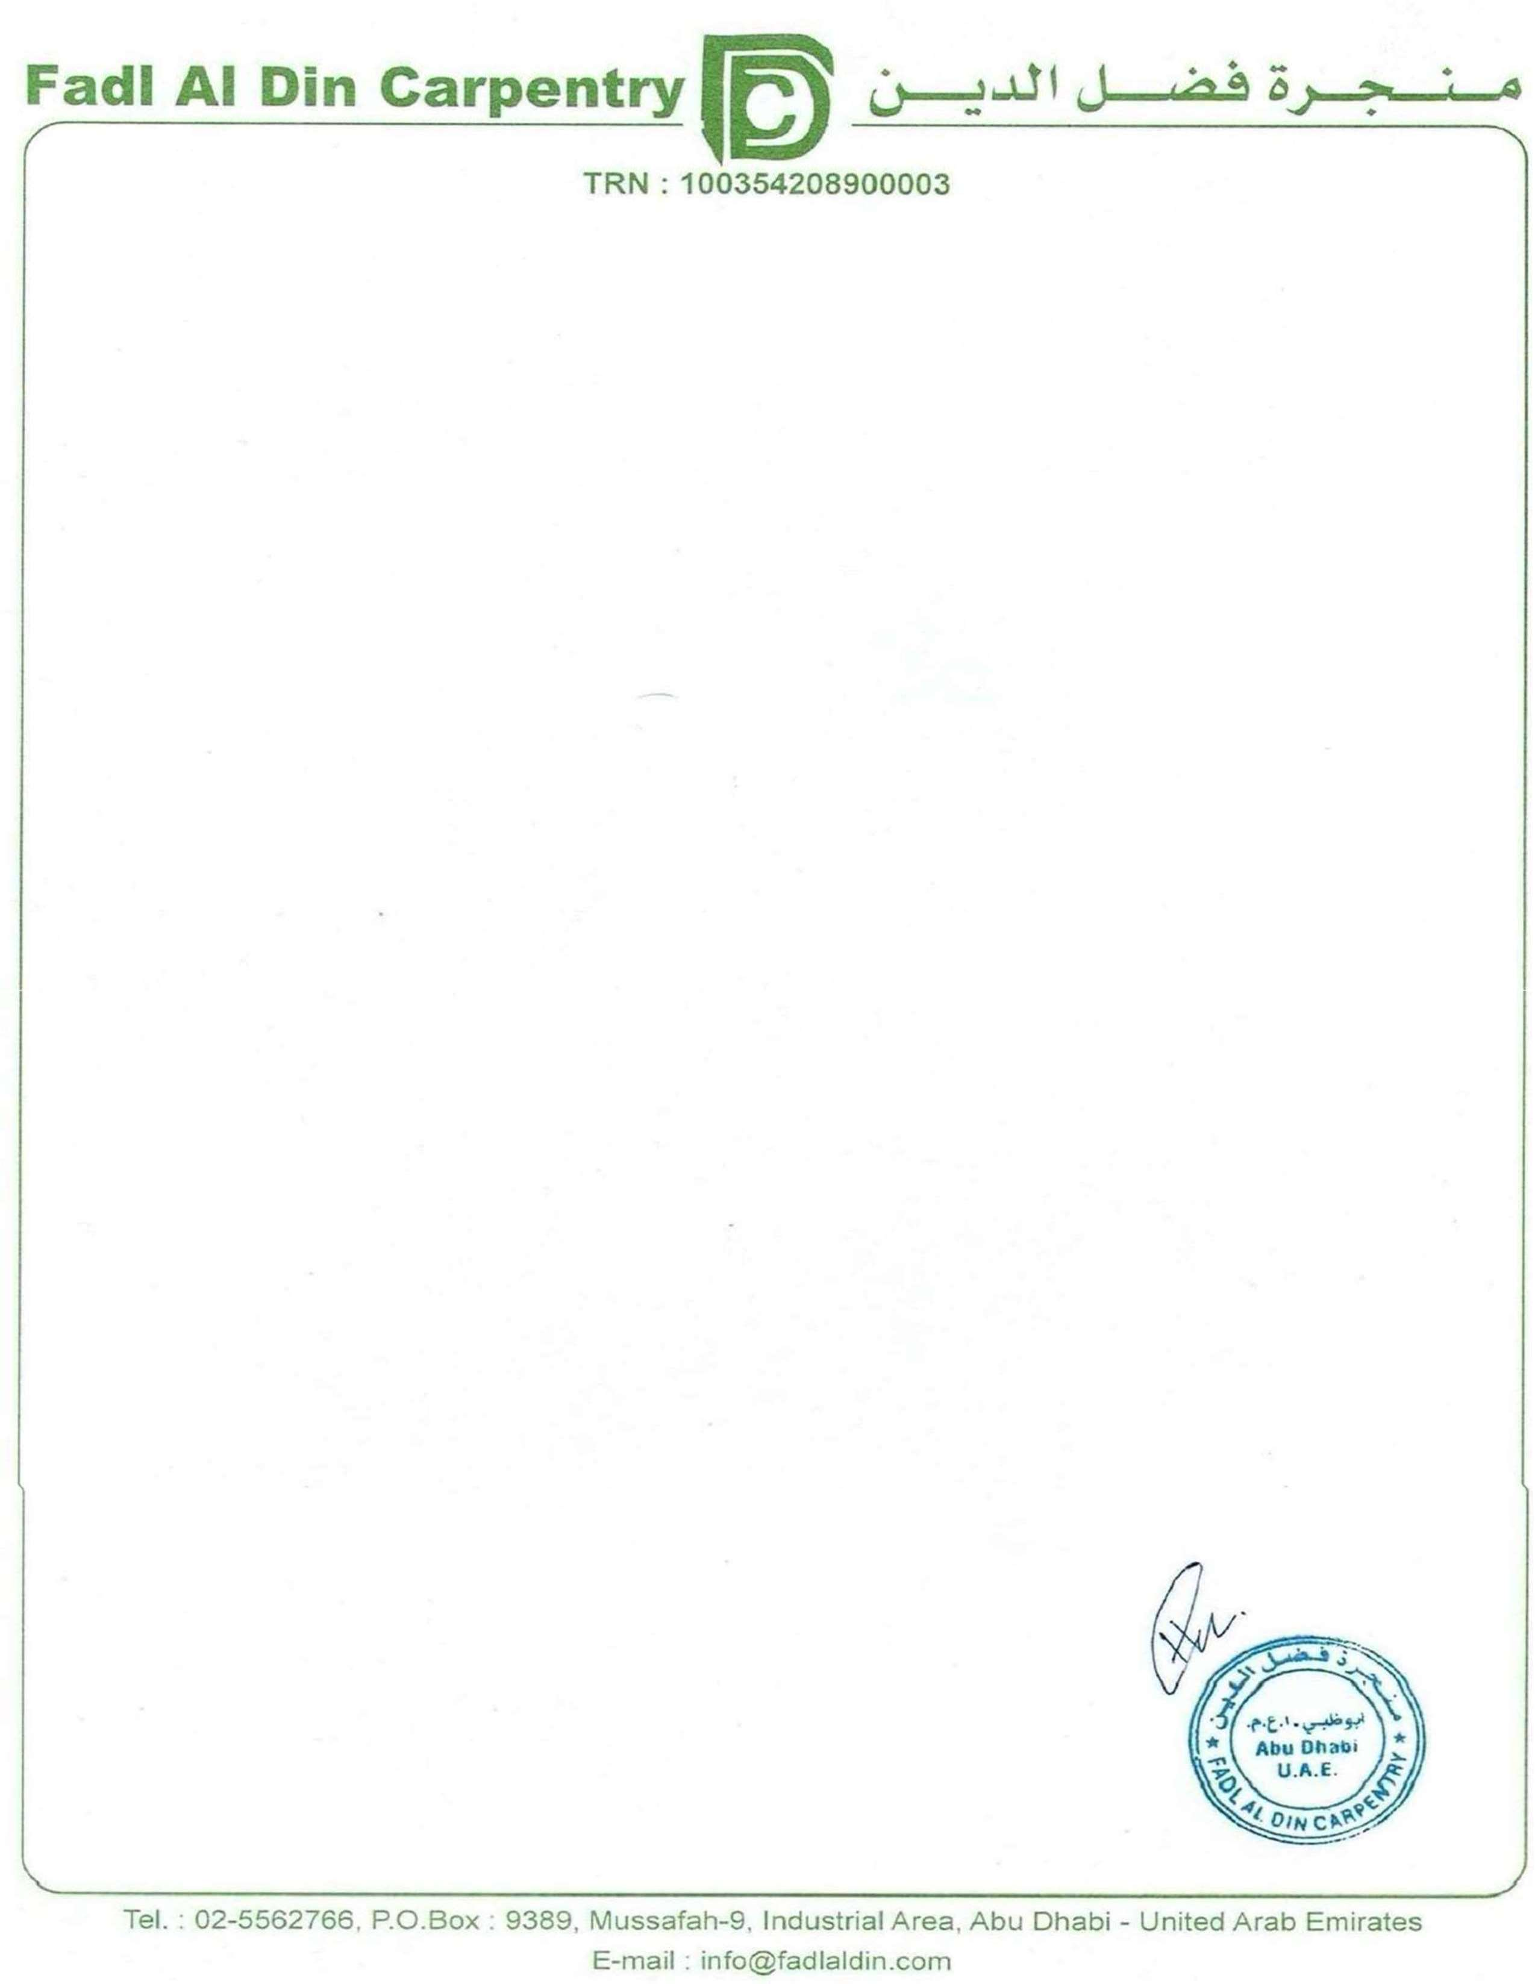
Ref-FADC -SUD–TEM– 2251 Date:30 – 09 - 2025
To,
Art Domain
Quotation forCarpentry work

No. | Description |  | Qty | Unit | Unit Price | Total Amount
 | Salah Bathroom
1 | Supply and installation of:  - 18mm MDF lower vanity with deco paint finish with round molding on front with drawers 260cm x 25cm x 60cm  - 18mm MDF upper basin vanity without marble finish 145cm x 25cm x 60cm | 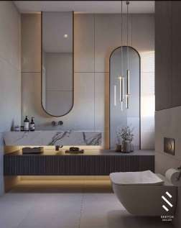 | 1 | Pcs | 3000 | 3000
2 | Supply and installation of:  - 18mm MDF lower vanity with deco paint finish with round molding on front with drawers 197cm x 25cm x 60cm  - 18mm MDF upper basin vanity without marble finish 197cm x 25cm x 60cm  - 18mm MDF side cabinet with deco paint finish 30cm x 290cm x 60cm depth | 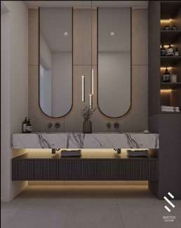 | 1 | Pcs | 4500 | 4500
 | Majlis Bathroom
 | Supply and installation of:  - 18mm MDF pedestal vanity for basin two numbers  - 18mm MDF floating vanity supporting the basins 180cm x 25cm | 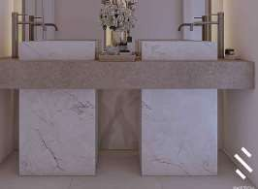 | 1 | Pcs | 1800 | 1800
 | Supply and installation of:  - 18mm MDF pedestal vanity for basin  - 18mm MDF floating vanity 25cm x 180cm  - 18mm MDF cabinet above vanity counter 70cm x 220cm x 60cm | 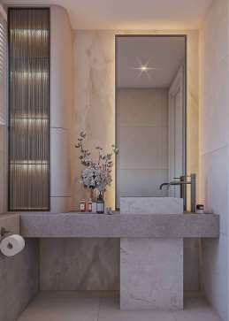 | 1 | Pcs | 3500 | 3500

No. | Description |  | Qty | Unit | Unit Price | Total
 | Play Bathroom
1 | Supply and installation of:  - 18mm MDF vanity counter with veneer and polish 120cm x 25cm x 60cm  - 18mm MDF cabinet with deco paint finish 15cm x 60cm x 300cm | 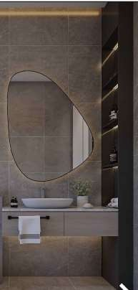 | 1 | Pcs | 3000 | 3000
 | Office Bathroom
2 | Supply and installation of:  - 18mm MDF vanity counter upper with marble lower with drawers with deco paint finish 120cm x 45cm x 60cm  18mm MDF cabinet with deco paint finish 20cm x 85cm x 215cm with open shelves in center and sides closed | 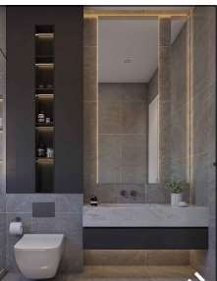 | 1 | Pcs | 4000 | 4000
 | Master Bathroom
 | Supply and installation of:  - 18mm MDF upper vanity with for basin 150cm x 18cm x 60cm  - Lower vanity with drawers with veneer and polish 220cm x 25cm x 60cm one drawer on the left only remaining closed  - Side cabinet with open shelves with deco paint finish 25cm x 260cm x 25cm  - Right side closed box with veneer and polish  45cm x 25cm depth x 260cm height | 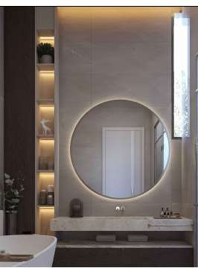 | 1 | Pcs | 5000 | 5000
 | Gym Bathroom
 | Supply and installation of:  - 18mm MDF vanity with veneer and polish and polish 120cm x 25cm x 60cm  - Side cabinet with doors and shelves with deco paint finish 85cm x 205cm x 30cm | 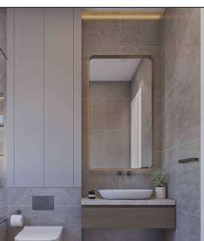 | 1 | Pcs | 3000 | 3000
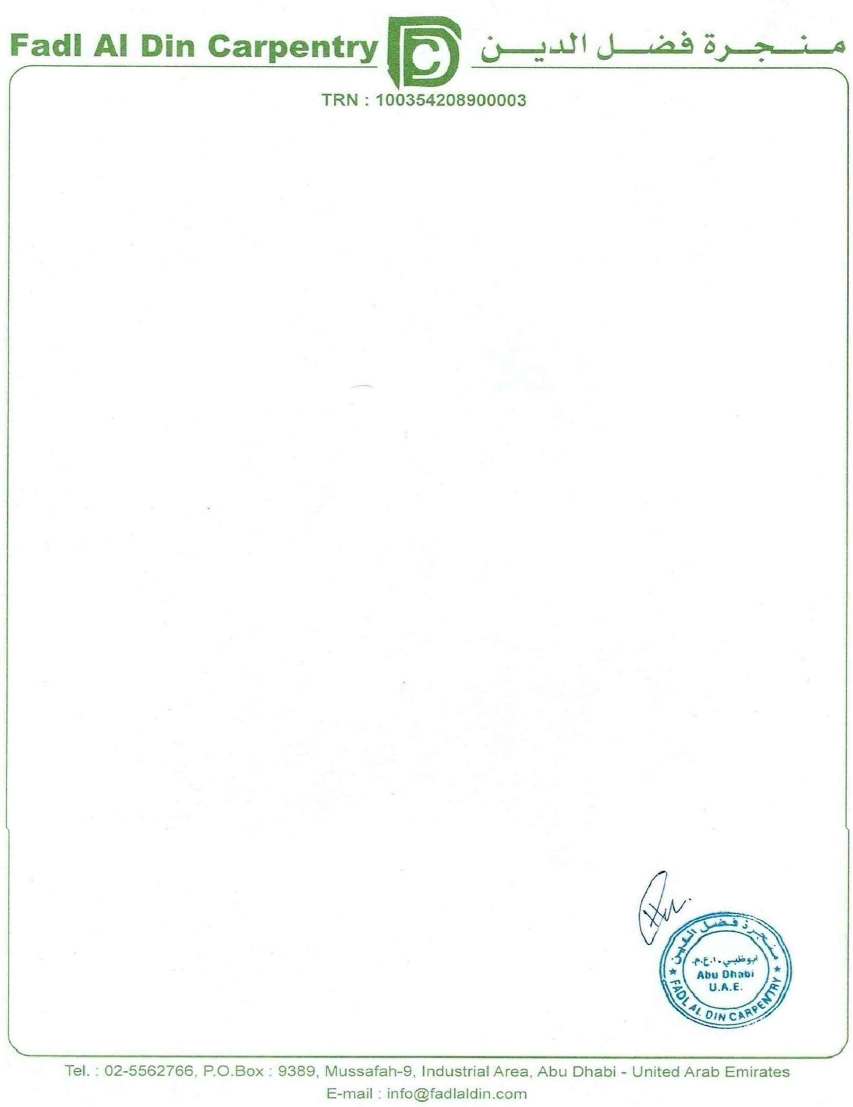

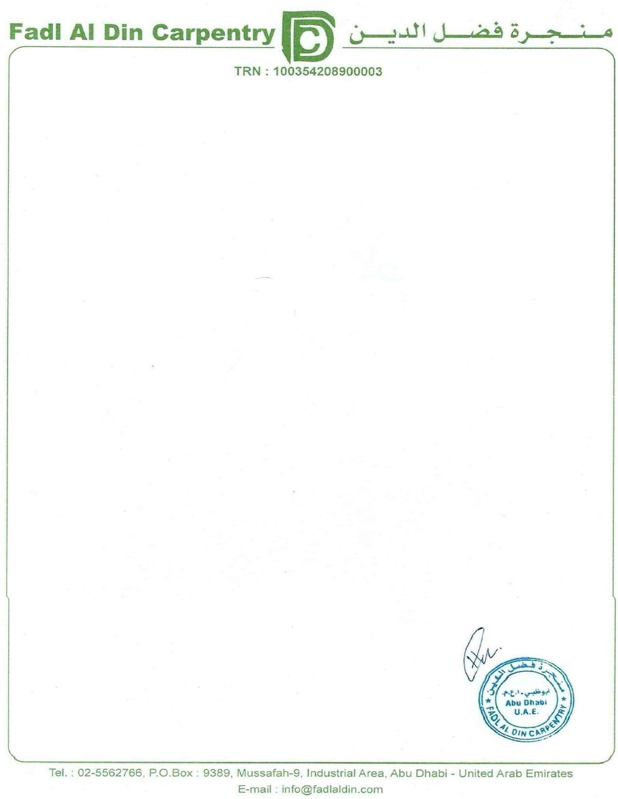
No. | Description |  | Qty | Unit | Unit Price | Total
 | Girls Bathroom
1 | Supply and installation of:  - 18mm MDF vanity counter with grooves design with deco paint finish 115cm x 25cm x 60cm  - 18mm MDF cabinet with veneer and polish finish 25cm x 30cm x 210cm  - Back wall of mirror cladding with honey comb structure grooves using MDF with  deco paint finish 90cm x 210cm | 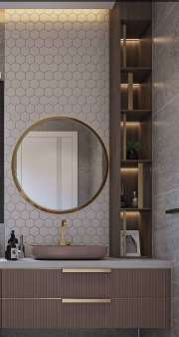 | 1 | Pcs | 6500 | 6500
 | Boys Bathroom
2 | Supply and installation of:  - 18mm MDF vanity counter with veneer and polish 115cm x 25cm x 60cm  - 18mm MDF cabinet with deco paint finish 15cm x 60cm x 300cm | 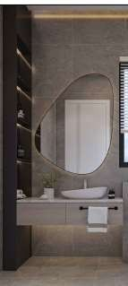 | 1 | Pcs | 3000 | 3000
 | Total Amount |  |  |  |  | 37300
 | VAT 5% |  |  |  |  | 1865
 | Net Amount |  |  |  |  | 39165

Terms and Conditions:
The above price does not include any kind of marble, gypsum basin accessories, mirror work, lighting work. Work will start after receiving 50% advance, and the remaining should be paid with the progress of the work.
Thank you,
Regards,
Fadl Al Din Carpentry

