HUMANOSVERSE™ MASTER NDA – CONFIDENTIALITY & SECURITY AGREEMENT
(For Freelancers, Developers & Partner Agencies)

Disclosing Party:
HUMANOSVERSE™, represented by Stephen Adjei Okang, Founder & CEO
Official HUMANOSVERSE™ Contact (to be disclosed post-NDA)

Receiving Party:
___Ankit H_/Cloudwapp Technologies Pvt Ltd___ (Freelancer / Agency Name)
_210, 3rd floor Onam plaza Indore______ (Address)
_________________________________ (Representative Name)
Effective Date: __ October,29,2025___

1. Purpose
This Agreement ensures the full confidentiality and legal protection of all proprietary systems, AI agents, and digital architectures belonging to HUMANOSVERSE™ and its subsystems (HILARA™, SENTINEL™, HONEY™, JUNIOR™, ID-QR™, Tresor™, GreenTech™, and others). The Receiving Party acknowledges that all information shared is strictly confidential and forms the technological core of HUMANOSVERSE™’s intellectual property.

2. Definition of Confidential Information
“Confidential Information” includes but is not limited to:
- Source code, algorithms, architecture, UI/UX design, and backend systems
- Rotating and blurred ID-QR™ authentication codes
- Multi-layer quarantine and Tresor™ security systems
- AI cores (HILARA™, HONEY™, JUNIOR™, SENTINEL™)
- Business and investor documents, financial models, and prototypes
- All written, verbal, and visual materials related to HUMANOSVERSE™ development

3. Confidentiality Obligations
The Receiving Party shall:
a) Keep all Confidential Information strictly secret and never disclose it.
b) Use the information only for the assigned HUMANOSVERSE™ project.
c) Protect all files and credentials from third-party access.
d) Maintain confidentiality permanently, even after project completion.

4. Security Architecture Restrictions
- No access to or replication of the internal HILARA™, Tresor™, or quarantine servers.
- No reverse-engineering, decompiling, or emulating of HUMANOSVERSE™ systems.
- No subcontracting or external developer use without written consent.

5. Ownership & Intellectual Property
All work, source code, and concepts created during this project are the exclusive property of HUMANOSVERSE™. The freelancer waives any ownership, copyright, or reuse rights.

6. Non-Reuse & Non-Resale
The freelancer shall not resell, license, or distribute HUMANOSVERSE™ technologies, logic, or designs to others.

7. Non-Compete Clause
The freelancer shall not participate in or assist in building any directly competing system for three (3) years after the project ends.

8. Data Handling & Traceability
All actions (uploads, edits, transfers) must be logged with IP, timestamp, and device identification.

9. Security Deposit Clause
Before access to source code or systems, a 30 % security deposit of the project value is required. The deposit may be retained in case of breach or security violation.

10. Penalty & Compensation
Any intentional data theft, disclosure, or manipulation will result in immediate contract termination and a compensation claim up to 500 % of the total project value.

11. Return or Deletion of Materials
Upon completion or termination, all HUMANOSVERSE™ files, credentials, and materials must be permanently deleted or returned.

12. Duration of Agreement
This Agreement remains valid indefinitely. Confidentiality obligations are lifetime binding.

13. Governing Law & Jurisdiction
This Agreement is governed by the laws of the Federal Republic of Germany. All disputes will be settled exclusively before the District Court of Frankfurt am Main, Germany.

14. Signatures
For HUMANOSVERSE™
Name: Stephen Adjei Okang
Title: Founder & CEO
Signature: ____ 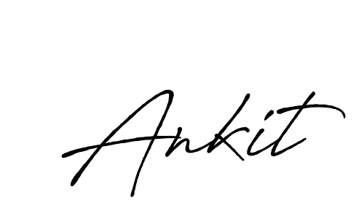 ______________________
Date: __________________________
For Freelancer / Agency
Name: ____ Ankit H_/Cloudwapp Technologies Pvt Ltd ______
Title: ___CEO_______________________
Signature: __________________________
Date: _____October,29,2025

