PROJECT PORTFOLIO DOCUMENTATION
Automated FastAPI Deployment Pipeline Using GitHub Actions and a Self-Hosted WSL Runner
A DevOps / Cloud Engineering Portfolio Project
Ecommerce API | FastAPI · WSL Ubuntu · systemd · GitHub Actions CI/CD
Prepared for portfolio, README, and technical review purposes

2. Project Introduction
This project demonstrates the end-to-end design, development, and automated deployment of a FastAPI backend application — the “Ecommerce API” — entirely within a Linux environment running on Windows Subsystem for Linux (WSL Ubuntu). The application exposes a set of RESTful endpoints for managing products (listing, retrieval by ID or slug, and administrative create/update/delete operations), and is hosted as a persistent background service using systemd.
The purpose of deploying a FastAPI application in this way is to simulate a realistic backend-service lifecycle: writing the API, running it locally for testing, and then promoting it to a long-running, auto-restarting service that survives reboots and crashes. FastAPI was chosen for its speed, automatic OpenAPI/Swagger documentation, and strong typing support via Pydantic, all of which are visible in the project's interactive API docs.
Automation and CI/CD form the core engineering focus of the project. Rather than manually re-deploying the application after every code change, a GitHub Actions workflow — executed by a self-hosted runner installed inside the same WSL Ubuntu machine — automatically pulls the latest code, reinstalls dependencies, and restarts the FastAPI systemd service whenever changes are pushed to the main branch. This mirrors, at a smaller scale, the same automated release patterns used in professional DevOps and cloud engineering environments.

3. Project Objectives
- Design and implement a FastAPI backend application (“Ecommerce API”) with product-management endpoints.
- Set up and configure a Linux development environment using WSL Ubuntu on Windows.
- Package and isolate Python dependencies using a virtual environment (venv) and a requirements.txt file.
- Run the FastAPI application as a persistent, auto-restarting background service using systemd.
- Automate the build-and-deploy workflow using a GitHub Actions CI/CD pipeline.
- Configure and register a self-hosted GitHub Actions runner inside the WSL environment.
- Author a shell-based deployment script (deploy.sh) that performs code pull, dependency installation, and service restart.
- Understand and apply core DevOps practices: version control discipline, automated deployment, and service reliability (Restart=always).
- Gain hands-on experience with the full Git → GitHub → Actions → Runner → Deployment workflow.

4. Technology Stack
Category | Technology | Purpose in This Project
Backend Framework | FastAPI 0.109.0 | Core Python web framework used to build the Ecommerce API
Language / Runtime | Python 3.14 (venv) | Application language, isolated in a project-local virtual environment
ASGI Server | Uvicorn 0.27.0 | Serves the FastAPI application (development run + systemd ExecStart)
Process Manager | Gunicorn 21.2.0 | Listed in requirements.txt as a production-grade process manager
Validation Layer | Pydantic 2.13.4 / Starlette 0.35.1 | Request/response validation and ASGI toolkit used internally by FastAPI
Operating System | Ubuntu (WSL 2 on Windows) | Linux development and hosting environment
Service Management | systemd (fastapi.service) | Keeps the API running continuously with auto-restart on failure
Version Control | Git / GitHub | Source control; repository: fb_clone-website
CI/CD | GitHub Actions (self-hosted runner) | Automates pull → install → restart on every push to main
Automation Scripting | Bash (deploy.sh) | Encapsulates the deployment steps executed by the pipeline
API Documentation | Swagger UI (OpenAPI 3.1) | Auto-generated interactive docs at /docs
Note: no external cloud provider (e.g., AWS, Azure, GCP, or a PaaS such as Render/Heroku) is visible anywhere in the captured workflow. The “deployment target” in this project is the WSL Ubuntu machine itself, acting as a self-managed Linux host with a self-hosted Actions runner. This is documented accurately below rather than assumed; extending the pipeline to a public cloud VM or container platform is listed as a future improvement in Section 13.

5. System Architecture
The project has two architectural layers: (1) how the FastAPI application runs on the host, and (2) how code changes flow from a developer's push into that running service.
Application Runtime Architecture (as configured on the WSL host)
WSL Ubuntu (DESKTOP-C0VJDQO)
|
/home/robot/fb_clone-website
|-- main.py
|-- requirements.txt
\-- venv/
|
v
systemd ---> fastapi.service
|
v
uvicorn
|
v
FastAPI app (127.0.0.1:8000)
End-to-End CI/CD Deployment Flow
Developer (You)
| git push origin main
v
GitHub Repository (fb_clone-website)
|
v
GitHub Actions (workflow trigger: push to main)
|
v
Self-Hosted Runner (WSL Ubuntu: ~/actions-runner)
| executes .github/workflows/deploy.yml
v
deploy.sh
|-- git pull origin main (fetch latest code)
|-- source venv/bin/activate
|-- pip install -r requirements.txt (build/install step)
\-- sudo systemctl restart fastapi (deploy step)
|
v
Running FastAPI Application (served by uvicorn via systemd)
This differs slightly from a conventional cloud pipeline in that the “build/test” and “deployment server” stages are collapsed onto the same host: the self-hosted runner and the production systemd service live on the same WSL Ubuntu machine. This is a valid and common pattern for home-lab, personal-server, and small-scale DevOps portfolio setups.

6. Development Environment Setup
The development environment was built from the ground up on WSL Ubuntu, running under the DESKTOP-C0VJDQO Windows host, with the working Linux user “robot”.

6.1 WSL Ubuntu Environment
All backend development, service configuration, and CI/CD runner execution take place inside a WSL Ubuntu shell. This gives the developer a native Linux toolchain (systemd, apt, bash) while still working from a Windows desktop, which is representative of how many engineers develop Linux-targeted services locally before pushing to a remote Linux server.

6.2 Repository Setup
The project repository, fb_clone-website, was cloned from GitHub using SSH after an initial HTTPS clone attempt required credential authentication that was interrupted (visible as a Ctrl+C on the HTTPS clone in the terminal history). The SSH clone completed successfully, retrieving 27 objects into the local fb_clone-website directory.

6.3 Required Packages and Dependencies
The python3-venv package was installed via apt to enable native Python virtual environments, pulling in python3-pip-whl, python3-setuptools-whl, and python3.14-venv as dependencies.

6.4 Python Virtual Environment
A project-local virtual environment was created with python3 -m venv venv and activated using source venv/bin/activate, isolating the project's Python packages (fastapi, uvicorn, gunicorn, and their sub-dependencies) from the system Python installation. All dependencies were then installed in one step via pip install -r requirements.txt.

7. Application Development

7.1 Application Structure
The application entry point is main.py, located at the root of the fb_clone-website repository. Inspection of the file (via grep FastAPI main.py) confirms the FastAPI app instance is created as: app = FastAPI(title="Ecommerce API", version="1.0.0"), with FastAPI, HTTPException, Query, and status imported from the fastapi package.

7.2 API Implementation
Based on the generated Swagger documentation, the Ecommerce API exposes the following endpoints:
Method | Path | Purpose
GET | / | Home / root endpoint
GET | /products | Retrieve the list of products
GET | /products/{product_id} | Retrieve a single product by its ID
GET | /products/slug/{slug} | Retrieve a single product by its URL slug
POST | /admin/products | Create a new product (admin)
PUT | /admin/products/{product_id} | Update an existing product (admin)
DELETE | /admin/products/{product_id} | Delete an existing product (admin)
GET | /admin/overview | Administrative overview endpoint

7.3 Running the Application Locally
During development, the application was started manually with: uvicorn main:app --host 0.0.0.0 --port 8000. The server log confirms a clean startup (“Application startup complete”) and that Uvicorn was listening on http://0.0.0.0:8000.

7.4 Testing the API
The API was tested and demonstrated using FastAPI's built-in Swagger UI at the /docs endpoint (localhost:8000/docs), which auto-generates interactive, OpenAPI 3.1-compliant documentation for every route, including the HTTPValidationError schema used for request-validation errors.

8. CI/CD Pipeline Implementation
The pipeline automates the full release cycle so that pushing code to GitHub is sufficient to update the running service, with no manual SSH deployment steps required.

8.1 Code Push to GitHub
Development changes are committed and pushed from a Git Bash (MINGW64) session on the Windows side of the project directory (e/Fast_Api/fb_clone-website), using a standard git add, git commit, git pull --rebase origin main, git push sequence to keep the local and remote main branches in sync.

8.2 GitHub Actions Trigger
A workflow file was authored at .github/workflows/deploy.yml inside the WSL-side clone of the repository (~/fb_clone-website/.github/workflows/), then committed with the message “Add GitHub Actions deployment pipeline.” This workflow is configured to run on a self-hosted runner (runs-on: self-hosted) whenever new commits land on main.

8.3 Self-Hosted Runner Registration
A self-hosted GitHub Actions runner (Linux, x64, version 2.336.0) was downloaded and configured directly inside the WSL environment under ~/actions-runner. Setup followed GitHub's standard runner registration flow:
mkdir actions-runner && cd actions-runner
curl -o actions-runner-linux-x64-2.336.0.tar.gz -L \
https://github.com/actions/runner/releases/download/v2.336.0/actions-runner-linux-x64-2.336.0.tar.gz
tar xzf ./actions-runner-linux-x64-2.336.0.tar.gz
./config.sh --url https://github.com/<org>/fb_clone-website --token <registration-token>
./run.sh
After configuration, the runner (named DESKTOP-C0VJDQO) appears in the repository's Settings → Actions → Runners page with a status of “Idle,” confirming it is registered and connected to GitHub, ready to accept jobs.
Registration tokens shown during setup are single-use / short-lived and are intentionally omitted from this document as a security best practice.

8.4 Installing Dependencies and Running the Build Step
The “build” portion of the pipeline is handled by the deployment script rather than a separate compilation step, since Python is interpreted: the runner activates the existing virtual environment and re-installs/validates the pinned dependencies from requirements.txt (pip confirms each package is “already satisfied” when no version has changed).

8.5 Deployment Process (deploy.sh)
The core of the automated deployment is a bash script, deploy.sh, stored in the project repository and invoked by the GitHub Actions job:
set -e

echo "Starting deployment..."
cd /home/robot/fb_clone-website

echo "Pulling latest code..."
git pull origin main

echo "Activating virtual environment..."
source venv/bin/activate

echo "Installing dependencies..."
pip install -r requirements.txt

echo "Restarting FastAPI service..."
sudo systemctl restart fastapi

echo "Deployment completed!"
set -e ensures the script exits immediately if any step fails, preventing a partially-completed deployment from being treated as successful.

8.6 Deployment Verification
The pipeline was executed multiple times end-to-end via ./run.sh on the self-hosted runner. Runner logs show an initial failed run, followed by three consecutive successful runs of the deploy job:
2026-08-05 08:12:07Z: Listening for Jobs
2026-08-05 08:12:13Z: Running job: deploy
2026-08-05 08:12:42Z: Job deploy completed with result: Failed
2026-08-05 08:12:50Z: Running job: deploy
2026-08-05 08:13:28Z: Job deploy completed with result: Succeeded
2026-08-05 08:13:35Z: Running job: deploy
2026-08-05 08:14:15Z: Job deploy completed with result: Succeeded
2026-08-05 08:14:22Z: Running job: deploy
2026-08-05 08:14:57Z: Job deploy completed with result: Succeeded
The initial failure and subsequent successful reruns are a normal and expected part of pipeline development (see Section 11 – Challenges Faced) and demonstrate that the workflow was iteratively debugged until it reliably passed.

9. Cloud Deployment Process
Based strictly on the screenshots provided, this project's “deployment target” is a self-managed Linux host — the WSL Ubuntu environment itself — rather than a third-party cloud platform. No AWS, Azure, GCP, DigitalOcean, or PaaS console, CLI, or credential screen appears anywhere in the captured workflow.

9.1 Server Configuration
The “server” is the WSL Ubuntu instance (DESKTOP-C0VJDQO), running the application under the local Linux user robot, from the working directory /home/robot/fb_clone-website.

9.2 Environment Setup
Environment isolation is achieved through the project's own Python venv rather than containerization; the systemd unit explicitly sets PATH to the virtual environment's bin directory so the correct interpreter and installed packages are always used.

9.3 Application Hosting (systemd Service)
The application is hosted as a systemd service so that it behaves like a real production service — starting on boot and restarting automatically if it crashes. The unit file, /etc/systemd/system/fastapi.service, is configured as follows:
[Unit]
Description=Ecommerce FastAPI API
After=network.target

[Service]
User=robot
WorkingDirectory=/home/robot/fb_clone-website
Environment="PATH=/home/robot/fb_clone-website/venv/bin"
ExecStart=/home/robot/fb_clone-website/venv/bin/uvicorn main:app --host 127.0.0.1 --port 8000
Restart=always

[Install]
WantedBy=multi-user.target
The service was registered and enabled with:
sudo systemctl daemon-reload
sudo systemctl enable fastapi

9.4 Accessing the Deployed API
During local verification, the API and its Swagger documentation were accessed at http://localhost:8000/docs. In the systemd configuration, the service binds to 127.0.0.1:8000 (loopback only); exposing it beyond the host — e.g., via 0.0.0.0, a reverse proxy, or a cloud load balancer — is flagged as a future improvement (Section 13), since it is not evidenced in the provided screenshots.

10. Screenshots Documentation
The following figures are drawn directly from the supplied screenshots, in the order the corresponding actions were performed.
Figure 1: Cloning the Repository via SSH
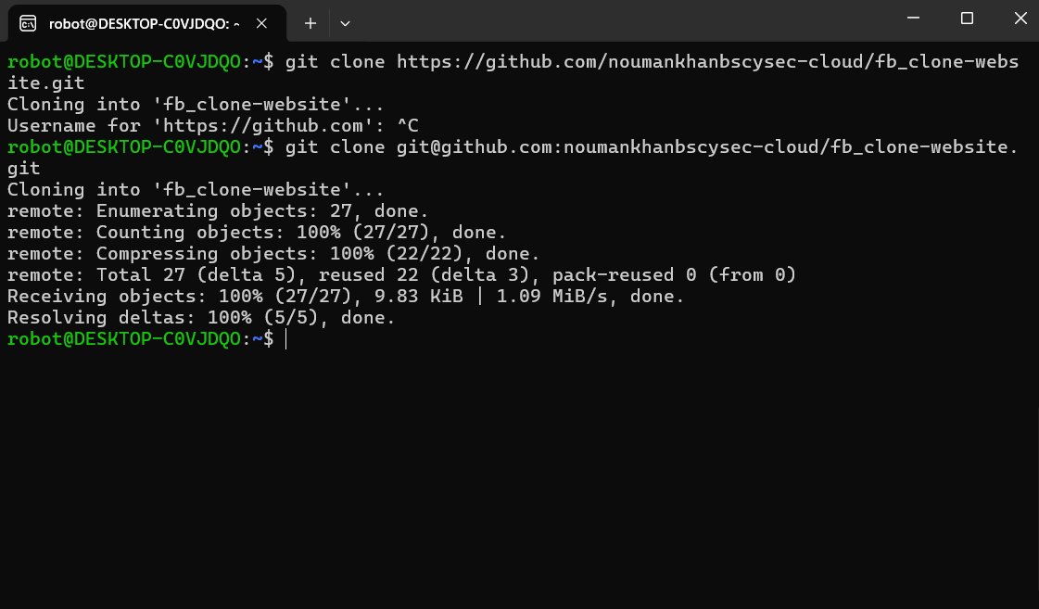
Shows the project repository (fb_clone-website) being cloned from GitHub. An initial HTTPS clone was interrupted at the credential prompt, and the clone was completed successfully over SSH instead. This is the starting point of the workflow — without a local copy of the source and CI/CD workflow files, no later step is possible.
Figure 2: Verifying the Local Project Directory
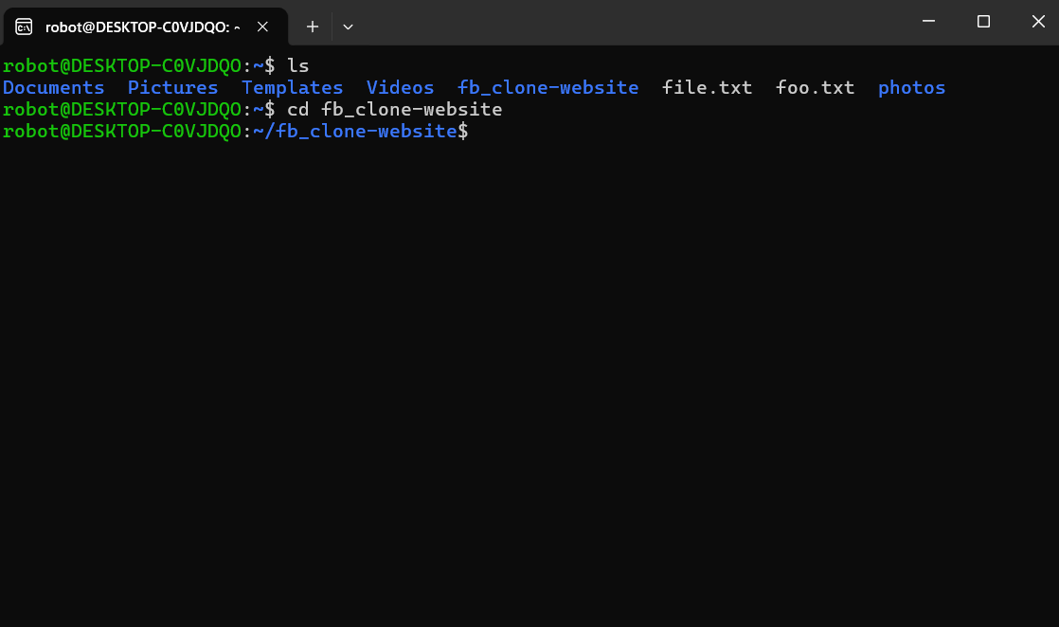
Confirms that the fb_clone-website folder was cloned into the home directory alongside other user folders, and that the developer navigated into it with cd fb_clone-website. This establishes the working directory used for every subsequent command.
Figure 3: Confirming a Clean Git Working Tree
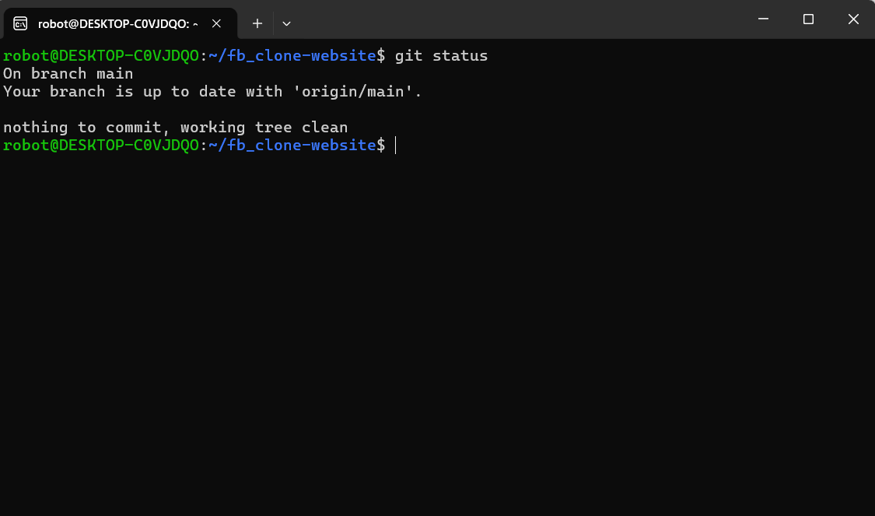
git status confirms the local branch is up to date with origin/main and that there are no uncommitted changes. Checking repository state before making environment changes is a basic but important habit that prevents accidental conflicts later in the pipeline.
Figure 4: Installing the Python Virtual-Environment Package
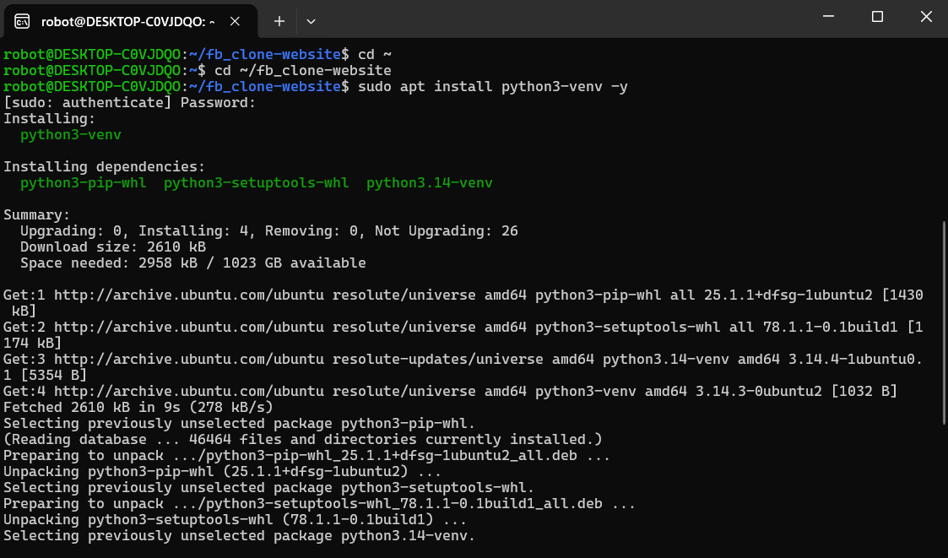
sudo apt install python3-venv -y installs the venv module (plus python3-pip-whl, python3-setuptools-whl, and python3.14-venv) on the WSL Ubuntu machine. This is a required system-level dependency before an isolated Python environment can be created.
Figure 5: Creating and Activating the Virtual Environment
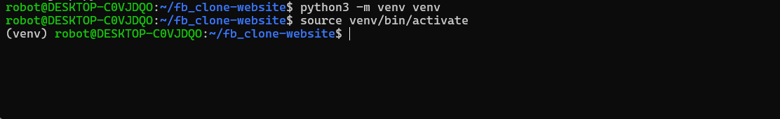
python3 -m venv venv creates a project-local virtual environment, and source venv/bin/activate activates it (indicated by the (venv) prefix in the prompt). Isolating dependencies this way prevents version conflicts with system-wide Python packages.
Figure 6: Installing Application Dependencies
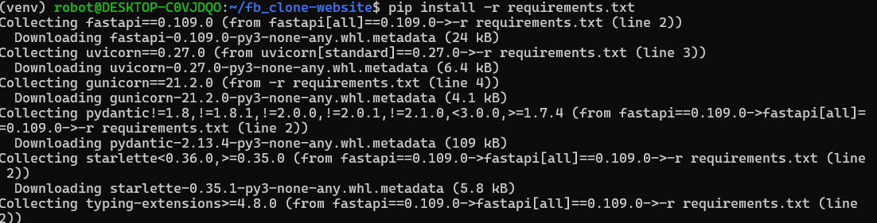
pip install -r requirements.txt installs FastAPI 0.109.0, Uvicorn 0.27.0, and Gunicorn 21.2.0, along with transitive dependencies such as Pydantic and Starlette. This step reproduces the exact dependency set the application needs to run.
Figure 7 & 8: Verifying the FastAPI Application Entry Point
grep FastAPI main.py confirms the application object is declared as app = FastAPI(title="Ecommerce API", version="1.0.0"). Verifying the entry point before running the server is a quick sanity check that the correct app instance will be served.
Figure 9: Starting the FastAPI Server Locally
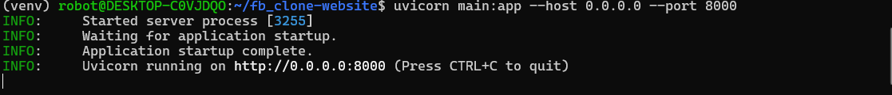
uvicorn main:app --host 0.0.0.0 --port 8000 starts the ASGI server. The log lines (“Application startup complete”, “Uvicorn running on http://0.0.0.0:8000”) confirm the API is live and reachable for local testing.
Figure 10: Interactive API Documentation (Swagger UI)
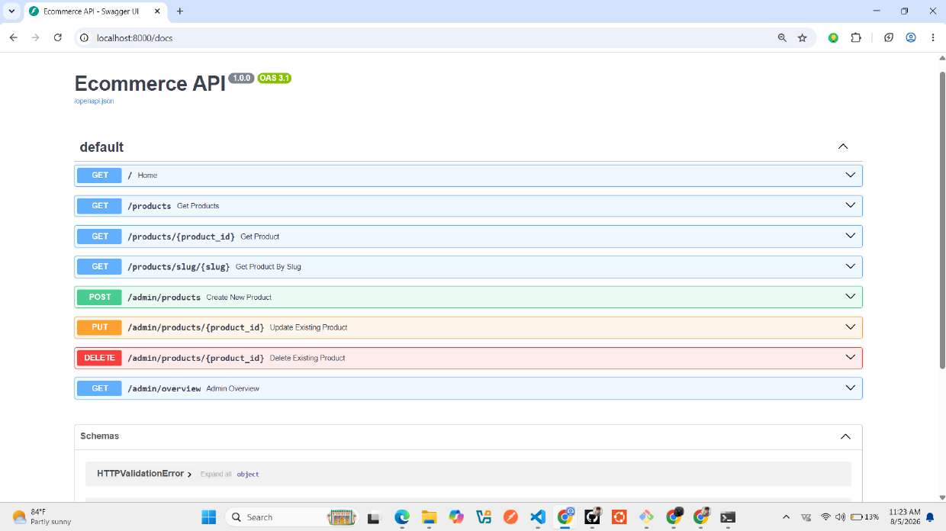
The auto-generated Swagger UI at /docs lists every route in the Ecommerce API — product listing, retrieval by ID/slug, and admin create/update/delete/overview endpoints — along with the OAS 3.1 schema. This is used to manually exercise and validate each endpoint without writing a separate test client.
Figure 11: Authoring the systemd Service Unit
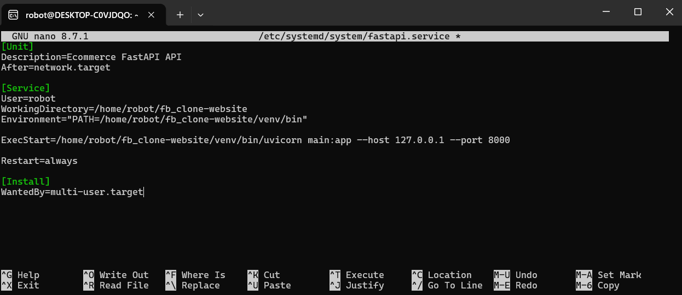
The fastapi.service unit file is created in nano, defining how the OS should run and supervise the application: as user robot, from the project's working directory, using the venv's uvicorn binary, with Restart=always so the service self-heals after a crash.
Figure 12: Enabling the Service
sudo systemctl daemon-reload reloads systemd's unit definitions, and sudo systemctl enable fastapi enables the service to start automatically on boot. This converts the API from a manually-run process into a managed, persistent system service.
Figure 13: Runtime Architecture Summary
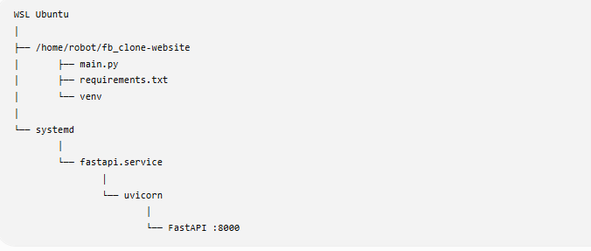
A summary diagram of how the pieces fit together on the host: the project directory feeds systemd's fastapi.service, which runs uvicorn, which serves the FastAPI app on port 8000.
Figure 14: Planned CI/CD Flow
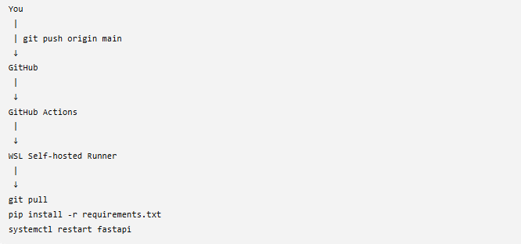
An early planning diagram of the intended pipeline: a push to GitHub triggers GitHub Actions, which hands off to a WSL self-hosted runner that pulls the code, installs dependencies, and restarts the service.
Figure 15: Writing the Deployment Script
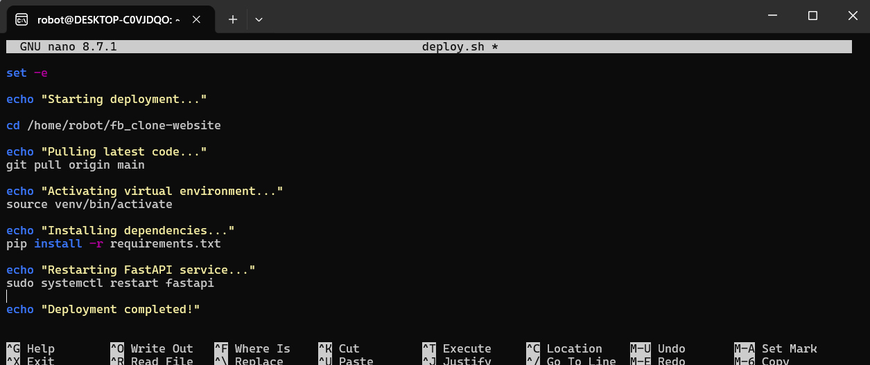
deploy.sh is authored in nano to codify the deployment steps as a single, repeatable script: pull latest code, activate the virtual environment, install dependencies, and restart the fastapi service, with status messages at each stage.
Figure 16: Running the Deployment Script Manually
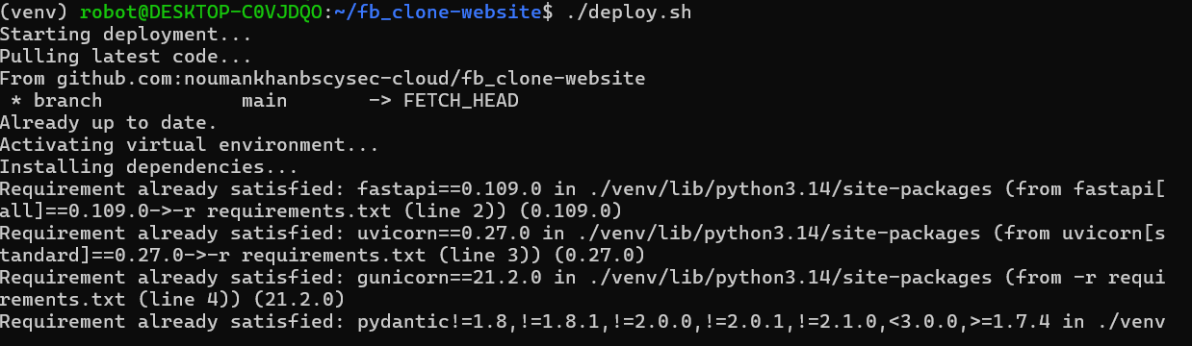
./deploy.sh is executed directly on the host to validate it end-to-end before wiring it into CI/CD. The output confirms the repository was already up to date and that all dependencies were already satisfied — proving the script is idempotent and safe to re-run.
Figure 17: Deployment Script Flow Summary
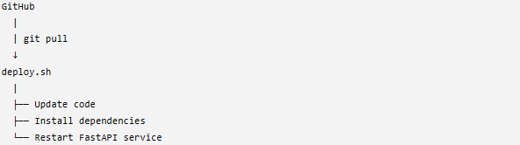
A simplified view of what deploy.sh does once triggered by GitHub: update the code, install dependencies, and restart the FastAPI service.
Figure 18: GitHub Actions Self-Hosted Runner Setup Page
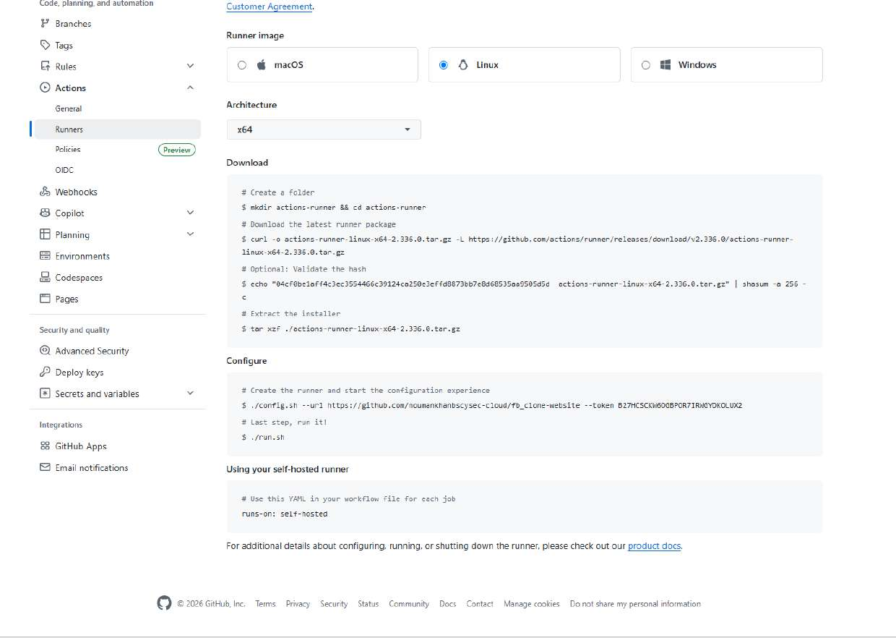
The repository's Settings → Actions → Runners → New self-hosted runner page, showing the official download/configure/run commands for a Linux x64 runner. This is where GitHub generates the setup commands (and a one-time registration token) used to attach a new machine as a runner.
Figure 19: Downloading the Runner Package
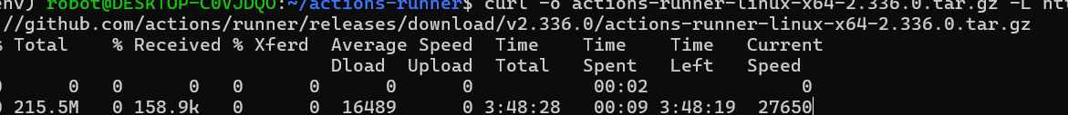
curl downloads the actions-runner-linux-x64-2.336.0.tar.gz release package directly onto the WSL Ubuntu machine, the first step in turning this machine into a GitHub Actions runner.
Figure 20: Extracted Runner Files
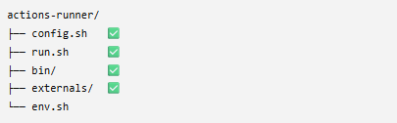
The extracted actions-runner/ directory containing config.sh, run.sh, the bin/ and externals/ runtime folders, and env.sh — the components needed to register and start the runner.
Figure 21: Registering the Self-Hosted Runner
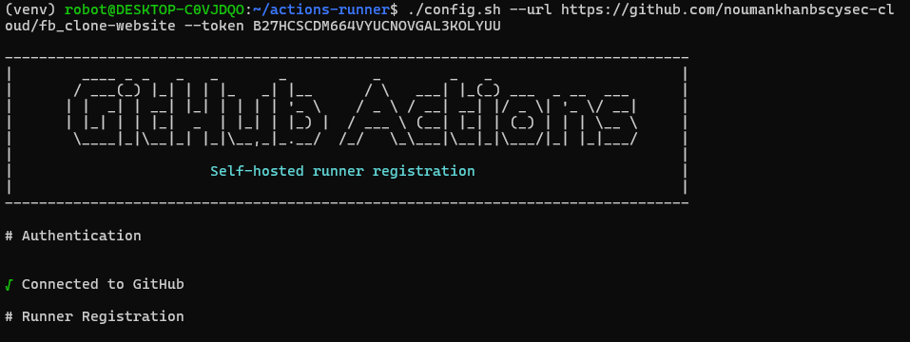
./config.sh --url ... --token ... registers this machine as a runner for the fb_clone-website repository. The “Connected to GitHub” confirmation shows the authentication handshake succeeded before runner-specific configuration continues.
Figure 22: Confirming the Runner Is Registered
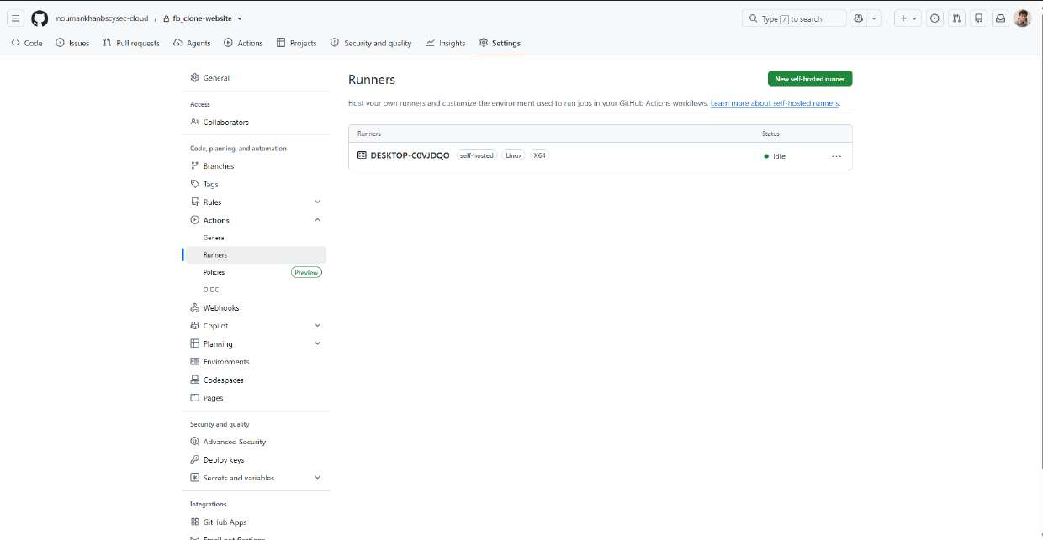
The repository's Runners page now lists DESKTOP-C0VJDQO as a self-hosted, Linux, X64 runner with an “Idle” status — confirming GitHub recognizes the machine and it is ready to accept jobs.
Figure 23: Authoring the GitHub Actions Workflow
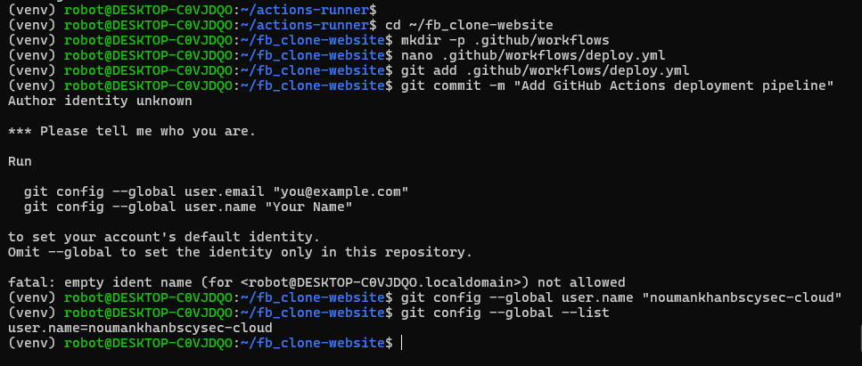
The .github/workflows directory and deploy.yml workflow file are created inside the repository. A first commit attempt failed with “Author identity unknown,” which was resolved by setting git config --global user.name, a common one-time Git setup step on a fresh machine.
Figure 24: Full CI/CD Wiring Summary
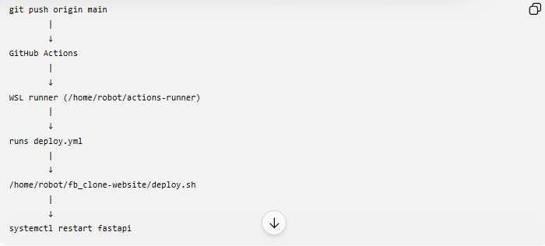
A consolidated view of the whole automated path: a push to main triggers GitHub Actions, which is picked up by the WSL runner at ~/actions-runner, which executes deploy.yml, which runs deploy.sh, which restarts the fastapi systemd service.
Figure 25: Pushing a Change from the Windows Side
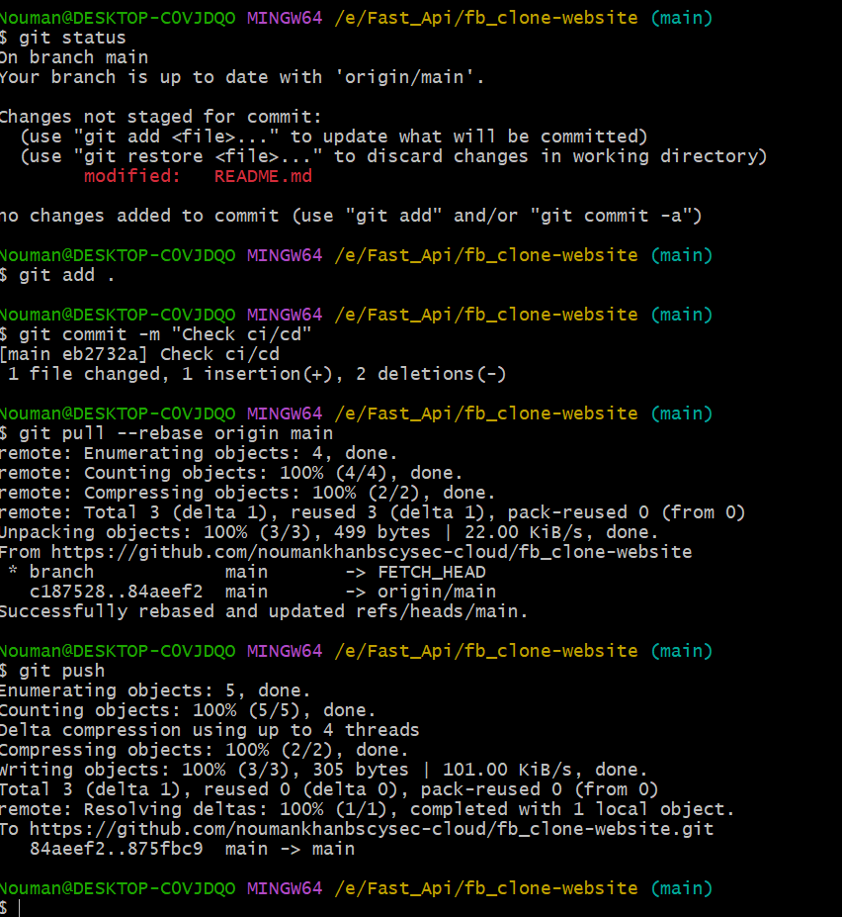
From a Git Bash (MINGW64) session on the Windows-side copy of the repository, changes are staged, committed (“Check ci/cd”), rebased onto the latest origin/main, and pushed — the trigger event the Actions workflow listens for.
Figure 26: Commit History and Runner Picking Up a Job
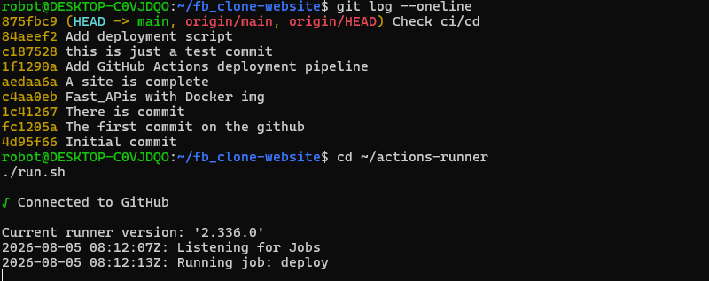
git log --oneline shows the project's commit history, from the initial commit through the CI/CD pipeline additions. Immediately after, starting the runner with ./run.sh shows it connecting to GitHub and picking up an incoming “deploy” job in real time.
Figure 27: First Pipeline Run in the GitHub Actions UI
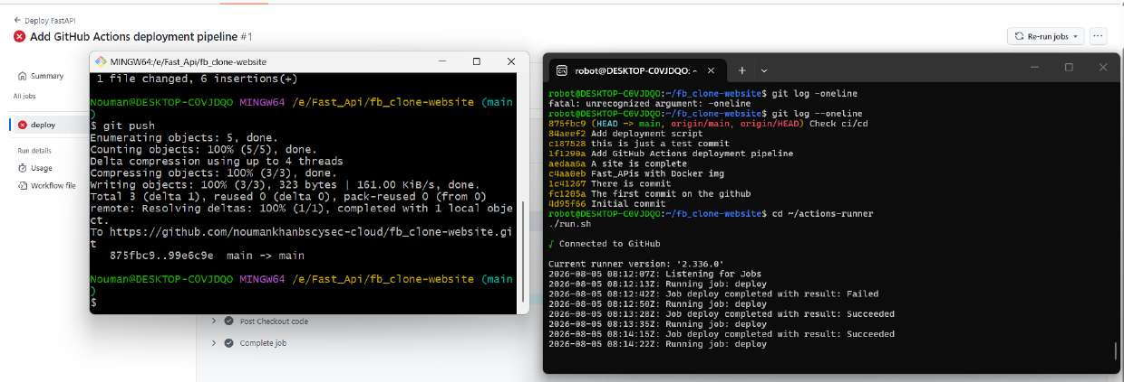
The GitHub Actions run page for “Add GitHub Actions deployment pipeline #1”, shown alongside the local terminals used to push the triggering commit and monitor the runner. The first run of the deploy job is marked as failed, prompting debugging of the workflow file and script.
Figure 28: Successful Pipeline Runs After Debugging
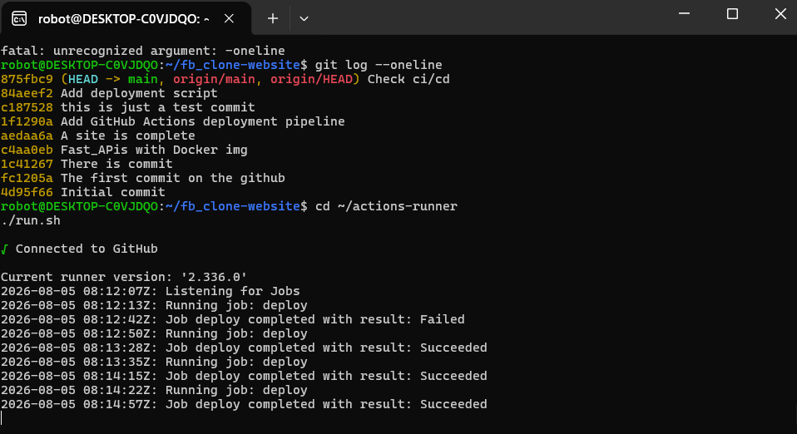
The runner log shows the deploy job's full history: an initial Failed result, followed by three consecutive Succeeded results after the workflow and deployment script were corrected — the final proof that the automated pipeline works end-to-end.

11. Challenges Faced and Solutions
Challenge | Root Cause | Solution Applied
Initial repository clone stalled | HTTPS clone paused at an interactive username/credential prompt | Cancelled the HTTPS clone (Ctrl+C) and re-cloned using an SSH remote URL, which authenticates via SSH keys with no interactive prompt
Git commit blocked with “Author identity unknown” | Git had no user.name/user.email configured on the WSL machine used to author the workflow file | Ran git config --global user.name (and email) once to set a persistent commit identity for the machine
First GitHub Actions run failed | Newly written deploy.yml / deploy.sh had not yet been fully validated against the self-hosted runner environment (e.g., paths, permissions, or service-restart steps) | Reviewed the failed run's logs in the GitHub Actions UI, adjusted the workflow/script, and re-triggered the pipeline; subsequent runs completed with a Succeeded result
Dependency install needed to be safely re-runnable | The deployment script re-runs pip install -r requirements.txt on every deploy, even when nothing changed | Relied on pip's built-in “requirement already satisfied” behavior and set -e in deploy.sh so the script is idempotent and fails fast on any real error
Keeping the API alive after crashes or reboots | Running uvicorn directly in a terminal does not survive logout, crashes, or machine restarts | Wrapped the app in a systemd unit (fastapi.service) with Restart=always and WantedBy=multi-user.target, and enabled it with systemctl enable

12. Results and Achievements
- Successfully built and locally validated a FastAPI “Ecommerce API” with product listing, retrieval, and admin CRUD endpoints, documented automatically via Swagger UI.
- Configured the application as a resilient, auto-restarting Linux service using systemd, decoupling it from any single terminal session.
- Designed and implemented a fully automated deployment workflow: a push to GitHub's main branch now triggers code pull, dependency installation, and a live service restart with no manual intervention.
- Registered and operated a self-hosted GitHub Actions runner, gaining direct, practical understanding of how CI/CD runners connect to and execute jobs from GitHub.
- Iteratively debugged a real pipeline failure and achieved three consecutive successful automated deployments, evidencing a working, reliable pipeline rather than a one-off demo.
- Strengthened practical DevOps skills across Linux service management, Git workflow discipline, and infrastructure automation scripting.

13. Future Improvements
- Containerize the application with Docker to make the environment fully portable and independent of the host's Python/venv setup.
- Deploy the containerized application to a managed cloud platform or orchestrator (e.g., Kubernetes, AWS ECS, or a simple cloud VM) for public accessibility, rather than binding to 127.0.0.1 on a personal machine.
- Add automated testing (unit/integration) as an explicit CI step before the deployment step, so the pipeline can block bad deploys rather than only restarting the service.
- Introduce monitoring and alerting with Prometheus and Grafana to track uptime, request latency, and error rates of the deployed API.
- Adopt Infrastructure as Code (e.g., Terraform) to declaratively provision and reproduce the hosting environment instead of manual systemd/runner setup.
- Harden security practices: move secrets (registration tokens, credentials) out of shell history and screenshots, restrict the systemd service's permissions further, and put the API behind HTTPS via a reverse proxy.
- Replace the single self-hosted runner with GitHub-hosted runners or an autoscaling runner pool for better isolation and reliability at scale.

14. Conclusion
This project delivers a complete, working example of modern backend deployment automation on a compact scale: a FastAPI service, built and tested in a WSL Ubuntu environment, made resilient with systemd, and released continuously through a self-hosted GitHub Actions CI/CD pipeline. Every stage of the software delivery lifecycle relevant to a junior DevOps or backend engineering role is represented here — environment setup, application development, service management, source control discipline, pipeline authoring, runner configuration, and iterative debugging of a real deployment failure.
While the current setup deploys to a self-managed host rather than a public cloud platform, the architecture is deliberately structured so that migrating to Docker, a cloud VM, or a managed orchestrator (see Section 13) is a natural next step rather than a redesign. As a portfolio piece, this project demonstrates not just that an API can be written, but that it can be reliably, automatically, and repeatably shipped — the core discipline at the heart of DevOps and Cloud Engineering practice.

