**MC**

**TASK 1**

**Step 01:Creation of local repositories in computer using clone command**

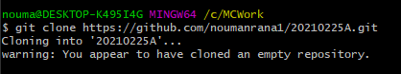

**Step 02:Creation of local file first.html and adding it to repository**



**Step 03:Commit:**  
 **First give your username and email using these commands**  
  **git config --global user.email "you@example.com"**

**git config --global user.name "Your Name"**

**Then Commit the file using command** 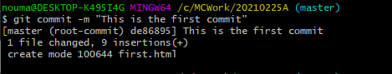

**Step 04:Use Status Command to confirm that every thing is commit**

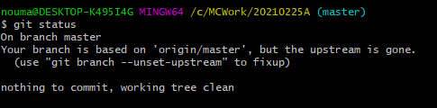

**Step 05:Push the files to actual repository using Push Command**

