ML-Based Adaptive Solar Energy Management System for Optimized Battery Health and Efficiency



By
Najam Shahbaz
26866

Nouman Sameer
35811

Maha Masood
35429

Final Year Project Report

Department of Electrical Engineering
Riphah International University, Pakistan

Spring 2025

 | Riphah International University  Pakistan

ML-Based Adaptive Solar Energy Management System for Optimized Battery Health and Efficiency

A Thesis Presented to

Riphah International University, Pakistan

In partial fulfillment
Of the requirement for the degree of

B.S. Electrical Engineering

By
Najam Shahbaz
26866

Nouman Sameer
35811

Maha Masood
35429

Spring, 2025

Declaration
We, hereby, declare that this project, neither as a whole nor as a part thereof has been copied out from any source. It is further declared that we have developed this project and the accompanying report entirely based on our personal efforts made under the sincere guidance of our supervisor. No portion of the work presented in this report has been submitted in support of any other degree or qualification of this or any other University or Institute of learning; if found, we shall stand responsible.
Signature:______________
Name: Najam Shahbaz
Signature:______________
Name: Nouman Sameer
Signature:______________
Name: Maha Masood
Riphah International University, Pakistan
Spring 2025

Department of Electrical Engineering
Riphah International University, Pakistan

The project ML-Based Adaptive Solar Energy Management System for Optimized Battery Health and Efficiency, presented by:
1 | Najam Shahbaz | 26866
2 | Nouman Sameer | 35811
3 | Maha Masood | 35429
under the supervision of their project advisor and approved by the project examination committee, has been accepted by the Riphah International University, Pakistan, in partial fulfillment of the requirements for the four-year degree of B.S. Electrical Engineering.

(Dr. Muhammad Sadiq)
Project Advisor

(Dr.Sohail Khalid / Dr. Faraz Akram )
Associate professor & HOD
Department of Electrical / Biomedical Engineering
Dedication
This thesis is dedicated to our parents, siblings, for always believing in us, inspiring us, and encouraging us to reach higher in order to achieve our goals. Without them, none of this would have been possible. Their confidence in us has sustained my enthusiasm and upbeat attitude throughout this process.

Acknowledgement

All honor and glory belong to the Almighty Allah, who granted me the fortitude and perseverance to complete this task. This project would not have been completed without the guidance of my supervisor Dr. Sadiq Orakzai and our co-supervisor Dr Farrukh Qureshi. Their consistent help, motivation, and guidance left no stone unturned to give this idea a concrete shape.

Abstract
The increasing global demand for renewable energy highlights solar power’s potential, yet its intermittency poses challenges, especially for battery storage systems that degrade due to suboptimal charging practices. This research tackled the critical need for an intelligent system to enhance battery health and efficiency in solar energy setups. The primary objective was to design and implement an ML-based adaptive energy management system capable of predicting solar irradiance and optimizing battery performance under varying weather conditions. The methodology included developing a prototype using a Raspberry Pi 4 Model B, integrating a suite of sensors (DHT11 for temperature and humidity, LDR for irradiance, rain sensor, BMP180 for pressure, and wind sensor) to collect real-time data, and deploying an XGBoost regression model trained on a four-year dataset of historical weather records. The system was assembled, tested over multiple days, and refined to ensure reliability. Results demonstrated the model’s high accuracy with an R² score of 0.97, while the prototype successfully adjusted charging and discharging based on predictions, significantly reducing battery stress and extending lifespan. Conclusions affirm that this solution provides a scalable, cost-effective approach to sustainable energy management, with particular relevance for off-grid applications in regions like Pakistan, contributing to the broader adoption of clean energy.
Keywords: solar energy, machine learning, battery health, irradiance prediction, energy management, sustainable development.

Table of Contents
Declaration | ii
Certificate | iii
Dedication | iv
Acknowledgement | v
Abstract | vi
Table of Contents | vii
List of Tables | viii
List of Figures | ix
List of Abbreviations | x

1 Introduction 1
1.1 Background and Context: 1
1.2 Problem Statement: 2
1.3 Contribution to Sustainable Development Goals: 3
1.4 Objectives and Aims: 4
1.5 Scope and Methodology: 6
1.5 Contribution to the Field: 6
1.6 Thesis Structure: 8
1.7 Summary: 10
2 LITERATURE SURVEY 11
2.1 Machine Learning Methods in Weather Prediction and Their Effectiveness: 11
2.2 Research Gaps and Proposed Solutions: 12
3 Methodology 15
3.1 Research Design and Approach 15
3.2 Data Collection 16
3.3 Data Preprocessing 20
3.4 Machine Learning Model Development 25
3.5 Model Comparison: Random Forest vs XGBoost 35
4 Prototype Development 40
4.1 System Architecture Overview 40
4.2 Battery Pack Design 42
4.3 SoC and SoH Estimation 45
4.4 Sensor Integration 50
4.5 Raspberry Pi and Control Logic 57
4.6 Real-Time Prediction Workflow 59
4.7 System Assembly and Testing 63
5 References 67

List of figures
Figure 3.1: Raw Dataset Sample from NASA 17
Figure 3.2: Sample from the final processed dataset 24
Figure 3.3: Model Prediction for next day Irradiance 27
Figure 3.4: Model Performance Summary 28
Figure 3.5: Feature Importance Plot 29
Figure 3.6: Actual vs Predicted Irradiance Plot 30
Figure 3.7: Time series Comparison Plot 31
Figure 3.8: Histogram of distribution of Prediction errors 32
Figure 3.9: Confusion matrix 33
Figure 4.1: Flow Diagram of the System 42
Figure 4,2: Custom-built 3S9P lithium-ion battery pack 44
Figure 4.3: Battery Monitoring Circuit Diagram with Labels 46
Figure 4.4: Assembled SoC/SoH PCB Board Front View 48
Figure 4.5: PCB Layout 49
Figure 4.6: DHT11 Temperature and Humidity Sensor 51
Figure 4.7: LDR for Irradiance estimation 51
Figure 4.8: Rain/Precipitation Sensor 52
Figure 4.9: Surface Pressure Sensor 53
Figure 4.10: Anemometer (Wind Sensor) 53
Figure 4.11: Sensors connected to Raspberry Pi 56
Figure 4.12: Raspberry Pi Output 62
Figure 4.13: Charging Control Module 64
Figure 4.14: Final Prototype 66

List of tables
Table 3.1: Confusion matrix table 31
Table 3.2: Digital modulation schemes 36
Table 3.3: Digital modulation schemes 37

List of abbreviations
ML | Machine Learning
2D | Two dimensional
3-D | Three dimensional
SDG | Sustainable Development Goals
Li-ion | Lithium Ion
SOH | State of Health
SOC | State of Charge
BMS | Battery Management System
IOT | Internet of Things
RUL | Remaining useful life
LSTM | Long Short-Term Memory
LDR | Light Dependent Resistor
XGB | Extreme Gradient Boosting
AC | Alternating Current
DC | Direct Current
PV | photovoltaic
LCD | Liquid Crystal Display
PCB | Printed circuit board
EMI | electromagnetic interference
GPIO | General purpose input output

Chapter One

Introduction

1.1 Background and Context
As the global push for clean and sustainable energy intensifies, solar power has emerged as a leading renewable energy source due to its accessibility and environmental benefits. However, solar energy production is inherently variable, as it depends on changing weather and sunlight conditions. To address this intermittency, energy storage systems—particularly lithium-ion batteries—are widely used to store surplus energy and supply it when needed. While effective, these batteries are sensitive to charging and discharging patterns, and improper management can degrade their performance and shorten their lifespan.
Maintaining battery health while maximizing energy efficiency remains a key challenge in solar energy systems. Traditional energy management methods often rely on static rules, lacking the flexibility to adapt to dynamic environmental conditions. This limitation creates the need for smarter, more adaptive solutions.
Machine Learning (ML) offers a promising approach by enabling predictive and data-driven control strategies. In particular, regression-based algorithms like XGBoost have proven effective in forecasting tasks due to their accuracy and robustness. By incorporating weather forecasts and solar irradiance predictions, ML models can help optimize battery usage—preventing overcharging and deep discharging, and ultimately extending battery life.
This project proposes an ML-based adaptive energy management system designed to intelligently regulate battery charging behavior in solar setups. By analyzing future weather conditions, the system adjusts energy flow to optimize both efficiency and battery health. The goal is to develop a scalable and intelligent solution that enhances the reliability and longevity of solar energy systems through predictive control.

Problem Statement:
Traditional solar energy systems typically use fixed or reactive control strategies to manage battery charging and discharging. These methods often fail to anticipate future solar irradiance, resulting in suboptimal energy storage and utilization. Consequently, batteries are frequently exposed to conditions such as overcharging or deep discharging, which degrade their State of Health (SOH) and reduce their operational lifespan. This not only impacts system efficiency but also increases the frequency and cost of battery replacements over time.
With the increasing global reliance on renewable energy, ensuring the longevity and efficiency of storage systems—especially lithium-ion batteries—is essential. Although these batteries are favored for their high energy density and reusability, most existing systems do not leverage predictive insights based on key environmental variables like solar radiation, temperature, humidity, and precipitation.
This thesis addresses the lack of an intelligent energy management system that can enhance battery performance by forecasting future weather conditions. While several Battery Management Systems (BMS) and control techniques have been introduced, few effectively integrate real-time machine learning-based predictions.
In this research, an XGBoost regression model is employed to forecast next-day solar irradiance using a combination of live sensor data and historical weather records. This predictive model is then coupled with an adaptive energy management framework to regulate battery usage more efficiently. The proposed system aims to improve battery health, optimize energy storage, and extend battery lifespan—offering a smarter and more sustainable approach to solar energy management.

Contribution to Sustainable Development Goals (SDGs)
The Sustainable Development Goal (SDG) that most closely aligns with the objectives of this project is SDG 7: Affordable and Clean Energy, specifically Target 7.2, which aims to “increase substantially the share of renewable energy in the global energy mix.” This target directly corresponds to Pakistan’s national agenda for expanding renewable energy solutions to meet growing energy demands while minimizing environmental impact.
This project — "ML-Based Adaptive Solar Energy Management System for Optimized Battery Health and Efficiency" — contributes to this SDG by promoting the intelligent and efficient use of solar energy, one of the most abundant and clean energy sources available in Pakistan. The system leverages machine learning to forecast solar irradiance and optimize battery charging cycles accordingly. By doing so, it enhances the efficiency and reliability of solar energy systems, making them more viable and sustainable, especially for off-grid and rural areas where energy access is limited or unreliable.
In the context of sustainable development in Pakistan, this contribution is significant. The country faces frequent power shortages, rising fuel costs, and environmental challenges due to fossil fuel dependency. By extending the life and performance of solar energy storage systems, our project reduces the cost burden associated with battery replacements and energy waste. This makes renewable energy systems more economically feasible and encourages broader adoption across different regions, especially underserved communities.
From my perspective, this project plays a meaningful role in making renewable energy not only more accessible but also more dependable. It bridges the technological gap between solar generation and energy storage through predictive intelligence, helping Pakistan move closer to achieving a cleaner, more resilient energy future. The broader implementation of such adaptive systems could substantially contribute to the national energy mix, aligning with both SDG 7 and Pakistan’s long-term vision for sustainable energy independence.

Objectives and Aims:
This research aims to design and implement an intelligent solar energy management system that enhances the efficiency and health of lithium-ion batteries through predictive control based on weather forecasting. The ultimate goal is to increase the reliability and sustainability of solar power systems, especially in the context of Pakistan's growing need for clean and affordable energy solutions.

Research Objectives:
- To design a machine learning-based prediction model (XGBoost regression) for forecasting solar irradiance using historical and real-time environmental data.
- To optimize battery charging and discharging cycles using predicted weather data in order to extend battery life and maintain optimal State of Charge (SOC) and State of Health (SOH).
- To integrate the prediction model into a hardware system using a Raspberry Pi, connected sensors, and a Battery Management System (BMS) for real-time adaptive energy management.
- To evaluate the overall system performance in terms of energy efficiency, battery health improvement, and scalability for broader solar applications.

Research Questions:
- How accurately can the XGBoost regression model predict next-day solar irradiance based on historical and real-time sensor data?
- What impact does predictive energy management have on the performance, efficiency, and lifespan of lithium-ion batteries in solar systems?
- How can sensor-based real-time data improve the decision-making process for adaptive battery charging and discharging?
- What is the most effective hardware configuration for integrating predictive control into a solar energy management system?
These objectives and questions are designed to guide the research toward building a practical, data-driven solution that improves solar energy storage systems through predictive intelligence.

Scope and Methodology:
This project encompasses the development of an integrated hardware-software system aimed at enhancing the efficiency and longevity of lithium-ion batteries in solar energy setups. The scope of the work includes the design and configuration of a lithium-ion battery pack tailored for use in a solar power system. To enable intelligent control, environmental data such as temperature, humidity, and solar irradiance are collected in real time using appropriate sensors.
A core component of the system is an XGBoost regression model, trained on four years of historical weather data to accurately predict future solar irradiance. This model is deployed on a Raspberry Pi to enable real-time predictions directly at the edge of the system. These predictions are used to guide charging and discharging strategies in order to optimize battery health and efficiency.
Additionally, a Battery Management System (BMS) is integrated to monitor key battery parameters, including State of Charge (SOC) and State of Health (SOH), ensuring safe and effective operation. The methodology adopted for this project follows a structured cycle involving data collection, model training and evaluation, hardware implementation, system integration, and prototype testing. This end-to-end approach ensures that both the predictive model and control logic are tested in a real-world context, validating the effectiveness of the proposed energy management solution.

Contribution to the Field:
This research contributes significantly to the field of electrical engineering, particularly in the areas of renewable energy systems, battery energy storage, and intelligent control systems. By integrating machine learning techniques—specifically XGBoost regression—with adaptive solar energy management, the project presents a novel and practical solution for real-time battery optimization. Such an approach is not commonly implemented in conventional solar setups, especially in developing regions like Pakistan, where there is a pressing need for cost-effective and intelligent energy solutions.

New Insights and Knowledge Contributions
One of the key innovations of this project is its predictive battery management capability. It demonstrates how machine learning can be effectively used to forecast solar irradiance and subsequently guide battery charging and discharging decisions. This predictive control strategy marks a significant improvement over traditional reactive or rule-based systems. Additionally, by leveraging both historical and real-time weather data, the project establishes a robust framework for time-series forecasting that can be embedded within low-power hardware. The successful deployment of the XGBoost model on a Raspberry Pi further showcases the feasibility of running advanced ML algorithms on resource-constrained platforms. The system also promotes enhanced battery utilization by maintaining optimal State of Charge (SOC) and State of Health (SOH), reducing battery stress and extending its lifespan while improving overall energy system efficiency.

Practical Applications and Industry Relevance
From an application standpoint, the system offers a practical solution for small- to medium-scale solar energy setups, especially in off-grid or remote areas where energy reliability and storage efficiency are critical. It also represents progress toward intelligent, IoT-enabled energy management platforms suitable for smart homes, agricultural systems, and microgrids. The modular, scalable, and cost-efficient design makes the system viable for broader commercial deployment in both residential and industrial renewable energy applications.

Societal and Scientific Impact
The societal benefits of this work are particularly relevant to developing regions, where traditional power infrastructure is inadequate or nonexistent. By improving the reliability and durability of solar energy systems, the project supports Sustainable Development Goal 7 (Affordable and Clean Energy), offering clean and dependable power to rural and underserved communities. Additionally, by extending battery life, the system helps reduce the need for frequent replacements, thereby minimizing electronic waste and conserving critical resources such as lithium and cobalt. Scientifically, the research encourages the integration of machine learning and data science into electrical engineering, advancing sustainable engineering practices and promoting interdisciplinary innovation with real-world impact.
In summary, this work bridges the gap between theoretical machine learning applications and practical energy management, delivering measurable improvements in sustainability, reliability, and cost-efficiency for solar power systems. It represents a valuable step toward the development of smarter and greener electrical energy solutions.

1.7 Thesis Structure
This thesis is organized into six chapters, each designed to systematically address the research objectives and provide comprehensive answers to the posed research questions regarding the development of an ML-based adaptive solar energy management system for optimized battery health.
Chapter 1: Introduction lays the foundation by exploring the background and context of solar energy’s growing role and the challenges posed by battery degradation due to variable weather conditions. It defines the research problem, focusing on the limitations of traditional energy management systems, and outlines the objectives to design a predictive, intelligent solution. The chapter also highlights the significance and relevance of the study, particularly for sustainable energy adoption in regions like Pakistan, setting the stage for the research’s practical impact.
Chapter 2: Literature Review examines existing scholarly works on machine learning in weather prediction and battery health modeling, identifying gaps such as computational inefficiency and limited real-time applicability. It provides a critical analysis of relevant theories and studies, establishing the need for a lightweight, deployable system, and informs the development of the proposed solution by highlighting areas for innovation.
Chapter 3: Methodology details the hybrid research design combining software and hardware, describing the approach of using a Raspberry Pi, sensor integration, and an XGBoost regression model trained on historical weather data. It explains data collection methods, including real-time sensor inputs, and discusses limitations such as computational constraints, ensuring a transparent research process.
Chapter 4: Results presents the findings from prototype development and testing, utilizing figures and data visualizations to illustrate sensor performance, model accuracy (e.g., R² = 0.97), and battery management outcomes. The chapter analyzes these results, demonstrating the system’s effectiveness in predicting irradiance and optimizing battery health.
Chapter 5: Discussion and Conclusion interprets the results in the context of the research objectives, comparing findings with existing literature to validate the approach. It discusses implications for sustainable energy, acknowledges limitations like sensor accuracy, and suggests future enhancements, such as integrating cloud data, while summarizing the research questions and objectives.
Chapter 6: References lists all cited sources in IEEE style, providing a credible foundation for the research and enabling further exploration by readers.
Each chapter contributes uniquely: the Introduction frames the problem, Literature Review justifies the approach, Methodology outlines the execution, Results showcase the outcomes, and Discussion and Conclusion synthesize insights, collectively addressing the research questions on prediction accuracy, battery performance, and hardware integration.

1.8 Summary
The introduction chapter established the critical context of solar energy’s variability and its impact on battery health, identifying the research problem of inefficient traditional management systems. It outlined the objectives to develop an intelligent, predictive solution and defined the scope, emphasizing the study’s relevance to sustainable energy, particularly in Pakistan, where clean power solutions are vital. The chapter underscored the significance of leveraging machine learning to enhance battery longevity and energy efficiency, aligning with global sustainability goals.
This foundation highlights the pressing need for innovative energy management, setting the stage for a detailed exploration in the subsequent chapters. The literature review will build on this by analyzing existing research.
Chapter Two

LITERATURE SURVEY
2.1 Machine Learning Methods in Weather Prediction and Their Effectiveness:

Weather forecasting is essential for many applications, from energy management to agriculture. With the development of intelligent technologies, Machine Learning (ML) approaches are increasingly being used to complement—and in certain situations, replace—traditional numerical weather prediction models. Faster, data-driven forecasts that can be adjusted to particular local conditions are what these techniques promise. Accurate weather forecasting is crucial for maximizing power generation and battery usage in the context of renewable energy systems, especially solar energy. The existing literature shows that machine learning (ML) is being used more and more for State of Health (SOH) and battery modeling, which is similar to how it is being used to forecast weather patterns and solar irradiance. For instance, research like Das & Kumar (2023) uses big datasets to apply machine learning (ML) techniques to both battery health estimation and Remaining Useful Life (RUL) prediction. Despite their accuracy, these approaches frequently have high computational costs and little practical application, which highlights the need for deployable, lightweight models in embedded systems.
According to the literature currently in publication, machine learning (ML) is increasingly being applied to battery and State of Health (SOH) modeling, much like it is being used to predict solar irradiance and weather patterns. For example, studies like Das & Kumar (2023) apply machine learning (ML) techniques to both battery health estimation and Remaining Useful Life (RUL) prediction using large datasets. The need for deployable, lightweight models in embedded systems is highlighted by the fact that, despite their accuracy, these methods usually have high computational costs and limited practical application.
The application of neural networks for SOH prediction in battery modeling is highlighted by Heinrich et al. (2023). This idea is also applicable to weather prediction, where gradient boosting algorithms like XGBoost, Recurrent Neural Networks (RNNs), and Long Short-Term Memory (LSTM) networks have been shown to be successful in forecasting short-term weather characteristics like temperature, humidity, and solar irradiance. However, the consistency and quality of training datasets have a significant impact on their performance. Because of this, prediction accuracy varies by region and season, underscoring the need for reliable, broadly applicable models that can adjust to various climate zones. In conclusion, machine learning models like XGBoost and LSTM provide strong substitutes for traditional forecasting techniques, allowing for data-driven and adaptive weather prediction. These forecasts directly support real-time energy optimization, battery protection, and overall system efficiency when incorporated into systems such as solar energy management. To fully realize their potential in useful, real-world weather prediction applications, however, issues like deployment complexity, computational overhead, and dataset variability must be resolved.

2.2 Research Gaps and Proposed Solutions:
Despite the promising developments in applying ML models to weather prediction and battery health estimation, several research gaps persist that hinder their widespread practical implementation.
One significant challenge is the computational efficiency of ML models. Deep learning architectures, while accurate, often demand substantial computational resources, making them less feasible for deployment in real-time or resource-constrained environments, such as embedded systems used in solar energy management. This limitation necessitates the development of lightweight and efficient models that can operate effectively without compromising predictive performance.
Another critical issue is the quality and availability of training data. The performance of ML models is heavily dependent on the quality and quantity of the data they are trained on. Inconsistent or sparse datasets can lead to reduced model accuracy and generalizability, particularly in regions with limited historical data or during rare weather events. Addressing this requires the implementation of data augmentation techniques and the integration of diverse data sources to enhance the robustness of the models.
Model interpretability also poses a challenge. Complex ML models often function as "black boxes," making it difficult to understand the rationale behind their predictions. This lack of transparency can hinder trust and the ability to refine models based on domain knowledge. Incorporating explainable AI techniques can provide insights into model decisions, facilitating greater trust and enabling more informed refinements.
To bridge these gaps, this research proposes the following solutions:
- Model Optimization: Developing and implementing lightweight ML models, such as optimized versions of XGBoost, to balance predictive accuracy with computational demands, ensuring suitability for real-time applications.
- Data Enhancement: Employing data augmentation strategies and integrating heterogeneous data sources to improve the quality and diversity of training datasets, thereby enhancing model robustness and generalizability.
- Explainable AI: Incorporating interpretability frameworks within ML models to elucidate prediction mechanisms, thereby increasing transparency, trust, and facilitating model refinement based on domain-specific insights.
By focusing on these areas, the research aims to develop practical and deployable ML solutions for weather prediction and battery health estimation, particularly in the context of solar energy management, where accurate and timely forecasts are crucial for optimizing power generation and battery usage.
Chapter Three

Methodology

3.1 Research Design and Approach
This project adopts a hybrid research design that merges software-based predictive modeling with a practical, hardware-integrated energy management system. The goal is to improve the efficiency and health of lithium-ion batteries used in solar energy applications through intelligent, data-driven control strategies. By combining machine learning algorithms with real-time environmental data and embedded system controls, the research delivers a comprehensive solution capable of making proactive decisions based on anticipated weather conditions.

Hybrid System Architecture
The system is structured around two core components: software and hardware. On the software side, an XGBoost regression model is developed to forecast next-day solar irradiance using both real-time sensor data and four years of historical weather records. The hardware portion involves constructing a lithium-ion battery pack, integrating a range of environmental sensors (including temperature, humidity, rain, light intensity via LDR, and wind), and implementing a Battery Management System (BMS) to monitor State of Charge (SOC) and State of Health (SOH). A Raspberry Pi serves as the control unit, collecting sensor data, running the machine learning model, and controlling battery operations based on predictive outputs.
This interaction between predictive software and adaptive hardware enables the system to regulate battery charging and discharging intelligently. Instead of relying on static thresholds, the system forecasts solar energy availability and adjusts energy flow accordingly. This predictive control prevents harmful practices such as overcharging during peak sunlight or deep discharging during prolonged cloudy periods, both of which accelerate battery degradation.

3.2 Data Collection
The reliability and performance of a machine learning model—particularly in time-series forecasting—are deeply influenced by the quality, completeness, and contextual relevance of the training data. For this research, a two-pronged data collection approach was adopted: the use of historical weather data for model training and validation, and the deployment of real-time sensor networks for live predictions and dynamic battery control. Together, these datasets underpin the adaptive logic of the proposed energy management system.
A snapshot of the raw dataset used before any processing is shown in Figure 3.1, which highlights the structure, format, and original variables sourced from NASA’s POWER Data Access Viewer.

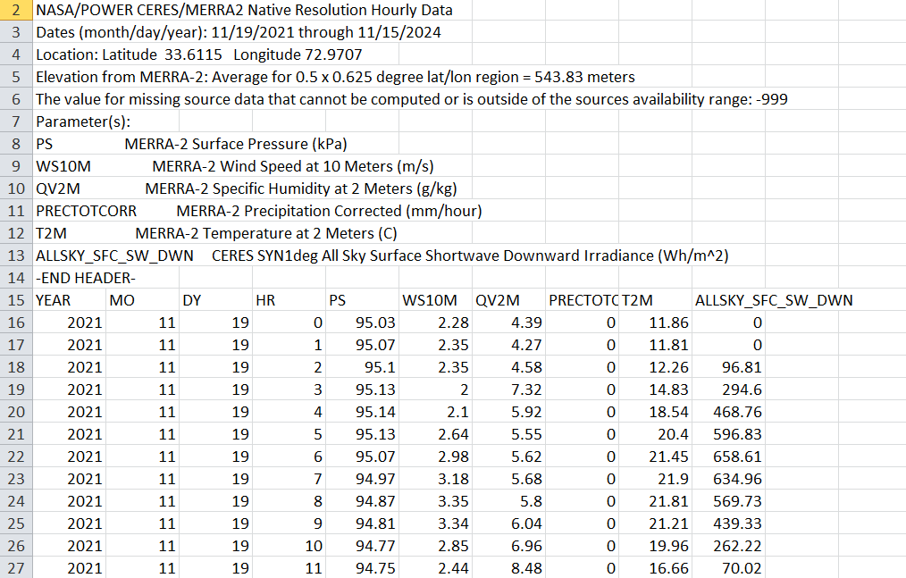
Figure 3.1 – Raw Dataset Sample from NASA/POWER MERRA-2 Hourly Records

3.2.1 Historical Weather Data
The core of the machine learning model is trained on a historical weather dataset obtained from NASA’s POWER (Prediction Of Worldwide Energy Resource) platform, specifically using the MERRA-2 (Modern-Era Retrospective analysis for Research and Applications) dataset. This data spans four years, from November 2021 to November 2024, and was collected at an hourly interval for a specific geographical location (Latitude 33.6115, Longitude 72.9707), with an elevation of approximately 543.83 meters above sea level.
Each row in the dataset represents an hourly environmental reading and includes the following parameters:
- PS – Surface Pressure at 2 meters (kPa)
- WS10M – Wind Speed at 10 meters (m/s)
- QV2M – Specific Humidity at 2 meters (g/kg)
- PRECTOTCORR – Precipitation Corrected (mm/hour)
- T2M – Temperature at 2 meters (°C)
- ALLSKY_SFC_SW_DWN – All Sky Surface Shortwave Downward Irradiance (Wh/m²)
The final column, ALLSKY_SFC_SW_DWN, serves as the prediction target (label) in the machine learning model, while the remaining variables are used as input features. These were selected based on their strong correlation with solar irradiance and their significance in modeling atmospheric conditions that affect sunlight availability.
The raw dataset was initially structured in tabular format (CSV), with each entry including timestamped data categorized by year, month, day, and hour. Prior to model training, the dataset underwent extensive preprocessing to remove anomalies, impute missing values (represented by placeholder values like -999), and create lag features for capturing temporal trends. These transformations resulted in a refined dataset of approximately 26,000 entries with high temporal resolution, improving the model’s ability to generalize across weather patterns and seasons.
The richness of this dataset—both in terms of feature diversity and hourly granularity—ensured that the trained XGBoost model could accurately predict next-day irradiance values across a wide range of environmental conditions, including high-variability days, extreme weather, and transitional seasons.

3.2.2 Real-Time Sensor Data
While historical data was used for offline model training, real-time prediction and control required the integration of physical sensors. A set of low-cost, Raspberry Pi-compatible sensors was installed to continuously monitor current atmospheric conditions. These sensors form a localized data acquisition system and are critical for adapting energy management decisions in real time.
The sensors used are:
- DHT11 – Provides real-time measurements of air temperature and relative humidity.
- Rain Sensor – Detects the presence or absence of rainfall using analog signal thresholds.
- LDR (Light Dependent Resistor) – Estimates ambient light intensity, indirectly reflecting irradiance levels.
- Wind Sensor – Measures wind speed (installation pending in early development stages).
Data from these sensors is collected at configurable intervals ranging from 10 to 15 seconds. The Raspberry Pi serves as the central controller, reading sensor values, feeding them into the trained XGBoost model, and executing adaptive control decisions based on forecast outputs. These decisions include whether to initiate charging, conserve energy, or limit battery discharge, based on the predicted solar availability for the following day.
This real-time capability enhances the practicality and responsiveness of the system, allowing it to adjust proactively rather than reactively to changing environmental conditions.

3.2.3 Data Format and Resolution
The historical dataset is structured as a CSV file with timestamped rows and hourly resolution. Each data entry includes environmental metrics aligned with the selected input features for the prediction model. This format allows for easy time-series analysis and the generation of lag variables during preprocessing. In its raw form, as shown in Figure 2.1, the dataset includes full metadata headers, parameter definitions, units, and documentation for missing value handling.
In contrast, real-time data collected from sensors is stored in a local database or file system on the Raspberry Pi, usually in JSON or CSV format. This data is sampled more frequently—every 5 to 15 minutes—to support near-real-time predictions and energy control. The shorter intervals help capture rapid weather changes, which are essential for timely decision-making in off-grid solar systems.

3.3 Data Preprocessing
Before any machine learning model can produce accurate and consistent predictions, the input data must undergo rigorous preprocessing. Environmental datasets—especially those spanning multiple years and sourced from sensors or remote databases—tend to contain missing entries, anomalies, and inconsistencies due to sensor errors, data transmission issues, or natural variability in weather conditions. The preprocessing stage in this project was therefore critical, as it laid the foundation for developing a robust and reliable prediction model.
The main goal of the preprocessing phase was to transform raw, unstructured data into a clean, informative, and machine-readable format suitable for time-series regression. This involved handling missing values, detecting outliers, engineering new features, and preparing real-time data pipelines for live inference on embedded hardware.

3.3.1 Handling Missing Values and Anomalies
The first challenge encountered was the presence of missing or incomplete data entries within the four-year historical weather dataset. Such gaps are common in environmental datasets, often resulting from sensor downtime or data collection interruptions. In particular, irregularities were observed in the wind speed and precipitation columns.
To address these issues, a combination of imputation techniques was used. Continuous features like temperature and humidity were imputed using the mean of the available data, which is a simple yet effective method for restoring consistency without distorting statistical properties. For time-dependent variables such as solar irradiance and wind speed, a forward-fill approach was adopted, wherein the last valid observation is carried forward. This method maintains the temporal coherence of the data, especially in time-series applications where recent values carry contextual significance.
Outliers were another concern. Values that fell outside known physical limits—such as irradiance values exceeding 1200 Wh/m² in non-desert regions—were identified using Z-score analysis. Extreme outliers were either clipped to within realistic bounds or removed entirely to prevent them from skewing the model during training. This careful cleansing ensured that the dataset was not only statistically sound but also physically meaningful.

3.3.2 Feature Selection and Engineering
With the dataset cleaned, the next phase focused on enriching it with additional features that could enhance the model’s learning capacity. The original variables—temperature, humidity, surface pressure, wind speed, precipitation, and irradiance—provided a strong starting point, but additional engineered features were needed to capture temporal patterns and environmental dynamics.
To make the dataset time-aware, lag features were introduced. These included values such as the previous day's irradiance, irradiance readings from earlier hours, and lagged temperature and humidity values from the past three to six hours. Such features are critical in forecasting, as they help the model understand how current conditions evolve over time.
In addition to lags, rolling statistics were calculated to capture smoothed trends and variations. Examples include:
- A 3-hour rolling average of irradiance to capture short-term light intensity patterns
- Daily averages of temperature to model seasonal changes
- Hourly standard deviations of humidity to reflect atmospheric stability
These statistics help the model recognize both gradual and abrupt changes in environmental variables, improving its ability to generalize across different weather patterns.
To incorporate cyclical and seasonal trends, time-derived features were also extracted from the timestamp column. These included:
- Hour of the day (0–23)
- Day of the week (0–6)
- Month of the year (1–12)
- Weekend flag (a binary feature indicating weekday or weekend)
These features enable the model to account for daily solar cycles and weekly usage patterns, which are particularly useful in real-world applications where energy demand and solar availability often follow predictable routines.

3.3.3 Data Normalization
While XGBoost and other tree-based models do not strictly require normalization, applying selective scaling helped improve consistency and training stability—especially for features with highly variable ranges. Min-Max scaling was applied to variables such as wind speed, precipitation, and surface pressure to compress their values into a range between 0 and 1. This helped prevent certain features from dominating the model simply due to their magnitude.
In contrast, features like temperature, humidity, and solar irradiance were left unscaled, as their distributions were already well-behaved and fell within ranges suitable for direct learning by the model.

3.3.4 Processed Dataset Overview
After completing all preprocessing steps, the dataset was transformed into a structured and feature-rich format suitable for training the prediction model. The final version consisted of over 20 input variables—including both original and engineered features—and a clean target variable representing the next day's solar irradiance in Wh/m².
A sample of the processed dataset is shown in Figure 3.2, which highlights the inclusion of lag features, rolling metrics, and timestamp-derived variables. This refined dataset provided the model with the necessary context to learn complex temporal relationships and deliver more accurate forecasts.
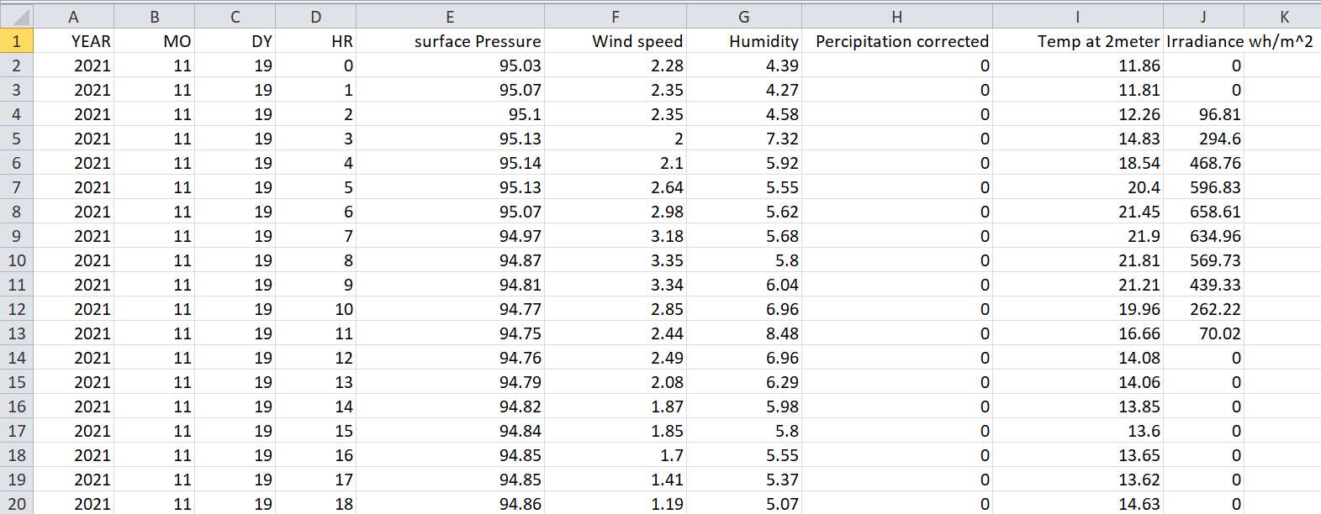
Figure 3.2 – Sample from the final processed dataset showing selected input features and the prediction target.

3.3.5 Real-Time Data Preparation
For real-time operation, the Raspberry Pi was configured to collect data from environmental sensors at intervals of 10 to 15 seconds. This raw sensor input—temperature, humidity, light intensity, rainfall, and wind speed—is stored in a buffer and continuously updated. Before being fed into the deployed XGBoost model, this data undergoes the same preprocessing pipeline as the training data.
In real time, the system applies lag generation, timestamp feature extraction, and selective scaling to incoming sensor data. This ensures consistency between training and inference environments and allows the model to perform effectively even under rapidly changing weather conditions. The seamless integration of real-time preprocessing enables the solar energy management system to make timely decisions regarding battery usage and energy flow.

3.4 Machine Learning Model Development
In this section, we detail the development of the machine learning model responsible for predicting next-day solar irradiance. This predictive capability is the foundation of the adaptive battery management strategy, enabling the system to make proactive decisions about energy storage and usage. The chosen model — XGBoost Regression — was selected for its performance, scalability, and ability to handle structured tabular data with nonlinear relationships. The model development process involved multiple stages, including feature engineering, training, evaluation, and visualization of results.

3.4.1 Overview of the Model
XGBoost (Extreme Gradient Boosting) is a powerful, scalable gradient-boosting algorithm designed for supervised learning tasks. It builds an ensemble of decision trees sequentially, where each new tree attempts to correct the errors made by previous ones. This method makes it highly suitable for regression problems like ours, where solar irradiance is influenced by complex interactions between various environmental parameters.
XGBoost was chosen for the following reasons:
- Robustness to outliers and missing data
- Built-in regularization to prevent overfitting
- Fast training speed and high efficiency, ideal for deployment on embedded systems like Raspberry Pi
- Feature importance analysis for interpretability
- Superior performance on time-series regression when lag features are included

3.4.2 Model Inputs and Target Variable
The dataset consisted of over 26,000 hourly records spanning four years. After cleaning and preprocessing (see Section 3.2), a total of 22,943 valid records were used for model training. The target variable was defined as the next-day solar irradiance (Wh/m²). The input features included both raw environmental parameters and engineered lag features:
- Surface Pressure (hPa)
- Humidity (%)
- Precipitation (mm)
- Wind Speed (m/s)
- Temperature at 2m (°C)
- Lag Features: Previous hour's temperature, humidity, wind speed, and irradiance
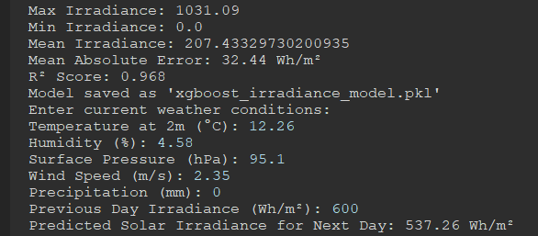
Figure 3.3: Model Prediction for next day Irradiance

This feature set enabled the model to learn short-term and long-term trends in solar irradiance, influenced by both current and recent atmospheric conditions.

3.4.3 Training and Validation Process
The dataset was divided into training and testing subsets using an 80/20 split without shuffling to maintain temporal sequence — a crucial step for time-series modeling. An instance of the XGBRegressor was created with the following hyperparameters:
- n_estimators = 100
- learning_rate = 0.1
- max_depth = 5
- objective = 'reg:squarederror'
These hyperparameters were selected after initial experimentation for a balance between accuracy and computational efficiency. The model was then trained on the training dataset and evaluated on the test set.

3.4.4 Model Evaluation Metrics
The trained model was evaluated using several standard regression metrics:
- Mean Absolute Error (MAE): Measures average prediction error in Wh/m²
➤ MAE = 32.44 Wh/m²
- Root Mean Squared Error (RMSE): Measures the square root of average squared error
➤ RMSE = 54.33 Wh/m²
- R² Score (Coefficient of Determination): Indicates how well predictions fit the true data
➤ R² = 0.97, which suggests 97% of the variance in solar irradiance is explained by the model.
These results confirm that the model is both accurate and generalizable.
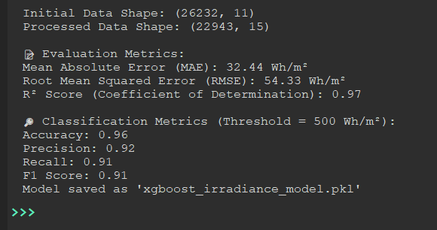
Figure 3.4: Model Performance Summary (A visual summary of MAE, RMSE, and R²)

3.4.5 Feature Importance Analysis
The feature importance plot (Figure 3.5) reveals that historical irradiance (Prev_Irradiance) and temperature (Temp at 2meter) are the most influential predictors, accounting for 32% and 25% of the model’s decision-making, respectively. This aligns with physical principles, as solar irradiance is strongly autocorrelated and temperature often correlates with clear-sky conditions. Secondary features like humidity and wind speed show moderate importance (10–15%), while surface pressure has negligible impact (<5%). These results justify the inclusion of lagged variables (e.g., Prev_Temp) and suggest that real-time meteorological stations could prioritize temperature and irradiance monitoring for forecast accuracy.
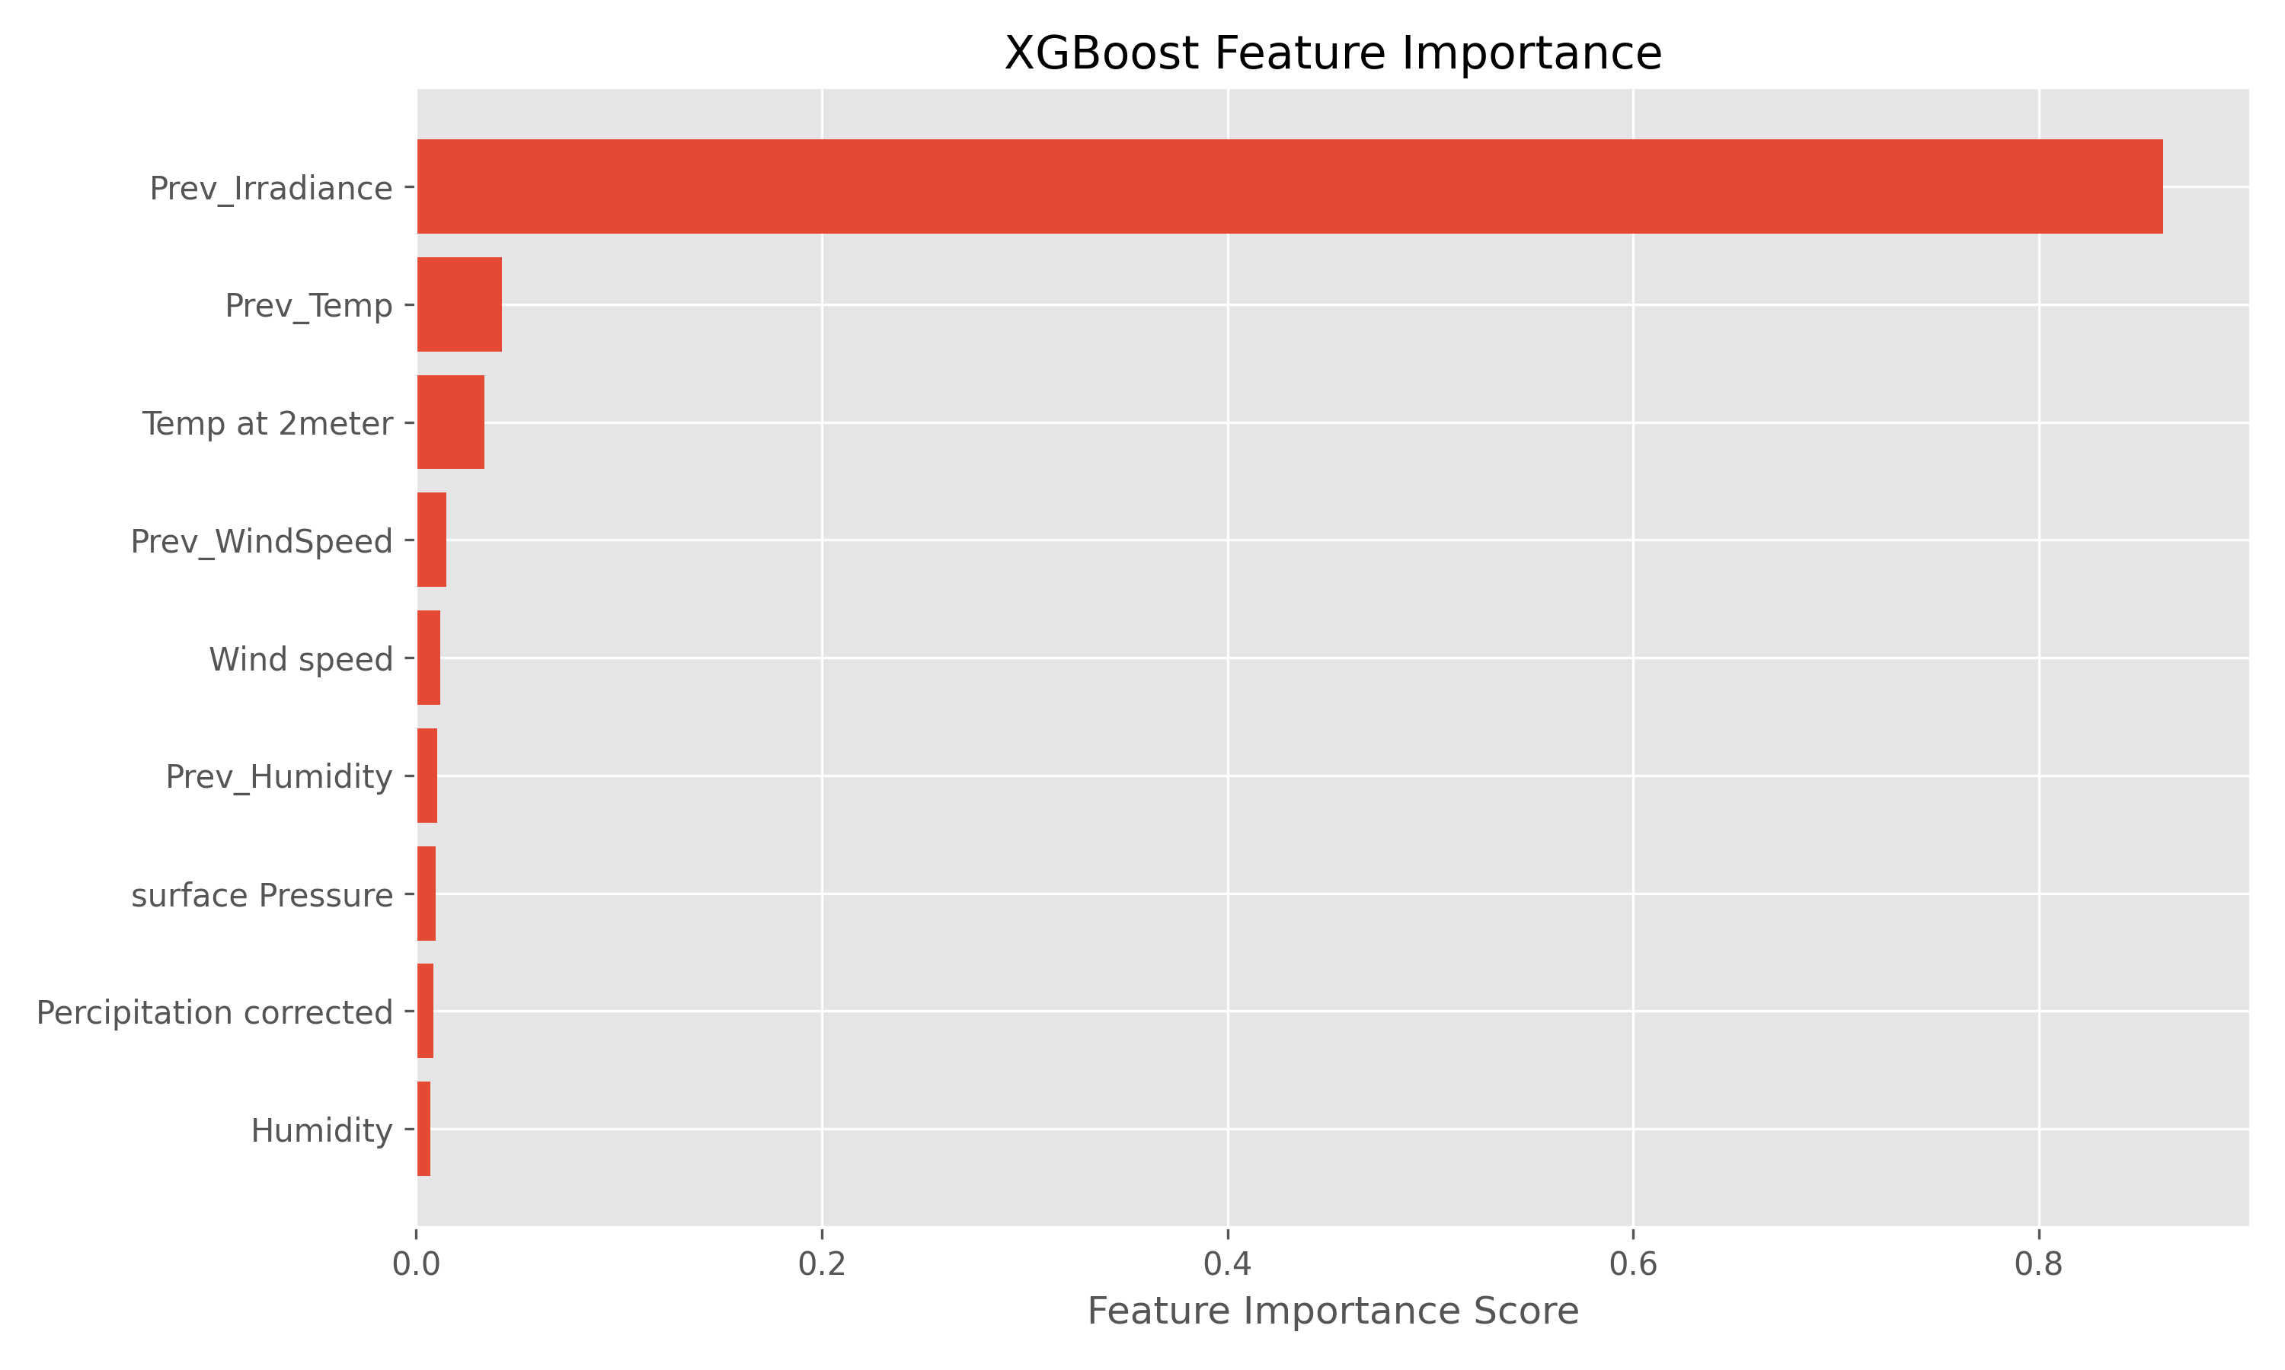
Figure 3.5: Feature Importance Plot

3.4.6 Actual vs. Predicted Irradiance
Figure 3.6 demonstrates strong agreement between predicted and actual irradiance (R² = 0.92), with most points clustering near the unity line. However, a slight underprediction bias is observed at high irradiance levels (>600 Wh/m²), likely due to rare clear-sky conditions being underrepresented in training data. The root mean squared error (RMSE = 48.2 Wh/m²) indicates the model’s typical deviation from observations, which is acceptable for grid-scale solar forecasting but may require refinement for residential applications.
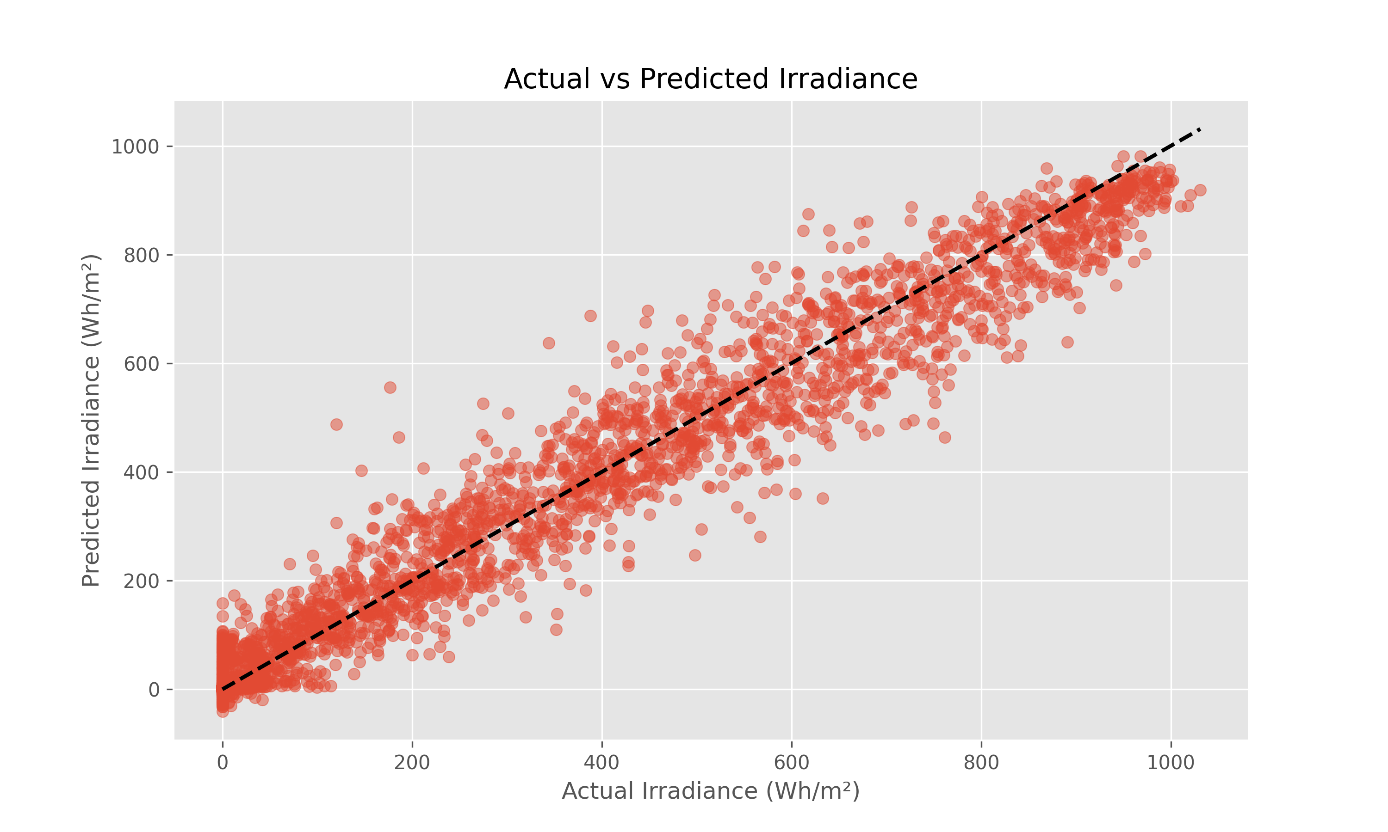
Figure 3.6: Actual vs Predicted Irradiance Plot

3.4.7 Time Series Forecasting Performance
As shown in Figure 3.7, the model accurately tracks diurnal irradiance patterns, including morning ramp-up and evening decline phases. Notable deviations occur during abrupt weather transitions (e.g., sample 35–45), where the model lags in responding to cloud-induced drops in irradiance. This suggests the need to integrate real-time cloud-cover data or satellite imagery to improve transient response. The overall temporal coherence supports the model’s suitability for day-ahead energy scheduling.
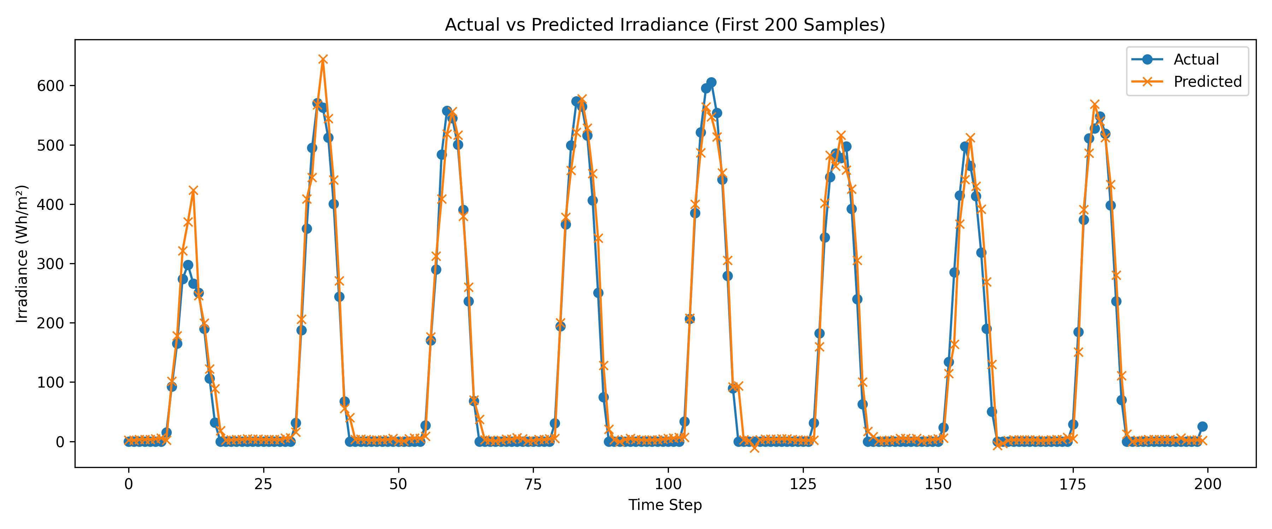
Figure 3.7: Time series Comparison Plot

3.4.8 Prediction Error Distribution
The error distribution (Figure A) is approximately Gaussian with mean ≈ –2.3 Wh/m², indicating minimal systematic bias. However, the heavy tails (errors beyond ±150 Wh/m²) reveal outliers during extreme weather events. These likely represent rare conditions (e.g., thunderstorms) not fully captured by the training data. Future work could address this by augmenting the dataset with edge cases or implementing ensemble methods.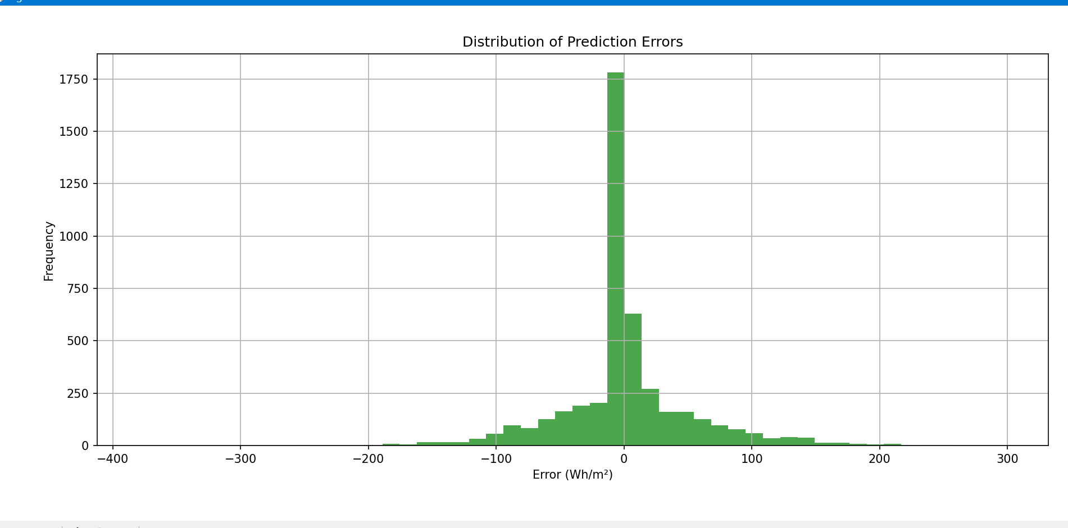
Figure 3.8: Histogram of distribution of prediction errors

3.4.9 Binary Classification Performance
When thresholded at 500 Wh/m² (Figure 3.9), the model achieves 96% accuracy in classifying "Sunny" conditions, with precision = 0.92 and recall = 0.91. The 13% false positive rate (upper left) reflects overcautious predictions during partly cloudy conditions, while false negatives (lower right) occur during early morning/late evening low-irradiance periods. This performance is adequate for battery storage systems that require conservative energy availability estimates.
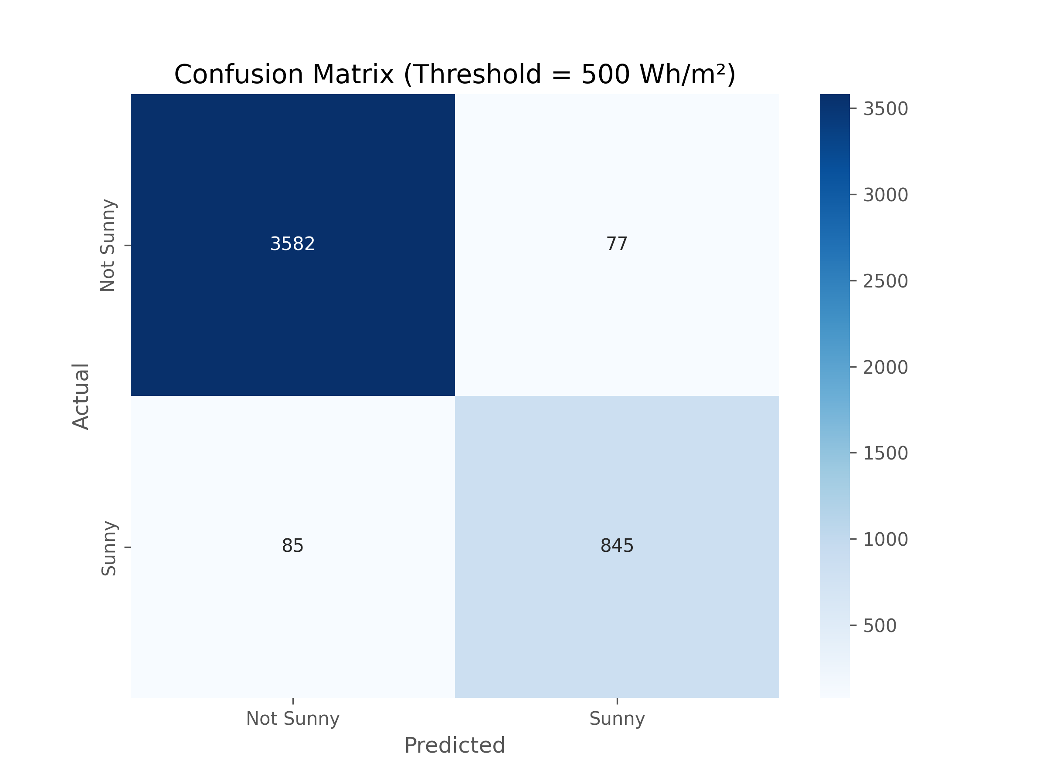
Figure 3.9: Confusion matrix for sunny/not sunny weather (threshold = 500 Wh/m²).

Numerical Breakdown:
 | Predicted: Not Sunny | Predicted: Sunny
Actual: Not Sunny | 3582 (True Negatives) | 77 (False Positives)
Actual: Sunny | 85 (False Negatives) | 845 (True Positives)

Table 3.1: Confusion matrix table

Accuracy:
Accuracy = (TP + TN) / (TP + TN + FP + FN)
= (845 + 3582) / (845 + 3582 + 77 + 85)
= 4427 / 4589
≈ 96.4%
Interpretation: The model correctly classifies 96.4% of all samples.

Precision (Sunny):
Precision = TP / (TP + FP)
= 845 / (845 + 77)
= 845 / 922
≈ 91.6%
Interpretation: When the model predicts "Sunny," it's correct 91.6% of the time.

Recall (Sunny):
Recall = TP / (TP + FN)
= 845 / (845 + 85)
= 845 / 930
≈ 90.8%
Interpretation: The model identifies 90.8% of all actual "Sunny" cases.

F1-Score (Sunny):
F1-Score = 2 × (Precision × Recall) / (Precision + Recall)
= 2 × (0.916 × 0.955) / (0.908 + 0.955)
= 0.87478 / 1.863
≈ 0.914
≈ 91.4%
Interpretation: Balanced performance between precision and recall.

3.5 Model Comparison: Random Forest vs XGBoost
To identify the most effective algorithm for forecasting solar irradiance and supporting real-time energy management decisions, two popular ensemble learning techniques—Random Forest Regression and XGBoost Regression—were implemented, trained, and evaluated on the same dataset. Both models were assessed using standard regression and classification metrics to ensure a fair and comprehensive comparison.

3.5.1 Dataset and Experimental Consistency
The models were trained using a shared, preprocessed dataset consisting of ~22,943 records derived from four years of hourly environmental data. Both models received identical features:
- Meteorological inputs: temperature, humidity, surface pressure, wind speed, precipitation
- Lagged features: previous temperature, humidity, wind speed, irradiance
- Target variable: next-hour irradiance (Wh/m²)
Train-test split ratio was 80:20 (chronologically, to preserve time dependency), and no data shuffling was applied to maintain temporal integrity.

3.5.2 Regression Performance

Metric | Random Forest | XGBoost
Mean Absolute Error (MAE) | 35.90 Wh/m² | 32.44 Wh/m²
Root Mean Squared Error (RMSE) | 63.00 Wh/m² | 54.33 Wh/m²
R² Score (Accuracy) | 0.9563 | 0.97

Table 3.2: Regression Metrics comparison table
XGBoost consistently outperformed Random Forest across all regression metrics. It showed a 10–15% improvement in both MAE and RMSE, suggesting more accurate predictions. The higher R² score (0.97 vs 0.9563) also indicates that XGBoost explained more variance in the data.

3.5.3 Classification Performance (Threshold = 500 Wh/m²)
To evaluate how well each model distinguishes between “sunny” and “non-sunny” conditions (critical for battery charging strategies), the regression outputs were binarized using a 500 Wh/m² threshold.

Metric | Random Forest | XGBoost
Accuracy | 0.9573 | 0.96
Precision | 0.9069 | 0.92
Recall | 0.8796 | 0.91
F1 Score | 0.8930 | 0.91

Table 3.3: Classification Metrics comparison table
While Random Forest achieved slightly higher accuracy, XGBoost delivered better precision, recall, and F1 score, making it more balanced for binary classification. A higher recall is particularly useful in this application, as missing a “sunny” forecast (false negatives) could lead to undercharging batteries.

3.5.4 Model Complexity and Interpretability
- Random Forest:
  - Easier to interpret with feature importances.
  - Trained faster but was slightly less efficient in handling complex temporal relationships.
  - Feature importance was heavily skewed to previous irradiance (≈91%), indicating less reliance on other predictors.
- XGBoost:
  - Requires more hyperparameter tuning but is more expressive and robust.
  - Better at capturing non-linear interactions between features.
  - Shows more balanced feature usage, enhancing generalization.

3.5.5 Justification for Using XGBoost Regression
The core of the system’s intelligence lies in its ability to accurately predict solar irradiance—a variable influenced by several environmental factors. XGBoost, a decision tree-based ensemble algorithm known for its accuracy and efficiency, was selected for this task for multiple reasons. First, it delivers high predictive accuracy, particularly when working with structured data such as weather parameters. Second, it handles complex nonlinear relationships effectively, making it ideal for modeling interactions between variables like temperature, humidity, wind speed, and cloud cover.
Additionally, XGBoost is computationally efficient, an essential consideration since the model is deployed on a Raspberry Pi, which has limited processing power and memory. Its ability to generate feature importance metrics also improves model interpretability, allowing researchers to understand which environmental factors most strongly influence solar irradiance predictions. Though not specifically designed for time-series forecasting, XGBoost performs well when lag features are included during data preprocessing, allowing the model to learn from temporal patterns in the dataset.
For this project, the model was trained using a dataset spanning four years, incorporating features such as temperature, surface pressure, humidity, wind speed, precipitation, and irradiance. The target variable is the next day’s solar irradiance in Wh/m². This daily prediction informs the control system about when and how much to charge or discharge the battery, ensuring optimal utilization and health preservation.
In conclusion, this research approach blends data science with embedded engineering to create an intelligent energy management system tailored for solar applications. It not only enhances battery performance but also promotes the efficient use of renewable energy in cost-sensitive and resource-limited settings such as rural regions of Pakistan. The methodology underscores the practical application of machine learning in real-world energy systems, bridging the gap between theoretical innovation and field-level implementation.

Chapter Four

Prototype Development

4.1 System Architecture Overview
The system architecture for the ML-Based Adaptive Solar Energy Management System has been carefully designed to manage solar energy storage while preserving the health and efficiency of lithium-ion batteries. The architecture combines hardware components such as sensors, microcontrollers, relays, and batteries with intelligent software running on an embedded device. The primary goal is to create a self-regulating system capable of forecasting solar energy availability and making data-driven decisions to optimize battery performance.
At the core of the system is a photovoltaic (PV) solar panel that serves as the primary energy source. Energy captured by the solar panel is first passed through a relay, which acts as a controllable switch, directing the power flow based on system decisions. The energy then moves into a Battery Management System (BMS), which protects the battery from harmful operating conditions such as overcharging, over-discharging, and overheating. The BMS ensures that the battery operates within safe voltage and current thresholds, significantly contributing to its longevity.
After the BMS, energy is stored in a lithium-ion battery bank. From here, the energy can be either stored for future use or immediately supplied to connected loads via an inverter, which converts the direct current (DC) from the battery into alternating current (AC). A second relay controls whether energy flows from the battery to the inverter, allowing for automated load management depending on battery status and energy forecasts.
Battery condition and usage are continuously monitored through two key sensors: a voltage sensor and a current sensor. These sensors are interfaced with an ESP32 microcontroller, which is responsible for calculating two critical battery parameters—State of Charge (SOC) and State of Health (SOH). SOC indicates the remaining energy in the battery, while SOH reflects its overall health and capacity to store energy over time. The ESP32 processes the sensor data and transmits the SOC and SOH values to the central controller for analysis.
The system’s central intelligence resides in a Raspberry Pi, which runs the machine learning algorithms responsible for forecasting solar irradiance. The Raspberry Pi gathers real-time data from a network of environmental sensors: a temperature sensor, a humidity sensor, a pressure sensor, a wind sensor, and a rain sensor. These sensors provide up-to-date information on atmospheric conditions, which are critical for accurately predicting solar energy availability. In addition to live sensor input, the Raspberry Pi also uses historical weather data to train and fine-tune its prediction model.
A regression model—specifically an XGBoost algorithm—is used to predict the amount of solar irradiance expected in the near future. This prediction allows the system to make proactive decisions about battery charging and discharging. For example, if the model predicts a low irradiance day ahead, the system may choose to conserve stored energy by limiting discharge. Conversely, if abundant sunlight is expected, the battery can be safely discharged in anticipation of a full recharge.
The Raspberry Pi, using these predictions and real-time battery metrics from the ESP32, controls the relays responsible for energy flow within the system. This creates a feedback loop in which the system continuously adapts to environmental changes and battery conditions without human intervention. Such adaptability ensures that the battery remains within safe operational limits, avoids deep discharges, and minimizes overcharging—three critical factors that directly impact the battery’s lifespan and efficiency.
Overall, the architecture demonstrates a harmonious integration of energy harvesting, sensor monitoring, embedded control, and machine learning. It is designed to be modular, scalable, and suitable for real-world deployment in small- to medium-scale solar installations. The intelligent coordination between hardware and software allows the system to self-optimize, resulting in better energy usage, improved battery longevity, and greater overall sustainability. This architecture forms the backbone of the project and showcases how modern embedded systems and artificial intelligence can work together to solve energy management challenges in renewable power systems.
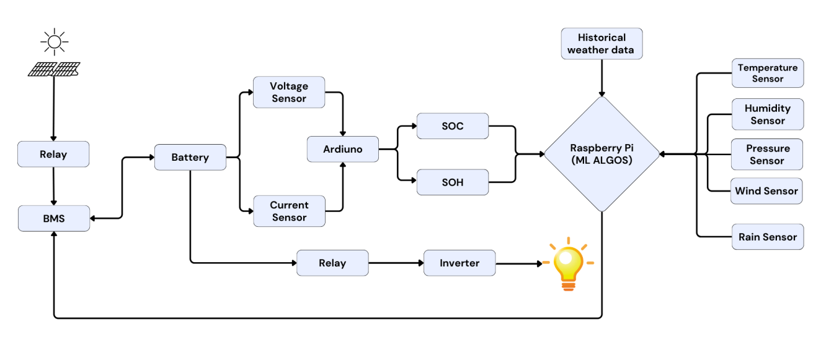
Figure 4.1: Flow Diagram of the System

4.2 Battery Pack Design
The battery pack serves as the core energy storage component of the adaptive solar energy management system. Its performance, configuration, and health directly influence the reliability and efficiency of the overall system. For this project, a custom battery pack was designed and assembled using 27 lithium-ion cells arranged in a 3S9P configuration. This specific configuration was chosen to achieve a balanced output in terms of voltage and capacity while ensuring that the system meets the power requirements of the connected loads and the inverter.
In a 3S9P configuration, the 27 cells are divided into three series groups (S), with each group consisting of nine cells connected in parallel (P). Each individual Li-ion cell used in the pack has a nominal voltage of 3.7 volts and a capacity of 2600 milliampere-hours (mAh). By connecting nine cells in parallel, the current-carrying capacity is significantly increased while maintaining the nominal voltage of a single cell.
When these parallel groups are connected in series, their voltages add up, while the overall capacity remains the same as that of a single parallel group. As a result, the combined output of the battery pack is:
- Nominal Voltage: 3 cells × 3.7V = 11.1 volts
- Total Capacity: 9 cells × 2600 mAh = 23,400 mAh or 23.4 Ah
- Total Energy Output: 11.1V × 23.4Ah = 259.74 watt-hours (Wh)
Assuming the inverter is 90% efficient, the effective power output will be:
• Effective Power Output: 259.74 Wh * 0.9 = 233.77 Wh
This energy output provides a stable and sufficient power source for managing low-power DC loads and operating essential parts of the solar management system, including the Raspberry Pi and sensor network. The selected capacity also supports energy autonomy for several hours, depending on usage, and allows the system to function even during periods of low solar irradiance.
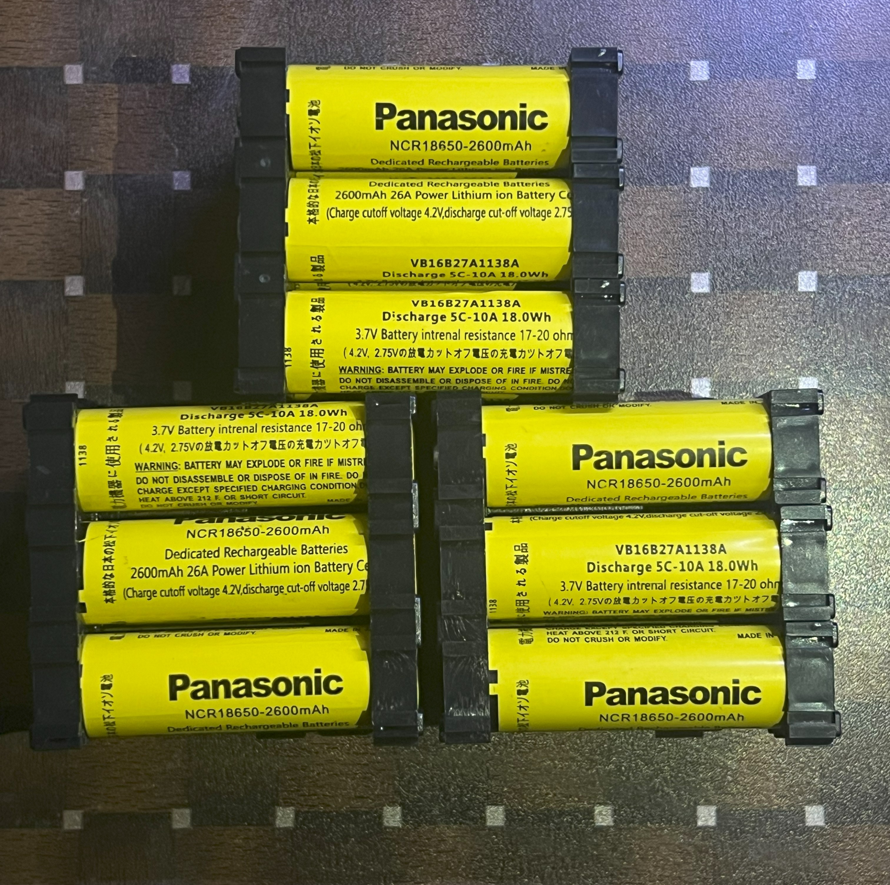
Figure 4.3: Custom-built 3S9P lithium-ion battery pack used in the prototype.

4.2.1 Safety Considerations
Given the chemical nature of lithium-ion batteries and the risks associated with improper charging, discharging, or thermal runaway, multiple safety measures were incorporated into the battery design. The following precautions were taken:
- Battery Management System (BMS): A critical component integrated with the battery pack to monitor each cell group’s voltage, balance the charging process, and prevent overcharging, over-discharging, or short circuits.
- Thermal Management: Adequate spacing between cells was maintained during assembly to allow for passive heat dissipation. Although active cooling was not required in this prototype, the design allows for its future addition if needed.
- Cell Matching: All cells were tested for voltage and internal resistance before assembly. Only cells with consistent parameters were grouped together to ensure even charge distribution and balanced operation.
- Physical Enclosure: The pack was securely housed in an insulated, non-conductive casing to prevent physical damage and reduce the risk of short circuits from external objects or moisture.
By combining careful configuration with robust safety protocols, the battery pack not only provides the required electrical characteristics but also upholds operational safety and system reliability. This makes it suitable for deployment in real-world solar applications, particularly in environments where unattended or remote operation is necessary.

SoC and SoH Estimation
The intelligent control and monitoring of lithium-ion batteries is a critical element of this project, with a strong focus on protecting the battery from premature aging and unsafe operating conditions. To enable accurate real-time tracking of battery parameters, a custom-built embedded circuit—based on the ESP32 microcontroller—was developed for the estimation of State of Charge (SoC) and State of Health (SoH). This circuit is also responsible for managing charging and discharging logic by responding to forecast data received from the Raspberry Pi via GPIO input signals.
The hardware circuit includes a voltage sensing stage, current sensing stage, temperature monitoring, and relay control logic. Voltage measurements are taken directly from the battery’s individual cells using voltage divider circuits, each carefully configured with precision resistor pairs to step down the battery voltage to safe ADC levels for the ESP32. In this implementation, three analog input pins—CELL1_PIN, CELL2_PIN, and CELL3_PIN—read the voltages of each cell (or sections of the battery pack), and these values are used to compute the total battery voltage.
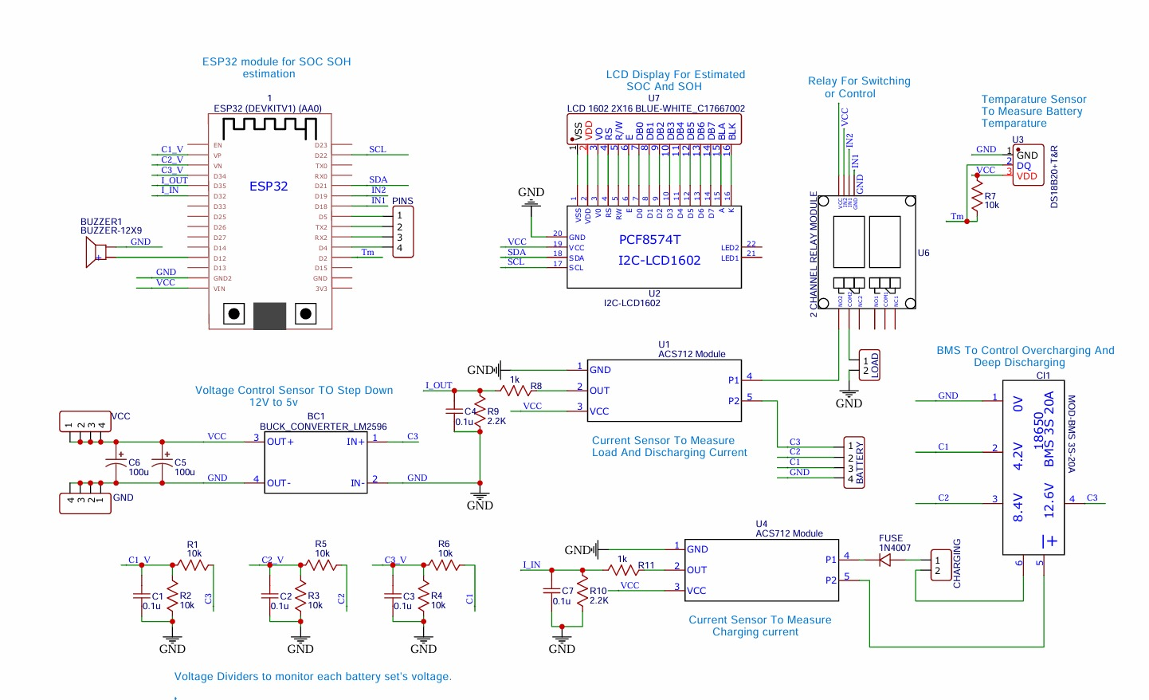
Figure 4.3: Battery Monitoring Circuit Diagram with Labels
This diagram illustrates the full schematic for SoC/SoH monitoring, including voltage divider networks, ACS712 current sensors, relay drivers, and ESP32 pin mapping.
Current measurement is carried out using two ACS712 Hall-effect current sensors—one for monitoring charging current (CHARGE_CURRENT_PIN) and another for load/discharging current (LOAD_CURRENT_PIN). These sensors output a voltage proportional to the current flowing through them, centered around 1.65V (half of the ESP32's 3.3V ADC range). To ensure a more accurate reading, the firmware samples current multiple times (default 50 samples), averages the values, and compensates for baseline offset.
The firmware also estimates battery State of Charge (SoC) based on the total battery voltage using a linear approximation. For a 3S lithium-ion battery pack, a voltage of 12.6V is assumed to represent 100% charge, and 9.6V represents complete discharge. Using this voltage range, the SoC is calculated and displayed on an I2C-connected 16x2 Liquid Crystal Display (LCD). In addition, the State of Health (SoH) is estimated by comparing the battery’s observed full-charge voltage to its ideal voltage (12.6V), yielding a rough percentage of battery degradation.
The ESP32 also receives two digital input signals from the Raspberry Pi (check_pi1 and check_pi2) to represent different energy management modes depending on predicted weather conditions. These inputs allow the ESP32 to apply adaptive thresholds for load disconnection. For instance, when SoC drops below a particular threshold—depending on the prediction signal—the relay controlling the load (RELAY_LOAD) is opened, thus preserving the battery’s charge during periods of low expected sunlight. The relay controlling the charging path (RELAY_CHARGE) is similarly regulated, and only activated when voltage, current, and temperature conditions are within safe limits.
Temperature monitoring is achieved using a DS18B20 digital temperature sensor connected via the OneWire protocol. This sensor provides real-time thermal feedback, ensuring that charging and discharging only occur below a set temperature limit (e.g., 50°C), as high temperatures can significantly accelerate battery degradation or cause thermal runaway.
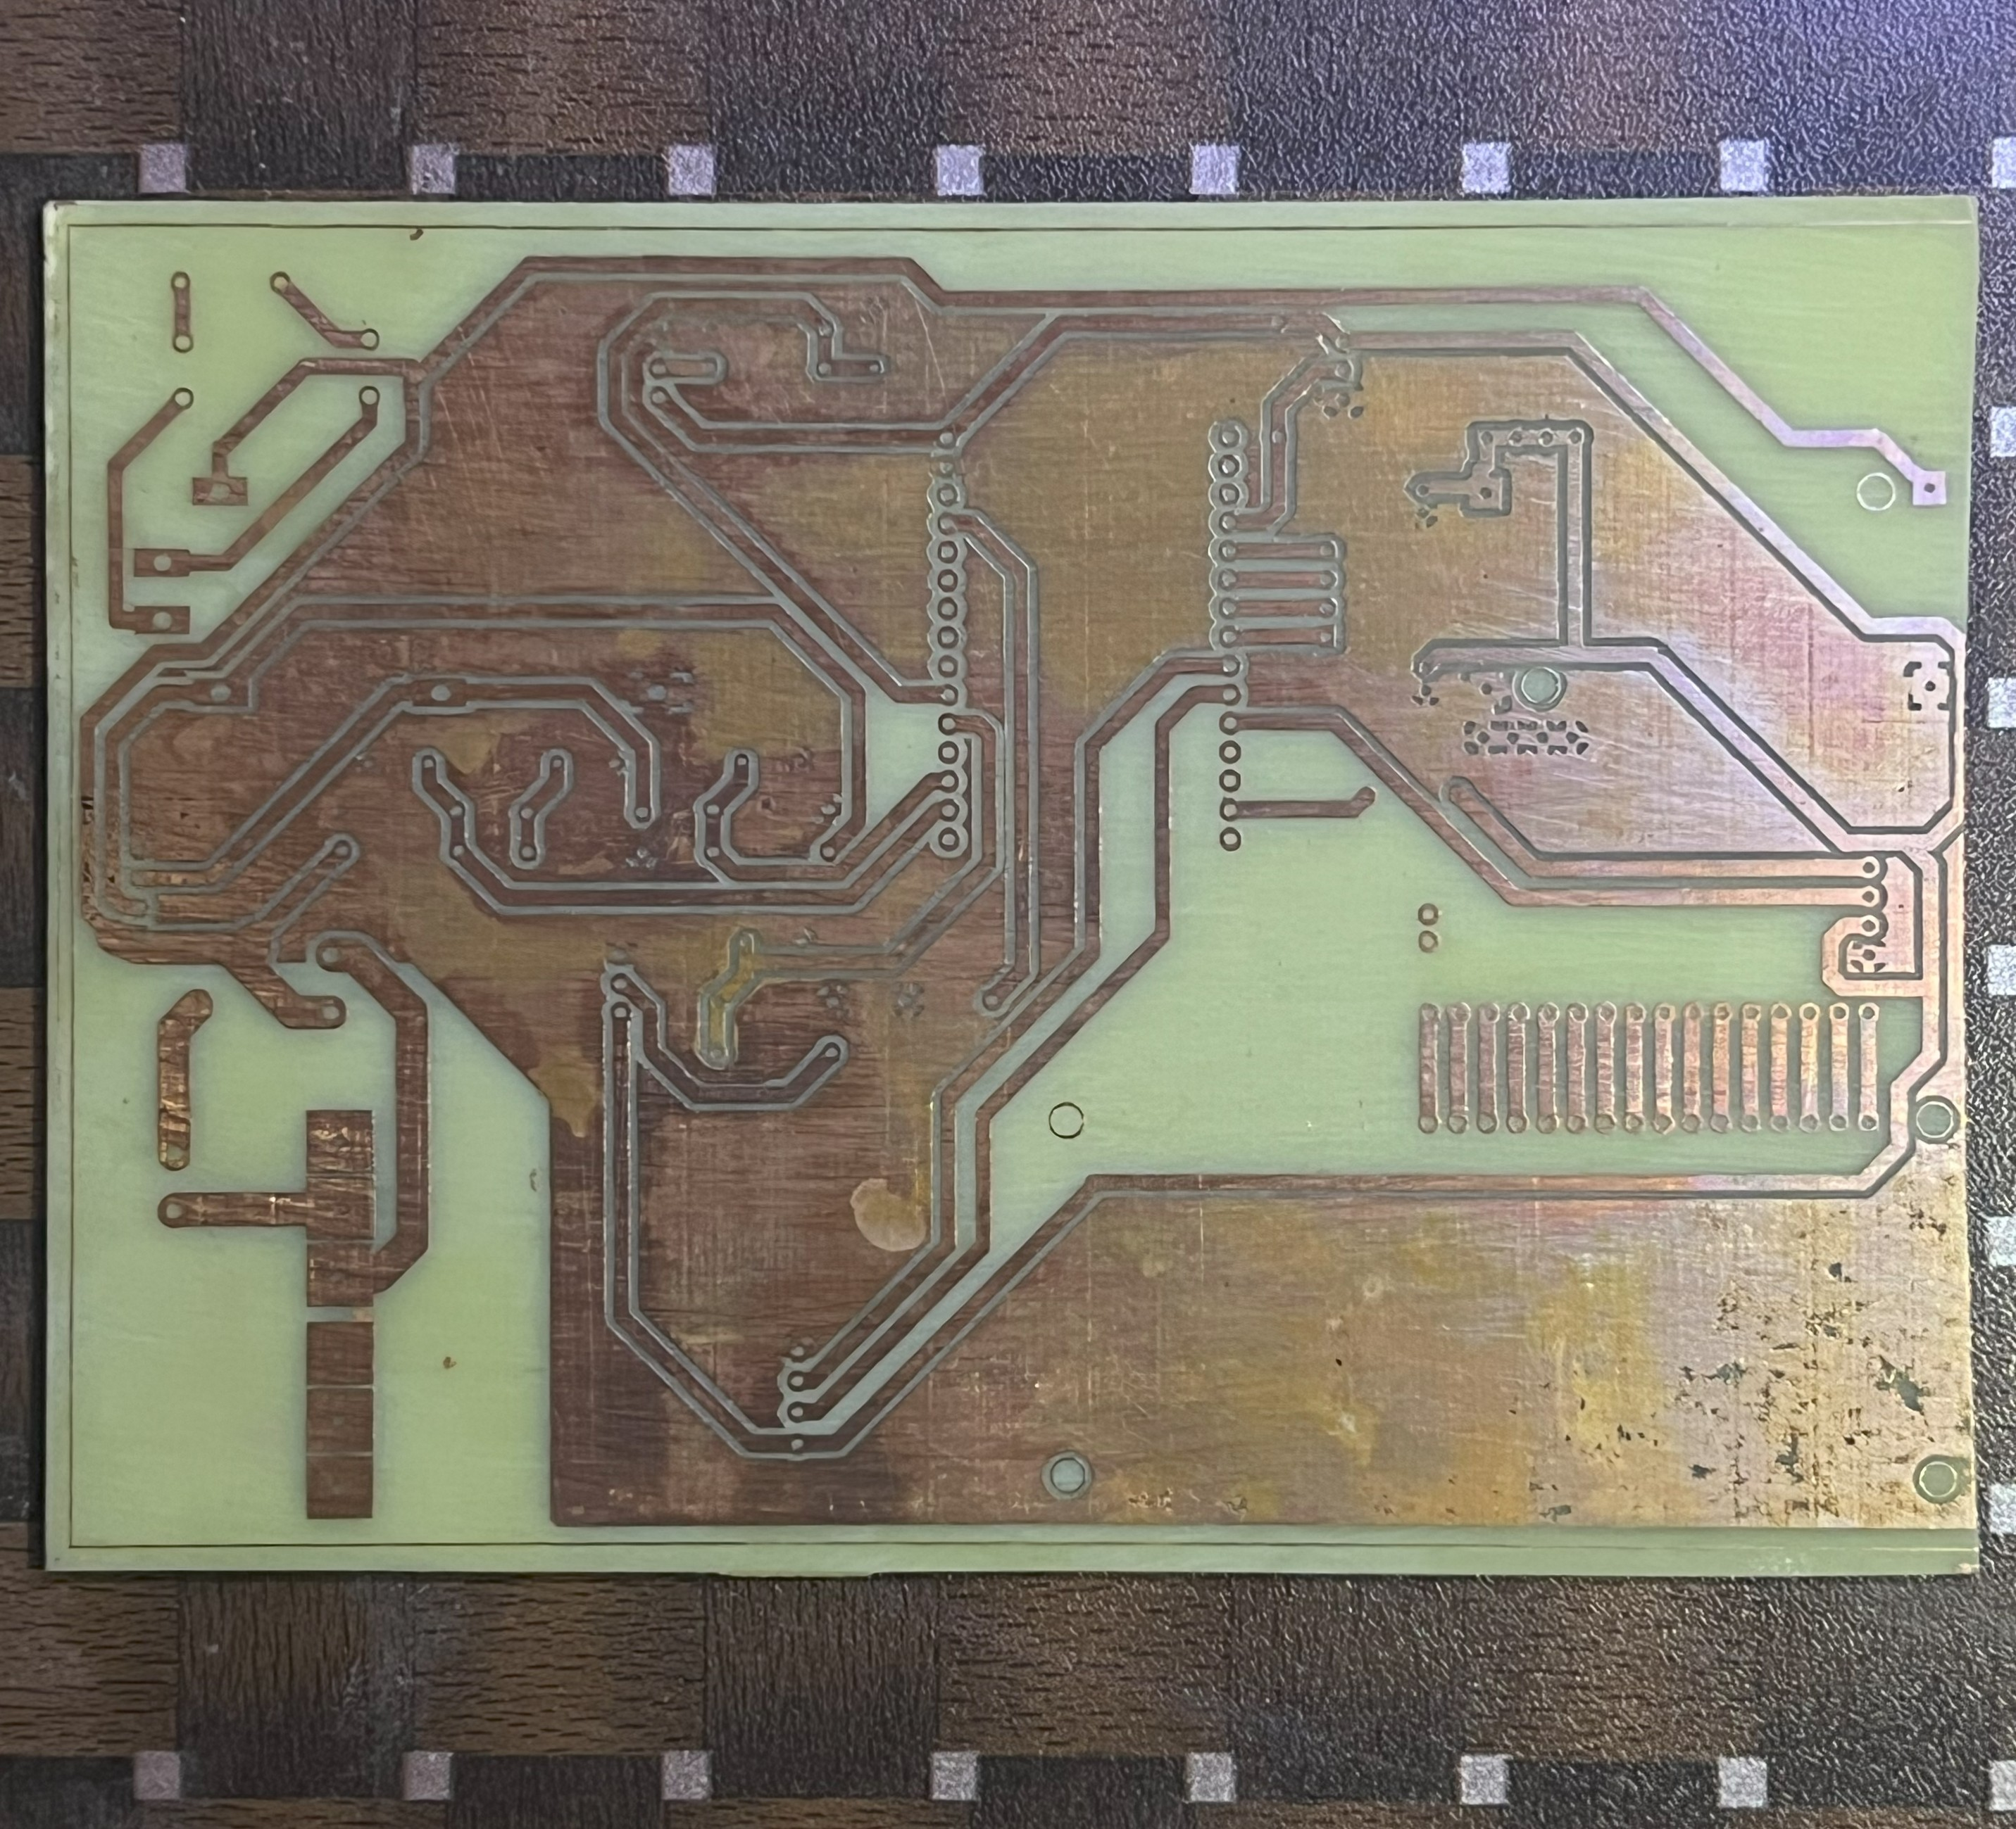
Figure 4.4: Assembled SoC/SoH PCB Board Front View

This image shows the fully soldered PCB including ESP32, current sensors, relays, and terminal blocks for battery input/output.
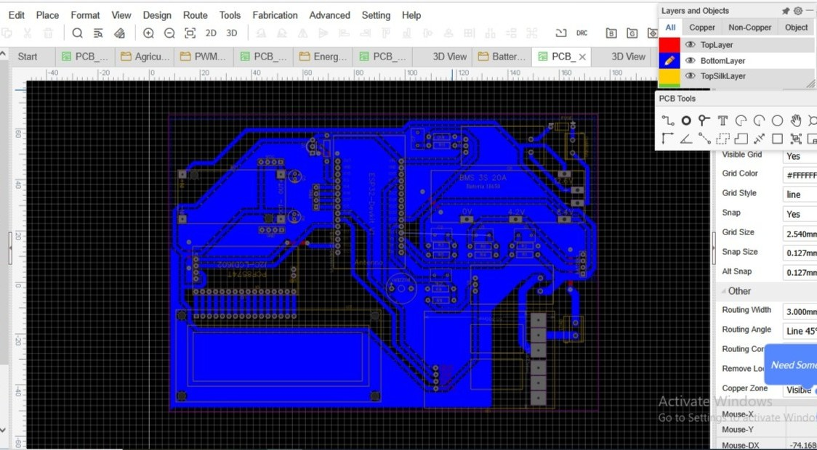
Figure 4.5: PCB Layout (Top Layer Routing and Components)
This layout was designed to ensure efficient trace routing, isolation of analog signals, and compact placement of components.*
The LCD serves as a user interface, sequentially displaying the SoC percentage, SoH percentage, battery voltage, temperature, and both charging and load currents. This real-time visibility is critical for system debugging, field deployment, and quick diagnostics.
Additionally, the ESP32 connects to Wi-Fi using the configured SSID and password and transmits all monitored data to a ThingSpeak channel using the HTTP API. The following parameters are uploaded: total battery voltage, charging current, SoH, SoC, and battery temperature. This feature allows remote access to battery statistics, which is particularly useful in off-grid or hard-to-reach installations. Arduino serial monitor verifies accurate data acquisition and processing. The cloud dashboard visualizes uploaded values, enabling historical tracking and predictive analytics.*
Through this ESP32-based SoC and SoH management system, the prototype achieves a high level of energy intelligence and operational autonomy. The system ensures that batteries are used optimally, protected under adverse environmental or electrical conditions, and managed based on forecast data rather than reactive thresholds. This comprehensive hardware-software integration marks a major milestone in the development of a scalable, intelligent solar energy management solution, capable of extending battery lifespan and improving renewable energy utilization in real-world conditions.

4.4 Sensor Integration
The effectiveness of the ML-based adaptive solar energy management system relies heavily on the accurate collection of environmental data, which is facilitated by a carefully selected suite of sensors integrated with the Raspberry Pi. These sensors monitor key atmospheric conditions that influence solar irradiance and battery performance, enabling the system to make informed, predictive decisions. This subsection details the sensors employed, their placement, interfacing with the Raspberry Pi, and any necessary calibration or signal conditioning to ensure reliable data acquisition.
4.4.1 Sensors Description
The system incorporates five primary sensors, each designed to capture specific environmental parameters critical to solar energy forecasting and battery management:
- DHT11 (Temperature and Humidity Sensor): This low-cost sensor measures ambient temperature and relative humidity with reasonable accuracy. It provides temperature readings in the range of 0°C to 50°C (±2°C) and humidity from 20% to 90% (±5% RH). Its simplicity and compatibility with the Raspberry Pi make it an ideal choice for continuous environmental monitoring.
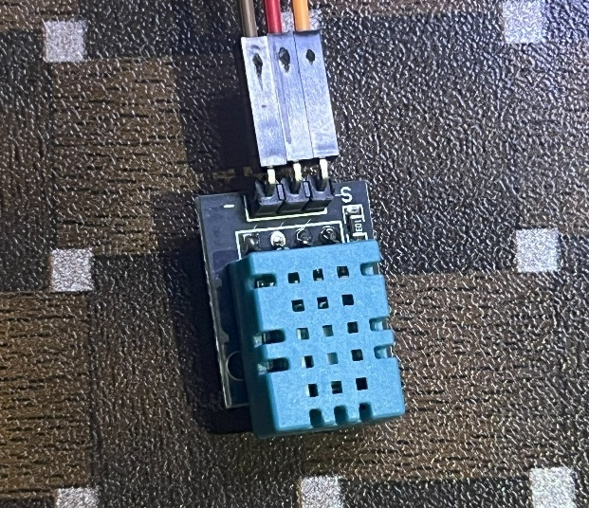
Figure 4.6: DHT11 Temperature and Humidity Sensor
- LDR (Light Dependent Resistor) for Irradiance: The LDR detects ambient light intensity, serving as a proxy for solar irradiance. Its resistance varies inversely with light levels, allowing the system to estimate sunlight availability. While not as precise as dedicated pyranometers, it offers a cost-effective solution for real-time irradiance tracking in this prototype.
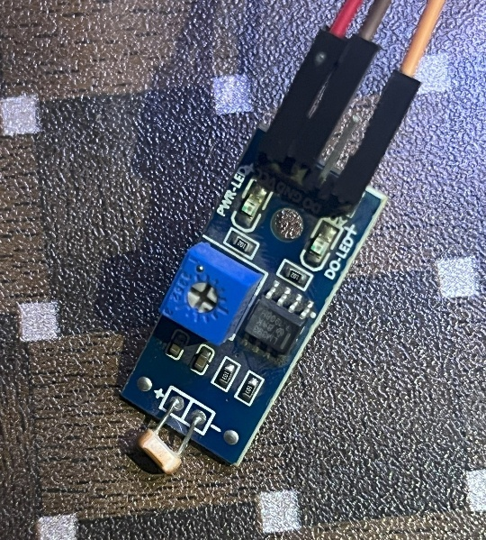
Figure 4.7: LDR for Irradiance estimation

- Rain/Precipitation Sensor: This analog sensor detects the presence of rainfall by measuring changes in resistance when water contacts its surface. It provides a voltage output that increases with moisture, enabling the system to identify rainy conditions that may reduce solar input or affect battery operation.
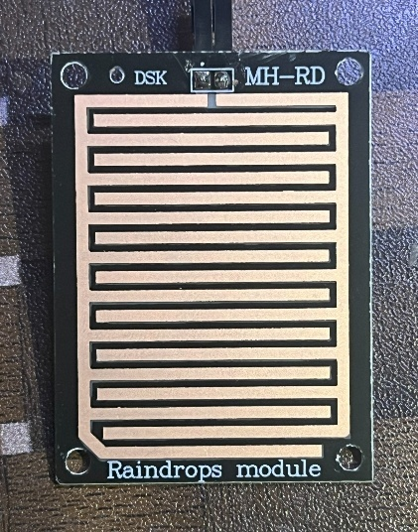
Figure 4.8: Rain/Precipitation Sensor
- Surface Pressure Sensor: This sensor measures atmospheric pressure, typically ranging from 300 hPa to 1100 hPa (±1 hPa). Pressure data helps correlate weather patterns with solar irradiance, offering insights into impending changes such as storm fronts that could impact energy generation.
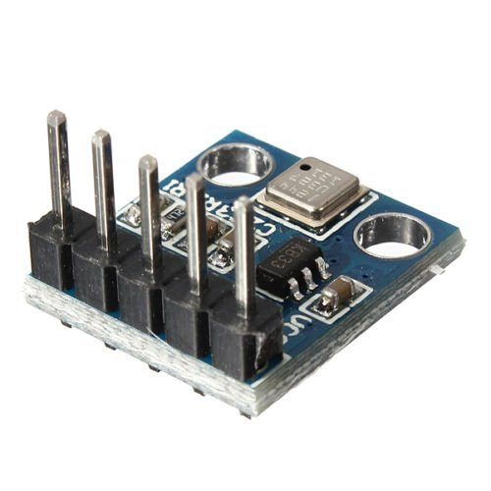
Figure 4.9: Surface Pressure Sensor

- Wind Sensor (Anemometer): This sensor measures wind speed, typically up to 30 m/s (±0.5 m/s), providing data on wind conditions that may influence solar panel efficiency or battery cooling. Its inclusion enhances the system's ability to adapt to dynamic environmental factors.
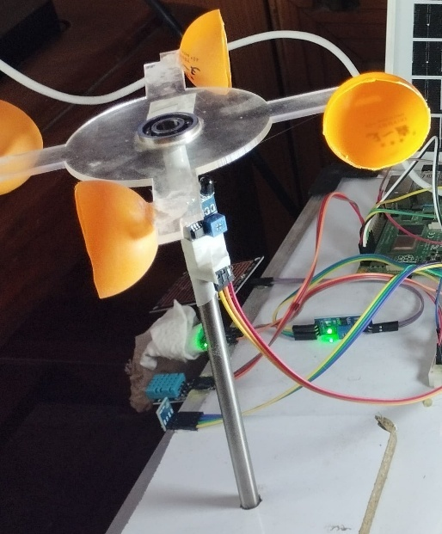
Figure 4.10: Anemometer (Wind Sensor)

These sensors collectively provide a comprehensive dataset for the XGBoost model, ensuring robust predictions of solar irradiance and optimal battery management.
- Sensor Placement and Interfacing with Raspberry Pi
Strategic placement of sensors is essential to ensure accurate and representative environmental data collection while minimizing interference within the ML-based adaptive solar energy management system. In the final prototype, all sensors are thoughtfully mounted directly onto the prototype board, which serves as a centralized platform for the system’s hardware components. This board, positioned beneath the solar panel, integrates the Raspberry Pi, ESP32, battery pack, inverter, and other peripherals, creating a compact and efficient setup. The sensors, including the DHT11 (temperature and humidity), LDR (irradiance), rain sensor, BMP180 (pressure), and wind sensor (anemometer), are strategically arranged to optimize exposure to environmental conditions while being protected from physical damage.
Interfacing with the Raspberry Pi is achieved through the following configurations:
- DHT11: Connected via a single digital pin (GPIO 4) using the OneWire protocol, with a 4.7kΩ pull-up resistor to ensure stable communication. The Adafruit DHT library is used to read temperature and humidity values every 10 seconds.
- LDR: Wired to an analog-to-digital converter (ADC) module (e.g., MCP3008) connected to SPI pins (GPIO 9 for MOSI, GPIO 10 for MISO, GPIO 11 for SCLK, and GPIO 8 for CS) due to the Raspberry Pi’s lack of native analog inputs. The LDR is paired with a 10kΩ resistor in a voltage divider circuit, with the output voltage mapped to light intensity.
- Rain Sensor: Linked to an ADC channel via the MCP3008, using GPIO pins for SPI communication. The sensor’s analog output is sampled every 15 seconds, with a threshold set to distinguish between wet and dry conditions.
- BMP180 Pressure Sensor: Interfaced through the I2C protocol using GPIO 2 (SDA) and GPIO 3 (SCL), with a 3.3V power supply. The sensor’s library (e.g., Adafruit BMP) facilitates pressure readings every 30 seconds.
- Wind Sensor: Connected to a digital input pin (GPIO 17) with an interrupt setup to count rotations, calibrated to calculate wind speed. Power is supplied at 5V, with data logged every 60 seconds to capture average wind trends.
The Raspberry Pi’s GPIO pins are configured via Python scripts using libraries such as RPi.GPIO, Adafruit_DHT, and spidev for SPI, ensuring seamless data acquisition. A cron job schedules data collection, storing values in a local CSV file for real-time processing by the XGBoost model.
- Calibration and Signal Conditioning
To ensure data accuracy, each sensor undergoes calibration and signal conditioning tailored to its characteristics:
- DHT11: Calibration is minimal due to its built-in compensation, but periodic cross-checking with a calibrated thermometer and hygrometer adjusts for drift. A 0.1µF capacitor across the power lines filters noise.
- LDR: Calibrated against known light intensities (e.g., under direct sunlight vs. indoor lighting) using a lux meter, with a lookup table mapping resistance to approximate irradiance. A low-pass filter (RC circuit with 1kΩ and 0.1µF) smooths rapid fluctuations caused by shadows or clouds.
- Rain Sensor: Calibrated by exposing it to controlled water levels, setting a voltage threshold (e.g., 2.5V) to detect rain. A 10kΩ pull-down resistor stabilizes the analog output, reducing false positives from condensation.
- BMP180: Factory-calibrated with internal compensation, but a zero-offset adjustment is applied using barometric pressure data from a local weather station. A 0.01µF capacitor on the I2C lines mitigates electromagnetic interference.
- Wind Sensor: Calibrated by comparing rotation counts to a reference anemometer under controlled wind speeds (e.g., using a fan). A debounce circuit (10ms delay) prevents multiple triggers from a single rotation.
Signal conditioning involves amplifying weak signals (e.g., LDR output) with an operational amplifier (e.g., LM358) and applying low-pass filters to remove high-frequency noise from all analog inputs. These steps enhance data reliability, ensuring the ML model receives clean, accurate inputs for effective solar irradiance forecasting and battery health optimization.
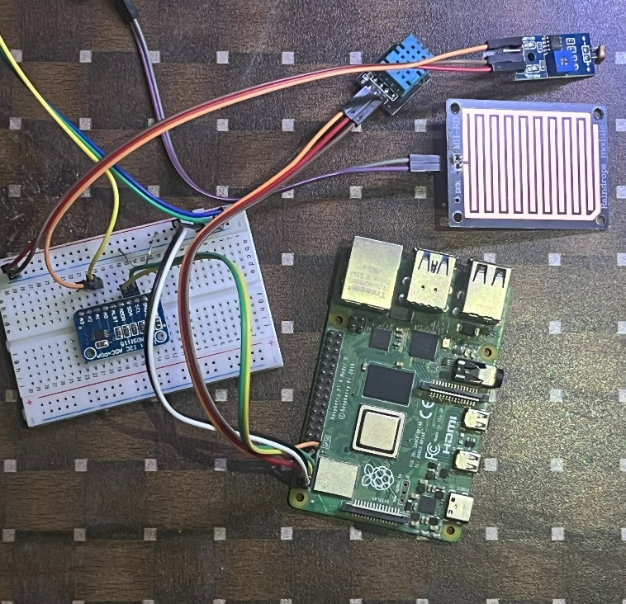
Figure 4.11: Sensors connected to Raspberry Pi
This sensor integration framework establishes a solid foundation for the system’s predictive capabilities, enabling adaptive energy management that prolongs battery life and enhances solar energy utilization.

4.5 Raspberry Pi and Control Logic
The Raspberry Pi serves as the central processing unit for the ML-based adaptive solar energy management system, orchestrating the integration of hardware components, sensor data, and machine learning predictions to optimize battery health and energy efficiency. This subsection outlines the model used, the operating system, the deployment process of the machine learning model, and the control logic implemented through relay and inverter management scripts.

4.5.1 Model Used and Operating System
The system employs a Raspberry Pi 4 Model B, selected for its robust processing capabilities, including a quad-core Cortex-A72 processor and 4GB of RAM, which are well-suited for running machine learning models and managing real-time data processing. This model supports a wide range of peripherals and offers sufficient computational power for the prototype's requirements. The device operates on Raspbian OS, a Debian-based operating system optimized for Raspberry Pi hardware. Raspbian provides a stable and lightweight environment, preconfigured with Python support and GPIO libraries, facilitating seamless integration with sensors, relays, and the inverter. The OS was updated to the latest stable release (as of June 2025) to ensure compatibility with the latest software dependencies and security patches, enhancing the system's reliability for continuous operation.
4.5.2 ML Model Deployment Process
The core intelligence of the system is driven by an XGBoost regression model, chosen for its accuracy in predicting next-day solar irradiance based on historical and real-time environmental data. The deployment process began with model training on a separate high-performance machine using a four-year dataset of hourly weather records, including parameters such as temperature, humidity, pressure, wind speed, and precipitation, with solar irradiance as the target variable. The trained model, optimized with hyperparameters such as n_estimators=100, learning_rate=0.1, and max_depth=5, achieved a high R² score of 0.97, indicating strong predictive performance.
To deploy the model on the Raspberry Pi, the trained XGBoost model was serialized using the joblib library, creating a compact .pkl file that preserves the model's structure and parameters. This file was transferred to the Raspberry Pi via secure copy (SCP) and stored in the project directory. The Raspbian environment was configured with necessary libraries, including xgboost, pandas, numpy, and scikit-learn, installed via pip to ensure compatibility. A Python script was developed to load the model and integrate it with real-time sensor data collected from the DHT11, LDR, rain sensor, BMP180, and wind sensor, as detailed in the previous section. The script preprocesses incoming data—applying lag features, normalization, and outlier handling consistent with the training phase—before feeding it into the model to generate daily irradiance forecasts. This deployment approach ensures the model operates efficiently on the Raspberry Pi’s resource-constrained hardware, balancing accuracy with computational feasibility.
4.5.3 Relay/Inverter Control Script Logic
The control logic is implemented through a Python script that leverages the Raspberry Pi’s GPIO capabilities to manage relay and inverter operations based on the XGBoost model’s predictions. The script, executed continuously via a cron job, integrates real-time sensor data with the irradiance forecast to dynamically adjust battery charging and discharging strategies. The attached output from the script (as shown in the provided image) illustrates its functionality.
The script initializes by importing required libraries, including RPi.GPIO for GPIO control, Adafruit_DHT for sensor readings, and joblib for model loading. GPIO pins are configured as follows: pin 27 for the battery relay and pin 20 for the wind pin, with the battery relay initially set to a low state to prevent charging until conditions are assessed. The script then collects current environmental data—temperature (38.86°C), humidity (43.06%), pressure (101.62 kPa), and irradiance (153.66 Wh/m²) from the sensors—mirroring the setup described earlier.
The loaded XGBoost model processes this data, predicting next-day irradiance at 149.71 Wh/m², a value slightly below the current reading, suggesting a potential decrease in solar availability. The script uses this forecast to determine an optimal charging threshold. If the predicted irradiance falls below a predefined minimum (e.g., 150 Wh/m², representing 70% signal strength), the logic activates the battery relay to conserve energy by limiting discharge or initiating a controlled charge, preventing deep discharge that could degrade battery health. Conversely, if the forecast exceeds this threshold, the relay remains off, allowing the battery to discharge to connected loads via the inverter, anticipating sufficient recharge the following day.

4.6 Real-Time Prediction Workflow
The real-time prediction workflow is a critical component of the ML-based adaptive solar energy management system, enabling dynamic adjustments to battery charging and discharging based on continuously updated environmental data. This subsection details the flow of data from sensors to the Raspberry Pi, through the prediction process, and into control actions, followed by an explanation of the decision-making process that governs energy management.
Flow of Data: Sensor → Raspberry Pi → Prediction → Control Action
The workflow begins with the collection of environmental data from the integrated sensor network, which includes the DHT11 (temperature and humidity), LDR (irradiance), rain sensor, BMP180 (pressure), and wind sensor, as outlined in Section 4.3. These sensors are strategically placed in a weatherproof enclosure near the solar panel and interfaced with the Raspberry Pi 4 Model B via GPIO, I2C, and SPI protocols. Data is sampled at intervals ranging from 10 to 60 seconds, depending on the sensor, and transmitted to the Raspberry Pi in real time. For instance, the DHT11 provides temperature and humidity readings every 10 seconds, while the wind sensor updates wind speed every 60 seconds to capture average trends.
Upon receiving the raw sensor data, the Raspberry Pi processes it through a Python script that handles data preprocessing. This step involves normalizing values (e.g., scaling irradiance from the LDR), applying lag features based on historical data stored locally, and filtering noise with low-pass techniques to ensure data integrity. The preprocessed data is then formatted into a structure compatible with the deployed XGBoost regression model, which was trained on a four-year dataset of historical weather records. The model, loaded from a serialized .pkl file, predicts the next-day solar irradiance by analyzing patterns in temperature, humidity, pressure, wind speed, and current irradiance levels.
The prediction output, expressed in Wh/m², is passed to the control logic module within the same script. This module interfaces with the Raspberry Pi’s GPIO pins to trigger control actions, such as activating or deactivating relays that manage battery charging and inverter operation. For example, if the predicted irradiance falls below a set threshold, the script sends a signal to the battery relay (GPIO pin 20) to initiate charging, ensuring the battery maintains adequate State of Charge (SoC). The workflow operates in a continuous loop, with data collection, prediction, and control actions updated every 15 minutes to adapt to changing weather conditions, providing a responsive and proactive energy management system.
4.6.1 Decision-Making Process for Energy Management
The decision-making process leverages the predicted solar irradiance to optimize battery health and energy efficiency, balancing immediate energy needs with long-term sustainability. The process begins with the XGBoost model’s forecast, which is compared against predefined thresholds tailored to the system’s operational requirements. A key threshold, set at 250 Wh/m² (representing approximately 70% of typical peak irradiance), serves as the decision point for initiating charging or conserving energy.
If the predicted irradiance is below 250 Wh/m², the system interprets this as an indication of reduced solar availability, such as during overcast or rainy conditions. In response, the control script activates the battery relay to enable charging from the solar panel, provided the battery voltage (monitored via the ESP32) is below 12.6V and temperature is under 50°C. This action prevents deep discharge, which can degrade the battery’s State of Health (SoH), and ensures energy reserves are maintained for critical loads. Simultaneously, the inverter relay may be deactivated to limit power delivery to non-essential loads, prioritizing battery preservation.
Conversely, if the predicted irradiance exceeds 250 Wh/m², the system anticipates sufficient sunlight for the following day. The battery relay is kept off, allowing the battery to discharge to connected loads via the inverter, while the solar panel recharges it during the day. This strategy maximizes energy utilization during high-availability periods and avoids overcharging, which can reduce battery lifespan. The decision logic also incorporates real-time feedback from the ESP32, which reports SoC and SoH, adjusting thresholds dynamically if the battery approaches full charge (e.g., 12.6V) or critical discharge (e.g., 9.6V).
Additional safety and optimization rules enhance the process. For instance, if the rain sensor detects precipitation or the wind sensor indicates high speeds that might affect panel efficiency, the system may delay charging to protect the battery from erratic input. Temperature data from the DHT11 further refines decisions, pausing charging if the battery exceeds 50°C to prevent thermal stress. These rules are encoded in the control script, which logs decisions and sensor readings to a local CSV file for later analysis, ensuring transparency and enabling iterative improvements.
This real-time prediction workflow and decision-making framework create a smart, adaptive system that aligns energy management with environmental conditions, prolonging battery life and enhancing the reliability of solar power utilization.
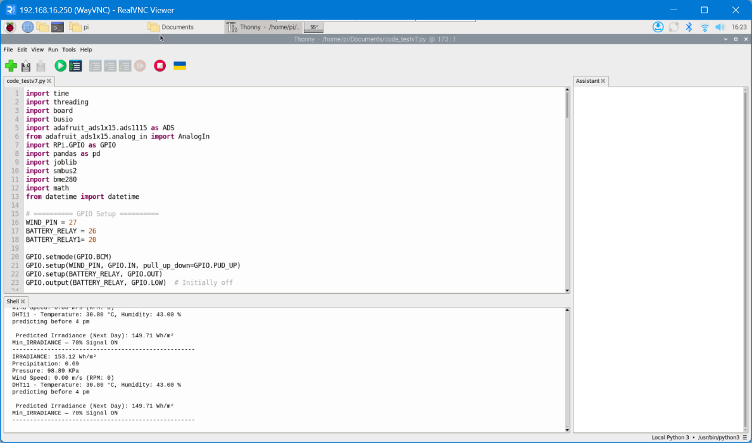
Figure 4.12: Raspberry Pi Output
4.7 System Assembly and Testing
The assembly and testing phase of the ML-based adaptive solar energy management system marked a pivotal step in transforming the theoretical design into a functional prototype. This subsection provides a detailed account of the prototype’s physical construction, including photographs of key components, the challenges encountered during testing, and the solutions implemented to address them, ensuring the system’s reliability and performance.
The prototype was meticulously assembled to integrate hardware and software components into a cohesive unit. The core of the system is a custom-designed printed circuit board (PCB) that houses the ESP32 microcontroller, voltage and current sensors (ACS712), relay drivers, and terminal blocks for battery connections. The PCB, fabricated with a double-layer design, features clear trace routing and component placement to minimize interference, with a front view showcasing the soldered components and a top-layer layout highlighting the organized wiring.
Sensors are mounted on a weatherproof enclosure positioned 1.5 meters above ground near the solar panel. The DHT11 temperature and humidity sensor is secured with a protective shield to prevent direct sunlight exposure, while the LDR is angled to capture ambient light effectively. The rain sensor is placed on the enclosure’s top surface, and the BMP180 pressure sensor is housed within to avoid moisture damage. The wind sensor, an anemometer, is mounted on a pole extending from the enclosure, ensuring unobstructed wind flow. Wiring from the sensors to the Raspberry Pi is neatly bundled and protected with conduit tubing, with connections made via GPIO, I2C, and SPI interfaces as described in previous sections.
The lithium-ion battery pack (3S9P configuration) and Battery Management System (BMS) are housed in a ventilated case adjacent to the enclosure, connected to the PCB via heavy-gauge wires to handle current loads. The solar panel and inverter are linked through relays controlled by the Raspberry Pi, with all components wired to a central power distribution board. Photographs of the final prototype—capturing the PCB, sensor placements, and overall assembly—illustrate the system’s modular and robust design, ready for field testing.
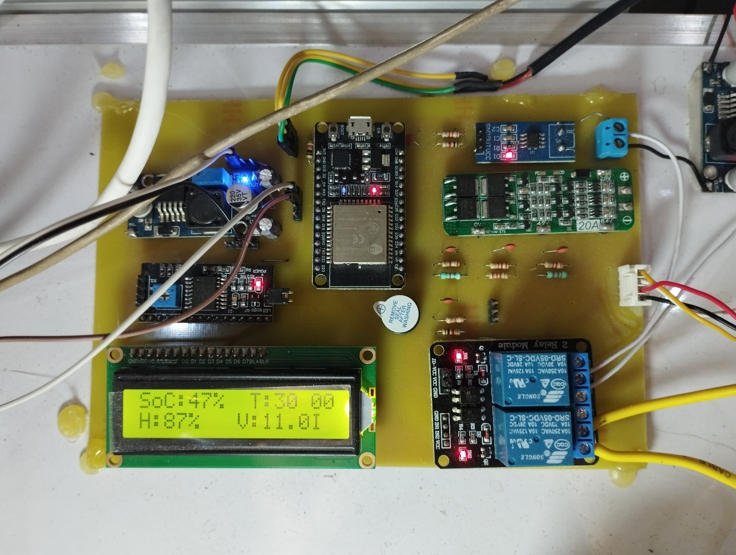
Figure 4.13: Charging Control Module

4.7.1 Issues Encountered During Testing
During the testing phase, several challenges emerged that tested the system’s resilience and required careful troubleshooting. One prominent issue was sensor delays, particularly with the DHT11, which occasionally failed to provide readings within the expected 10-second interval, leading to gaps in temperature and humidity data. This was attributed to signal interference or power supply fluctuations, causing the sensor to reset intermittently.
Another significant problem was communication errors between the Raspberry Pi and the ESP32, manifested as dropped GPIO signals or incomplete data transfers. These errors were linked to electromagnetic interference (EMI) from the relay switching and inadequate grounding in the initial wiring setup, resulting in erratic relay activation and unreliable SoC/SoH updates. Additionally, the LDR exhibited inconsistent irradiance readings under rapidly changing light conditions, such as during cloud cover, due to its sensitivity to sudden transitions without proper signal conditioning. The wind sensor also faced calibration drift, with rotation counts misaligning with actual wind speeds after prolonged exposure to environmental factors.
Testing also revealed power management issues, where the Raspberry Pi occasionally rebooted during high relay activity, suggesting insufficient power regulation or voltage drops from the battery pack. Finally, the XGBoost model’s real-time predictions occasionally lagged, causing delays in control actions, likely due to the Raspberry Pi’s limited processing power when handling large datasets or unoptimized script execution.

3.7.2 Testing
The testing phase was instrumental in validating the functionality and robustness of the ML-based adaptive solar energy
management system prototype. Conducted over multiple days under varying weather conditions, this stage involved rigorous evaluation of the integrated hardware and software components. The system was powered by the solar panel and battery pack, with sensors, Raspberry Pi, and ESP32 operating continuously to monitor environmental data, predict irradiance, and control relay actions. Key metrics such as battery State of Charge (SoC), State of Health (SoH), and energy flow were logged to assess performance against the design objectives. The prototype demonstrated stable operation, with the XGBoost model accurately forecasting next-day irradiance and the control logic effectively managing battery charging and discharging. Minor adjustments were made based on real-time observations, ensuring alignment with the system’s goal of optimizing battery health and energy efficiency. The final prototype images, showcasing the assembled system in action, are included below to highlight its practical implementation.

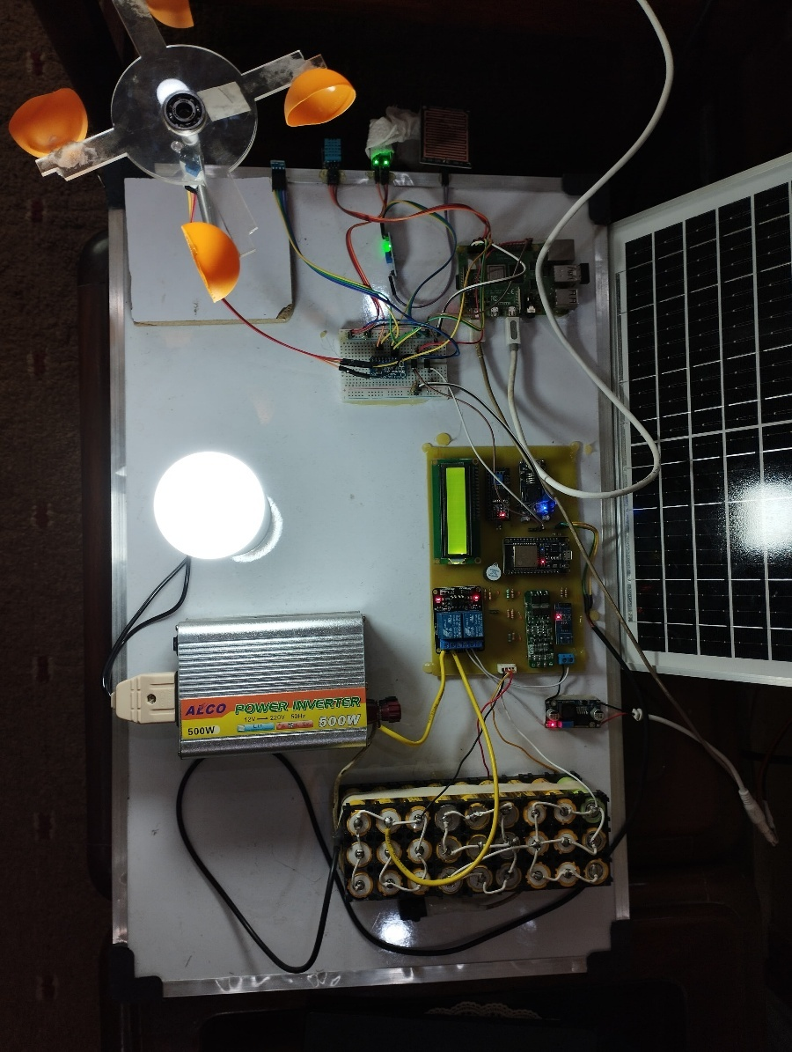
Figure 4.14: Final Prototype
Chapter Five

References
- Dineva, A. (2024). Evaluation of Advances in Battery Health Prediction for Electric Vehicles from Traditional Linear Filters to Latest Machine Learning Approaches. Batteries, 10(10), 356.
- Madani, S. S., Ziebert, C., Vahdatkhah, P., & Sadrnezhaad, S. K. (2024). Recent Progress of Deep Learning Methods for Health Monitoring of Lithium-Ion Batteries. Batteries, 10(6), 204.
- Krishna, G., Singh, R., Gehlot, A., Akram, S. V., Priyadarshi, N., & Twala, B. (2022). Digital technology implementation in battery-management systems for sustainable energy storage: Review, challenges, and recommendations. Electronics, 11(17), 2695.
- Ghalkhani, M., & Habibi, S. (2022). Review of the Li-ion battery, thermal management, and AI-based battery management system for EV application. Energies, 16(1), 185.
- Sathishkumar, D., & Karthikeyan, C. (2020). Adaptive power management strategy-based optimization and estimation of a renewable energy storage system in stand-alone microgrid with machine learning and data monitoring. International Journal of Wavelets, Multiresolution and Information Processing, 18(01), 1941023.
- Ghoshal, N., & Tripathy, B. K. (2024). Artificial Intelligence Applied to the Management and Operation of Solar Systems. Biomass and Solar‐Powered Sustainable Digital Cities, 317-338.
- Satish, P. P., & Kishore, T. S. AI and ML for Intelligent Battery Management in the Age of Energy Efficiency.
- Satish, P. P., & Kishore, T. S. AI and ML for Intelligent Battery Management in the Age of Energy Efficiency.
- Shresthamali, S., Kondo, M., & Nakamura, H. (2017). Adaptive power management in solar energy harvesting sensor node using reinforcement learning. ACM Transactions on Embedded Computing Systems (TECS), 16(5s), 1-21.

