Top of Form

DBS - Quiz#3 (Fall 2020)

Version 013112312020

Your email address (**bcsf18m027@pucit.edu.pk**) will be recorded when you submit this form. Not you? [Switch account](https://accounts.google.com/AccountChooser?continue=https://docs.google.com/forms/d/e/1FAIpQLScV_ChBz5RLNdUOrOa6CSdy6aKa0R3D0IiiormC8meQlF-Qjg/viewform?usp%3Dpp_url%26entry.366340186%3D5%26urp%3Dgmail_link%26gxids%3D7757&service=wise)

* Required

Roll No *



Create the following two tables using the appropriate datatype and apply the mentioned constraints.

8 points

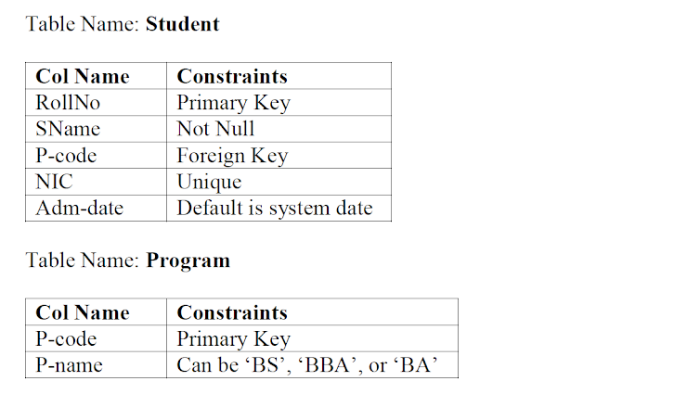



1. create table STUDENT ( RollNO Number(4) primary key, SNAME VARCHAR2(10) NOT NULL, P-code Number(4) , NIC Number(13) unique, Adm-date default sysdate )
2. create table Program ( P-code Number(4) primary key, P-name VARCHAR2(10) CHECK (PROGRAM IN('BS','BBA','BA')) )
3. alter table student add foreign key(P-code) references Program(P-code)

____________ anomaly occurs when it is required to change multiple rows to change single fact.

1 point

Delete

**Update**

Insert

Redundancy

Clear selection

If Pno -> Pname,Pqty; Then, Pno -> Pname and Pno -> Pqty. Which inference rule is applied in this scenario?

1 point

Transitivity

**Decomposition**

Augmentation

Reflexivity

Clear selection

A view is also called ___________

1 point

Data dictionary table

Base table

**Virtual table**

Authorization Table

Clear selection

A relation will be in ___________ if every non-key attribute is functionally dependent on the full set of primary key attributes

1 point

**2NF**

3NF

4NF

1NF

Clear selection

Consider a relation R (A, B, C, D, E, F) with (A, B) as primary key of the relation. The functional dependency A, B -> C, D, E, F is an example of

1 point

Partial Functional Dependency

Transitive Dependency

**Full Functional Dependency**

Strong Dependency

Clear selection

_____________ is a functional dependency between non key attributes.

1 point

Non-key dependency

Trivial Dependency

**Transitive Dependency**

Partial Dependency

Clear selection

Index improves the performance of the following operations:

1 point

**Select**

Insert

Delete

Update

Clear selection

Submit

Never submit passwords through Google Forms.

Bottom of Form

This form was created inside of PUCIT, University of the Punjab, Lahore. [Report Abuse](https://docs.google.com/forms/u/0/d/e/1FAIpQLScV_ChBz5RLNdUOrOa6CSdy6aKa0R3D0IiiormC8meQlF-Qjg/reportabuse?source=https://docs.google.com/forms/d/e/1FAIpQLScV_ChBz5RLNdUOrOa6CSdy6aKa0R3D0IiiormC8meQlF-Qjg/viewform?usp%3Dpp_url%26entry.366340186%3D5%26urp%3Dgmail_link%26gxids%3D7757)

[Forms](https://www.google.com/forms/about/?utm_source=product&utm_medium=forms_logo&utm_campaign=forms)