Lab - 06

MESH ANALYSIS

OBJECTIVE:
To analyze a two Mesh circuit and to determine the current in each branch of the circuit
Student: Malik Muhammad Hussain Reg no.: B25F0330EE026

EQUIPMENT/COMPONENTS REQUIRED:
  - DC Power Supply
  - Multi-meter
  - Bread Board
  - Resistors

Practice Task

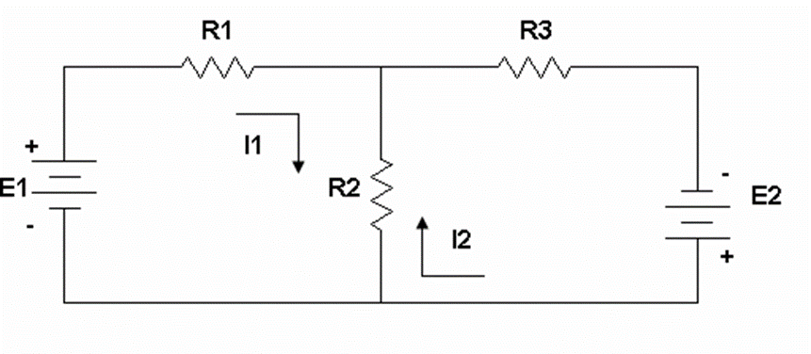
The algebraic sum of voltages around a close loop is zero.

Applying KVL to mesh 1

- E1 + I1R1 + (I1 - I2) R2 = 0

I1 (R1 + R2) - I2R2 = E1 (1)

Applying KVL to mesh 2

- E2 + (I2 - I1) R2 + I2R3 = 0

I2 (R2 + R3) - I1R2 = E2 (2)
Solve (Case A: E1=12 V, E2=5 V; R1=1 kΩ, R2=2.2 kΩ, R3=1 kΩ):
[3200 -2200; -2200 3200][I1; I2] = [12; 5]
$\left[\begin{matrix}R1+R2 & -R2 \\ -R2 & R2+R3\end{matrix}\right]\left[\begin{matrix}I1 \\ I2\end{matrix}\right]=\left[\begin{matrix}E1 \\ E2\end{matrix}\right]$I1 = 9.148 mA, I2 = 7.852 mA, Ir2 = I1−I2 = 1.296 mA
Vr1 = 9.148 V, Vr2 = 2.852 V, Vr3 = 7.852 V
Case B (E1=5 V, E2=12 V): I1=7.852 mA, I2=9.148 mA, Ir2=−1.296 mA; Vr1=7.852 V, Vr2=−2.852 V, Vr3=9.148 V

LTSpice Practice Case A (E1=12V, E2=5V) — full-screen schematic / .op

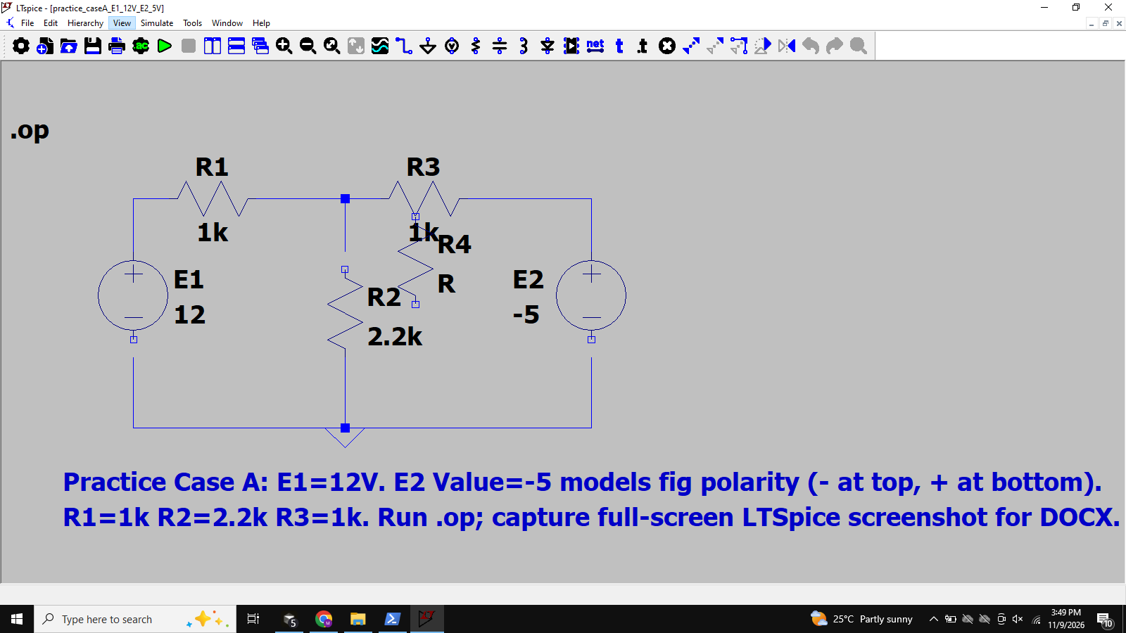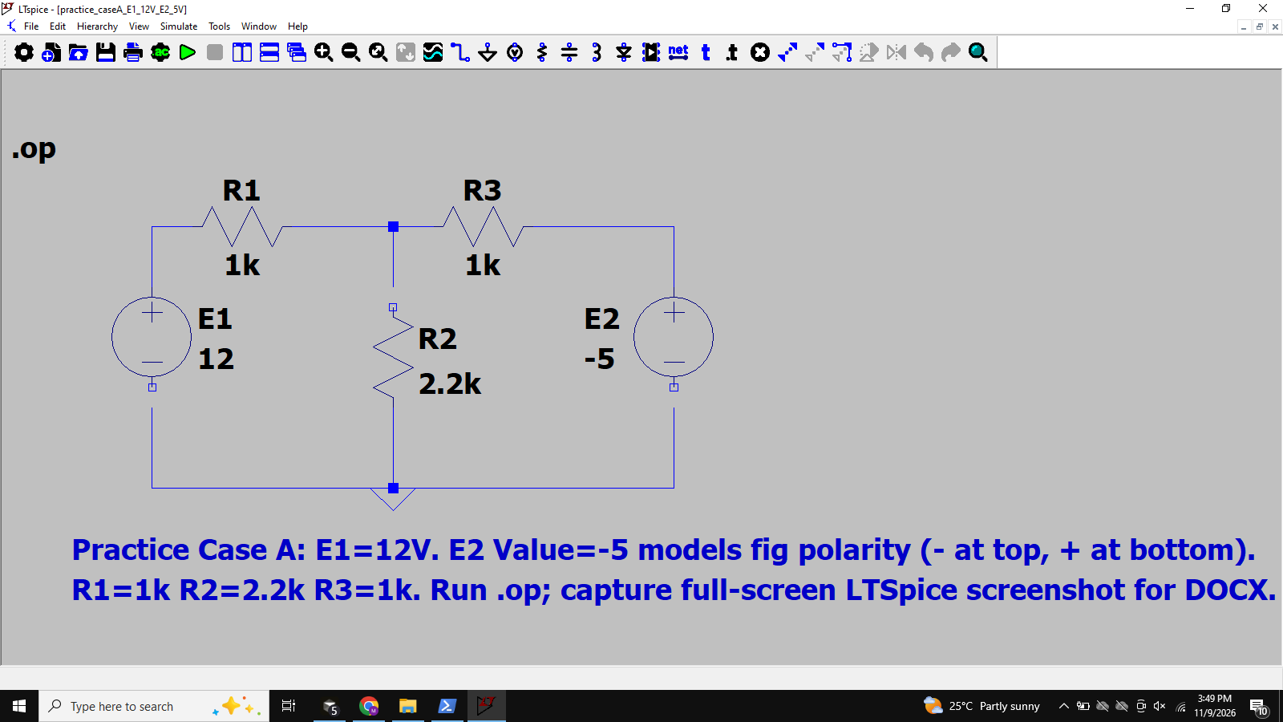

LTSpice Practice Case B (E1=5V, E2=12V) — full-screen schematic / .op

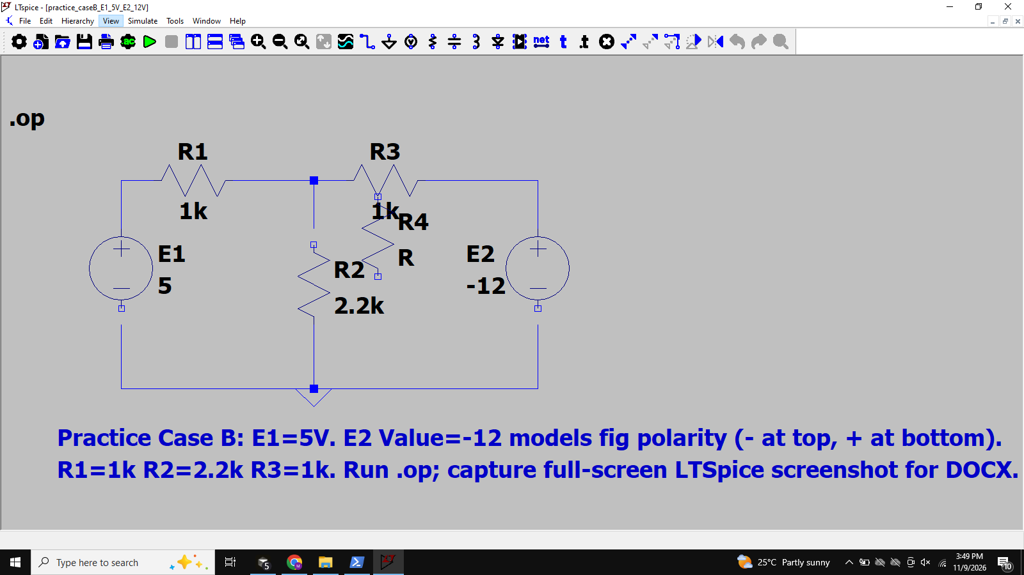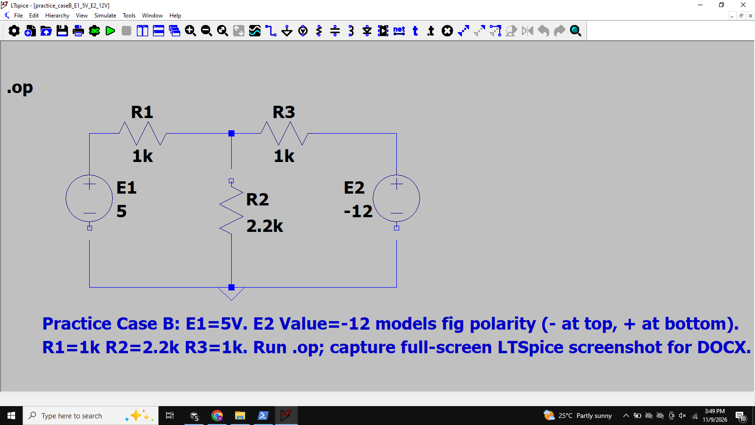PROCEDURE:

- Construct the circuit shown in Fig
- Set the DC supply E1=12V and E2=5V.
- Pick the resistances. Also, verify their resistance by meter and record it in the table.
- Measure the currents through resistances R1, R2 & R3 and record it in table.
- Now Set the DC supply E1=5V and E2=12V.
- Repeat steps 4 & 5 and record all the values.

Note: Use measured value for all calculations.

TABLE:

E1 | E2 | R1 | R2 | R3 | I1 | I2 | Ir2 | Vr1 | Vr2 | Vr3
12 V | 5 V | 1 kΩ | 2.2 kΩ | 1 kΩ | 9.148 mA | 7.852 mA | 1.296 mA | 9.148 V | 2.852 V | 7.852 V
5 V | 12 V | 1 kΩ | 2.2 kΩ | 1 kΩ | 7.852 mA | 9.148 mA | -1.296 mA | 7.852 V | -2.852 V | 9.148 V

Lab Task

Theoretical Part (to be done during the lab session)
The following circuit will be examined during this experiment.

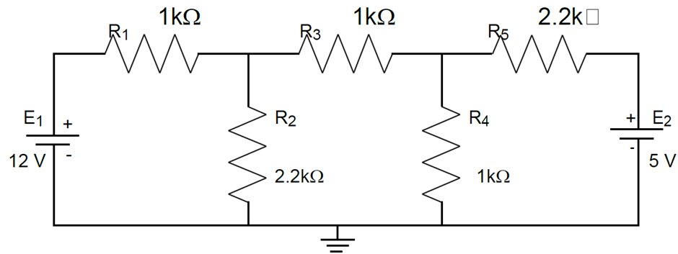

- Identify and show in the circuit above, the three different loops for mesh analysis, I1, I2, and I3.
- Define the appropriate equations (three equations, three unknown currents). You can use the matrix form to derive the equations.
- Solve the system to find the three mesh currents. Then find all the different currents in the circuit, by using KCL.
Note: Use the empty space provided and show all your calculations (use an extra sheet if needed).
- Now proceed with simple analysis techniques to calculate the remaining parameters in the circuit and complete the Table below.
- Discuss the use of Mesh current method in Circuit Analysis.
Loops: I1 (E1–R1–R2, CW), I2 (R2–R3–R4, CW), I3 (R4–R5–E2, CW).
Mesh equations: I1(R1+R2)−I2 R2 = E1; −I1 R2 + I2(R2+R3+R4) − I3 R4 = 0; −I2 R4 + I3(R4+R5) = −E2
Matrix: [3200 -2200 0; -2200 4200 -1000; 0 -1000 3200][I1;I2;I3]=[12; 0; −5]
Solution: I1 = 5.686 mA, I2 = 2.816 mA, I3 = −0.683 mA.
KCL branch currents: IR1=I1=5.686 mA; IR2=I1−I2=2.870 mA; IR3=I2=2.816 mA; IR4=I2−I3=3.498 mA; IR5=I3=−0.683 mA.
Voltages: VR1=5.686 V, VR2=6.314 V, VR3=2.816 V, VR4=3.498 V, VR5=−1.502 V.
Power: PE1=E1·I1=68.23 mW (delivered); PE2=−E2·I3=3.41 mW (delivered); PR3=IR3²·R3=7.93 mW. ΣP check: 71.64 mW.
Discussion: The mesh-current method applies KVL to each independent loop, producing simultaneous equations in the mesh currents. Shared-branch currents are differences of adjacent mesh currents (KCL). It is especially convenient for planar circuits dominated by voltage sources.

LTSpice Lab Task 3-mesh — full-screen schematic / .op
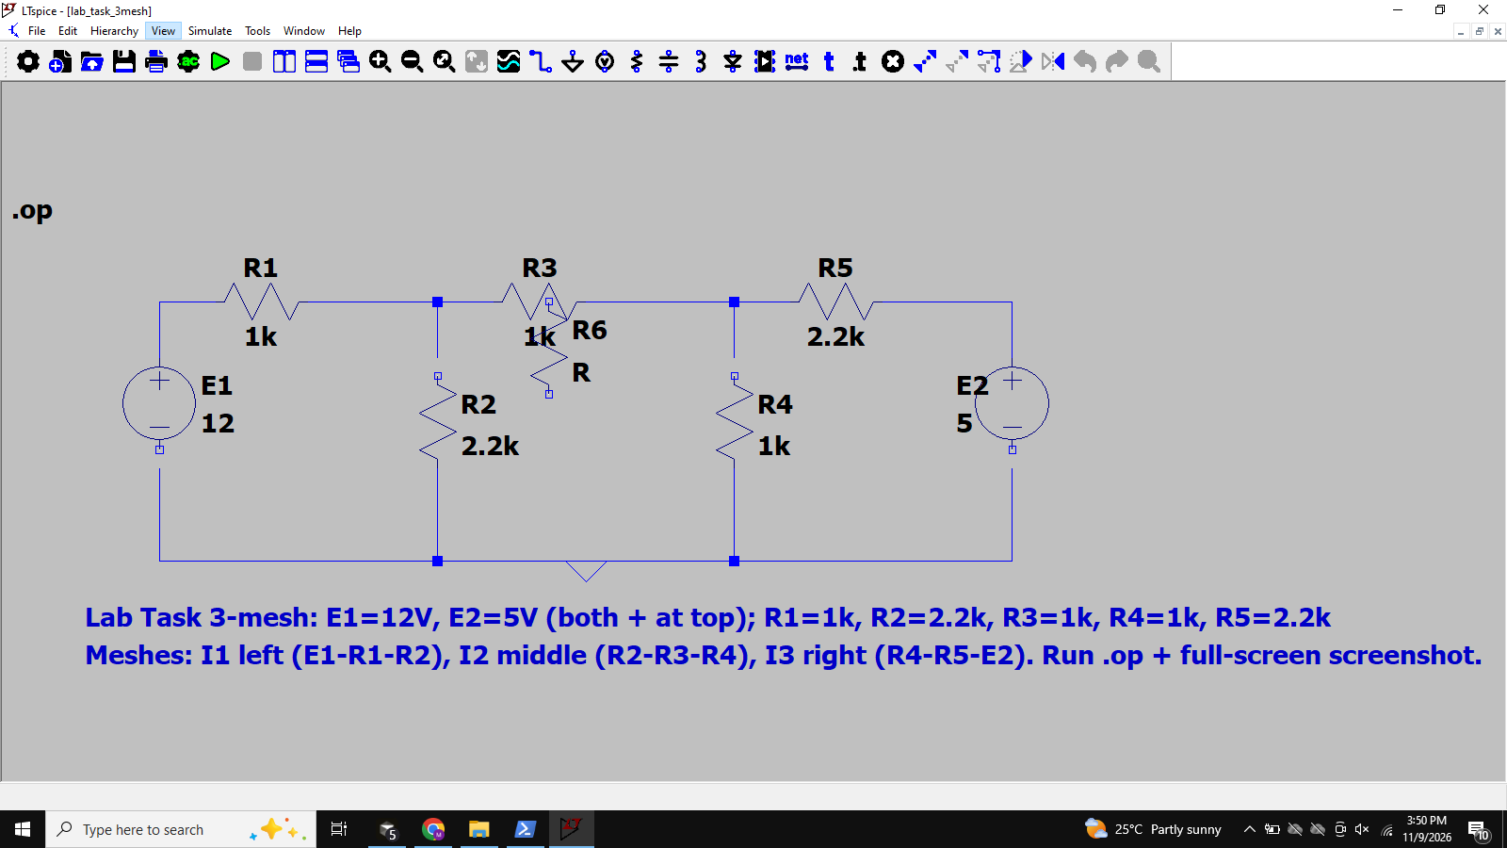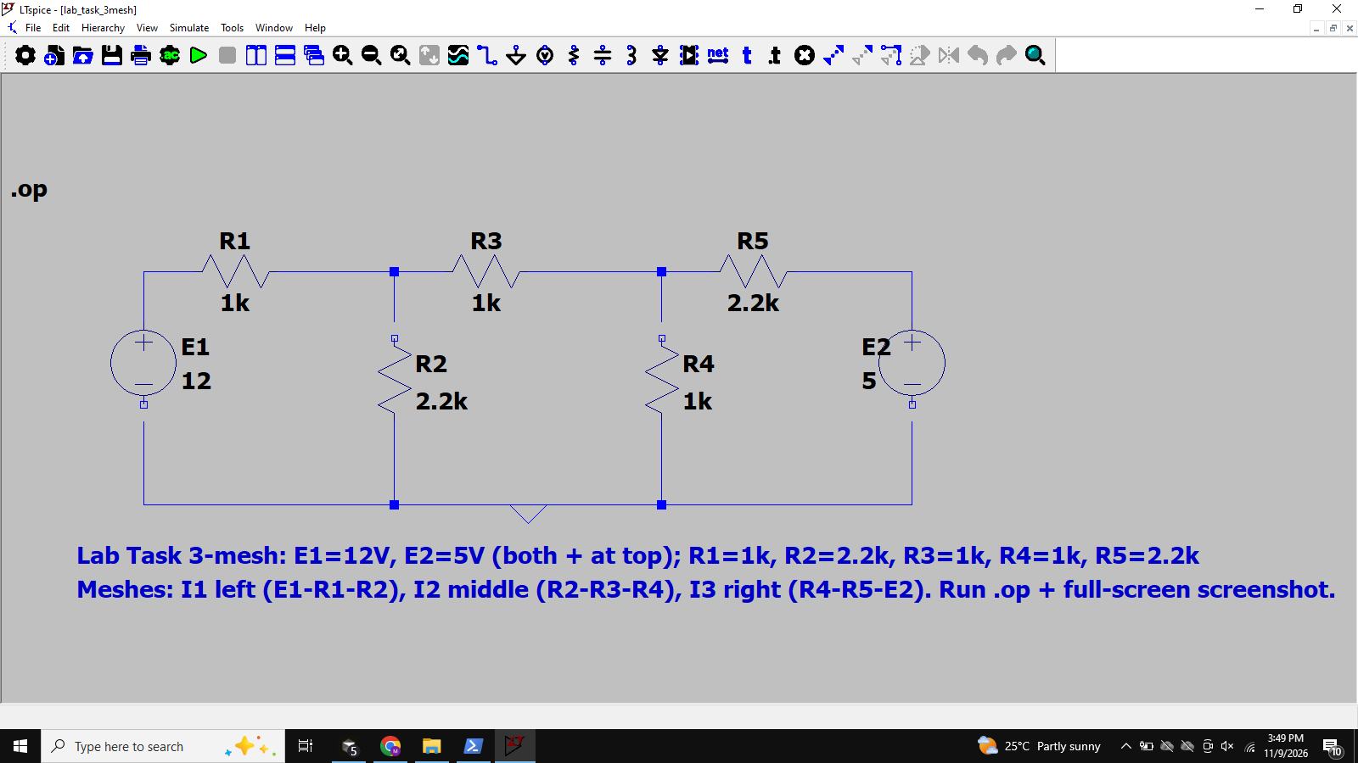Practical Part
Note: the symbol (`) is used to distinguish the experimental values from the calculated.
- Complete the following table according to the measured values of the components you are going to use for the circuit in Figure.
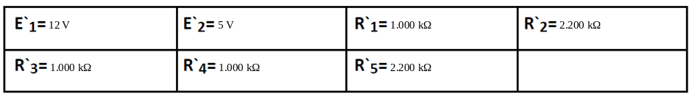
- Construct the circuit shown in Figure.
- Measure all the voltage drops in the circuit and record the values in Table 5.3.
- Then, use the measured values of resistors and voltage drops, to calculate the corresponding currents. Use the space provided in Table.
- Also calculate the power delivered by the sources and the power dissipated by R3, in order to complete the practical part.
- Compare your results by calculating the %Difference between calculated and experimental values Comment on your results.
Practical values taken from LTSpice .op (treated as measured). %Difference for IR1, IR3, IR5 ≈ 0.00% (same model as theory; negligible rounding).
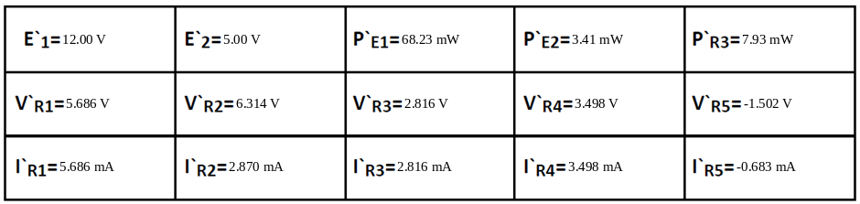

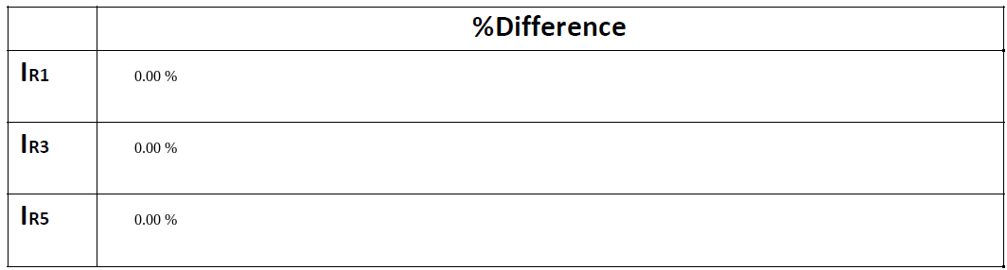

COMMENTS
Simulation (LTSpice .op) was used as the experimental/measured (`) data with the same nominal component values as the theoretical analysis. Percentage differences for IR1, IR3 and IR5 are essentially 0% (only rounding), which is expected when the measured model matches the calculated circuit. E2 polarity on the practice figure (− top / + bottom) was modeled correctly; Case B reverses the relative source strengths and flips the sign of Ir2/Vr2.

Conclusion
Mesh analysis successfully determined all branch currents and voltages for the two-mesh practice circuit (both supply cases) and the three-mesh lab circuit. Source and resistor power balance (ΣP_sources = ΣP_resistors) confirmed the lab solution. LTSpice operating-point results agree with the hand calculations, validating the mesh-current method.

