Lab - 07

Student: Malik Muhammad Hussain Reg no.: B25F0330EE026
Nodal Analysis

Objective:

The objective of this experiment is to introduce circuits with more than one source and obtain a linear relationship between the sources and a voltage output. The concept of superposition will be discussed and used to demonstrate linearity for multiple sources.
Background:
Before doing this experiment, students should be able to
- Analyze simple circuits consisting of combinations of resistors.
- Measure nodal voltages using the Voltmeter.
- Implement resistive networks on the protoboard.
- Use both Alice Meter-Source and Voltmeter tools.
- Review the background for the previous experiments.
- Calculate the slope of linear data.
Learning Outcomes: Students will be able to
- Perform nodal analysis when more than one voltage source exists in the circuit.
- Understand that a system with more than one variable can be linear.
- Apply experimental results to determine the superposition equation relating sources to Pre-Lab
Required Reading: Before beginning the lab, read over and be generally acquainted with this document and the other.
required reading materials.

Part A – Nodal Analysis

Background

A node is defined as a junction of two or more branches. If we now define one node of any network as a reference (that is, a point of zero potential or ground), the remaining nodes of the network will all have a fixed potential relative to this reference. For a network of N nodes, therefore, there will exist (N-1) nodes with a fixed potential relative to the assigned reference node. Equations relating to these nodal voltages can be written by applying Kirchhoff’s current law at each of the (N-1) nodes. To obtain the complete solution of a network, these nodal voltages are then evaluated in the same way loop currents were found in loop analysis.
The nodal analysis method is applied as follows:
- Determine the number of nodes within the network.
- Pick a reference node and label each remaining node with a subscripted value of voltage: V1, V2, and so on.
- Apply Kirchhoff’s current law at each node except the reference. Assume that all unknown currents leave the node for each application of Kirchhoff’s current law. In other words, for each node, don’t be influenced by the direction that an unknown current for another node may have had. Each node is to be treated as a separate entity, independent of the application of Kirchhoff’s current law to the other nodes.
- Solve the resulting equations for the nodal voltages. A few examples will clarify the procedure defined by step 3. It will initially take some practice writing the equations for Kirchhoff’s current law correctly, but in time the advantage of assuming that all the currents leave a node rather than identifying a specific direction for each branch will become obvious.

When analyzing circuits with multiple sources, the process developed in the previous laboratories remains unchanged.
- Identify the nodes.
- Define a ground.
- For each voltage source, use voltage difference concepts to identify the voltage at a node.
- For each remaining unknown nodal voltage, apply KCL to obtain a linearly independent equation.
- Transform the system of equations into matrix form.
- Solve the matrix expression for the unknown voltages.

Item number three represents a new observation. For each voltage source, the voltage at a node can be identified. In experiment 9, where only one voltage source was present, we were able to identify the voltage at a node. For the circuit in Figure A-1, with two sources, two of the nodes will have known voltages. In this case, we will leave the voltage values in symbolic form, V1 and V2. We consider these fixed values that can be assigned later.

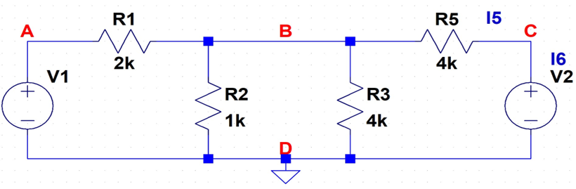Figure A-1. Two Source Circuit Example
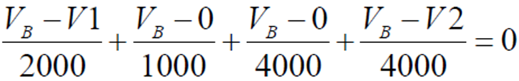
In Figure A-1, the nodes have been identified and node D is set to ground. The nodal voltage at A is determined by voltage differences and symbolically set as VA = V1. Again we consider that a known value, even though it does not have an explicit voltage. Similarly, we can set VC = V2. We can then apply KCL to get the equation,

With some rearranging, the equation that results from applying KCL will have the form,
$$V_{node}=aV_{1}+bV_{2}$$
Where a and b represent the coefficient terms for each of the source voltages. In this equation, the voltage at the unknown node is a linear function of both source voltages. The coefficients a and b can be considered the slopes associated with the corresponding input voltage, V1 and V2 respectively. Since the expression is linear, we can find those coefficients experimentally.

Figure A-1 work (numeric check with V1=5 V, V2=9 V):
Nodes: A (VA=V1), B (unknown VB), C (VC=V2), D = ground.
KCL at B: (VB - V1)/2000 + VB/1000 + VB/4000 + (VB - V2)/4000 = 0
Multiply by 4000: 2(VB-V1)+4VB+VB+(VB-V2)=0 => 8 VB = 2 V1 + V2
=> VB = (1/4)V1 + (1/8)V2 (a=1/4, b=1/8)
Numeric: VB = 2.375 V; LTSpice .op measured VB = 2.375 V `
LTSpice Figure A-1 — full-screen schematic / .op
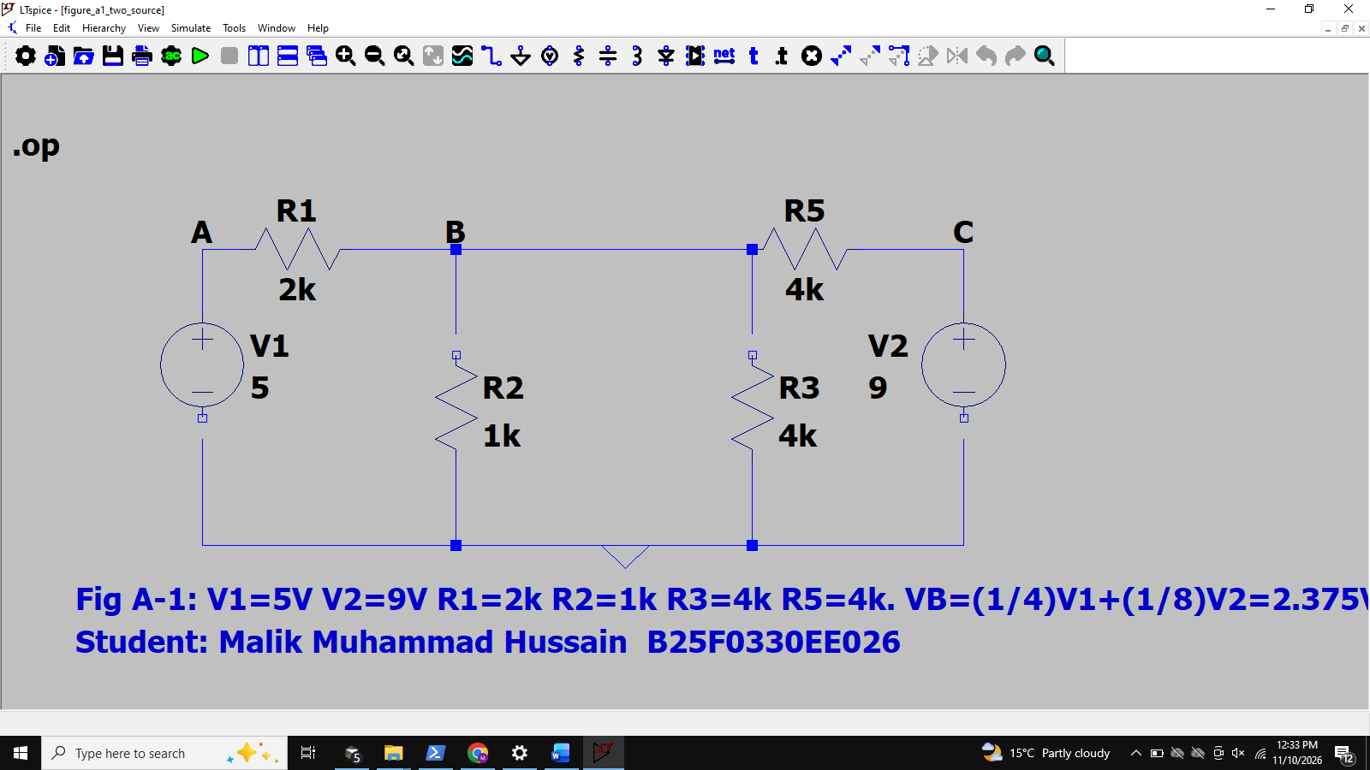
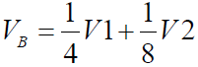

Practice Task
- Using the DC circuit trainer, connect the circuit shown in Fig.
Take V1= 5 volts, V2= 9 volt. R1= 100Ω, R2= 220Ω, R3= 470Ω.

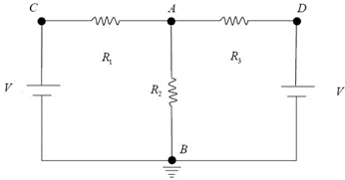

Figure A-2. Two Source Experiment

- Identify the nodes in the circuit.
- Place the ground at a convenient location.
- Use the symbolic values, V1 and V2, identify two different nodal voltages.
- Apply KCL at the remaining unknown node.
- Rearrange the expression to get the form.

Nodes (Fig A-2): Node A = junction of R1,R2,R3 (unknown); Node B = ground (0 V); Node C = V1+; Node D = V2+.
Ground placed at Node B (bottom rail).
Known nodal voltages (symbolic): VC = V1, VD = V2, VB = 0. Unknown: VA.
KCL at Node A (all currents leaving): (VA - V1)/R1 + (VA - 0)/R2 + (VA - V2)/R3 = 0
Rearranged: VA*(1/R1 + 1/R2 + 1/R3) = V1/R1 + V2/R3
=> VA = a*V1 + b*V2, where a = (1/R1)/G, b = (1/R3)/G, G = 1/R1+1/R2+1/R3
With R1=100, R2=220, R3=470: a = 0.5998, b = 0.1276
Numeric (V1=5 V, V2=9 V): VA = 4.147 V
Currents (magnitudes through resistors): IR1 = 8.527 mA, IR2 = 18.852 mA, IR3 = 10.325 mA
Voltages: Vab = VA-VB = 4.147 V; Vac = VA-VC = -0.853 V; Vad = VA-VD = -4.853 V

$$V_{node}=aV_{1}+bV_{2}$$

- Measure the current of "R1, R2 & R3", then record it in table below:

 | 100Ω | 220Ω | 470Ω
Calculated Current | 8.527 mA | 18.852 mA | 10.325 mA
Measured Current | 8.527 mA ` | 18.852 mA ` | 10.325 mA `

- Measured the voltage to each node in the circuit.

 | Vab | Vac | Vad
Calculated Voltages | 4.147 V | -0.853 V | -4.853 V
Measured Voltages | 4.147 V ` | -0.853 V ` | -4.853 V `

- Comment on your results.

- Comments: Practical (LTSpice .op, treated as measured `) values match the theoretical nodal solution within rounding (%Difference ~ 0%). On a physical trainer, differences would mainly come from resistor tolerance, meter loading, and contact resistance; here the same nominal values are used in theory and simulation.
- LTSpice Practice Fig A-2 — full-screen schematic / .op
- 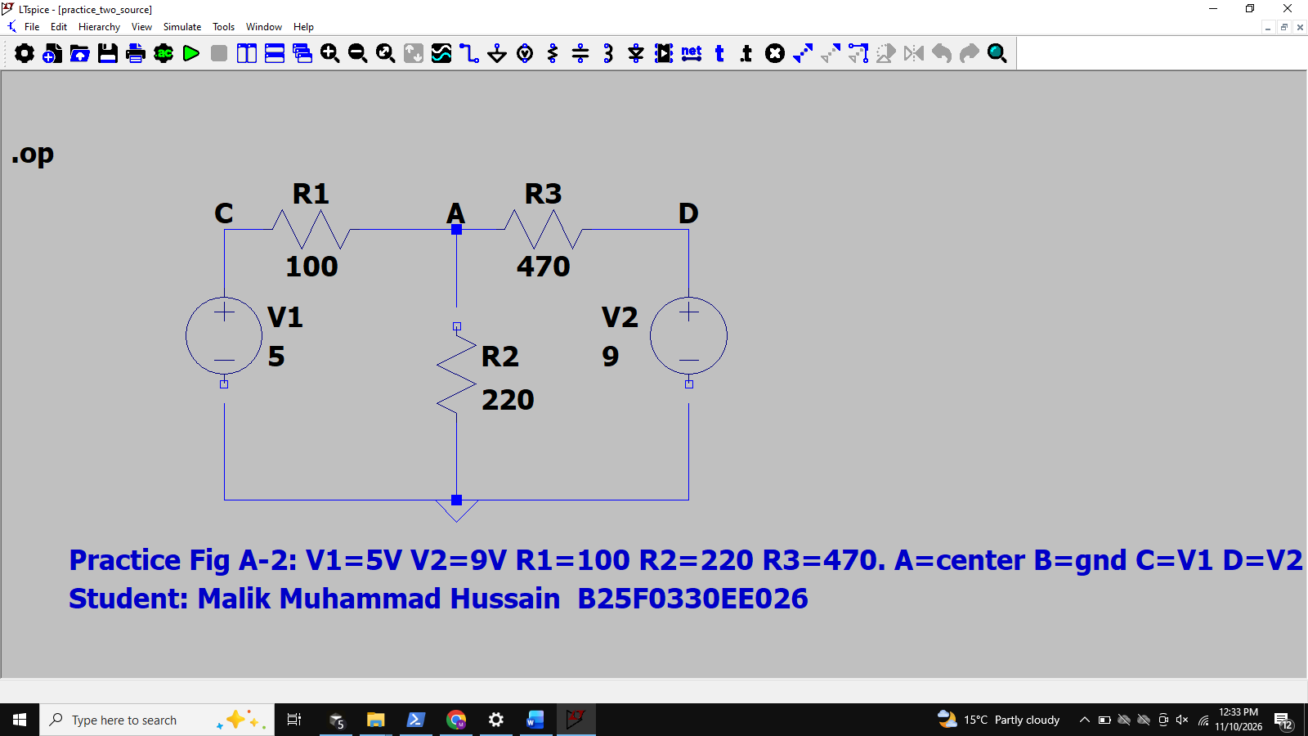
- 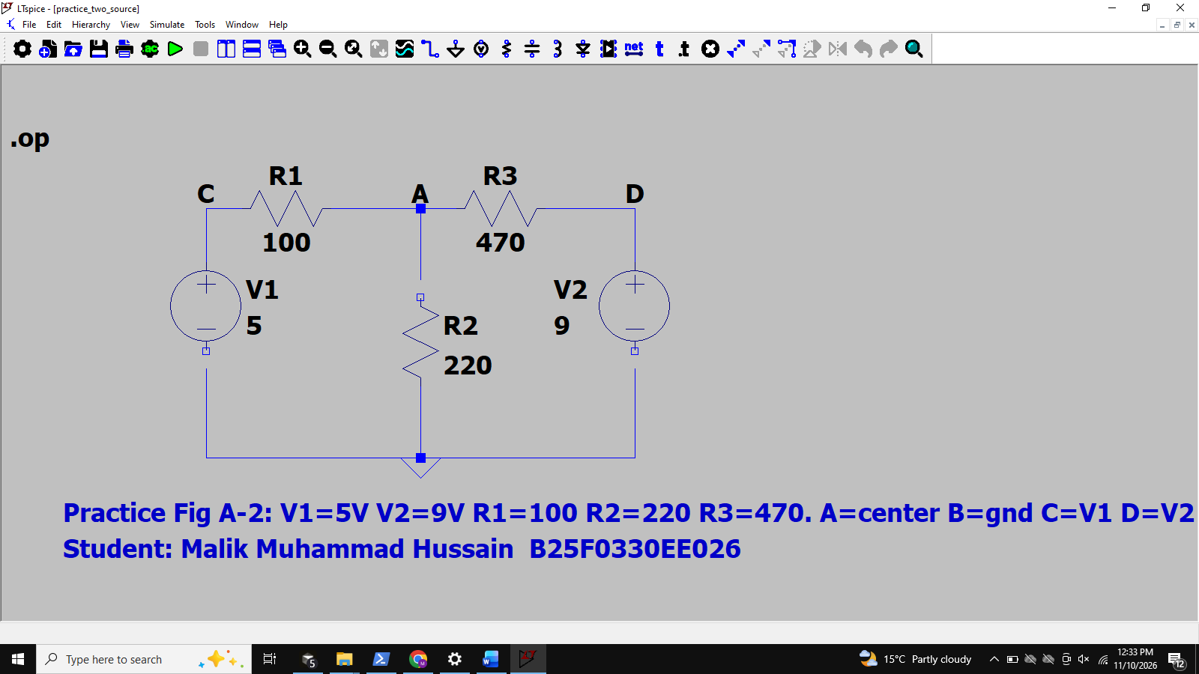
- Compare between the practical and theoretical results.

Tasks

Find VB, VC on the figure below:

Tasks — Find VB, VC (ground at D):
Known: VA = Vs1 = 3 V, VE = Vs2 = 4 V, VD = 0. Unknown: VB, VC.
R1=1 kOhm (A-B), R2=2.2 kOhm (B-D), R3=1.5 kOhm (B-C), R4=3.3 kOhm (C-E), R5=820 Ohm (C-D).
KCL at B: (VB-3)/1000 + VB/2200 + (VB-VC)/1500 = 0
KCL at C: (VC-VB)/1500 + (VC-4)/3300 + VC/820 = 0
Matrix: [1/1000+1/2200+1/1500, -1/1500; -1/1500, 1/1500+1/3300+1/820][VB;VC]=[3/1000; 4/3300]
Solution: VB = 1.756 V, VC = 1.089 V
LTSpice Tasks Find VB, VC — full-screen schematic / .op
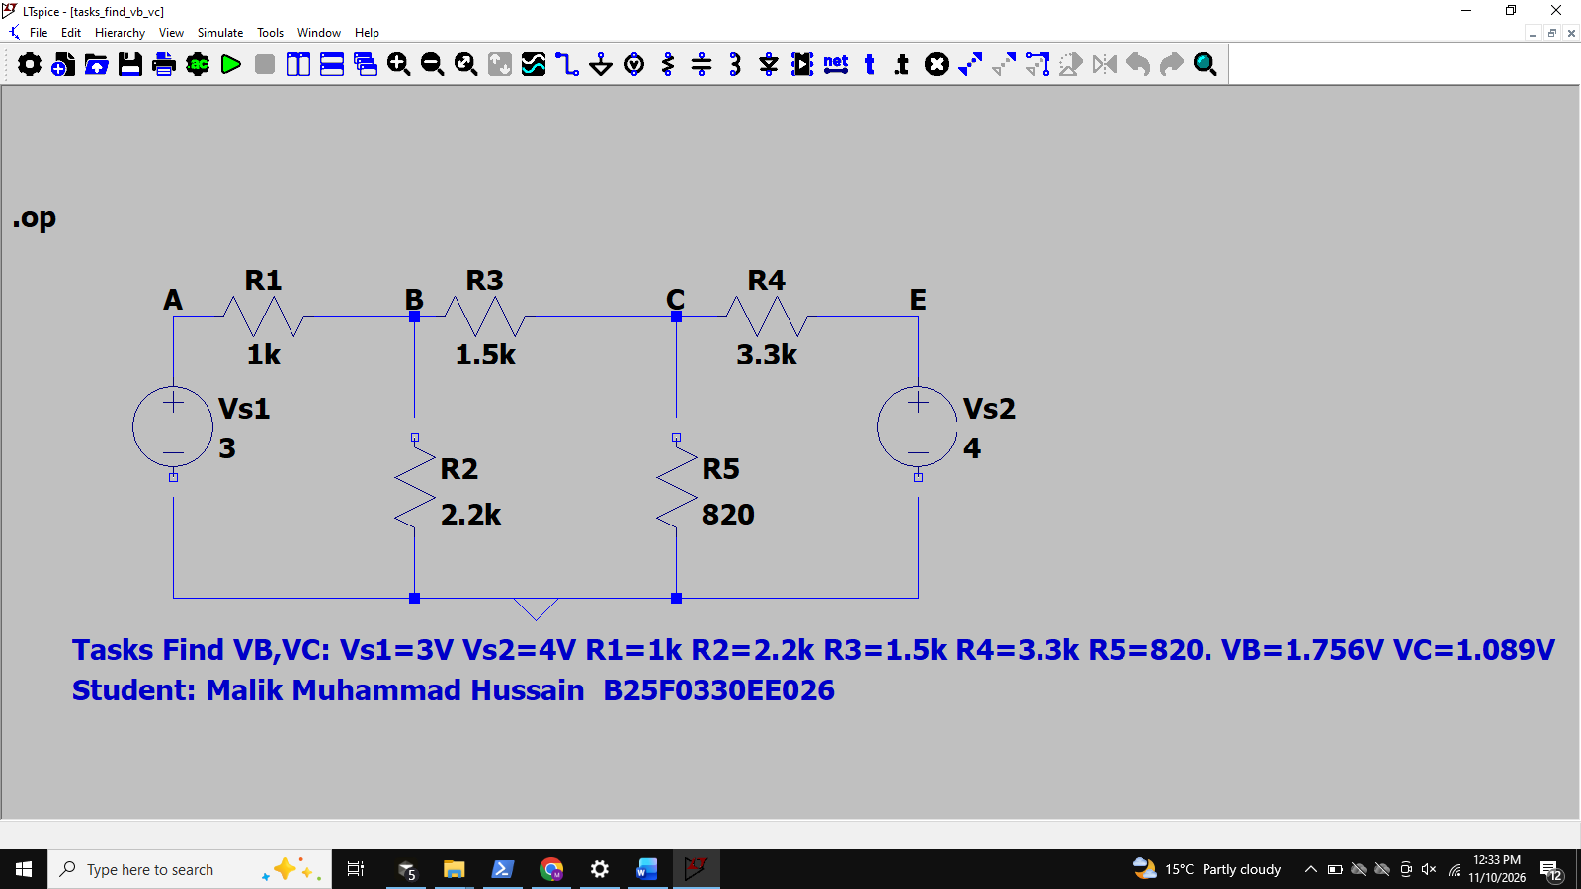
LTSpice .op measured: VB = 1.756 V `, VC = 1.089 V ` (%Diff ~ 0%)



