LAB 05

Student: Malik Muhammad Hussain Reg no.: B25F0330EE026
Handout as printed: KVL R5=1.5 kOhm; KCL R5=1.2 kOhm; Vs=5 V. LTSpice .op = measured (`).
Experimental Validation of Kirchhoff's Voltage Law(KVL) & Kirchhoff's Current Law (KCL) in Electrical Circuits

OBJECTIVE:
Verify Kirchhoff’s Voltage Law (KVL) and Kirchhoff’s Current Law (KCL) using mesh and nodal analysis of the given circuit
EQUIPMENTS REQUIRED:
Sr. no | Name | Range | Quantity
1 | Resistors | 1k,2.2k,1.8k,1k,1.5k/1.2k,2.7k | 6
2 | DC variable voltage supply | 0-30 V (set 5 V) | 1
3 | Digital Multimeter | DMM / LTSpice | 1
4 | Others | wires | 1

THEORY:
1. KIRCHHOFF’S VOLTAGE LAW (KVL)
Kirchhoff’s Voltage Law “states that the algebraic sum of all the voltages around any closed path (loop or mesh) is zero”.
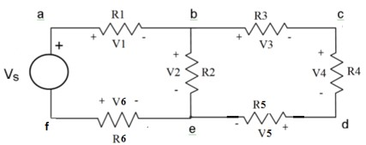
FIGURE 1.
Applying Kirchhoff’s voltage law to the first and the second loops in the circuit shown in Figure 1 yields the equation below respectively
𝑉₁ + 𝑉₂ − 𝑉₆ −𝑉_{𝑆} = 0 (LOOP “a b e f a”) (1a)
𝑉₃ + 𝑉₄ + 𝑉₅ − 𝑉₂ = 0 (LOOP “b c d e b”) (1b) BREAD BOARD LAYOUT
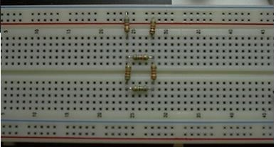
FIGURE 2.
PROCEDURE: KIRCHOFF’S VOLTAGE LAW (KVL)
- Construct the circuit shown in Figure 1 using the values below:
R1 = 1 KΩ R2 = 2.2 KΩ
R3 = 1.8 KΩ R4 = 1 KΩ
R5 = 1.5 KΩ R6 = 2.7 KΩ
- Set the Variable Power Supply (Vs) to 5 Volts.
- Accurately measure all voltages in the circuit using the Digital Multi-Meter (DMM).
- Record the measurements in the observation table containing the measured voltage values as shown below.

- KVL verification (table polarities + to -):
- LTSpice KVL circuit — full-screen schematic / .op
- 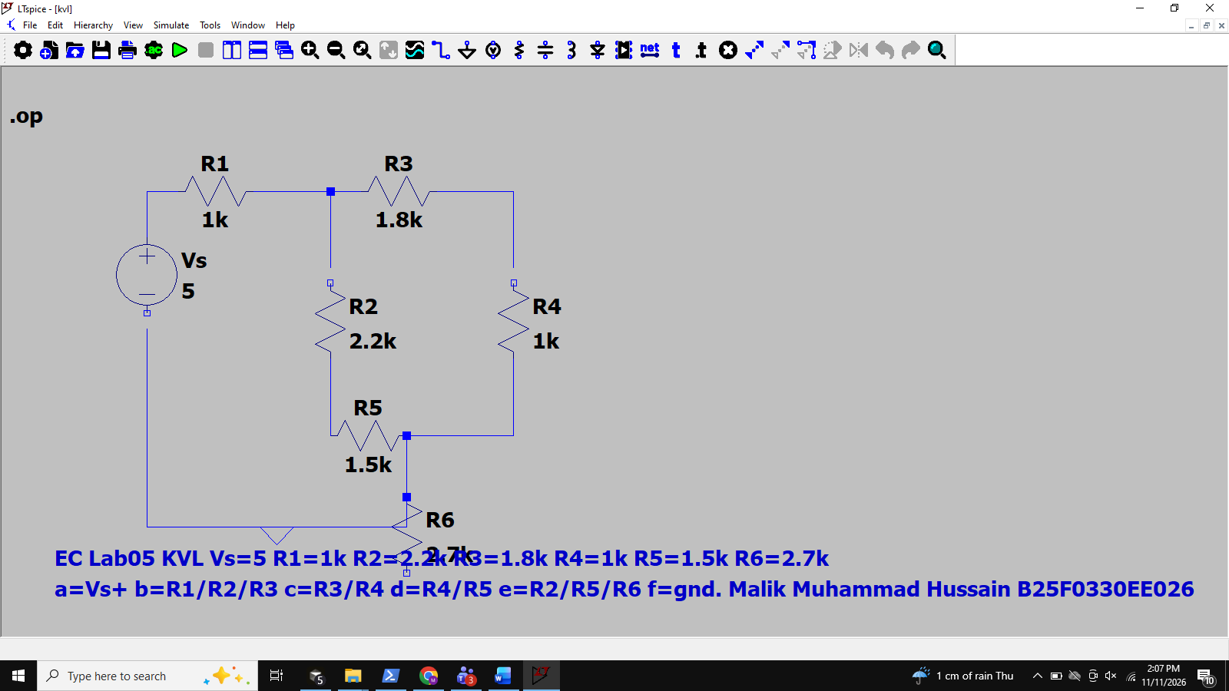
- 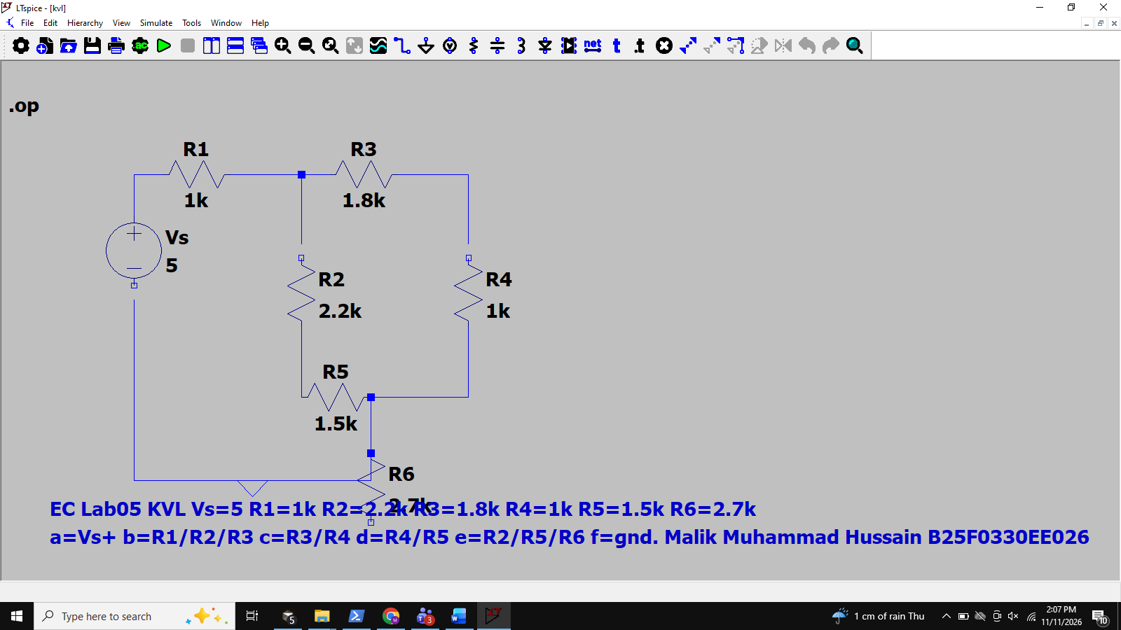
- Loop a-b-e-f-a: V1+V2+V6-Vs = 0.970+1.412+2.619-5.000 = 0.001 ~ 0 ` (handout eq 1a writes -V6; with listed +e/-f polarity the loop sum uses +V6).
- Loop b-c-d-e-b: V3+V4+V5-V2 = 0.591+0.328+0.492-1.412 = -0.001 ~ 0 `
- Verify the results theoretically and record the value in the observation in the column for calculated value.
- Verify KVL for the loops in the circuit using equations ‘1a’ and ‘1b’.

OBSERVATION TABLE:
Element | Specified value | Element  Voltage |  |  | Element voltage |  | LOOP VOLTAGE “a b e f a”  𝑉₁ + 𝑉₂ − 𝑉₆ −𝑉_{𝑆} = 0  Calculated:
Element | Specified value | Element  Voltage | Nodes |  | Measured value (V) | Calculated value of  voltage  (V)
Element | Specified value | Element  Voltage | + | − | Measured value (V) | Calculated value of  voltage  (V)
R₁ | 1 kOhm | 𝑉₁  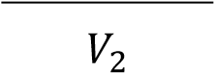  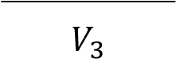 | a | b | 0.970 ` | 0.970 | Measured:
R₂ | 2.2 kOhm |  | b | e | 1.412 ` | 1.412 | Measured:
R₃ | 1.8 kOhm |  | b | c | 0.591 ` | 0.591 | LOOP VOLTAGE “b c d e b”  𝑉₃ + 𝑉₄ + 𝑉₅ −𝑉₂ = 0  Calculated:  Measured:
R₄ | 1 kOhm | 𝑉₄  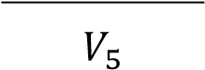 | c | d | 0.328 ` | 0.328
R₅ | 1.5 kOhm |  | d | e | 0.492 ` | 0.492
R₆ | 2.7 kOhm | 𝑉₆ | e | f | 2.619 ` | 2.619
Vs | 5 V | 𝑉_{𝑠} | a | f | 5.000 ` | 5.000

1. KIRCHHOFF’S CURRENT LAW (KCL):
KIRCHHOFF’S CURRENT LAW “states that the algebraic sum of all the currents at any node is zero”. Applying Kirchhoff’s current law to the nodes in the circuit shown in Figure 3 yields the following equations;
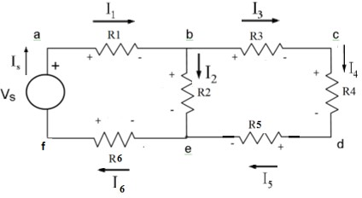
FIGURE 3.
Node a: -I_{s} + I₁ = 0 (2a)
Node b: -I₁ + I₂ + I₃ = 0 (2b)
Node c: -I₃ + I₄ = 0 (2c)
Node d: - I₄ + I₅ = 0 (2d) Node e: - I₅ - I₂ + I₆ = 0 (2e)
Node f: +I_{s} – I₆ = 0 (2f) PROCEDURE: KIRCHOFF’S Current LAW (KCL)
- Construct the circuit shown in Figure 3 using the values below:
R1 = 1 KΩ R2 = 2.2 KΩ
R3 = 1.8 KΩ R4 = 1 KΩ
R5 = 1.2 KΩ R6 = 2.7 KΩ
- Set the Variable Power Supply (Vs) to 5 Volts.
- Accurately measure all current in each branch using the Digital Multi-Meter (DMM) as shown in figure 4.
- Record the measurements in the observation table containing the total current into and total current out of respectively.
- Verify the results theoretically and experimentally and record the value in the observation in the column for calculated and measured value.
- Verify KCL for the nodes in the circuit using equations ‘2a’ through ‘2f’.

KCL currents (R5=1.2 kOhm): Is=I1=I6=0.977 mA; I2=0.630 mA; I3=I4=I5=0.347 mA.
LTSpice KCL circuit — full-screen schematic / .op
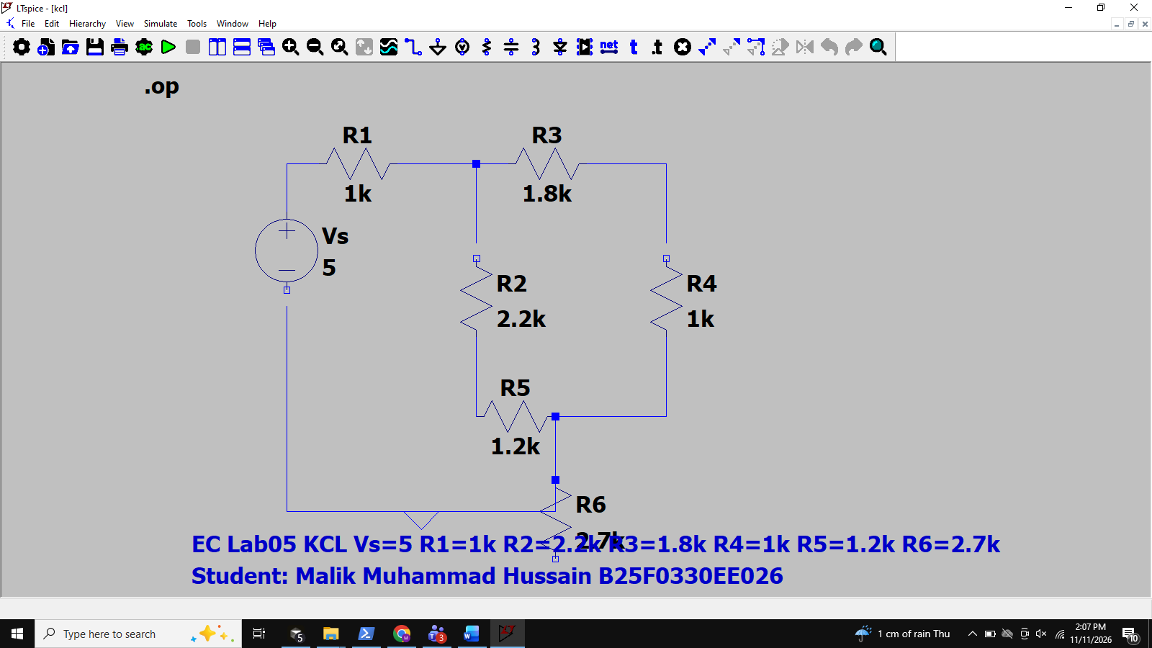
Nodes a..f: Iin - Iout = 0 (within rounding) for both calculated and LTSpice measured `.
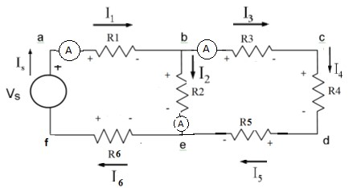
FIGURE 4.

OBSERVATION TABLE:
Node | Total current into (I_{in}) (A) |  | Total current out of (I_{out}) (A) |  | KCL  (I_{in} – I_{out}) (A)
Node | Calculated | Measured | Calculated | Measured | Calculated | Measured
a | 9.767e-4 | 9.767e-4 ` | 9.767e-4 | 9.767e-4 ` | 0 | 0 `
b | 9.767e-4 | 9.767e-4 ` | 9.767e-4 | 9.767e-4 ` | 0 | 0 `
c | 3.466e-4 | 3.466e-4 ` | 3.466e-4 | 3.466e-4 ` | 0 | 0 `
d | 3.466e-4 | 3.466e-4 ` | 3.466e-4 | 3.466e-4 ` | 0 | 0 `
e | 9.767e-4 | 9.767e-4 ` | 9.767e-4 | 9.767e-4 ` | 0 | 0 `
f | 9.767e-4 | 9.767e-4 ` | 9.767e-4 | 9.767e-4 ` | 0 | 0 `

Conclusion: KVL was verified on loops a-b-e-f-a and b-c-d-e-b; algebraic voltage sums are ~0 V. KCL was verified at nodes a–f; Iin − Iout ~ 0 A. LTSpice .op (measured `) matched calculated branch voltages/currents for the handout resistor sets (KVL R5=1.5 kOhm; KCL R5=1.2 kOhm) with Vs=5 V.

Conclusion: KVL was verified on loops a-b-e-f-a and b-c-d-e-b; algebraic voltage sums are ~0 V. KCL was verified at nodes a–f; Iin − Iout ~ 0 A. LTSpice .op (measured `) matched calculated branch voltages/currents for the handout resistor sets (KVL R5=1.5 kOhm; KCL R5=1.2 kOhm) with Vs=5 V.

