Lab 06: Application of Superposition theorem in Sinusoidal Steady State
Student: Malik Muhammad Hussain Reg no.: B25F0330EE026
Course: ENA (Electric Network Analysis). Experimental values from LTSpice transient (.meas PP).
Locked parts: C=10 nF, L=10 mH, R=1 kOhm (handout text; ignore figure labels 1.2 mH / 470 pF).
Locked sources: E1 = 2 Vpp sine @ 1 kHz; E2 = 2 Vpp sine @ 10 kHz. Source internal Z = 50 Ohm when replaced (and series FG Z=50 Ohm on active source).
Note: handout also mentions 200 kHz in places; this report uses the locked 1 kHz / 10 kHz set only.
Circuit (Figure 1 topology)
E1 -- Rs1(50) -- A -- L(10mH) -- MID -- C(10nF) -- B -- Rs2(50) -- (E2 or GND); R(1k) from MID to GND. Both sources referenced to ground.
Table 1 — Source One Only (E1 @ 1 kHz; E2 → 50 Ω)
Quantity | Theory (Vpp) | Experimental LTSpice (Vpp) | %Error
E1 (V(A)) | 1.9044 | 1.9044 | 0.00%
E2 (V(B)) | 0.0060 | 0.0064 | 6.67%
VR (V(MID)) | 1.9081 | 1.9081 | 0.00%

Figure T1a — LTSpice schematic (Source One Only), full screen
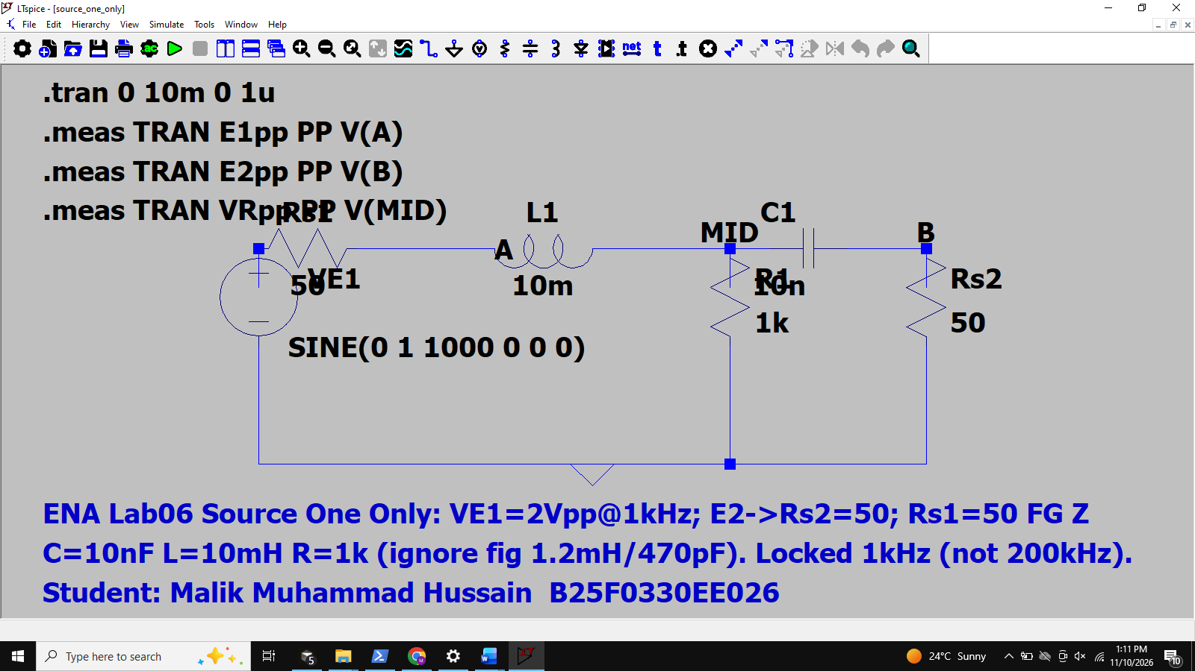

Figure T1b — LTSpice / scope stand-in waveforms (Source One Only), full screen
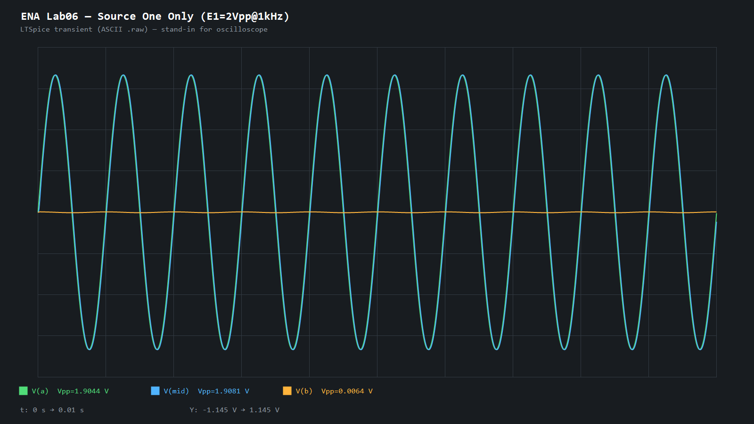

Table 2 — Source Two Only (E2 @ 10 kHz; E1 → 50 Ω)
Quantity | Theory (Vpp) | Experimental LTSpice (Vpp) | %Error
E1 (V(A)) | 0.0668 | 0.0669 | 0.15%
E2 (V(B)) | 1.9782 | 1.9782 | 0.00%
VR (V(MID)) | 0.8426 | 0.8485 | 0.70%

Figure T2a — LTSpice schematic (Source Two Only), full screen
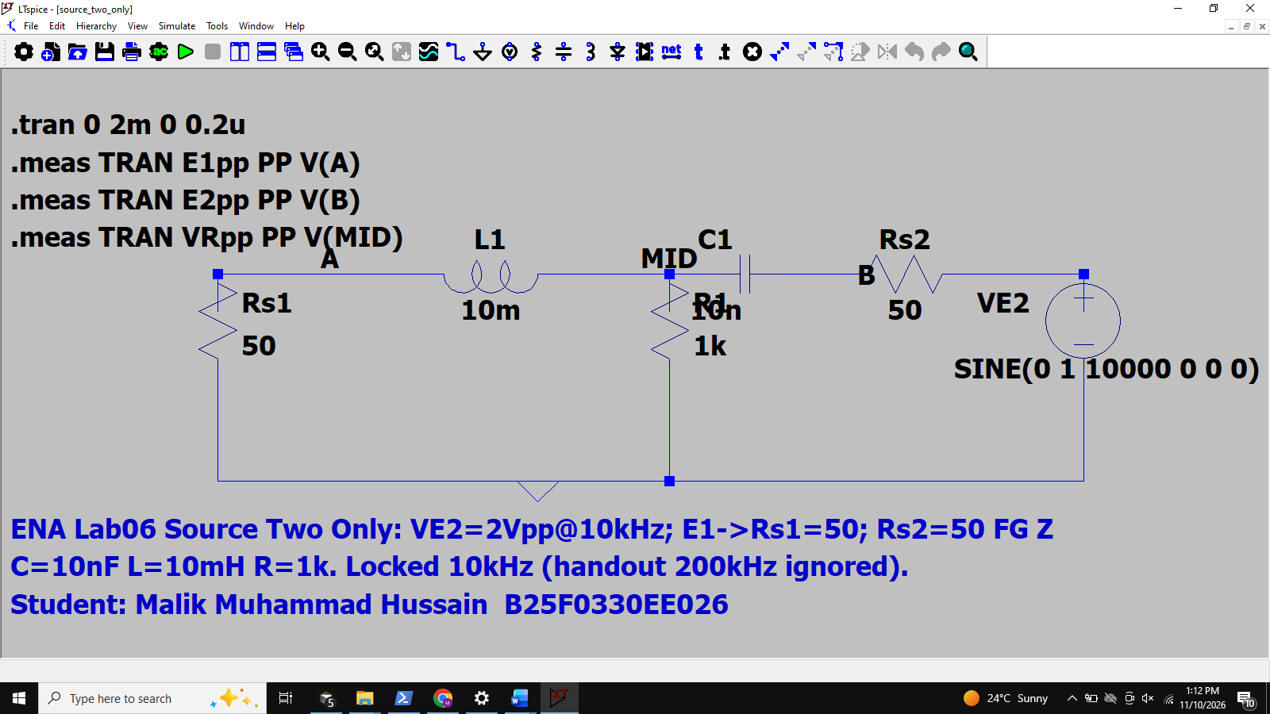

Figure T2b — LTSpice / scope stand-in waveforms (Source Two Only), full screen
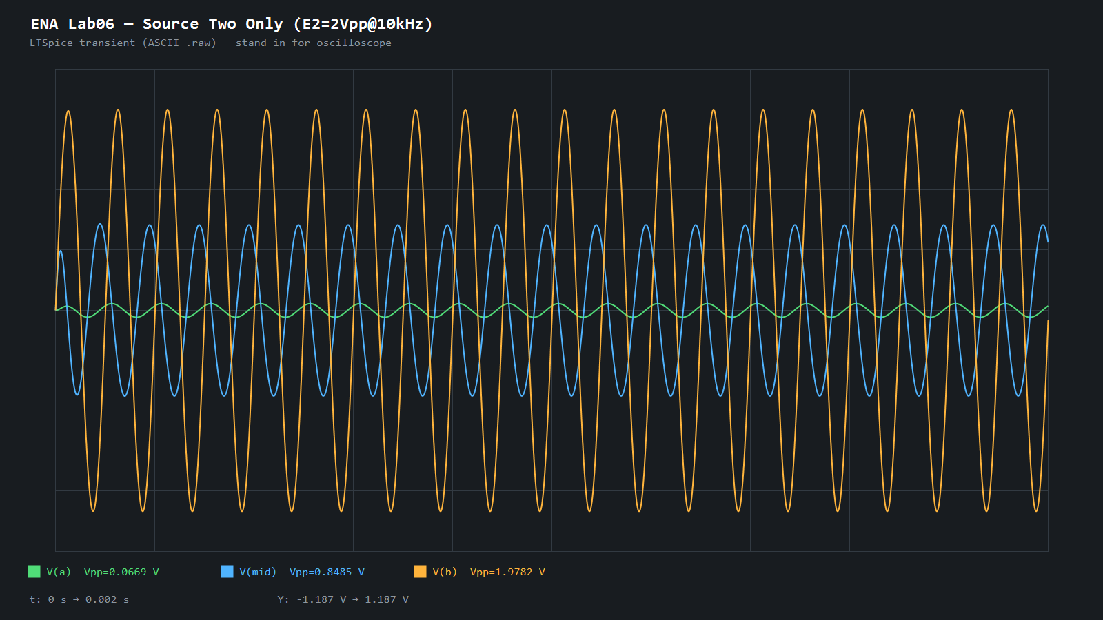

Table 3 — Sources One and Two (sum of contributions vs both-sources run)
Theory column = algebraic sum of Table 1 and Table 2 Vpp contributions (as required by the handout). Because the tones differ in frequency, the combined waveform is a beat; expected VR envelope max ≈ 2.751 Vpp, min ≈ 1.066 Vpp.
Quantity | Theory (Vpp) | Experimental LTSpice (Vpp) | %Error
E1 (V(A)) | 1.9712 | 1.9490 | 1.13%
E2 (V(B)) | 1.9842 | 1.9841 | 0.01%
VR (V(MID)) | 2.7507 | 2.7271 | 0.86%

Figure T3a — LTSpice schematic (Both Sources), full screen
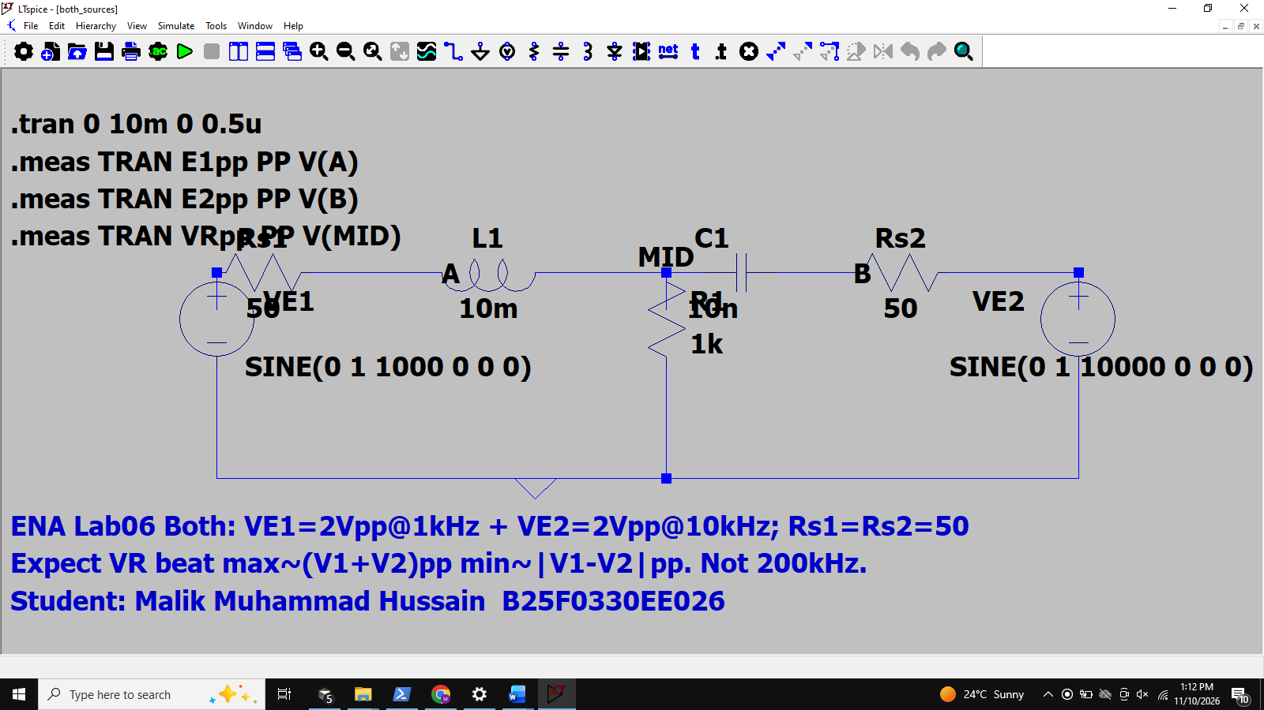

Figure T3b — LTSpice / scope stand-in waveforms (Both Sources — beat), full screen
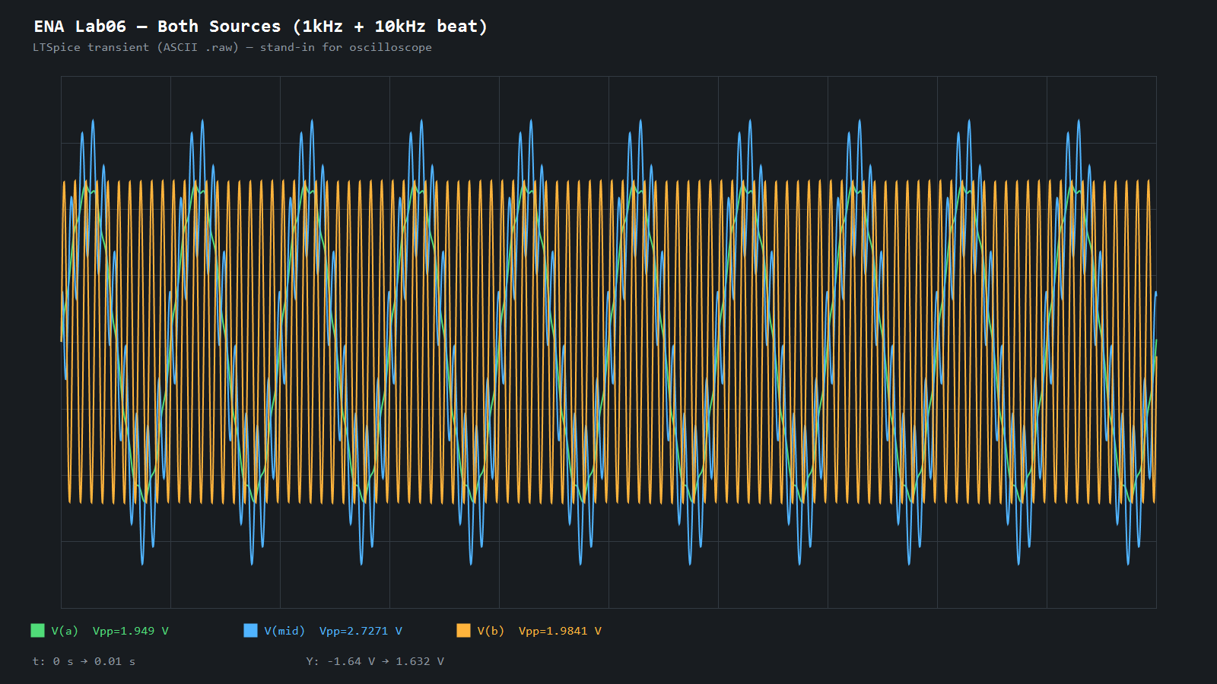

Mathematical calculations (superposition / phasor AC)
General model (peak phasors; report tables in Vpp = 2·|Vpeak|). Unloaded FG set to 2 Vpp ⇒ E = 1∠0° V peak. Each active FG modeled as ideal voltage in series with Rs=50 Ω. Inactive source replaced by 50 Ω.

Reactances: XL = ωL, XC = 1/(ωC), ω = 2πf.
L = 10 mH, C = 10 nF, R = 1 kΩ.

========== SOURCE ONE ONLY (f = 1 kHz) ==========
ω1 = 6283.19 rad/s
XL1 = 62.832 Ω, XC1 = 15915.49 Ω
E1 active: chain VE1–Rs1–A–L–MID–C–B–Rs2–GND; R from MID to GND.
Z_right = XC + Rs2 = 50 − j15915.49 Ω
Z_par = R ∥ Z_right
Z_tot = Rs1 + jXL1 + Z_par
I = E / Z_tot
V(A) = I · (jXL1 + Z_par) → |V(A)|pp = 1.9044 V
V(MID) = I · Z_par → |VR|pp = 1.9081 V
V(B) = V(MID) · Rs2 / Z_right → |V(B)|pp = 0.0060 V

At 1 kHz, XC ≫ R so almost no current through the capacitor branch; VR ≈ V(A) and V(B) is millivolts.

========== SOURCE TWO ONLY (f = 10 kHz) ==========
ω2 = 62831.9 rad/s
XL2 = 628.32 Ω, XC2 = 1591.55 Ω
E2 active: GND–Rs1–A–L–MID–C–B–Rs2–VE2; R from MID to GND.
Z_left = jXL2 + Rs1
Z_par = R ∥ Z_left
Z_tot = Rs2 − jXC2 + Z_par
I = E / Z_tot
V(B) = I · (−jXC2 + Z_par) → |V(B)|pp = 1.9782 V
V(MID) = I · Z_par → |VR|pp = 0.8426 V
V(A) = V(MID) · Rs1 / Z_left → |V(A)|pp = 0.0668 V

========== BOTH SOURCES (different frequencies) ==========
Superposition in time: v_total(t) = v1(t) + v2(t). Phasors at different ω cannot be added as complex numbers.
Handout Table 3 theory = sum of Vpp contributions:
E1: 1.9044 + 0.0668 = 1.9712 Vpp
E2: 0.0060 + 1.9782 = 1.9842 Vpp
VR: 1.9081 + 0.8426 = 2.7507 Vpp (≈ expected beat maximum)
VR beat minimum ≈ |1.9081 − 0.8426| = 1.0656 Vpp.
LTSpice both-sources run measured VR Vpp ≈ 2.727 V (near the predicted maximum).
Conclusion
The superposition theorem was verified for a linear RLC network driven by two sinusoidal sources at different frequencies. Theoretical phasor / series-parallel analysis (including 50 Ω source impedances) matches LTSpice transient peak-to-peak measurements within about 1% for the single-source cases (Tables 1–2). With both sources active, the mid-node voltage shows the expected multi-tone / beat waveform; the measured VRpp ≈ 2.73 V agrees with the sum-of-contributions maximum ≈ 2.75 V. Frequency-dependent reactances explain why E1@1 kHz mainly appears across R while E2@10 kHz is more strongly divided by the C–R network. Handout inconsistencies (figure 1.2 mH/470 pF vs text 10 mH/10 nF; stray 200 kHz lines) were resolved by the locked lab conditions used throughout.

