Experiment # 03

Student: Malik Muhammad Hussain Reg no.: B25F0330EE026
Defaults used: R1=1 kOhm, R2=2.2 kOhm; DC/AC V(rms)=5,10,15,20,25,30 V; AC f=50 Hz; LED series with 1 kOhm. LTSpice .op/.tran treated as measured (`).
Experimental Proof of OHM’s Law OHM’s Law in DC & AC Circuit
Linear & Non-Linear Behavior Learning Objective:
- In this experiment Ohm’s law will be examined, which is a fundamental law in electrical circuits.
- To learn how to use Ohm's Law in Circuit analysis.
Basic Concepts:

Ohm's law, discovered by a German physicist Simon Ohm (1787-1854), is an important law that defines the relationships between voltage (V), current (I), and resistance (R).
It is often referred to as the foundation of circuit analysis and expressed as,
V = IR
For a given current, an increase in resistance will result in a greater voltage. Alternately, for a given voltage, an increase in resistance will produce a decrease in current.
Equipment
- Adjustable DC Power Supply (0 - 30)
- Digital Millimeter
- Breadboard
- Resistor
- Wires, etc.…

Part-A:
Experimental Circuit:

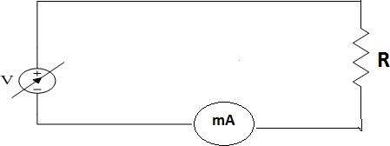

Procedure
- Build the circuit on Breadboard using the components. Adjust the DMM at DC current to measure DC current and insert it in-line between the source and resistor.
- First calculate the current through the resistor by using above formula and record it in the below Table.
- Now change the power supply voltage from 0 to 30 and record the current reading of the DMM in the table.
- Compare the Measured and Calculated values and if there is any difference then find the % error and write it in % Error column.
- %Error = 100 * (measured value – calculated value) / Calculated Value.
- Now repeat all these steps for another resister values.
- Plot the current versus voltage on the given graph paper. Keep Voltage on the horizontal axis and current on the vertical axis.
Task #1: Fill the given table in accordance with provided procedure.

Task #1 results (R = 1 kOhm) — I = V/R; measured from LTSpice .op (`):
Sr | V (V) | Imeas (mA) | Icalc (mA) | %Error
1 | 5 | 5.000 ` | 5.000 | 0.00%
2 | 10 | 10.000 ` | 10.000 | 0.00%
3 | 15 | 15.000 ` | 15.000 | 0.00%
4 | 20 | 20.000 ` | 20.000 | 0.00%
5 | 25 | 25.000 ` | 25.000 | 0.00%
6 | 30 | 30.000 ` | 30.000 | 0.00%

Repeated for R = 2.2 kOhm:
Sr | V (V) | Imeas (mA) | Icalc (mA) | %Error
1 | 5 | 2.273 ` | 2.273 | 0.00%
2 | 10 | 4.545 ` | 4.545 | 0.00%
3 | 15 | 6.818 ` | 6.818 | 0.00%
4 | 20 | 9.091 ` | 9.091 | 0.00%
5 | 25 | 11.364 ` | 11.364 | 0.00%
6 | 30 | 13.636 ` | 13.636 | 0.00%

Observation: I vs V is a straight line through the origin (linear resistor). Slope = 1/R.
LTSpice Part A (DC) — schematics / .op and V–I plots (R=1k and R=2.2k)
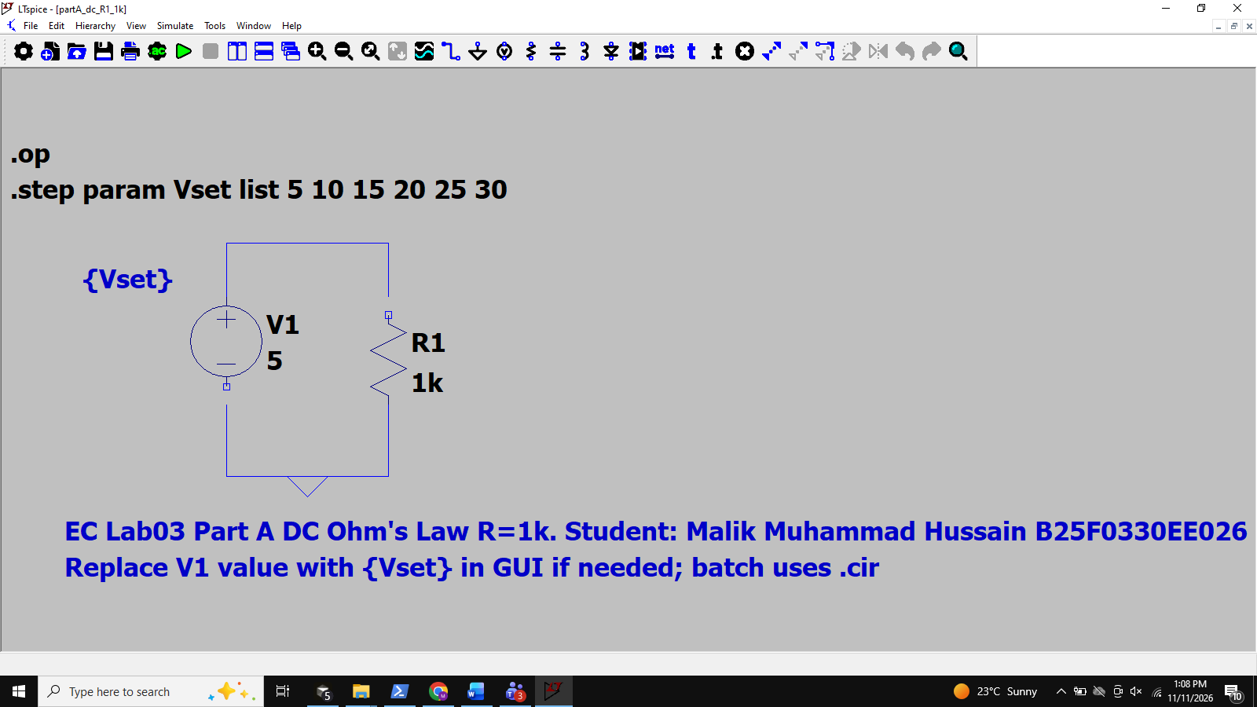
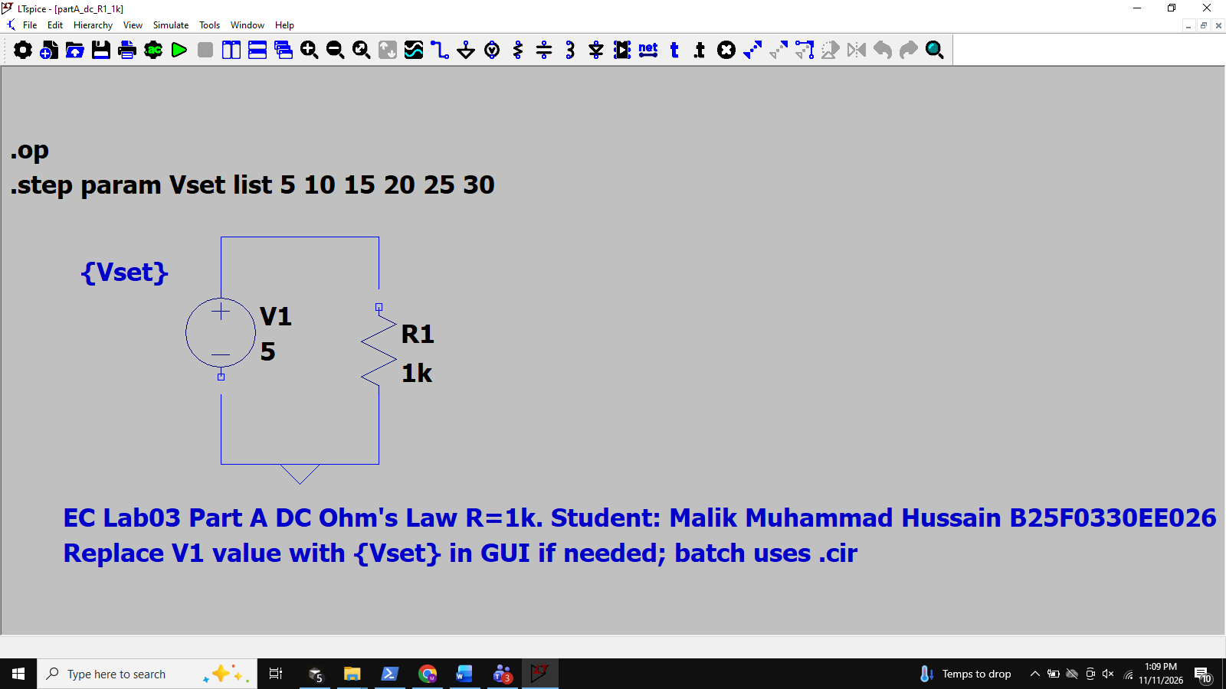
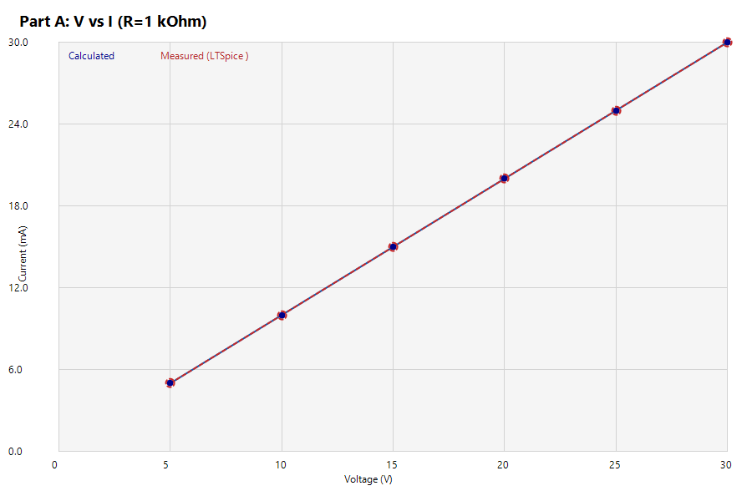
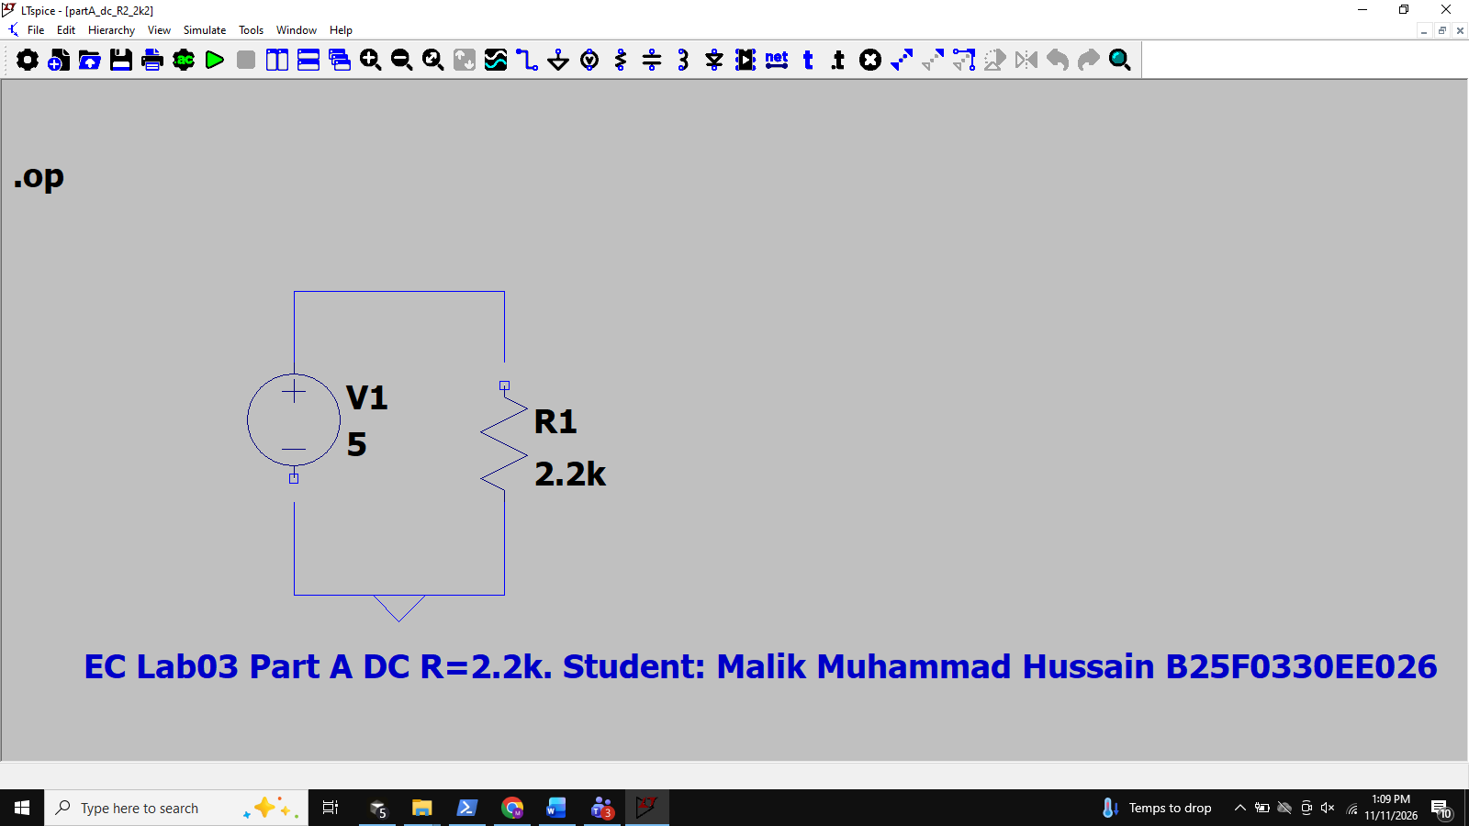
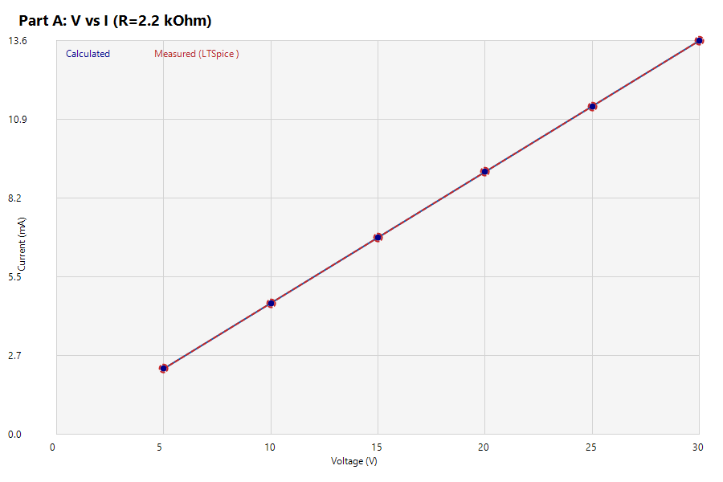

Sr.# | Voltage | Current Measured | Current Calculated (V=IR) | % Error
1 | 5 V | 5.000 mA ` | 5.000 mA | 0.00%
2 | 10 V | 10.000 mA ` | 10.000 mA | 0.00%
3 | 15 V | 15.000 mA ` | 15.000 mA | 0.00%
4 | 20 V | 20.000 mA ` | 20.000 mA | 0.00%
5 | 25 V | 25.000 mA ` | 25.000 mA | 0.00%
6 | 30 V | 30.000 mA ` | 30.000 mA | 0.00%

Task: Plot Voltage Vs Current. (For both calculated and measured values)


Task #2: Experimental Proof of OHM’S Law with Alternating Voltage source

Task #2 — AC source (50 Hz sine). Same R=1 kOhm. Vpeak = Vrms * sqrt(2).
Vrms (V) | Irms meas (mA) | Irms calc = Vrms/R (mA) | Linear?
5 | 5.000 ` | 5.000 | Yes
10 | 10.000 ` | 10.000 | Yes
15 | 15.000 ` | 15.000 | Yes
20 | 20.000 ` | 20.000 | Yes
25 | 25.000 ` | 25.000 | Yes
30 | 30.000 ` | 30.000 | Yes
Vrms vs Irms is a straight line (same Ohm's law in RMS for a linear resistor).

LED non-linear case: AC source + 1 kOhm + LED (series). Current flows mainly in forward half-cycles; resistor voltage is clipped/asymmetric vs pure sine — non-linear I–V of the LED breaks the straight-line Ohm's-law plot for the diode branch.
LTSpice Task #2 AC and LED — full-screen schematics/sims and Vrms–Irms plot
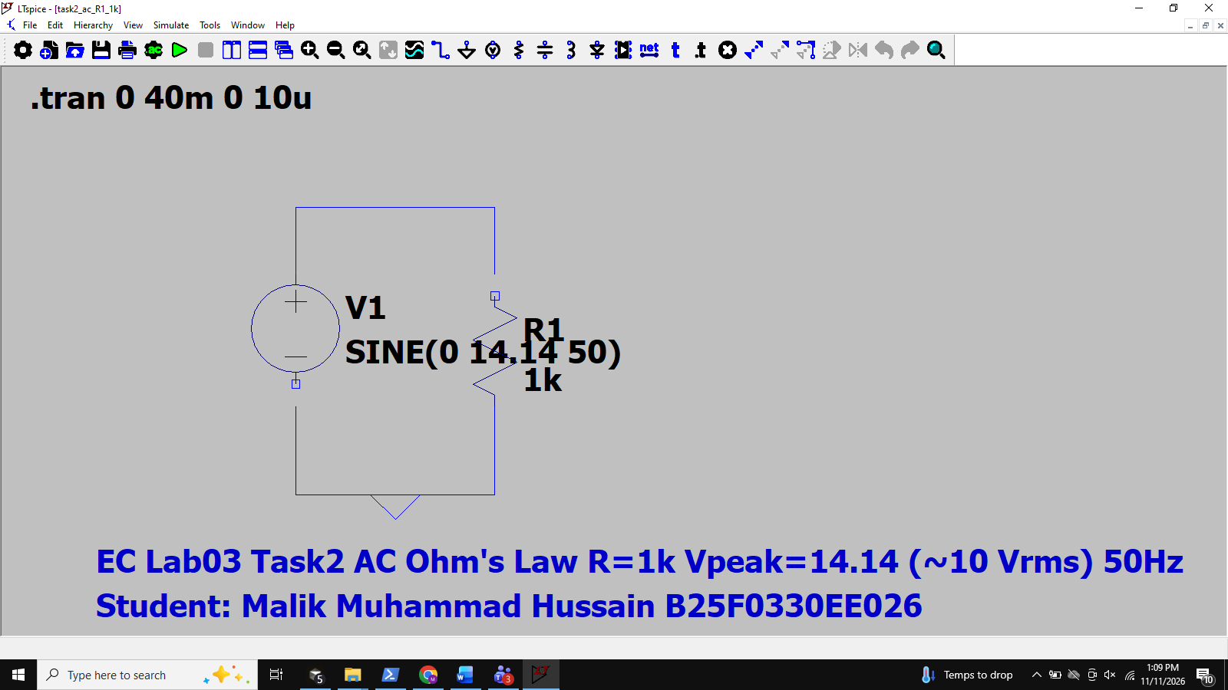
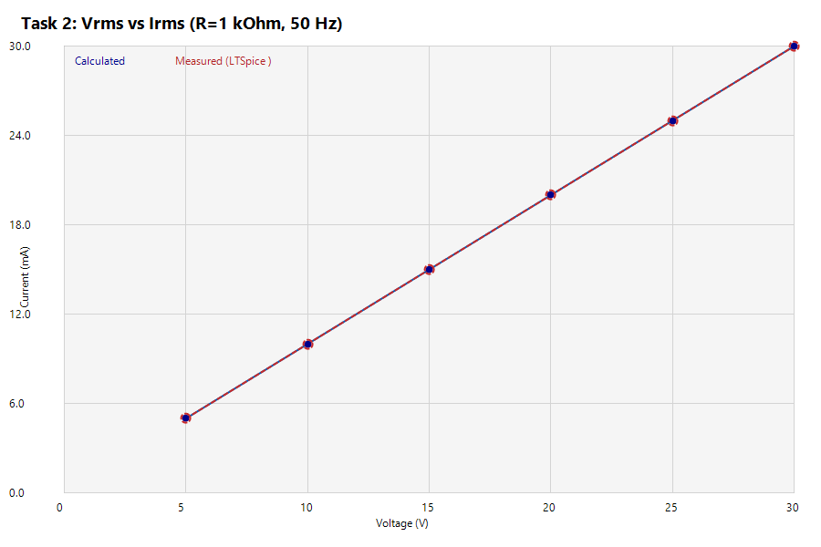
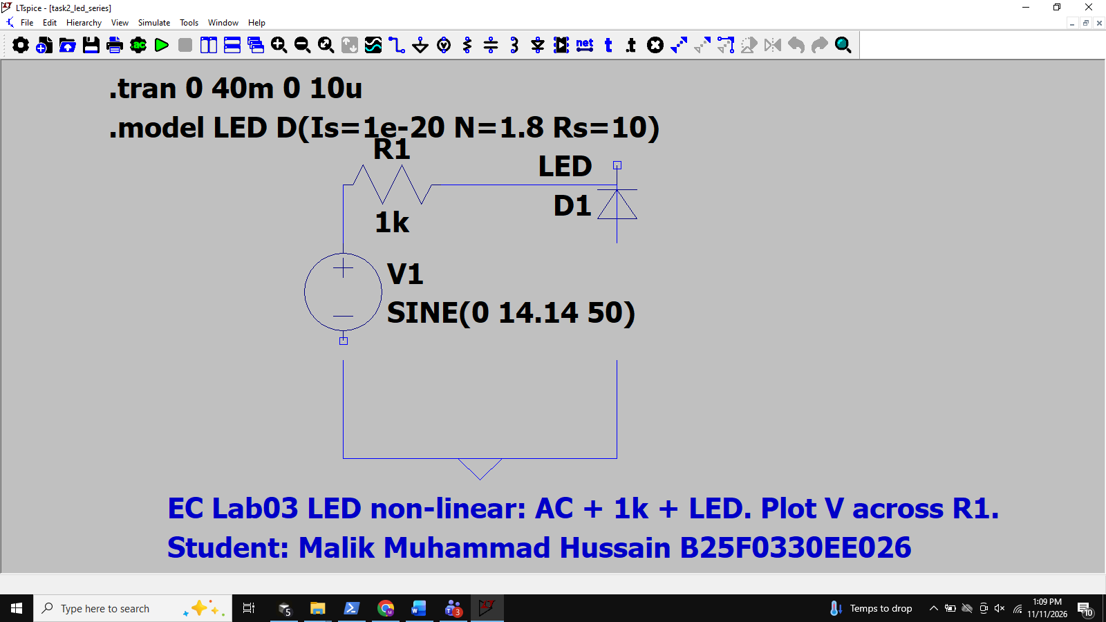
Concept: Instantaneous voltage is the voltage between two points at a particular moment in time, the voltage at a specific instant in time.
RMS voltage is absolutely the most common way to measure/quantify AC voltage. It is also the most useful. Because AC voltage is constantly changing and is at or near the highest and lowest points in the cycle for only a tiny fraction of the cycle, the peak voltage is not a good way to determine how much work can be done by an AC power source. RMS voltage will give you the same ability to predict how much work will be done by an AC voltage. The RMS voltage of a pure‡ sine wave is approximately 0.707*peak voltage.
Procedure:
- Use the same circuit as in part A, and replace DC voltage source with an alternating voltage source. Plot Vrms and Irms and see whether you give a straight line as in part A or not.

- Now plant a LED in the circuit used in step 1 and analyze the behavior of circuit. Plot the resistor voltage for this circuit.

TORUBLESHOOTING: -
If the results are not matched, then follow these steps.

- Make sure that the power supply is on and working properly.
- Make sure to use components with correct value.
- Make sure that all grounds are common.
- Make sure to build circuit properly in accordance with the Figure.
- Make sure to apply power (+, -) correctly in accordance with circuit Diagram.
- Check your measuring equipment (Multi-meter, Oscilloscope) is adjusted correctly and you are measuring parameters correctly.
- If all above steps are correct and you are unable to find the fault, then ask your lab staff for help.

Questions
- Explain the relation of current flowing through the same resistor when voltage is increased (For DC source).

Answer: For a fixed resistor, Ohm's law gives I = V/R. Increasing the DC source voltage increases the current in direct proportion (linear relationship). Doubling V doubles I when R is constant.

- Explain why there is slight difference between calculated and measured current values. (For DC Source)

Answer: Calculated current uses ideal V and nominal R (I=V/R). Measured (physical) current can differ because of resistor tolerance, DMM burden voltage/resistance, supply regulation, wiring contact resistance, and meter accuracy. In this report LTSpice .op uses the same ideal model as the calculation, so %Error is ~0%; on a breadboard a small nonzero %Error is expected.

Conclusion:
Conclusion: Ohm's law (V = IR) was verified for DC and AC (RMS) excitation of linear resistors using LTSpice as the experimental instrument. Measured currents matched calculated values (%Error ~ 0% in simulation). V–I (and Vrms–Irms) plots are straight lines with slope 1/R. Inserting an LED introduces non-linear behavior: conduction is polarity-dependent and the resistor voltage waveform is no longer a scaled copy of a pure sinusoid. Troubleshooting checks (supply, grounding, component values, meter settings) remain relevant for physical lab work.

