LAB 04

Student: Malik Muhammad Hussain Reg no.: B25F0330EE026
Defaults: Series/Parallel R1=1 kOhm, R2=2.2 kOhm, R3=3.3 kOhm, VT=10 V. VDR: VS=10 V, R1=5k, R2=2.5k, R3=2.5k. CDR: VS=6 V, same R. LTSpice treated as measured (`).
Resistance in Series and Parallel & Voltage and Current Distribution (Dividers Law) in circuits

OBJECTIVE:
• Total resistance in a combination of resistors in series and parallel circuits. • Distribution of the voltage and current to each resistor in a network.
EQUIPMENTS REQUIRED:
Sr. no | Name | Range | Quantity
1 | Resistors | 1k, 2.2k, 3.3k; 5k, 2.5k, 2.5k | set
2 | DC variable voltage supply | 0-30 V | 1
3 | Digital Multimeter | DMM / LTSpice | 1
4 | Others | wires etc | 1

CIRCUIT DIAGRAM AND CALCULATION:
1. Series resistance
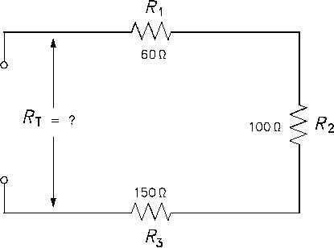

Figure 1. Resistors connected in series.

R_{T} = R₁ + R₂ + R₃

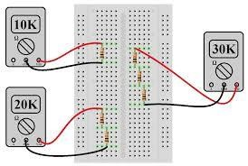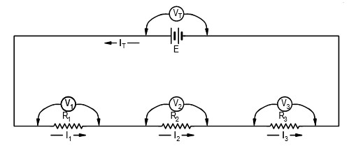

Figure 2. Snapshot of how resistors can be connected in series on
breadboard.

A
A

Figure 3. Voltage And Current Relation In A Resistive Series Circuit

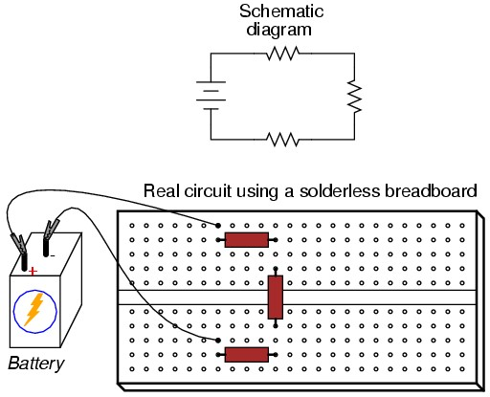

The voltage drop across the battery V_{T} will be the total sum of the individual drops across each of the 3 resistors, and
V_{T} =V₁ + V₂ + V₃
V_{T} = R_{T} I_{T}
V₁ = I₁ × R₁
V₂ = I₂ × R₂
V₃ = I₃ × R₃

In this circuit the current supplied by the battery flows through each resistor, with the current in each resistor being the same. If the current supplied by the battery is I_{T}, the current in each resistor is I₁, I₂, and I₃, and they are all one and the same, then
I_{T} = I₁ = I₂ = I₃
PROCEDURE:
- Identify the resistance of the resistors using the color code and write the value of each resistors in the table below.
- Calculate the total resistance RT and write in the table below.
- Connect the resistors as shown in figure 1.
- Using the multimeter in the resistance mode observe the resistance of the circuit at terminal RT.
- Write the observed value of the resistance in the table.

OBSERVATION TABLE:

SERIES RESULTS (R1=1k, R2=2.2k, R3=3.3k):
LTSpice Series circuit — full-screen schematic / .op
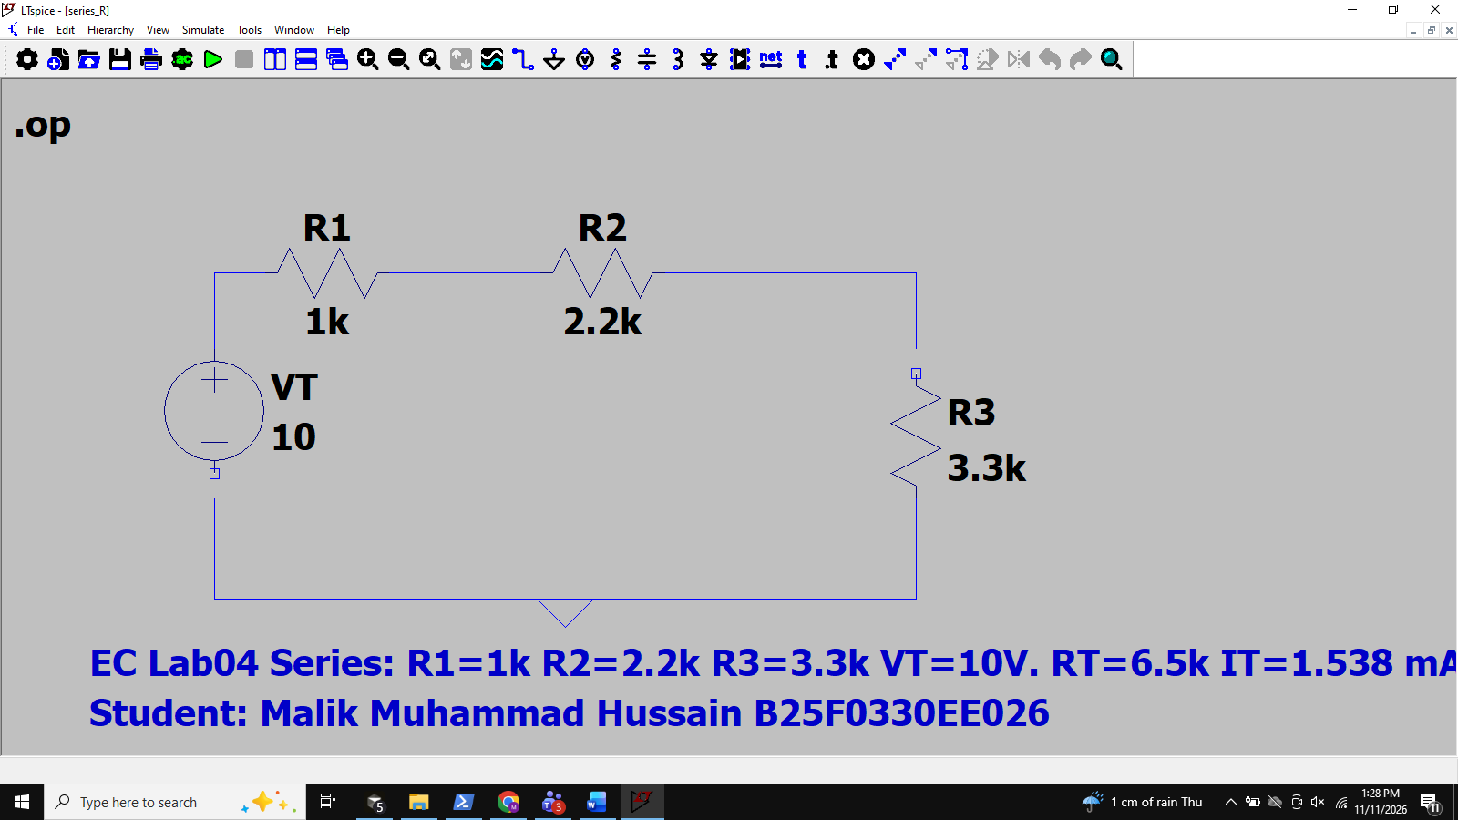
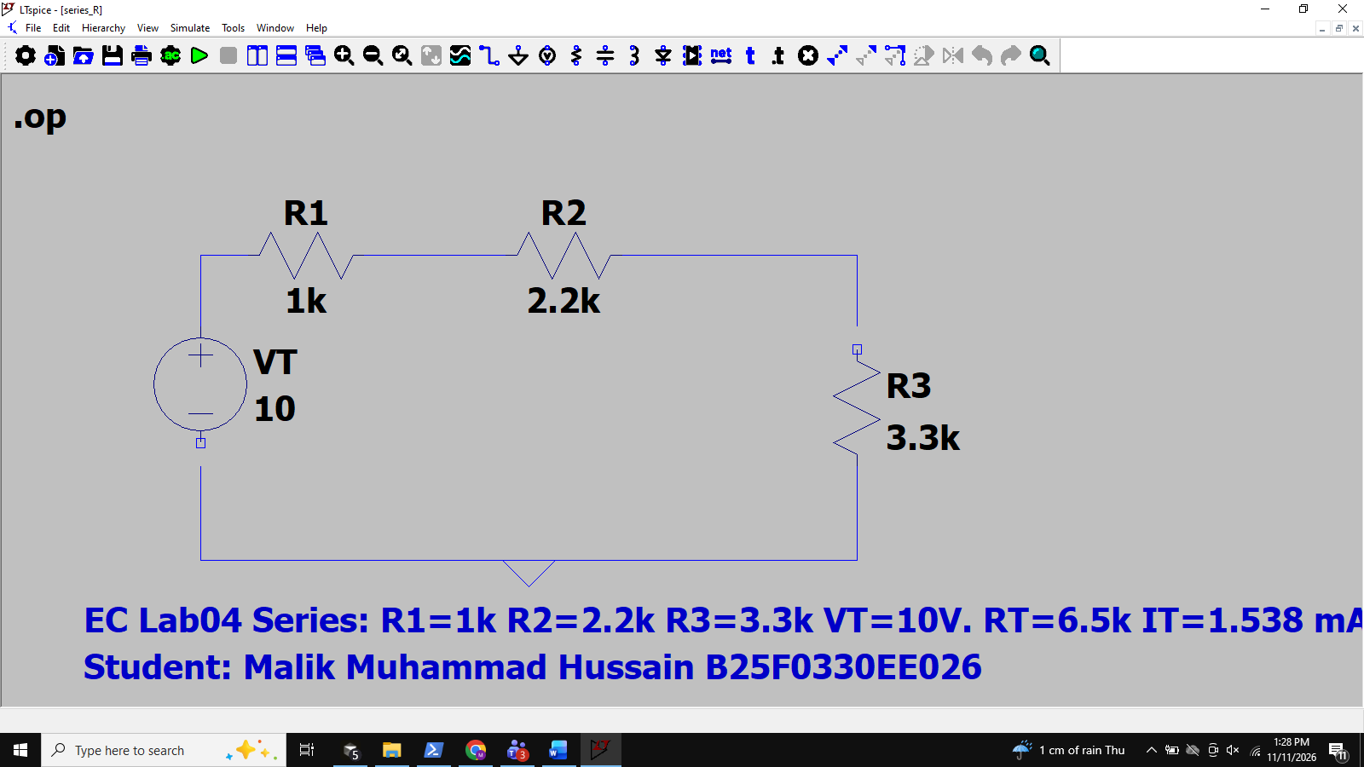
Color/nominal: R1=1000 Ohm, R2=2200 Ohm, R3=3300 Ohm
Observed (LTSpice / ideal DMM `): same as nominal.
Theoretical RT = R1+R2+R3 = 6500 Ohm; Observed RT ` = 6500 Ohm.

Voltage/current at VT=10 V:
IT = VT/RT = 10/6500 = 1.538 mA ` (I1=I2=I3)
V1 = IT*R1 = 1.538 V `; V2 = 3.385 V `; V3 = 5.077 V `
VT check = V1+V2+V3 = 10.000 V
Calculated currents from V/R match IT (series: same current).

Standard Color Code | Resistance Value From Color Code (Ω) | Observed Value From DMM (Ω) | Theoritical RT (Ω) | Observed RT (Ω)
R1= Brn-Blk-Red | 1000 | 1000 ` | 6500 | 6500 `
R2= Red-Red-Red | 2200 | 2200 ` | 6500 | 6500 `
R3= Org-Org-Red | 3300 | 3300 ` | 6500 | 6500 `

Procedure For Obtaining Voltage And Current Relation For Series Circuit:

- Connect the circuit as shown in the figure.
- Set the voltage of the voltmeter to 10 V.
- Mark this voltage as V_{T} and note this voltage in the table below.
- Using the DMM in the current mode observe the current I_{T} and write the value of current in the table.
- Using DMM in the voltage mode observe the value for voltages across the resistors R₁ , R₂ , R₃ as V₁ , V₂ , V₃ respectively.
- Using the values of R₁ , R₂ , R₃ and I₁ , I₂ , I₃ calculate the value for V₁ , V₂ , V₃ respectively.
- Write these value in the table below.
- Using the DMM in current mode write the values of current I₁ , I₂ , I₃ in the table.
- Using values of the voltage across the resistors R₁ , R₂ , R₃ obtain the value of current I₁ , I₂ , I₃ .
- Write these values in the table below.
- Compare the observed and calculated values of the voltages and current to verify the results.

OBSERVATION TABLE:
Measured  Voltage V_{T}(V) | Measured Voltage  Across the resistors (V) | Calculated Voltage  Across the resistors (V) | Calculated voltage V_{T} (V) | Measured current  Across the  resistors (I) mA | Calculated current  Across the resistors  (I)mA
VT = 10.000 ` | V1=1.538 ` V2=3.385 ` V3=5.077 ` | V1=1.538 V2=3.385 V3=5.077 | VT = 10.000 | I1=1.538 ` I2=1.538 ` I3=1.538 ` | I1=1.538 I2=1.538 I3=1.538

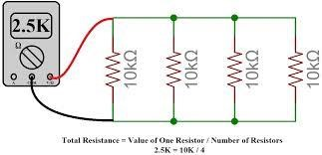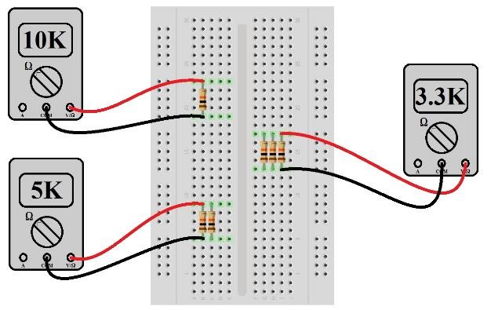
2.

Parallel resistance

Procedure For Measurement Of Parallel Resistance And Its Related Voltage And Current:
- Using the resistance values R₁ , R₂ , R₃ calculate the total resistance using the formula for total resistance in parallel
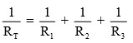
- Verify the value of the calculated resistance using the DMM.
- Note these values in the table below.
OBSERVATION TABLE:
Standard Color Code | Resistance Value From Color Code (Ω) | Observed Value From DMM (Ω) | Theoritical RT (Ω) | Observed RT (Ω)
R1= Brn-Blk-Red | 1000 | 1000 ` | 568.97 | 568.97 `
R2= Red-Red-Red | 2200 | 2200 ` | 568.97 | 568.97 `
R3= Org-Org-Red | 3300 | 3300 ` | 568.97 | 568.97 `

CIRCUIT DIAGRAM:
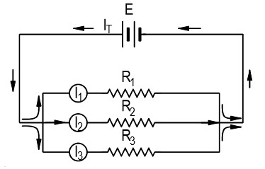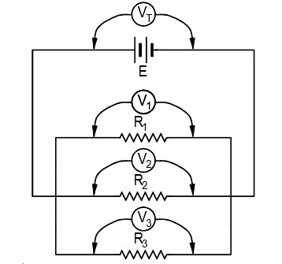
Figure 3. Three resistors R1, R2, and R3 connected in parallel showing the flow of current and potential differences all being equal.

The total current flowing in the circuit is the sum of the separate currents flowing through the resistors,
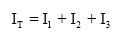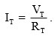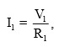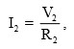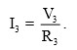

The voltage drops across the battery and resistors are all equal, and as illustrated in Figure 3,

Procedure For Obtaining Voltage And Current Relation For Parallel Circuit:

  - PARALLEL RESULTS (same R values, VT=10 V):
  - LTSpice Parallel circuit — full-screen schematic / .op
  - 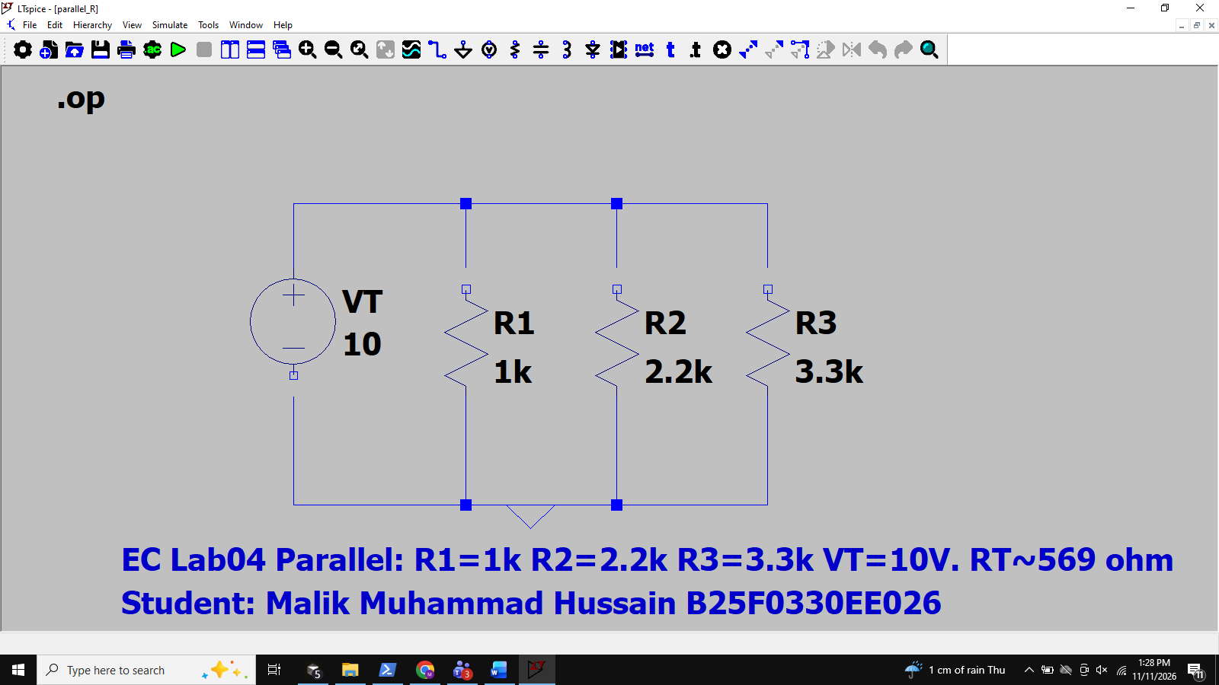
  - 1/RT = 1/1k + 1/2.2k + 1/3.3k => RT = 568.97 Ohm `
  - I1 = VT/R1 = 10.000 mA `; I2 = 4.545 mA `; I3 = 3.030 mA `
  - IT = I1+I2+I3 = 17.576 mA `
  - V1=V2=V3=VT=10.000 V ` (parallel voltages equal)
  - Using DMM measure the currents I₁ , I₂ , I₃ and . Also measure the value of VT.
  - Wirte these value in the table below.
  - Using the value of resistors and the voltage across the it calculate the value of the currents I₁ , I₂ , I₃.
  - Note these value in the table below.
  - Use these value of current to calculate I_{T}.
  - Compare and verify the results.

OBSERVATION TABLE:
Calculated current  IT(A) | Calculated current  Across the resisitors (A) | Measured current  Across the resisitors (A) | Measured current  IT (A) | Calculated voltage  Across the resisitors (V) | Measured voltage  Across the resisitors  (V)
IT = 17.576 mA | I1=10.000 mA I2=4.545 mA I3=3.030 mA | I1=10.000 ` I2=4.545 ` I3=3.030 ` | IT = 17.576 mA ` | V1=10.000 V2=10.000 V3=10.000 | V1=10.000 ` V2=10.000 ` V3=10.000 `

Voltage Divider Rule:
The Voltage Divider Rule (VDR) states that the voltage across an element or across a series combination of elements in a series circuit is equal to the resistance of the element or series combination of elements divided by the total resistance of the series circuit and multiplied by the total impressed voltage:
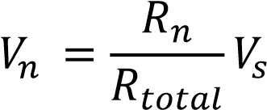
𝑉_{𝑛} = 𝑣𝑜𝑙𝑡𝑎𝑔𝑒 𝑎𝑐𝑟𝑜𝑠𝑠 𝑡ℎ𝑒 𝑒𝑙𝑒𝑚𝑒𝑛𝑡,
𝑅_{𝑛} = 𝑟𝑒𝑠𝑖𝑠𝑡𝑎𝑛𝑐𝑒 𝑜𝑓 𝑡ℎ𝑒 𝑒𝑙𝑒𝑚𝑒𝑛𝑡
𝑉_{𝑠} = 𝑖𝑚𝑝𝑟𝑒𝑠𝑠𝑒𝑑 𝑣𝑜𝑙𝑡𝑎𝑔𝑒 𝑜𝑟 𝑠𝑢𝑝𝑝𝑙𝑦 𝑣𝑜𝑙𝑡𝑎𝑔𝑒
𝑅_{𝑡𝑜𝑡𝑎𝑙} = 𝑡𝑜𝑡𝑎𝑙 𝑟𝑒𝑠𝑖𝑠𝑡𝑎𝑛𝑐𝑒 𝑜𝑓 𝑡ℎ𝑒 𝑠𝑒𝑟𝑖𝑒𝑠 𝑐𝑖𝑟𝑐𝑢𝑖𝑡
CIRCUIT DIAGRAM:
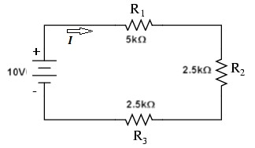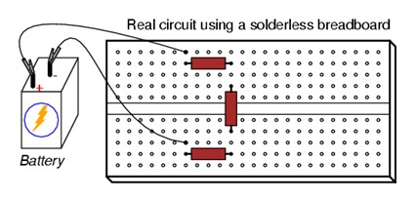
FIGURE 1. SEREIS CIRCUIT CALCULATION:
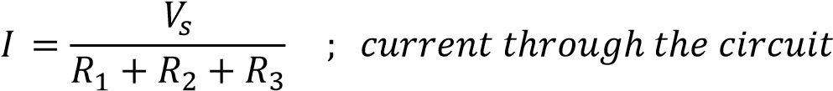

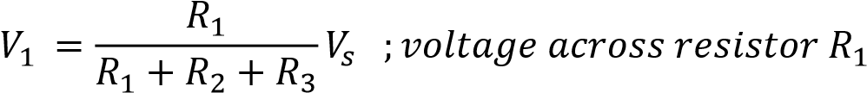

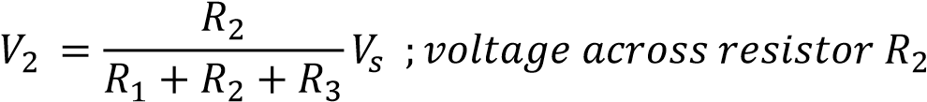

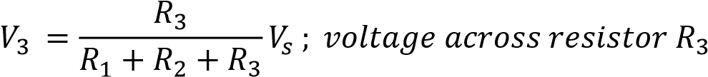

PROCEDURE FOR VOLTAGE DIVISION (VDR):

- VDR RESULTS (VS=10 V, R1=5k, R2=2.5k, R3=2.5k):
- LTSpice Voltage Divider — full-screen schematic / .op
- 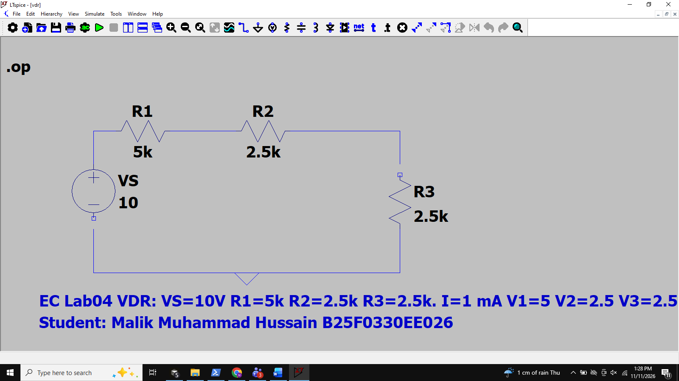
- RT = 10 kOhm; I = VS/RT = 1.000 mA `
- V1 = I*R1 = 5.000 V `; V2 = 2.500 V `; V3 = 2.500 V `
- VDR check: Vx = VS * Rx/RT => same values. V1+V2+V3 = 10.000 V `
- Remark: Observed (LTSpice) matches calculated; voltage divides proportional to resistance.
- Connect the circuit shown in Fig. (1).
- Take V_{S} = 10V, R₁=5KΩ, R₂=2.5KΩ and R₃=2.5KΩ.
- Using ohm’s law calculate the current "𝐼" through the circuit in figure 1.
- Practically verify this current using the digital multimeter.
- Using the formula for the voltage divider calculate the voltage across each resistor.
- Write the calculated voltage in the table below in the column for calculated value.
- Measure the voltage across the resistors R₁, R₂ & R₃ using a digital multimeter in the DC voltage mode.
- Write the value of the voltage across the resistors in the table below in the column for the observed value.
- Write the remark from the result obtained from the observed and calculated values.

OBSERVATION TABLE:
Impressed / supply voltage  (V) | Calculated  Current  (mA) | Observed  Current  (mA) | Calculated Value Of  Voltage Across Resistors (V) | Observed Value Of  Voltage Across Resistors (V)
VS = 10 | 1.000 | 1.000 ` | V1 = 5.000 | V1 = 5.000 `
VS = 10 | 1.000 | 1.000 ` | V2 = 2.500 | V2 = 2.500 `
VS = 10 | 1.000 | 1.000 ` | V3 = 2.500 | V3 = 2.500 `
VS = 10 | 1.000 | 1.000 ` | VT=V1+V2+V3=10.000 | VT=V1+V2+V3=10.000 `

The Current Divider Rule (CDR) states that the current through one of two parallel branches is equal to the resistance of the other branch divided by the sum of the resistances of the two parallel branches and multiplied by the total current entering the two parallel branches. That is,
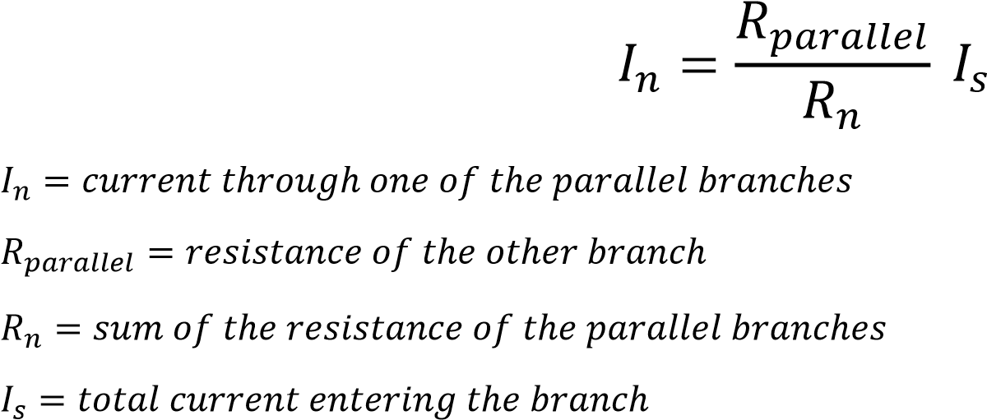
CIRCUIT DIAGRAM:
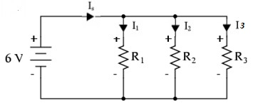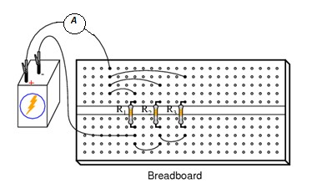

(a) (b)
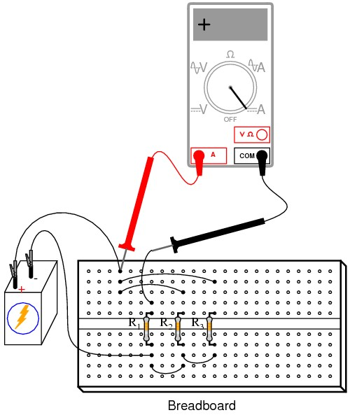
(c)
Figure 2. Current divider CALCULATION:
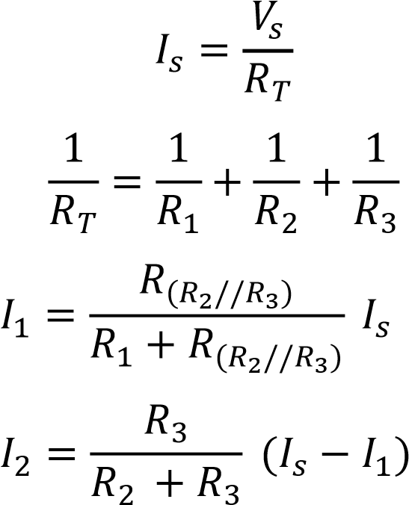
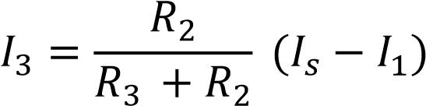
PROCEDURE FOR CURRENT DIVISION (CDR):

- CDR RESULTS (VS=6 V, R1=5k, R2=2.5k, R3=2.5k in parallel):
- LTSpice Current Divider — full-screen schematic / .op
- 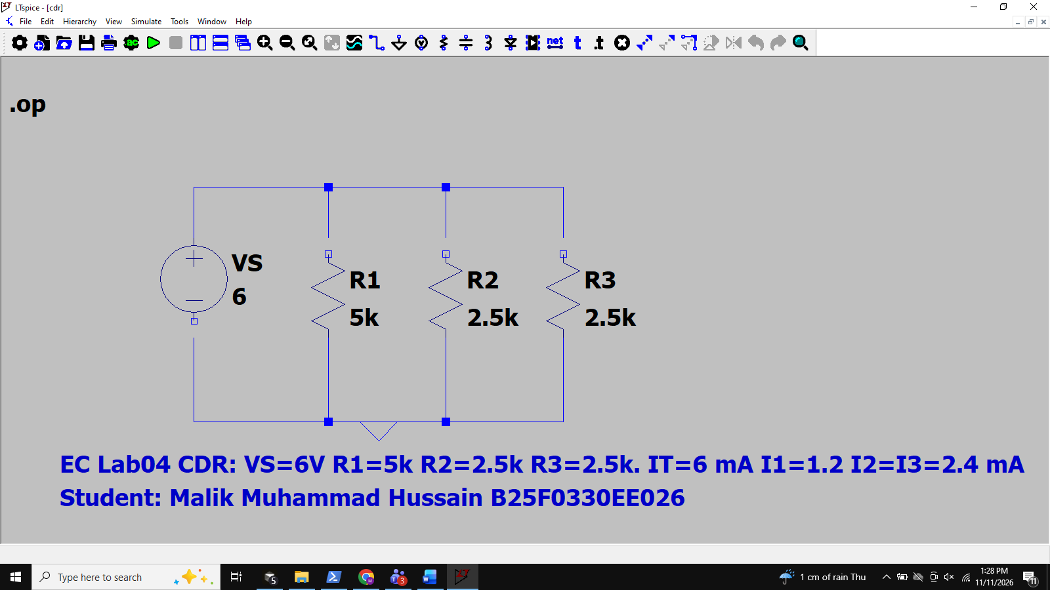
- IT = VS*(1/R1+1/R2+1/R3) = 6.000 mA `
- I1 = VS/R1 = 1.200 mA `; I2 = 2.400 mA `; I3 = 2.400 mA `
- I1+I2+I3 = 6.000 mA = IT `
- Remark: Current divides inversely with resistance; smaller R takes larger share. Observed matches calculated.
- Connect the circuit as shown in Fig. (2a).
- Take V_{S} = 6V, R₁=5KΩ, R₂=2.5KΩ and R₃=2.5KΩ.
- Using ohm’s law calculate the current 𝐼 through the circuit in figure 2 (a).
- Practically verify this current using the digital multimeter as shown in figure 2(b)
- Using the formula for the current divider calculate the current flowing through each resistor.
- Write the calculated current in the table below in the column for calculated value.
- Measure the current through the resistors R₁, R₂ & R₃ using a digital multimeter in the DC current mode as in figure 2 (c).
- Write the value of the current through the resistors in the table below in the column for the observed value.
- Write the remark from the result obtained from the observed and calculated values.
OBSERVATION TABLE:
Impressed / supply voltage  (V) | Calculated  Current  (mA) | Observed  Current  (mA) | Calculated Value Of  Current Through Resistors (mA) | Observed Value Of  Current Through Resistors (mA)
VS = 6 | IT = 6.000 | IT = 6.000 ` | I1 = 1.200 | I1 = 1.200 `
VS = 6 | IT = 6.000 | IT = 6.000 ` | I2 = 2.400 | I2 = 2.400 `
VS = 6 | IT = 6.000 | IT = 6.000 ` | I3 = 2.400 | I3 = 2.400 `
VS = 6 | IT = 6.000 | IT = 6.000 ` | IT=I1+I2+I3=6.000 | IT=I1+I2+I3=6.000 `

Conclusion:

Conclusion: Series resistors add (RT=R1+R2+R3) and share one current while voltages add to VT. Parallel resistors share one voltage while branch currents add to IT; RT is less than the smallest branch. The voltage divider gives Vx = VS*Rx/RT in a series string; the current divider allocates current inversely with resistance among parallel branches. LTSpice .op (measured `) agreed with calculated values for all four experiments (% difference ~ 0% with ideal models).
-

