Smart Financial Account Management System: A File-Based Banking Program in C++ with SHA-256 PIN Protection and Account Lockout
Nour Hamdy, Menna Khaled, Mariam Hany, Menna Abdelnasser, and Yassmin Zakaria
Egyptian Chinese College for Applied Technology (ECCAT), Suez Canal University
Supervisors: Dr. Zakaria Hassan and Eng. Nada Hussain

Abstract—We built a small banking program in C++ that keeps all of its data in two text files. A user can create an account, deposit, withdraw, transfer money, check a balance, read the history of operations and change the PIN. Because a bank handles money, we focused on protecting the PIN: it is never stored, only its SHA-256 hash is; it is hidden while it is typed; every input is validated; and an account is locked for five minutes after three wrong PINs. We tested every menu option and the main failure cases with scripted inputs, and all 16 checks passed. The program is a learning project and not ready for real money, mainly because plain text files can be edited and SHA-256 alone is too fast to protect a short PIN from offline guessing.
Index Terms—C++, file handling, SHA-256, PIN security, account lockout, audit log
I. Introduction
Every bank has to keep a record of accounts, change balances when money moves, and make sure only the owner can touch an account. Our course assignment asked for a C++ program that handles account creation, deposits, withdrawals, balance inquiries, transfers and transaction records, and it told us to work with files.
When we looked at how simple programs of this kind are usually written, three weak points kept appearing: the PIN is saved as plain text, there is no limit on wrong guesses, and nothing records what happened to an account. Our goals were to practise file handling, to close those three gaps, and to keep the code short enough for every team member to explain. The rest of the paper describes the design (Section II), the security mechanisms (Section III), the tests (Section IV), and the limits and future work (Sections V and VI).
II. System Design
A. Structure
The program is a single C++ file of about 290 lines. Each operation is a separate function that returns true when it worked and false when it did not. This maps directly onto the flowchart in Fig. 1: a failed operation returns to the menu, and a successful one asks whether the user wants another operation. Deposits need only the account number, as in a real bank, while withdraw, transfer, balance, transaction records and change PIN also require the PIN.
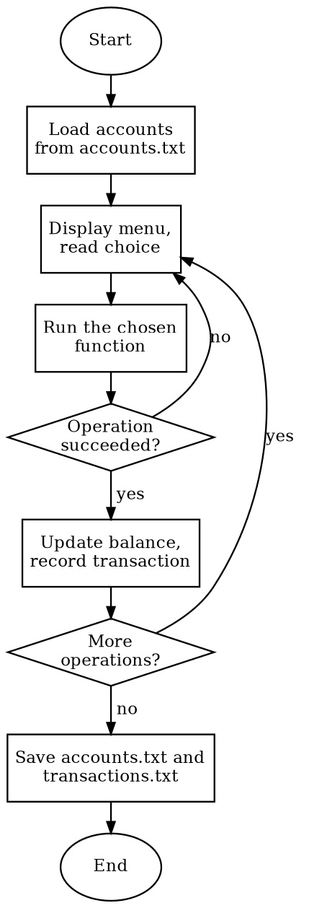
Fig. 1. Flowchart of the program. A failed operation returns to the menu; a successful one asks whether to continue.
B. Data and files
While the program runs, accounts are kept in a vector of records holding the account number, the PIN hash, the balance, the number of failed attempts, the lock time and the name. Two text files are used. The first, accounts.txt, has one line per account and is rewritten completely when the data is saved. The second, transactions.txt, has one readable line per operation and is only appended to, so old records are never lost. Showing the history reads the whole file and prints only the lines of one account. In this way the program uses four file operations: read, overwrite, append, and read-and-filter [2].
III. Security Mechanisms
A. Hashing the PIN
A hash function turns any text into a fixed-size fingerprint and cannot practically be reversed. We implemented SHA-256 [1] ourselves in about 35 lines. The message is padded to a multiple of 64 bytes, each 64-byte block goes through 64 rounds that mix eight 32-bit numbers using rotations, XOR, AND and addition, and the final numbers are written as 64 hexadecimal characters. The account number is placed in front of the PIN before hashing, which works as a simple salt, so two accounts with the same PIN get different hashes. At login the typed PIN is hashed the same way and compared with the saved hash, so the PIN itself never needs to be kept.
B. Hidden input and validation
The PIN is read without echo. It must be exactly six digits, amounts must be above 0 and at most 50,000, and letters or negative numbers are rejected. A wrong account number and a wrong PIN produce the same message, so the program does not reveal which account numbers exist.
C. Account lockout
Each account counts wrong PINs in a row. On the third, the account is locked for five minutes, and even the correct PIN is refused during that time. The counter is saved immediately after every wrong attempt. In our first version it was saved only at exit, so closing the program after two wrong tries gave the user a fresh counter; saving at once closed that gap.
D. Audit record
Every operation, every wrong PIN and every lock is written to transactions.txt, which gives a trail that can be checked later.
IV. Testing and Results
We fed the program scripted inputs for every menu option and for the failure cases we could think of, then checked the output and both files. Table I summarises the 16 checks, and all of them passed. We also confirmed that accounts.txt contains the hash and never the PIN, and that our SHA-256 output matches Python's hashlib [3] on five different inputs, including an empty string and a 1,000-character string. The automatic unlock was tested with a copy of the program in which the lock time was shortened to three seconds, because waiting five minutes for each run was not practical.
TABLE I
Summary of Test Results
Group of checks | No. | Result
Input validation (mismatched PINs, PIN length, invalid amounts, unknown account) | 4 | Passed
Money rules (overdraft, transfer to self or to a missing account, total money) | 4 | Passed
PIN handling (old PIN after change, SHA-256 vs. hashlib) | 2 | Passed
Lockout (three wrong PINs, correct PIN while locked, restart, unlock, reset) | 5 | Passed
Persistence (data survives a restart) | 1 | Passed
Total | 16 | 16 passed

V. Limitations
The two files are plain text, so someone with access to the computer could edit a balance or set the lock time back to zero. SHA-256 is designed to be fast; if accounts.txt is stolen, all one million six-digit PINs can be tried offline very quickly, and the lockout does not help because it works only inside the running program. The salt is the known account number rather than a random value. The lock depends on the computer clock, money is stored as a double rather than whole cents, and data is saved at exit, so closing the window early loses unsaved changes.
VI. Future Work
A password hash that is deliberately slow, such as bcrypt, Argon2 or PBKDF2 with a random salt for each account, would remove the main weakness above [4]. The text files could be replaced by a database or protected by a signature so that edits are detected. Other improvements are storing money as integer cents, notifying the owner when an account locks, adding an administrator unlock, and building a graphical interface.
VII. Conclusion
We built a working console bank in C++ that covers every operation in the assignment, keeps its data in files, and protects the user in the places where small programs are usually weak. The project showed us how read, overwrite, append and filter operations fit together, why a hash is different from encryption, and how easily a gap such as a visible PIN or a lock that resets on exit stays hidden until the program is tested the way an attacker would test it.
Acknowledgment
The authors thank their supervisors, Dr. Zakaria Hassan and Eng. Nada Hussain, for their guidance.
References
[1] National Institute of Standards and Technology, “Secure Hash Standard (SHS),” FIPS PUB 180-4, Aug. 2015.
[2] cppreference.com, “Input/output library.” [Online]. Available: https://en.cppreference.com/w/cpp/io
[3] Python Software Foundation, “hashlib — Secure hashes and message digests.” [Online]. Available: https://docs.python.org/3/library/hashlib.html
[4] OWASP Foundation, “Password Storage Cheat Sheet.” [Online]. Available: https://cheatsheetseries.owasp.org/cheatsheets/Password_Storage_Cheat_Sheet.html

