

Egypt University of Informatics

Computer and Information Systems

Data Analysis Course

The Analysis of how the student’s gender influences their academic performance.

By: Nour Hany

# Introduction

Curious about the link between gender and academic performance? This report explores how male and female students differ in studying behaviour, grades, GPA. Discover insights that could improve educational support and create a more inclusive learning environment for all. Whether you're a student, educator, or parent.

# Research Question

# How the student’s gender influences their academic performance, including studying habits, GPA, and grades?

# Hypothesis

There is a significant difference between STEM males and females in their studying habits and overall grades.

# Population of Interest:

# STEM university students

# Sampling Method:

The research employed convenience sampling, selecting participants based on their availability and willingness to take part in an online survey. While stratified sampling would have been preferable to ensure representation from various universities, limitations prevented us from reaching a more diverse sample.

# Bias Identification:

In designing this survey, we have taken steps to identify and minimize potential sources of bias. define your own bias and how you made sure it didn't leak into your questions.

# Survey Questions:

What's your gender?

What's your age?

What’s your university?

What is your major?

What's your level?

Do you attend lectures for their effectiveness or for the attendance?

How frequently do you attend lectures?

On a scale of 1 to 5(max), how well do lectures hold your attention?

Do you take notes during the lectures?

Do you think lectures are important?

Do you think tutorials are important?

Where do you study the material from?

Do you study alone or in groups?

How many hours do you study on weekends?

How many hours do you study on weekdays?

How many hours do you study per day on the week leading up to an exams?

What's you CGPA?

Are you satisfied by your academic performance?

Online Survey link:<https://docs.google.com/forms/d/e/1FAIpQLSeD8bR0eH1QEpnL-IpNYbFPDndW9CwraizJqFVlteqKLXobAQ/viewform?usp=sf_link>

Number of samples collected: 29

# Analysis:

Males: 22

Females: 6

Mode of gender: Males

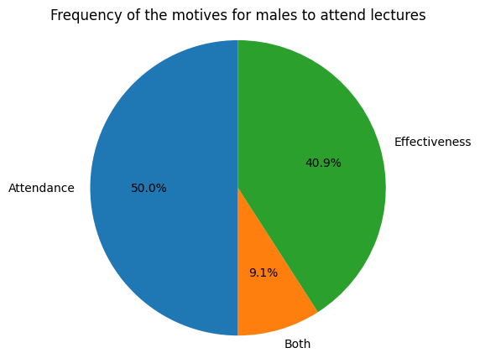

This pie chart represents the motives behind attending lectures for males and females, and both has approximately the same percentage.

This pie chart represents behind if the students take notes during the lecture or not, and how it differs between males and females, and they have the same percentage.

Attendance is represented from scale of 1(rarely attends) to 4(attends all lectures) and there is no significant difference between males and females.

Mean of Studying hours per day (weekday):

Males 2.81 Females 2.66

Mean of Studying hours per day (weekend):

Males 4.63 Females 6.33

Mean of Studying hours per day (week leading up to an exams):

Males 5.25 Females 6.16

Males' CGPA Mean: 3.14 Males' CGPA Mean: 3.26

Males' CGPA Median: 3.15 Males' CGPA Median: 3.475

Males' CGPA Mode: 3.91, count=3 Males' CGPA Mode: 2.35, count=1

# Conclusion

Males and Females both has the same studying behaviours, and they have close academic performance.

# Any potential issues

1. The sampling method is not the most suitable.
2. The sample was too small to represent the population.
3. The females’ size was relatively small in comparison with malls so the comparison was not fair